Web Appendix

Whether and How Prepurchase Word of Mouth Affects Postpurchase Word of Mouth

Hung M. Dao (hung.dao@liverpool.ac.uk), Kshitij Bhoumik (k.bhoumik@leeds.ac.uk), Reika Igarashi (r.igarashi@napier.ac.uk)

WEB APPENDIX A: MANIPULATIONS OF INTERPERSONAL CLOSENESS ACROSS STUDIES 2
WEB APPENDIX B: ATTENTION CHECK QUESTION USED IN STUDIES 1A, 2, AND 4 5
WEB APPENDIX C: ADDITIONAL MEDIATION ANALYSES (STUDY 2) 6
WEB APPENDIX D: ADDITIONAL ANLAYSES (STUDY 3) 10
WEB APPENDIX E: ADDITIONAL ANALYSIS (STUDY 4) 15
WEB APPENDIX F: WITHIN-STRANGER EFFECTS 16
WEB APPENDIX G: CORRELATION BETWEEN INTERPERSONAL CLOSENESS MANIPULATION CHECK AND WORD-OF-MOUTH ACROSS STUDIES 20
REFERENCES 22

These materials have been supplied by the authors to aid in the understanding of their paper. The AMA is sharing these materials at the request of the authors.

WEB APPENDIX A: MANIPULATIONS OF INTERPERSONAL CLOSENESS ACROSS STUDIES

Study 1a
Friend’s recommendation | Stranger’s recommendation
Take a moment to think of a close friend. Please write the name or initials of that close friend in the text below.  [Next page] Imagine that you are surfing the homepage of Instagram to find out what your friends are up to. You come across a post by [the friend’s name they wrote down] about his/her evaluation of a newly released smartwatch. | Imagine that you are surfing the homepage of Instagram to find out what your friends are up to. You come across a post by a stranger about his/her evaluation of a newly released smartwatch.
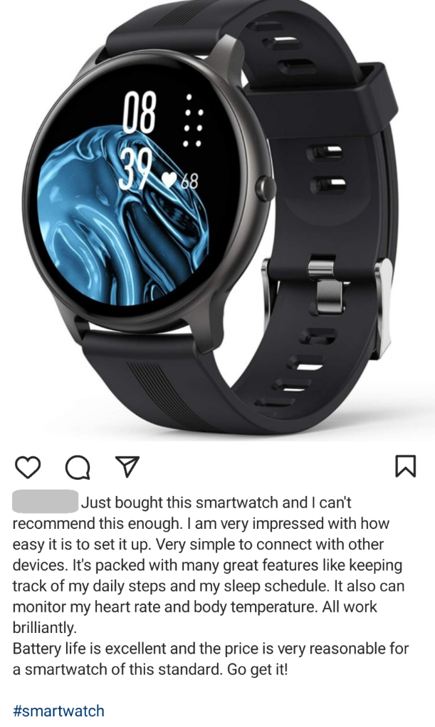

(All participants saw this recommendation post.)
(Next, all participants read the following product failure scenario.)
Because of this post, you immediately order the smartwatch from Amazon and it arrives 3 days later.
However, after using the product for a few days, you noticed so many issues with the watch. It frequently showed the wrong time. Smartwatch constantly gets disconnected from your other Bluetooth and Wi-Fi devices. The alarm and weather settings were not working sometimes. The step counter was inaccurate, and the monitors weren't picking up sleep, blood pressure, and heartbeats correctly as advertised. The watch had a very poor quality overall.

Study 1b
Friend’s recommendation | Stranger’s recommendation
Take a moment to think of a close friend. Please write the name or initials of that close friend in the text below.  [Next page] Imagine that you are surfing the homepage of Instagram to find out what your friends are up to. You come across a post by [the friend’s name they wrote down] about his/her evaluation of a newly released smartwatch. | Imagine that you are surfing the homepage of Instagram to find out what your friends are up to. You come across a post by a stranger about his/her evaluation of a newly released smartwatch.

(All participants saw this recommendation post.)
(Next, all participants read the following product failure scenario.)
Based on this review, you decided to try the restaurant a few days later.
When you reached the restaurant you had to wait 20 minutes to be seated while there are still plenty of empty tables. The food took a further 40 minutes to show up and it was very underwhelming.
The staff was not very friendly and didn't offer you any apology and explanation for the low-quality food and service.

Studies 2-4
Friend’s recommendation | Stranger’s recommendation
Take a moment to think of a close friend. Please write the name or initials of that close friend in the text below.  [Next page] Imagine that you are surfing Facebook’s home page to find out what your friends are up to. You come across a post by [the name they wrote down] about his/her evaluation of a newly released VR headset. | Imagine that you are surfing Facebook’s home page to find out what your friends are up to. You come across a post by a stranger about his/her evaluation of a newly released VR headset.
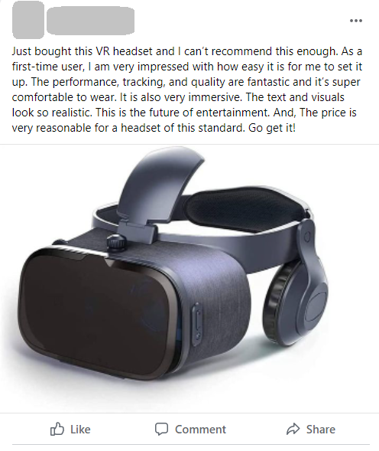

(All participants saw this recommendation post.)
(Next, all participants read the following product failure scenario.)
After reading the post, you immediately order the same VR headset from Amazon, and it arrives 3 days later. As a first-time user of a VR headset, you are very excited to use it. You open the package and start to set it up. The headset boots up, but you have trouble connecting it with your computer or cell phone properly. You try to change the settings, but the connection seems to go on and off. In addition, the vision is so blurred you cannot see anything clearly on the screen. You refer to the instruction manual, but it is not helpful.
You spend nearly all day trying to figure out the functionality of the headset, but it does not operate.

WEB APPENDIX B: ATTENTION CHECK QUESTION USED IN STUDIES 1A, 2, AND 4

Attention check
People drink throughout the day. We want to learn about how many times a day you drink. This page is to see if you are reading the instructions carefully. For the questions that follow this paragraph, please give the answer none to each question. Please just ignore the text of the questions, and type the word none as your answer. Thank you for answering these questions.
On average, how many times a day do you DRINK SOMETHING? Please give your best estimate:

WEB APPENDIX C: ADDITIONAL MEDIATION ANALYSES (STUDY 2)

Additional analyses for negative online review intention
We conducted separate mediation analyses for all three variables, perceived extent of misleadingness, anticipated impact, and relationship norm, using PROCESS model 4 (Hayes 2017) with 5,000 bootstrapped samples and 95% confidence intervals (CIs) (See Figure W1).
When anticipated impact was entered into the model, the analysis revealed an overall indirect effect through anticipated impact (indirect effect = −.173, SE = .0673, 95% CI [–.3106, –.0444]). Particularly, participants anticipated a higher impact of writing a negative review when the product was recommended by a stranger than by a friend (b = −.29, t = −2.62, p = .009). The anticipated impact, in turn, increased the intention to write a negative review (b = .59, t = 7.07, p < .001).
When perceived extent of misleadingness was entered into the model, the analysis also revealed an overall significant indirect effect (indirect effect = −.275, SE = .085, 95% CI [–.4530, –.1208]). Particularly, participants perceived that a negative review by a stranger misled more people than a review by a friend (b = −.797, t = −6.32, p < .001). Perceived extent of misleadingness, in turn, increased participants’ intention to write a negative review (b = .345, t = 4.43, p < .001).
When relationship norm was entered into the model, the analysis again revealed an overall significant indirect effect (indirect effect = −.12, SE = .0558, 95% CI [–.2438, –.0219]). Particularly, participants were less willing to publicly go again the friend than the stranger who wrote the recommendation post (b = .839, t = 4.40, p < .001). This relationship norm, in turn, reduced participants’ intention to write a negative review (b = −.14, t = −2.74, p = .007).
C: Mediation model of relationship norm
b =.839***
Interpersonal closeness (0 = stranger; 1 = friend)
Relationship norm
Online review intention
b = -.14**
b = -.695***
b = -.574***
B: Mediation model of perceived extent of misleadingness
b = -.797***
Interpersonal closeness (0 = stranger; 1 = friend)
Perceived extent of misleadingness
Online review intention
b = .345***
b = -.695***
b = -.420*
A: Mediation model of anticipated impact
b = -.29**
Interpersonal closeness (0 = stranger; 1 = friend)
Anticipated impact
Online review intention
b = .59***
b = -.695***
b = -.522**
Figure W1. Separate mediation analyses for anticipated impact (Model A), perceived extent of misleadingness (Model B), and relationship norm (Model C)

Additional analyses for in-person negative WOM
Parallel mediation analysis. To investigate the mediating roles of anticipated impact and relationship norm we conducted a multiple mediation analysis with two factors entered simultaneously using PROCESS model 4 (Hayes 2017) with 5,000 bootstrapped samples (See Figure W2). The analysis revealed a significant indirect effect through both anticipated impact (indirect effect = −.0620, SE = .0401, 95% CI [–.1582, –.0053]) and relationship norm (indirect effect = −.0977, SE = .0486, 95% CI [−.2034, −.0146]). The direct effect of interpersonal closeness on negative direct WOM was weaker after we controlled for the mediating effects (b = –.507, p < .001, 95% CI [−.7962, −.2178]).
b = -.291***
Interpersonal closeness
(0 = stranger; 1 = friend)
Anticipated impact
Relationship norm
In-person negative
WOM
b = .213**
b = .839***
b = -.116**
b = -.667***
b = -.507***
Figure W2. Effect of interpersonal closeness on in-person negative WOM through mediating roles of anticipated impact and relationship norm (Study 2).

Separate Mediation Analyses. We also conducted separate mediation analyses for all three variables, anticipated impact, perceived extent of misleadingness, and relationship norm, using PROCESS model 4 (Hayes 2017) with 5,000 bootstrapped samples and 95% confidence intervals (CIs) (See Figure W3).
When anticipated impact was entered into the model, the analysis revealed an overall indirect effect through anticipated impact (indirect effect = −.0668, SE = .0405, 95% CI [–.1607, –.0064]). Particularly, participants anticipated a higher impact of sharing a negative review when the product was recommended by a stranger than by a friend (b = −.29, t = −2.62, p = .009). The anticipated impact, in turn, increased the intention to share in-person negative WOM (b = .2294, t = 2.975, p = .003).
When perceived extent of misleadingness was entered into the model, the analysis also revealed an overall significant indirect effect (indirect effect = −.238, SE = .085, 95% CI [–.4027, –.1075]). Particularly, participants perceived that a negative review by a stranger misled more people than a review by a friend (b = −.7965, t = −6.32, p < .001). Perceived extent of misleadingness, in turn, increased participants’ intention to share in-person negative WOM (b = .2992, t = 4.48, p < .001).
When relationship norm was entered into the model, the analysis again revealed an overall significant indirect effect (indirect effect = −.11, SE = .0492, 95% CI [–.2161, –.0219]). Particularly, participants were less willing to publicly go again the friend than the stranger who wrote the recommendation post (b = .839, t = 4.40, p < .001). This relationship norm, in turn, reduced participants’ intention to share in-person negative WOM (b = −.13, t = −2.81, p = .005).
C: Mediation model of relationship norm
b =.839***
Interpersonal closeness (0 = stranger; 1 = friend)
Relationship norm
In-person negative WOM

b = -.13**
b = -.667***
b = -.561***
B: Mediation model of perceived extent of misleadingness
b = -.797***
Interpersonal closeness (0 = stranger; 1 = friend)
Perceived extent of misleadingness
In-person negative WOM

b = .30***
b = -.667***
b = -.429**
A: Mediation model of anticipated impact
b = -.29**
Interpersonal closeness (0 = stranger; 1 = friend)
Anticipated impact
In-person negative WOM
b = .23**
b = -.667***
b = -.600***
Figure W3. Effect of interpersonal closeness on in-person negative WOM through mediating roles of anticipated impact and relationship norm (Study 2).

WEB APPENDIX D: ADDITIONAL ANLAYSES (STUDY 3)

Possible alternative explanations: attribution of responsibility and intention to contact the recommender
To further examine alternative explanations, we considered the attribution of responsibility, or the degree to which consumers blame recommender for leaving misleadingly positive reviews. In particular, consumers might blame their close friend (vs. stranger) to a lesser degree, as people mostly view their friends as an extension of themselves (Aron, Aron, and Smollan 1992), and people always try to avoid self-blame to maintain a positive self-view (Tennen and Affleck 1990); thus, they are more likely to complain when a stranger (vs. friend) is responsible for the failure (Choi and Mattila 2008). In addition, consumers may directly contact the person who wrote the positive review; especially talking to their friend to complain is easier than talking to a stranger. Therefore, they might have less of a need to write an online review about a failed product. Thus, participants responded to two single-item scales (1 = “strongly disagree,” 7 = “strongly agree”) measuring (1) attribution of responsibility (“I blame the person who posted the review [the friend’s name] for overpraising this VR headset”) and (2) intention to contact the recommender (“I would send a message to the stranger who wrote the review [the friend’s name] about this issue”).

Parallel Mediation Analyses
Mediation analyses. To investigate the mediating roles of anticipated impact, attribution of responsibility, and intention to contact the recommender, we followed Bhattacharjee and Mogilner’s (2013) approach and conducted a multiple mediation analysis with three factors entered simultaneously using PROCESS model 4 (Hayes 2017) with 5,000 bootstrapped samples and 95% confidence intervals (CIs) (See Figure W4). The analysis revealed only a significant indirect effect through anticipated impact (indirect effect = −.196, SE = .1029, 95% CI [–.4196, –.0149]), with no other significant indirect effects (attribution of responsibility: indirect effect = .036, SE = .0667, 95% CI [−.0828, .1887]; intention to contact: indirect effect = .181, SE = .2844, 95% CI [−.4463, .6875]). The direct effect of interpersonal closeness on negative online review intention turned nonsignificant after we controlled for the mediating effect (b = –.365, p = .38, 95% CI [−1.1762, 4463]).
b = .03
b = -.34*
Interpersonal closeness (0 = stranger; 1 = friend)
Anticipated impact
Attribution of responsibility
Intention to contact recommender
Online review intention
b = .57***
b = -.69**
b = 3.21***
b = -.05
b = -.544*
b = -.365
Figure W4. Parallel mediation analyses for (Study 3)

Separated Mediation Analyses
We also conducted separate mediation analyses for all three variables anticipated impact, attribution of responsibility, and intention to contact recommender using PROCESS model 4 (Hayes 2017) with 5,000 bootstrapped samples and 95% confidence intervals (CIs) (See Figure W5).
When anticipated impact was entered into the model, the analysis revealed an overall indirect effect through anticipated impact (indirect effect = −.20, SE = .0967, 95% CI [–.3876, –.0139]). Particularly, participants anticipated a higher impact of writing a review when the product was recommended by a stranger than by a friend (b = −.34, t = −2.12, p = .03). The anticipated impact, in turn, increased the intention to write a negative review (b = .59, t = 6.25, p < .001).
In contrast, when attribution of responsibility or intention to contact the recommender was entered into the model, both analyses revealed overall non-significant indirect effects (attribution of responsibility: indirect effect = −.0721, SE = .0618, 95% CI [–.2102, .0349]; intention to contact the recommender: indirect effect = .3462, SE = .2717, 95% CI [–.1801, .8837]).
C: Mediation model of intention to contact recommender
b = 3.21***
Interpersonal closeness (0 = stranger; 1 = friend)
Intention to contact recommender
Online review intention
b = .11
b = -.544*
b = -.890*
B: Mediation model of attribution of responsibility
b = -.69**
Interpersonal closeness (0 = stranger; 1 = friend)
Attribution of responsibility
Online review intention
b = .105
b = -.544*
b = -.472*
A: Mediation model of anticipated impact
b = -.34*
Interpersonal closeness (0 = stranger; 1 = friend)
Anticipated impact
Online review intention
b = .59***
b = -.544*
b = -.341
Figure W5. Separate mediation analyses for anticipated impact (Model A), attribution of responsibility (Model B), and intention to contact recommender (Model C)

Additional Moderated Mediation Analyses
Parallel moderated mediation analyses. We ran PROCESS model 8 with 5,000 bootstrapped samples and 95% confidence intervals (CIs) to test the mediating roles of anticipated impact, attribution of responsibility, and the intention to message the recommender on the effect of interpersonal closeness and self-construal on online review intention. The analysis revealed that only anticipated impact mediated the interactive effect on online review intention (index = -.35, SE = .13, 95% CI = [-.6071, -.1113]) while the moderated mediation model through attribution of responsibility (index = .02, SE = .04, 95% CI = [-.0539, .1230]) and intention to message the review were non-significant (index = -.01, SE = .048, 95% CI = [-.1124, .0840]).
Particularly, self-construal moderated the effect of interpersonal closeness on anticipated impact (F(1,187) = 11.53, p < .001), such that interpersonal closeness reduced anticipated impact of the review among high self-construal participants (+1SD; M_{stranger} = 5.66 vs. M_{friend} = 4.80; b = –.85, t = –3.85, p < .001) but not among low self-construal participants (–1SD; M_{stranger} = 4.85 vs. M_{friend} = 5.06; b = .21, t = .96, p = .34). Self-construal also moderated the effect of interpersonal closeness on intention to message the recommender (F(1,187) = 3.91, p = .05) but did not moderate the effect on attribution of responsibility (F(1,187) = 1.22 , p = .27). However, only anticipated impact then increased online review intention (b = .54, SE = .13, t (184) = 4.24, p < .001) while the effects of intention to message the recommender (b = .02, SE = .095, t (184) = .246, p = .81) and attribution of responsibility (b = -.054, SE = .083, t (184) = -.66, p = .51), and the direct effect of interpersonal closeness (b = 2.38, SE = 1.68, t (184) = 1.407, p = .16) were non-significant.

Additional separate moderated mediation analyses. We tested the separated moderated mediation effect models for attribution of responsibility and intention to contact the recommender as a mediator using PROCESS model 8. The results again confirmed that both attribution of responsibility (index = .008, SE = .044, 95% CI = [-.1137, .0732]) and intention to contact the recommender (index = -.04, SE = .056, 95% CI = [-.1628, .0663]) did not mediate the interactive effect of interpersonal closeness and self-construal on negative online review intention.

WEB APPENDIX E: ADDITIONAL ANALYSIS (STUDY 4)

Mediation analysis
We also tested the role of anticipated impact in mediating the effect of interpersonal closeness on online review intention using PROCESS model 4. The results again showed a significant indirect effect through anticipated impact (indirect effect = −.2604, SE = .0911, 95% CI [–.4544, –.0957]). Particularly, participants anticipated a higher impact of writing a review when the product was recommended by a stranger than by a friend (b = −.43, t = −3.17, p = .002). The anticipated impact, in turn, increased the intention to write a negative review (b = .61, t = 6.03, p < .001). The direct effect of interpersonal closeness on negative online review intention turned nonsignificant after we accounted for the mediating effect (b = –.3996, p = .06, 95% CI [−.8079, 0087]), indicating an indirect-only mediation.

WEB APPENDIX F: WITHIN-STRANGER EFFECTS (A SUPPEMENTARY STUDY)

To further enhance the practical implications of our research, we conducted a supplementary study to explore the impact of interpersonal closeness among unfamiliar reviewers. Existing literature suggests that incidental similarities between individuals can engender feelings of interpersonal closeness (Jiang et al. 2009). Notably, in online marketplaces such as Amazon and eBay, reviewer details like country, city, name, and gender are often available. An investigation into the effects of such shared similarities between the reviewer and the reader is, therefore, of significant managerial importance. We predict that consumers are more likely to share negative WOM after a product failure when the reviewer's attributes are dissimilar, in contrast to when they share similar attributes with the reviewer.

Method
One hundred fifty-two United Kingdom participants recruited from Prolific completed an online study in return for monetary compensation (M_{age} = 38.9; 57.2% female, 39.5% male, and 2.6% prefer not to say). We randomly assigned participants to two interpersonal closeness conditions (high: shared similarity vs. low: no similarity). We manipulated this factor by presenting details about the reviewer’s name and country.
Specifically, participants first imagined browsing for a VR headset across various online retailers. They eventually came across a globally shipping e-retailer offering the desired headset, which received overall positive reviews. In the high interpersonal closeness condition, they encountered a review written by "Olivia from the United Kingdom." Since all participants are from the United Kingdom and "Olivia" is a common name in the UK (Clark 2023; Ghosh and Stevens 2022), participants in this condition shared certain similarities with the reviewer. Conversely, participants in the low interpersonal closeness condition read a review from "Sun-Young from South Korea." The content of the review and subsequent product failure scenario, adapted from Study 2, remained consistent across conditions. The detailed manipulations are provided below:
High-similarity reviewer’s recommendation
Imagine you're considering buying a VR headset. You've been browsing various electronic retailers online to determine which one catches your interest. You stumble upon an online retailer that sells the VR headset you've been eyeing and ships internationally. As you scroll through the website, you decide to check out the reviews to get a better sense of the product. The overall sentiment seems very positive. One review, in particular, stands out. It's from a buyer named Olivia from the United Kingdom. Here's what the buyer had to say:
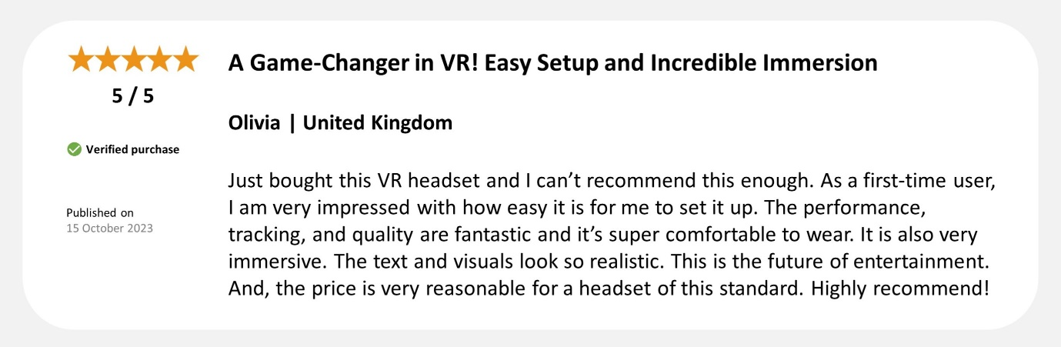
Low-similarity reviewer’s recommendation
Imagine you're considering buying a VR headset. You've been browsing various electronic retailers online to determine which one catches your interest. You stumble upon an online retailer that sells the VR headset you've been eyeing and ships internationally. As you scroll through the website, you decide to check out the reviews to get a better sense of the product. The overall sentiment seems very positive. One review, in particular, stands out. It's from a buyer named Sun-Young from South Korea. Here's what the buyer had to say:
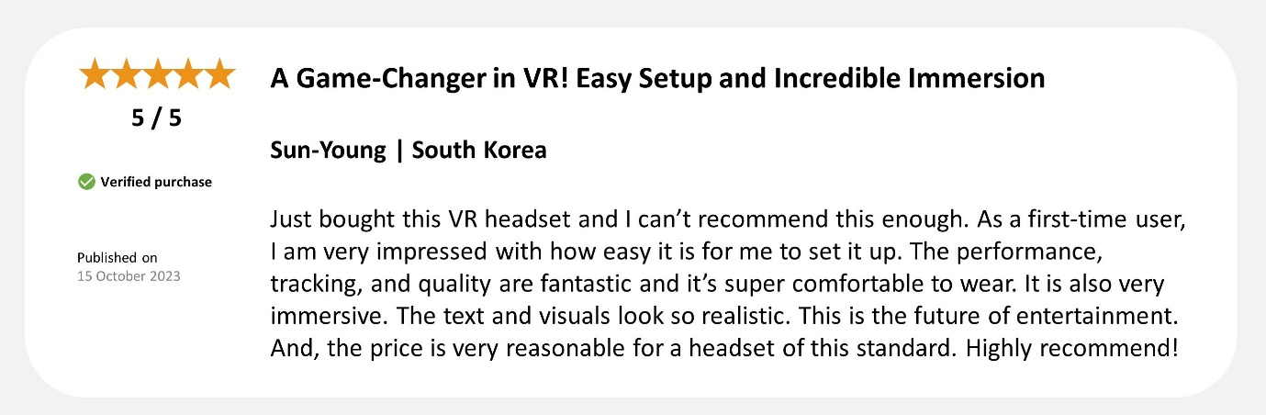
(Next, all participants read the following product failure scenario.)
As a first-time user of a VR headset, you are very excited to use it. You open the package and start to set it up. The headset boots up, but you have trouble connecting it with your computer or cell phone properly. You try to change the settings, but the connection seems to go on and off. In addition, the vision is so blurred you cannot see anything clearly on the screen. You refer to the instruction manual, but it is not helpful. You spend nearly all day trying to figure out the functionality of the headset, but it does not operate.

Next, to measure overall online review intention, participants rated their likelihood to share their negative e-WOM (“How likely are you to share your negative VR headset experience on this retailer's website?” 1 = “extremely unlikely,” 7 = “extremely likely”; “I would write a negative online review about this VR headset.” 1 = “strongly disagree,” 7 = “strongly agree”; α = .83) and gave a star rating on the retailer’s website adapted from Study 1a. Finally, participants completed the two-item measure of perceived interpersonal closeness as manipulation check from Study 1b (α = .95).

Results
Manipulation checks. A one-way ANOVA revealed that while participants in the high similarity condition felt somewhat closer (M = 2.01, SD = 1.44) than those in the low similarity condition (M = 1.76, SD = 1.12), the difference was not statistically significant (F(1, 150) = 1.35, p = .25).
Negative online review intention. Accidental similarity shared with the reviewer had a marginally significant main effect on negative online review intention (F(1, 150) = 3.868, p = .051), such that participants were more likely to leave negative online reviews about the failed product when recommended by a low-similarity reviewer (M = 5.43, SD = 1.35) as compared to a high-similarity reviewer (M = 4.99, SD = 1.42).
Online Product Rating. Similarly, accidental similarity shared with the reviewer had a marginally significant main effect on product rating (F(1, 150) = 3.314, p = .071), such that participants gave a lower rating of the failed product when recommended by a low-similarity reviewer (M = 1.54, SD = .79) as compared to a high-similarity reviewer (M = 1.79, SD =.90).

Discussion
This study provides further evidence that interpersonal closeness, even among strangers, can still shape negative WOM intentions. Specifically, when consumers shared a certain similarity with a stranger, they are less likely to post negative reviews upon product failure compared to when there's no shared similarity.

WEB APPENDIX G: CORRELATION BETWEEN INTERPERSONAL CLOSENESS MANIPULATION CHECK AND WORD-OF-MOUTH ACROSS STUDIES

Regression analyses were used to assess the relationship between the manipulation check of interpersonal closeness and various outcomes (including negative online review intention in Studies 1b-3 and the supplementary study; negative in-person WOM in Studies 1a-2; and product rating in Study 1a and the supplementary study) across different studies. The results consistently indicated that the manipulation check of interpersonal closeness is correlated with the outcomes in all studies, with a direction similar to that of the manipulations themselves (See Table WA1). Specifically, perceived interpersonal closeness (i.e., the manipulation check) is negatively correlated with negative online review intention and in-person negative WOM, while it is positively correlated with product ratings.
 | Stranger condition (Low similarity condition in the supplementary study) | Friend Condition (High Similarity condition in the supplementary study) | All Samples
Study 1a | Product Rating:  β = .227**, p = .01  Negative in-person WOM:  β = -.157**, p = .074 | Product Rating:  β = -.190*, p = .03  Negative in-person WOM:  β = .211*, p = .016 | Product Rating:  β = .160**, p = .01  Negative in-person WOM:  β = -.176**, p = .004
Study 1b | Negative online review Intention:  β = -.03, p = .71  Negative in-person WOM:  β = -.264*, p = .009 | Negative online review Intention:  β = -.109, p = .27  Negative in-person WOM:  β = -.063, p = .53 | Negative online review Intention:  β = -.144*, p = .042  Negative in-person WOM:  β = -.152*, p = .032
Study 2 | Negative online review Intention:  β = -.039, p = .64  Negative in-person WOM:  β = -.065, p = .445 | Negative online review Intention:  β = -.052, p = .54  Negative in-person WOM:  β = -.111, p = .194 | Negative online review Intention:  β = -.238***, p < .001  Negative in-person WOM:  β = -.281***, p < .001
Study 3 | Negative online review Intention:  β = .017, p = .87 | Negative online review Intention:  β = -.137, p = .19 | Negative online review Intention:  β = -.174*, p = .016
Supplementary Study | Negative online review Intention:  β = -.203, p = .078  Product Rating:  β = .521***, p < .001 | Negative online review Intention:  β = -.271*, p = .018  Product Rating:  β = .470***, p < .001 | Negative online review Intention:  β = -.252**, p = .002  Product Rating:  β = .496***, p < .001
Table W1. Correlation Between Interpersonal Closeness Manipulation Check and Word-of-Mouth Across Studies
NOTE: All coefficients reported above are standardized. *p < .05. **p < .01. *** p < .001

REFERENCES

Clark, D. (2023), "Most registered female baby names in England in 2021," (accessed October 20, 2023), [available at https://www.statista.com/statistics/318724/most-popular-baby-names-for-girls-in-england/].

Ghosh, Kanak and Chloe Stevens (2022), "Baby names in England and Wales: 2021," (accessed October 20, 2023), [available at https://www.ons.gov.uk/peoplepopulationandcommunity/birthsdeathsandmarriages/livebirths/bulletins/babynamesenglandandwales/2021].

Jiang, Lan, Joandrea Hoegg, Darren W. Dahl, and Amitava Chattopadhyay (2009), "The Persuasive Role of Incidental Similarity on Attitudes and Purchase Intentions in a Sales Context," Journal of Consumer Research, 36 (5), 778-91.

