Diurnal salivary cortisol and cortisone concentrations in
girls with Turner Syndrome: A preliminary report
Lily Jones¹, Julie Park^{1,2}, Silothabo Dliso³, Daniel B. Hawcutt^{1,3,4},
Alena Shantsila⁴, Gregory Y.H. Lip^{4,5}, Joanne Blair^{1,2,3,4*}
¹Department of Women’s and Children’s Health, University of Liverpool, ²Department of Endocrinology, Alder Hey Children’s NHS Foundation Trust, Liverpool, ³NIHR Alder Hey Clinical Research Facility, Alder Hey Children’s NHS Foundation Trust, Liverpool, ⁴ Liverpool Centre for Cardiovascular Science at University of Liverpool, Liverpool John Moores University and Liverpool Heart & Chest Hospital, Liverpool, United Kingdom; and ⁵Danish Center for Clinical Health Services Research, Department of Clinical Medicine, Aalborg University, Aalborg, Denmark

Corresponding Author:
Joanne Blair
Department of Endocrinology, Alder Hey Children's NHS Foundation Trust,
Liverpool
L12 2AP, UK
Email: jo.blair@alderhey.nhs.uk
Telephone: +44 151 228 4811 Fax: +44 151 282 4606
ORCID ID: 0000-0003-3128-5574

Background
Turner Syndrome (TS), in which there is loss of genetic material from the second X chromosome, affects approximately 1:2,000 females. Life expectancy is reduced by at least ten years.^{1,2} Approximately 50% of the increased mortality is due to cardiovascular disease which is primarily acquired.²
Higher hair cortisol concentrations are reported in women with TS compared to healthy controls.³ Increased cortisol exposure and disrupted diurnal profiles in shift workers are associated with increased cardiometabolic morbidity.⁴
Cortisol is inactivated by 11β hydroxysteroid dehydrogenase (11βHSD) type 2 and regenerated from cortisone by 11βHSD type 1. In this study we report the diurnal profile of salivary cortisol (SC) and cortisone (SCn) in girls with TS and healthy girls (HG). Only biologically active, free hormones are measured in saliva while measurements made in serum include free and bound hormone. This is important in patients treated with oestrogen, in whom cortisol binding is increased and measurements of serum cortisol are unreliable.

Methods
Saliva samples were collected using Salivettes 30 minutes after waking every two waking hours for 24-hours and analysed for SC and SCn by liquid chromatography tandem mass spectrometry. Girls with TS (TSG) were age matched (1:1) with healthy girls (HG). Girls with diagnoses or treatments likely to affect Sc or Scn were excluded. In TSG only, paired blood and saliva samples were collected at 09.00 and analysed for cortisol, SC and SCn.

Results
Ten TSG and ten HG participated. Characteristics are given in Table 1.

In TSG, median 09.00 serum cortisol was 282.5 nmol/L (IQR 185.0 – 384.0 nmol/L), SC 5.4 nmol/L (3.7 – 8.4 nmol/L) and SCn 23.1 nmol/L (20.8 – 33.0 nmol/L). Serum cortisol correlated with SC (r2 = 0.63, p=0.006) and SCn (r2 = 0.58, p=0.0107).

Area under the curve (AUC) was higher in TSG compared to HG (45.8 nmol/L [95%CI 17.3-74.2] vs 38.4 nmol/L [ 95%CI 16.7-60.0]), p=0.0016, while AUC for SCn did not differ (p=0.25) (Figure 1A-C).

A diurnal profile in the ratio of SCn:SC was seen in TSG and HG (Figure 1D), and was lower in TSG (77.8; 95%CI [59.66-95.9] vs 96.61; 95%CI [70.05-123.2]; p=<0.001) (Figure 1E).

Discussion
To our knowledge this is first study to describe the diurnal profile of cortisol in TSG. The mean AUC for SC was higher in TSG, despite a trend for higher BMI in HG which is associated with an increase in SC.⁵ Compared to HGs, the ratio of SCn:SC was lower in TSG at all time points, other than the waking sample. Differences in the relative activity of 11βHSD 1 and 2 may contribute to increased cortisol exposure, and the pathogenesis of cardiovascular disease in TS.

We would like to thank the Turner Syndrome Support Society UK for their guidance in study design.
This is a summary of independent research carried out at the National Institute for Health Research (NIHR), Alder Hey Clinical Research Facility. The views expressed are those of the author(s) and not necessarily those of the NHS, the NIHR or the Department of Health.

References
- Schoemaker MJ, Swerdlow AJ, Higgins CD, Wright AF, Jacobs PA. Mortality in women with turner syndrome in Great Britain: a national cohort study. J Clin Endocrinol Metab. 2008;93(12):4735-4742.
- Gravholt CH, Juul S, Naeraa RW, Hansen J. Morbidity in Turner syndrome. J Clin Epidemiol. 1998;51(2):147-158.
- Savas M, Wester VL, Dykgraaf RHM, et al. Long-Term Cortisol Exposure and Associations With Height and Comorbidities in Turner Syndrome. The Journal of Clinical Endocrinology & Metabolism. 2019;104(9):3859-3867.
- Golding H, Ritonja JA, Day AG, Aronson KJ, Tranmer J. Modeling the relationship between shift work and cardiometabolic risk through circadian disruption, sleep and stress pathways. Chronobiol Int. 2022 May;39(5):704-713
- Titman A, Price V, Hawcutt D, et al. Salivary cortisol, cortisone and serum cortisol concentrations are related to age and body mass index in healthy children and young people. Clin Endocrinol (Oxf). 2020;93(5):572-578.

Table 1: Characteristics of study participants

Table 1:

Parameter | Girls with Turner Syndrome | Healthy volunteers
Age (years) | 14.1 ± 2.3 | 14.1 ± 2.4
Height (SDS) | -2.0 ± 0.7 | 1.1 ± 0.6*
BMI (SDS) | 0.9 ± 1.5 | 1.5 ± 1.1*
GH treatment (N, %) | 8 (80) ** | -
Oestrogen and progesterone treatment (N, %) | 3 (30) oestrogen only  3 (30) oestrogen + progesterone | -
Systolic blood pressure (centile) | 86.0 (61.0 – 95.8) | -
Diastolic blood pressure (centile) | 87.5 (70.1 – 92.3) | -
SDS: standard deviation score; BMI: body mass index; GH: growth hormone; N: number. Data are shown as mean ± SD or median (IQR).
*Missing data for two participants ** two participants were treated with GH previously and have reached near adult height.

Figure 1: Salivary cortisol and cortisone profiles of girls with Turner Syndrome and healthy girls

Figure 1

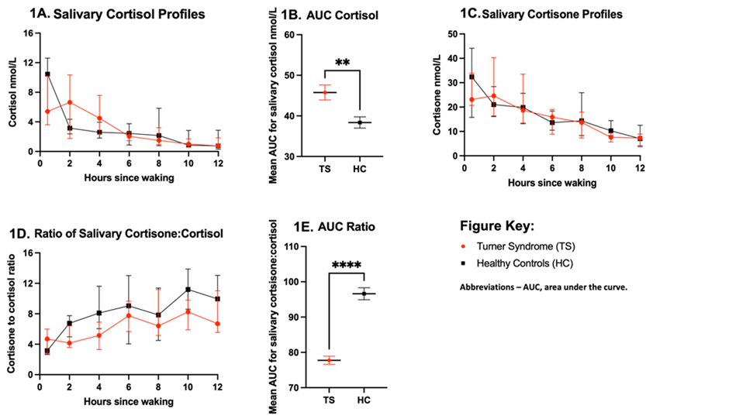

Data are shown as median (inter-quartile range)

