Value, Sustainability, and Heritage Impact
Christopher D. Dore (Heritage Business International) and Kenneth Aitchison (Landward Research Ltd)
At the CIfA Conference in Leeds this year, one of the authors (Dore) made the business case that to have a large heritage impact, organisations must be sustainable. And to be organisationally sustainable requires an ongoing increase in financial value.
These linkages and prerequisites had little relevance a professional generation ago when archaeology was funded through public sources or from wealthy patrons. But today, within the U.K. and internationally, archaeology has been privatised. Current estimates (Heritage Business International and Landward Research) are that commercial archaeology had a global value in 2018 of £1.5 billion pounds (US$ 1.8bn). In private archaeology, growth in financial value is essential for sustainability and impact.
While Dore’s CIfA lecture presented the case for value growth and its importance, it didn’t show how value is calculated and measured. Measuring value is the topic of this article. Financial value is defined as the intrinsic worth of a financial asset. Within privatised archaeology, a financial asset can be an organisation, a department, a project, a person, a business line, etc. Intrinsic worth is derived from the long-term cash flow-generating ability of the asset. The ability of the asset to generate cash flow, over a period of time, is measured by the discounted free cash flow.
What is free cash flow and why is it discounted? Free cash flow is cash that is available to an organisation’s financial stakeholders (e.g. creditors and shareholders) after accounting for all capital expenditures such as buildings or property, plant, and equipment. Free cash flow is used by heritage organisations to expand, develop new services, make acquisitions, pay dividends, and reduce debt. Discounting is a way to account for the ‘time value’ of money. A pound today doesn’t have the same value as a pound five years from now. The value today of a future amount of money (such as the payment made at the end of an archaeological project) is called the present value and is calculated as
$$Present Value=\frac{1}{{(1+r)}^{n}}$$
where r is the discount rate and n is the number of periods (typically years). Thus, if someone gave you £150 five years from now, assuming an annual inflation rate of 3 percent, the present value would be
$$£129.39=\frac{£150}{{(1+.03)}^{5}}$$
We can use this approach to look at the value growth (called real growth) versus the growth in today’s pounds (nominal growth) for commercial archaeology in the U.K.

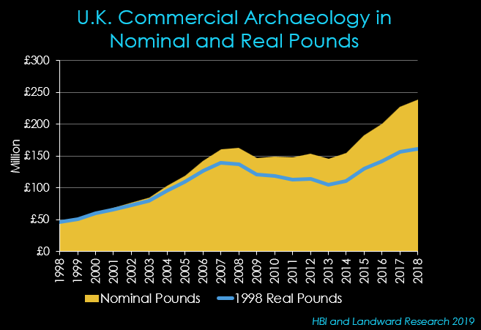
In Figure 1, the blue line represents real growth (inflation accounted for) and, thus, everything above the blue line is simply inflation.
Commercial archaeological organisations need capital to undertake projects. Typically, clients pay at the end of a project and, between the start of the project and getting paid by the client, there are a lot of expenses that must be paid. Not least of these are the salaries of the archaeologists doing the work. Thus, capital must be obtained prior to starting the project. Most heritage companies will borrow this money (purchase debt), issue stock (sell an ownership stake in the firm), or use retained earnings. Regardless of the source of capital, there is a cost to using it. When all sources of capital are considered, their cost is called the Weighted Average Cost of Capital (WACC). For value purposes, the WACC is what is used for the discount rate in the present value (or net present value) calculation
$$WACC=\frac{E}{E+D}\left(Re\right)+\frac{D}{E+D}(Rd)(1-T)$$
where Re = Cost of Equity (%), Rd = Cost of Debt (%), E = Market Value of Equity (£), D = Market Value of Debt (£), and T = Corporate (Corporation) Tax Rate (%) (the fact that some heritage organisations are constituted to not pay Corporation Tax is discussed below).
Let’s start with debt, and in this case it is long-term (more than a year) debt that is of interest.
Debt | Amount | Cost (Interest) | Cost (Pounds) | Weighted Percent
Bank Loan 1 | £21,734 | 6.50% | £1,413
Bank Loat 2 | £7,569 | 5.50% | £416
Car Loan | £15,468 | 4.25% | £657
Loan from Director | £10,000 | 2.35% | £235
TOTAL | £54,771 |  | £2,721 | 4.97%

We now have two of the figures we need for the WACC equation: market value of debt (£54,771) and the cost of debt (4.97%).
The cost of equity is calculated using the Capital Asset Pricing Model (CAPM). The CAPM describes the relationship between systematic risk and return for assets. (Systematic risk is the risk inherent in the overall market system.) Three inputs are required: an estimate of the risk-free interest rate (R_{f}), an estimate of the market risk premium (R_{m}), and an estimate of beta ($β$). Typically, the 30-year bond yield is used for the risk-free rate and the mean over the past twenty years is 3.7 percent. The market risk premium is the expected return for the overall market and can be estimated by using the FTSE 100. The average annual return for the past 30 years is 5.56 percent. Beta is a measure of the volatility in the value of an individual firm in comparison to the market as a whole. A 2018 beta for U.K. professional services firms is 1.19 (Duff & Phelps 2019).
$$5.91=3.7+1.19(5.56-3.7)$$
$$Cost of Equity=R_{f}+β(R_{m}-R_{f})$$
The two numbers that are still needed for the WACC, but have yet to be calculated, are the Market Value of the Equity and the Corporate Tax Rate. For these, we will assume the corporate tax rate to be 19.0 percent and the market value of this example firm to be £2,000,000. The formula may now be completed.
$$4.75\%=\frac{£2,000,000}{£2,000,000+£54,771}\left(5.91\%\right)+\frac{54,771}{£2,000,000+£54,771}(4.97\%)(1-0.19\%)$$
So, what does this mean? It means that the value break-even for this organisation is 4.75 percent profit. Thus, if year-end profits for this firm are positive, but below 4.75, the firm is losing value. When firms lose financial value, they are not sustainable. When profits are above 4.75 percent, the firm gains value. The WACC is the discount rate that is used on future free cash flows to calculate their present, or net present, value.
The WACC is powerful because it can be scaled. This technique can be used to value any financial asset: a firm, a department, a project, a person, etc. We advocate that firms substitute “value” for “profit” in day-to-day decision making. This requires, though, a significant change in the frame of reference for how we think about the business of commercial archaeology. For example, should a firm bid on a particular job? Use the WACC to discount the future free cash flows and calculate the net present value. If the net present value is greater than or equal to zero, then the project will return value to the organisation. The formula for net present value is simply the formula for present value calculated and summed on a year-by-year basis. In this example, the r would be the WACC of 4.75 percent. C_{t} is the free cash flow; C_{o} is the total investment costs—for a job it would be the marketing, sales, and proposal costs.
$$Net Present Value=\sum_{t-1}^{T}{\frac{C_{t}}{{(1+r)}^{t}}-C_{o}}$$

Why are we advocating a reconsideration of value in commercial archaeology? Because, as a whole, the commercial archaeology industry in the U.K. does not appear to be financially sustainable. Landward Research (2019) reports that the mean profit for commercial archaeology organisations was 7.5 percent in 2018. On the surface, that seems like a reasonable profit. However, Duff & Phelps (2019) reports that for U.K. professional service firms, which includes commercial archaeology, the WACC was 8.5 percent in 2018. Thus, overall for 2018, the industry lost one percent value and, hence, was not sustainable.
Approximately 52 percent of people working in commercial archaeology in the U.K. work for not-for-profit charities (calculated from Landward Research 2019). Charities don’t have equity and, thus, don’t have a cost of equity. As well, they are generally exempt from corporation tax. Thus, technically, the WACC approach to valuation isn’t applicable. In concept, though, it has merit. Charities also need to be profitable and return a certain level of value. One technique for substituting the cost of equity, discussed by Essaides (2016), is to use the required return on investment capital: “If a nonprofit board of directors has a mandate that an organization annually return $1 million of its assets through scholarships or other various charitable avenues and its assets base (i.e. invested capital) is $10 million, requiring a 10 percent annual return”. An internet search for WACC and non-profits will provide a number of resources for archaeological charities interested in adapting a financial value approach.
Archaeology as a discipline continues to evolve. The privatisation of our discipline over the last generation of practitioners now requires a different, and more sophisticated, method of evaluating financial value. If archaeological organisations are going to have a significant heritage impact, they must be sustainable. To be sustainable, they must return value. The WACC method provides a relatively easy, and scalable, solution for organisations to use to measure, monitor, and ensure business decisions are made in a way that returns value to the organisation.

References

Duff & Phelps. 2019. Valuation Handbook 2018: International Industry Cost of Capital, United Kingdom. Duff & Phelps, Chicago.

Essaides, N. 2016. FP&A for Nonprofits: Making Investment Decisions.
https://www.afponline.org/ideas-inspiration/topics/articles/Details/fp-a-for-nonprofits-making-investment-decisions. Association for Financial Professionals, Bethesda.

Landward Research. 2019. State of the Archaeological Market 2018.
https://landward.eu/wp-content/uploads/2019/03/Archaeological-Market-Survey-2017-18.pdf. Landward Research Ltd, Sheffield.

