Pre publication version of article published in Memory Studies

West, T. (2014). Remembering displacement: Photography and the interactive spaces of memory.
Memory Studies, 7(2), 176-190.
https://doi.org/10.1177/1750698013479049

4790492013 MSS0010.11

Remembering displacement:
Photography and the interactive spaces of memory

Tamara West
The University of Salford, UK

Abstract
This article draws upon research into the practices within and later memories of Displaced Persons camps in Germany. These camps, set up immediately after the close of the Second World War, stayed open much longer than had first been anticipated, some remaining in operation well into the late 1950s and early 1960s. During this period, specific notions and practices of nation and culture became established, and the camps came to serve as complex sites of identity, belonging and also of difference. Through investigation of the oral and visual narratives of former Displaced Persons, this article examines the initial construction and later (re) viewing of old photographs as well as the reframings involved in the taking of new photographs, and assesses their role in the imagined and physical spaces of embodied memory, place and the shifting sites of belonging and identity.
Keywords
Displacement, embodied practices, memory, photography, returns

Introduction
This article draws upon research conducted into the practices within and memories of Displaced Persons (DP) camps. These camps were set up by United Nations Relief Rehabilitation Administration (UNRRA; later superseded by the International Refugee Organisation) in Allied controlled West Germany immediately after the close of the Second World War in 1945. Their aim was to accommodate and help repatriate the over seven million people who had been forcibly removed from their home countries during the war. Although repatriation was initially successful, by 1946, many of the remaining East European DPs (particularly the Polish DPs on whom this research concentrates) refused to return to a Soviet-controlled Eastern Europe. Consequently, the camps stayed open much longer than had first been anticipated, some remaining in operation well into the late 1950s and early 1960s. During this period, specific notions and practices of nation and

culture became established, and the camps came to serve as complex sites of identity, belonging and also of difference.
The research utilised semi-structured interviews with a small nucleus of participants in Hildesheim, Germany, along with photographs from camps in the British Zone of Lower Saxony, archival data and participant-led revisits to sites of memory. All participants were either very young when they moved to the camps or, in most cases, were born into them. Their families had been unable to emigrate (due to illness or elderly family members) and as such remained in Germany after the closure of the camps. This article draws primarily on the oral and visual data from the interviews undertaken in Hildesheim, in order to explore the role of photography as not only a representation of memory but as an embodied and interactive space in the process of remembering and negotiating belonging and identity.

The spaces of memory and photography
Individual memory is never straightforward. As Levi (1989) suggests, ‘Human memory is a marvellous but fallacious thing’ (p. 11), its veracity and content alters, becoming ‘decantered’ with time. Thus, our memories ‘are not carved in stone; not only do they tend to become erased as the years go by, but often they change, or even increase by incorporating extraneous features’ (p. 11).
Memory is constantly (re) negotiated through actions, interactions and reactions. It alters in accordance with space, place, time and context and is invested with both the need to form connections as well as to assert or accept often subtle, though sometimes overt, relationships of power. Remembering is only one side of a process. What is forgotten – and why – is just as important as that which is recollected. Connerton (2008), for example, discusses several types of forgetting and their role in what is presented as necessary of remembrance. Tying in with this, memory can be institutional, as discussed by, for example, Derrida (1995) in terms of the archive (see also Featherstone, 2000), or Azaryahu (2003) and Lanzelius (2003) with respect to organised and selective commemoration. Memory is therefore entwined with place (it is localised, framed and made sense of through place) and the spaces (both physical and imagined) and times in which it occurs. However, as Massey (2005) theorises, space and time, rather than being binary opposites limited to a progressive understanding of linear time, exist on equal – multi-temporal – footing and are constantly constructed and reconstructed through contemporary activity. Space is neither fixed in form nor subservient to any conception of progressive time and is thus in a constant state of flux. Memory exists within, draws upon, and itself constructs these multi-temporal spaces of existence.
In terms of the purposes of this article, the most fundamental aspect of memory – and the practice of remembering – is that it is enacted and embodied. Here, memory is a shared activity and as such can be performed through narratives, as explored by Prus (2007) and Frosch (2007). These narratives are constructed, added to, moulded and, as Thrift and Dewsbury (2000) suggest, rehearsed and constantly practised. Memory is furthermore inscribed on and within the body of the person who remembers and helps form the ways in which they move, act and react. This, of course, goes beyond narrative, as Legg (2005) suggests, ‘Memories are embodied because they are multisensory and in many cases pre-linguistic’ (p. 419).
A key aspect of what, and how, we remember is defined through the medium of photography. Often, however, the visual is paradoxically marginalised, seen as too ubiquitous, as purely representational or as only significant in terms of what has been rather than what is. The photographic space is filled with dichotomies and exists on multiple sites, though very often discussions about the photograph and memory over-emphasise the sense of loss it can embody, drawing upon Barthes’ (1993) notion of the punctum in Camera Lucida. Here, Barthes suggests that a photograph can represent an event or person that is irrevocably lost, something that can never be regained. The image thus contains what he terms a punctum, an emotive quality to a photograph that directly touches the viewer. Undoubtedly, the photograph, with its depiction of past occurrences often populated with departed family or friends, contains an essence of loss and time past. However, photographs are taken and viewed in the present. As such a family snap (or any photographic representation) cannot be understood merely in terms of its existence as emotive or idealised portrayal of a socially constructed past. As Green (2003) suggests, there is at times a ‘shadow of the cloying melancholia of a post-Barthian era of photographic theory’ (p. 17) while there is in fact a more complex relationship of photographs to time than is usually acknowledged (p. 18). As much as the photographic image may be understood through notions of the past or of loss (or our relationship to that loss), it is much more a part of the constantly malleable construction of everyday life.
The techniques of photo-elicitation in the social sciences also highlight the integral role of the photograph in memory production and re-enactment: for example, Collier’s (2001) use of photographs to elicit responses from a community, Harper’s (2002) exploration of the use of photo-elicitation in anthropology, Meinhof and Galasinski’s (2000) examination of constructions of East/West German identities and Jenkins et al.’s (2008) use of images to explore military identities to name just a few. Here, photographs aid the interview process, enabling a greater depth and richness of narrative data. This approach exemplifies the active site of the image, highlighting the fact that a photograph can be discursively revisited and, as with memory, reworked according to context.
So, while the emotive aspect of the image cannot be overlooked, the emphasis in this article will be on the embodied aspect of photography and the photograph, the act of revisiting and reframing memory through the interactive spaces opened up by the image. Some interdisciplinary work has been done into the performative nature of photography, for example, Larson’s (2005) exploration of tourists sightseeing in which photography becomes a kind of performance. The visual here ceases to be merely representation; it is imbued with human agency. Larson situates a study of tourists within the wider context of the family album, wherein the photographing of tourist spots and the placing of oneself or family within that image perform certain relationships. The photographic performance here does not merely record, it produces and reaffirms. The physical act of taking a photograph can also be used as a means of negotiating trauma, as explored by Zelizer (2002). Drawing on examples from military, civil service and civilian life, Zelizer contends that the act of photographing or needing to bear witness, coupled with the presentation of images to others, provides an active negotiation with a traumatic experience.
The photograph is itself, as Edwards (2002) discusses, an object of material culture. It can exist within the formal archive as much as within the family one, and is shared, handled and situated within set discourses. As an object, the photograph can be held up, written on, even damaged or altered. It can also be a visual component in cultural constructions. The family album, for example, is something that is passed between people, handled and above all else, talked about. This talking, though, takes place within preset cultural understandings. Rose (2003), for example, has explored the domestic spaces involved within the viewing of the family album, while Kuhn (2007), referring to Langford’s ‘oral-photographic method’, has examined the role of the family album in understanding the processes of memory. Not only are oral narratives structured around images here, whole cultural discourses may be reaffirmed through the viewing of them.
Photography can provide a space in which older memories and identities may be negotiated, added to or questioned. Through the concept of post-memory, Hirsch (1996) examines how fragments of old, often second-hand, memories and identities can be revisited or reconfigured artistically. Post-memory here is initially a concept bound to the children of Holocaust survivors whose memories of their parents’ homelands had been passed to them through narratives and old photographs rather than through first-hand experience. It is also spatially specific: the children of the survivors ‘live on a further temporal and spatial remove from the decimated world of their parents’ (Hirsch, 1996: 659). The pre-war homelands of their parents are ones that the children will not experience; however, they are imbued with a narrative and knowledge of them. The now no longer existent homelands (at least in the pre-war form they had been for the parents) become a focus for the children’s sense of belonging and identity. Here, post-memory is very much linked to ‘a condition of exile from the space of identity’ (Hirsch, 1996: 662). Photography is also central to the maintenance and understanding of post-memory through the usage of old snapshots to create new configurations and artistic representations. Although Hirsch uses the term to refer to a specific occurrence and generation, it poses a broader question to all family memory in that the actual process of how memories are formed and reconfigured is examined. It also engages with the means by which memory is performed, revisited and renegotiated.
Post-memory inevitably contains within it traces of hauntings, for example, Sebald’s ‘spectral geographies’ (Wylie, 2007) in which the dead ‘are ever returning to us’ (Sebald, 2002: 23). This often occurs through fragmented narrative or post-memory and results in visits to sites of an orally and photographically related memory. Post-memories, be they in visual, oral or spectral incarnations, are always embodied. The visual is experienced through touch, sight and shared space; the oral through closeness, bodily gestures and sound; and the spectral given materiality through a multi-sensory understanding and experiencing of place. Attempted returns to the sites of others’ memory is echoed by Brennan (2003), whose attempt to discover the changed site of her parents’ pre-war home town leads her to the discovery that it exists only in terms of memory and that ‘separated from my Mother’s story by time, history, geography, language and cultural difference, I have come to see my project as framed by lack’ (p. 65). Post-memory can also to some extent be detected in the ways in which families draw upon Tolia-Kelly’s (2004) usage of ‘re-memory’ linked to everyday objects in the diasporic home. Here, re-memory, much like post-memory, is a recollection of identity and belonging that is contained within the everyday but not necessarily the memory of an actual experience. Religious artefacts, pictures and even postcards can reinforce a re-memory: an underlining of a pre-existing notion of identity and belonging that draws upon the previous experiences of others.
Before exploring these themes in relation to the memories and returns of the former DP children, I will first outline the role of photography within the camps and how the images produced there were to inform not only the memories but also the identities of the interviewees.

Photography in the camps
In the camps, photography was generally undertaken by a designated photographer. The resulting pictures would be numbered and sold to the residents. This led to families owning identical photographs; moreover, many images from different camps were highly similar in both content and appearance. Cohesion and community were a vital part of everyday life in the DP camps, and in the photographs, it is initially national and religious practices that appear to form the most obvious and apparent instances of this. Photographs here depict cultural or religious events such as communions, national celebrations, theatre productions or Christmases. Images 1 and 2 are good examples of this, each depicting communions (in Mariental and Wolterdingen camps). Occasionally, photographs of more general aspects of life are present-group photos, images of schoolchildren and photos of friends (see Image 3, a group of schoolchildren in Wolterdingen camp).
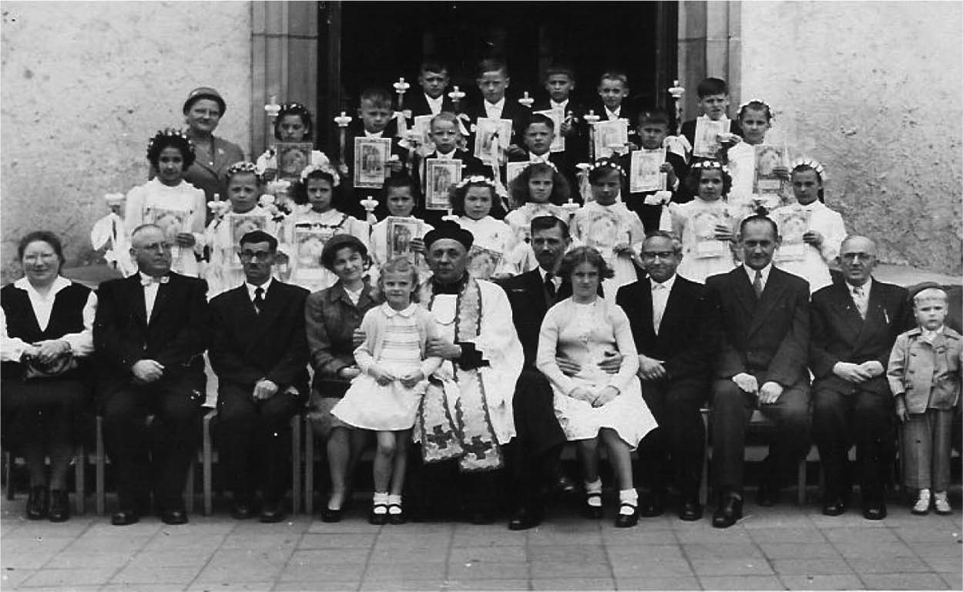
Image 1. Communion in Mariental.
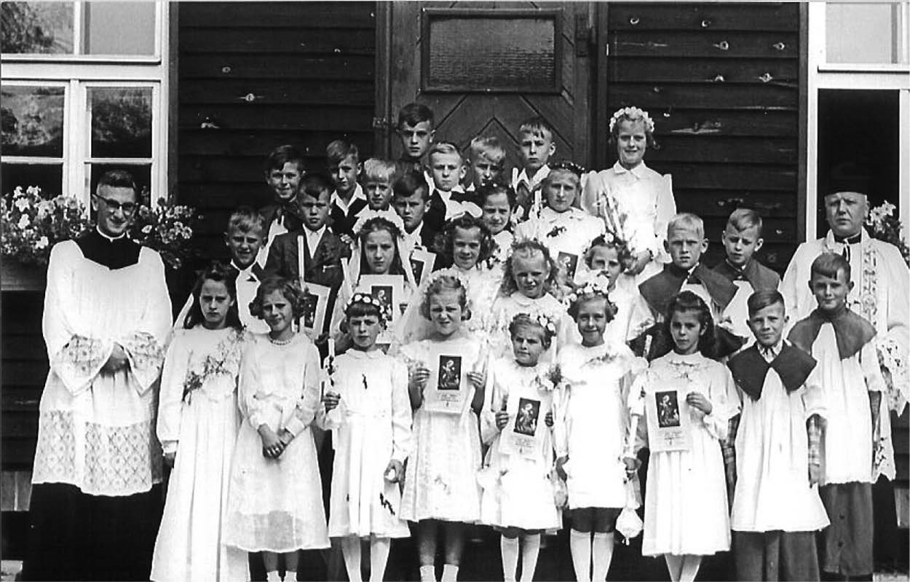
Image 2. Communion in Wolterdingen Camp.
Photo courtesy of Mikołaj Uwa (reproduced with permission).
Family and community photography rarely concerns itself with the bad times; usually, a more idealistic view is offered. Snapshots, as Williams (1994) suggests, always mirrored ‘family life as it ought to be, or as what we would wish it to be. Carefully coded, they acted as a talisman against the real’ (p. 13). The private collections used for this study support this. Community life was something that needed to be visibly recorded as proof of its existence and importance. In part, this is due to the fragmentation of homelands; however, it also draws upon the universal promise of photography to lend an event life beyond itself, to say not only that it existed but that it existed in a certain way.
Photography recorded events that were of major significance in camp life (religious and communal events), and it also helped to ensure that this significance was emphasised, enacted and
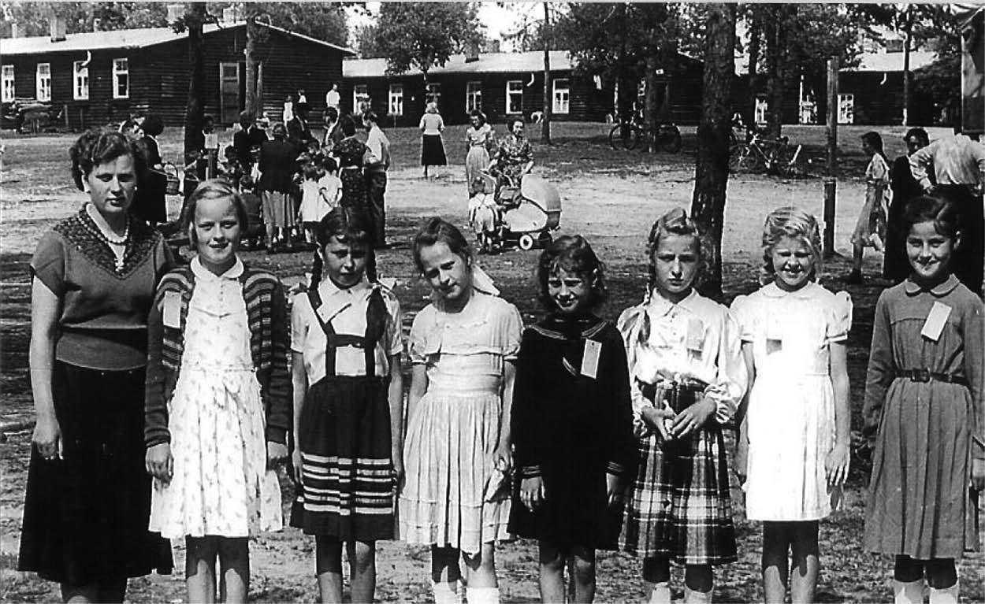
Image 3. Group of children, Wolterdingen camp. Photo courtesy of Mikołaj Uwa (reproduced with permission).
ultimately (re) distributed among not only camp residents but also a wider Western (aid-providing) audience. This is highlighted in Image 4, a photograph of the DP children performing a folk dance. The event had been staged for the British military and various aid organisations and sponsors; similar images were also used in aid pamphlets and in newspapers. Photographs here contain ideological and power-laden discourses in the same way that Tagg (1988) identified late nineteenth-century institutional photography to be an application of Foucault’s power/knowledge structure, or as with Ryan’s (1997) exploration of the ways in which the photographs taken of the British Empire were also representative of a whole system of meaning. The DP camp images present a certain idea of a Catholic and non-Communist Poland and depict the externally supported practices that defined DP life and with it the role of the DPs within the Western Cold War discourse in general. These were a distinctly marketable Catholicism, a practice sponsors and viewers in the mainstream of Western society could identify with, or at least understand, and a harmless patriotism (as opposed to the threat of Soviet Communism or the recent radical ideologies of Nazism).
Of course, the photographic image, and with it narrative memory, nevertheless retains its own personal significance, its punctum. Despite their similarity and reproducibility, each image still attests to what Baudrillard (1999), referring to Barthes punctum, describes as a tremor in the world. It is something which might if not hold then at least trouble the endless flow. For Baudrillard, this was the endless flow of the virtual; here, it may well be the endless flow of the everyday routines and experiences. The photograph, much as with memory itself, upholds a selective mixture of the real and the imagined. Together with narrative, this creates an intarsia effect wherein feelings and experiences are knitted together to create personalised patterns and pictures. This personal dimension is of course only one aspect of the image. Whatever the content – or context – of the photograph, from production through to sharing, it involves human, multi-sensory agency. The photograph positions the photographer, subject and viewer within an interactive and contemporaneous space of embodied memory.
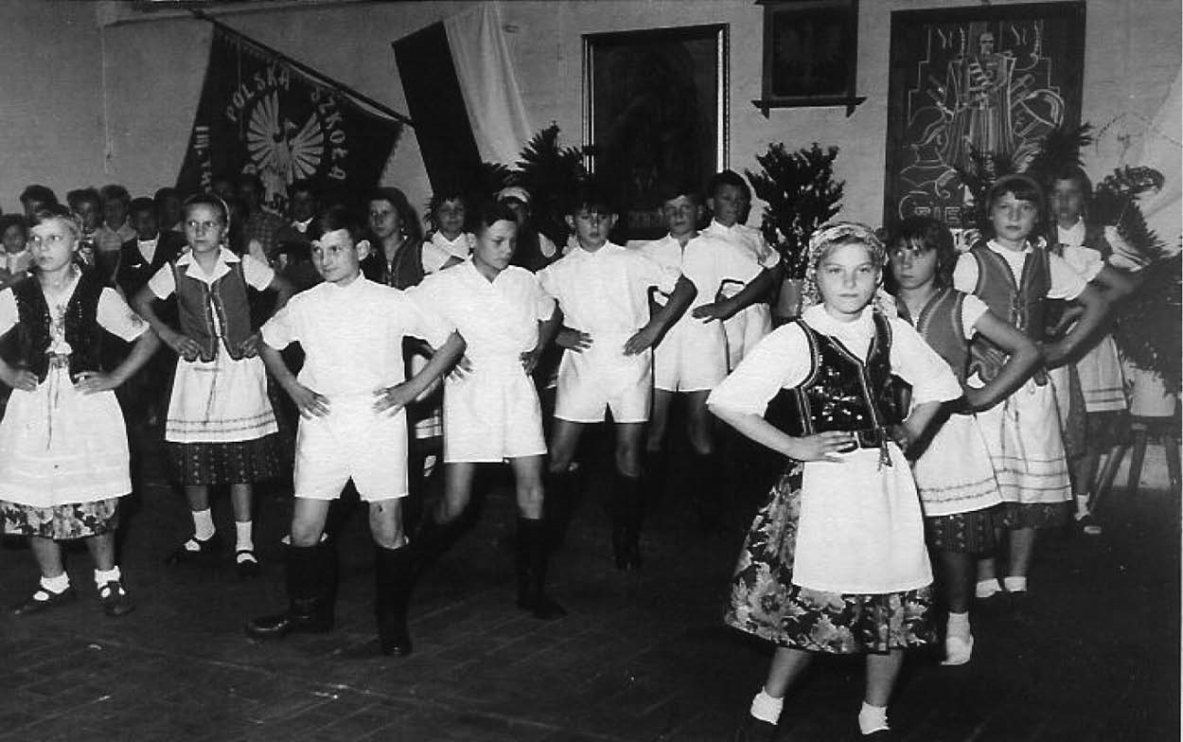
Image 4. Folk dance, children from Mariental Camp.

The DP camp photographs and oral narratives
This research utilised photography from mainly private sources. I already had 20 photographs and found many similar ones online. Additionally, there were approximately 50 images used by the participants in their interviews. Here, the photographs drew out accounts or feelings, triggering other memories, though they were always owned and chosen by the interviewees themselves. The images were used as a way of bringing me into their experiences, or as a means of emphasising their accounts.
For some interviewees, photographs at times defined their narratives. They were used from the beginning both to underline meaning and as a way through which to address their memories from their current position. The images also ordered the narrative flow. One interviewee, Leszek, brought with him a cigar box full of old photos and sought out a relevant image for each story. Another, Helena, had laid out piles of pictures on the table prior to the interview, and Irena, Klara and Bernard had each brought their own set of photos to their group interview and used them to underline the individuality of their own memories. However, it must be noted that the photographs could briefly conflict. For example, Irena, being the eldest sister, was often absent from her siblings’ photographs, and this would also lead to her absence from a particular story. Often Klara would hold up an image and say, ‘See, you were not there, Irena ...’ or ‘Here you were away’. The brief conflicts would usually be settled or let fall, and a different, shared memory presented. In other interviews, dates or places were sometimes called into question. Helena, for example, at one point looks at the back of a photograph and says she had thought it was in a different place or at a different time, but after seeing the date on the back of the photo comments that she must be wrong. There is an assumption that her recollection would necessarily be less correct than the data written on the photograph, or perhaps it is a contentedness in the notion of the photograph as gatekeeper to a memory, as material object and therefore as tangible evidence. To question it may require casting doubt on the reliability of the narrative, or belief in the person (assumedly a relative) who has written the date on it.
In addition to supporting the oral narrative, the photographs often displayed absences, for example, missing family members. These may have been temporary, children away with host families in other countries, in the hospital recovering from tuberculosis (TB), or in a different camp. Other absences may have been more constant, for example, emigrated families or relatives missing since before or after the war. Mikołaj, for example, had no photos of his father who had left the family at the beginning of their time in the DP camps, and Leszek and Krystyna had no images of their unknown father. There are no photographs of the darker events that were related in the interviews. Family members leaving, violence, heavy drinking, boredom and apathy do not fit into the ideological discourses of the family album. Nevertheless, they do constitute a haunting within and beyond the space of the image, which often inspires the recollection of a related event or backstory, perhaps precisely because it is not visually evident.
The photographs were thus used as a point of entry, a way to describe or to start off a story that was not necessarily bound to the events depicted within the image. Often phrases would be used that highlighted the role of the photographs as material evidence to accompany the narrative. Leszek used phrases such as ‘I also have the pictures with me’ and ‘these are the pictures of those events’. Similarly, photos are used to situate the stories within definable areas. Helena, for example, points to a place on an image and comments, ‘We were here. Block one, and there was block six’. However, as well as providing a visual counterpart, the images are also used as a means of creating a connection between narrator and listener. For example,
Her name is Maria ... that’s me, that’s my godparent. You’ve already seen this one, haven’t you? This is the building where we lived. That was our window. These were the steps. (Leszek)
Here is one (holds up photo). Shambello, you know him, don’t you? And here is my Brother ... (Helena)
The listener constitutes a further embodied aspect of the narrative, they are in on the story, and the photographs allow them not only a visualisation of the world being presented to them but also a role in its narrative development. They are integral to the performance of memory, part of the interactions and landscapes. Here, something akin to Shotter’s (1997) living landscapes in which the discursive is influenced by the everyday backgrounds to life becomes apparent. Narrative is relational to the verbal and bodily actions of others, adapting itself intuitively to the presence of others and the time, situation or location. This was apparent in the ways in which the interviewees adapted their stories to the people who were present. They found common ground – a name, a relative or a shared photograph. This in turn resulted in new tangents of conversation and content. Here, there are conversational spaces that exist between those who speak and those who listen, ‘interactive moments when a second person must react or respond in some way to the activities of a first’ (Shotter, 1997: 347), as well as the reactions or responses to our surroundings, the backgrounds to our lives.
The viewing of photos from a distance of years lends added complexity to the identities and memories of the former DPs. In terms of place, not only are they no longer in the DP camp, the camp itself is not accessible in the way it once was. Linked to this is the weakening of old emotional and social ties. The previous group enactments of Polishness (the dances, theatre productions or even the everyday daily interactions between DPs both within and beyond the camps) gradually lessened as the older figures of DP society passed away. The recollections are not only memories of the camp but also memories of the practices of displacement itself. This undoubtedly results in a certain out of placeness with regards to the spaces of memory, an alienation in terms of who the children once were (as outside of German society in their DP (and stateless) identity, their cultural and national practices) and who they now are (as German citizens).
Added to this is the bodily change that has taken place and must be negotiated while viewing the images. Here, an embodied understanding of the spaces of remembered time is evident. Leszek, for example, points to himself on a photograph remarking on how he was ‘still slim then’, and ‘Oh! There I was still handsome’. He also recalls his TB as a child when he views photographs in which he is very thin. Here, the bodily and sensory memory is of an illness that not only affected his appearance but that also caused an exclusion (his separation from his family and the camp for almost a year). This resonates with Soo-Jin Lee’s (2003) assertion that the body itself becomes a site of memory. Here, ‘fragmentation is also integral to bodily memory, creating moments of reflection, for example, in the confrontation of one’s younger self with one’s aged body’ (p. 95). During this process, a bodily remembering takes place that needs to reconcile the passing of time. This physical alteration results in a change (or revision) in the perception not only of the current state of the body as opposed to the body within the photograph (and with it, in memory) but also of the way their surroundings looked. Objects and surroundings are recognised as different just as they themselves looked different. This relates to the replacing of the body within a remembered space and will be discussed shortly in relation to the revisits to camp. There can, however, be an understanding of changes in the perception of items within the image itself. Helena, for example, comments on the furniture and décor in the DP accommodation on a photograph: ‘Of course everything is old. It used to look quite good to me at the time. But when you look at it now, it’s bad’.
Conceptions of time and space here are extremely complex. The space of the photograph was arguably always fragile, representing only a moment. However, from a distance of years, it holds much more within it, none of it any less fragile. Losses and gains, desires and longings are found reflected within the image, but also conflicts and ambiguities. Physical changes are made all the more apparent, and absences more acute. These can be the understanding of contemporary changes though they can equally be the recollections of previous changes. In her interview, Klara shows a photo of her father and comments that in it he had started to look better than he had done after the close of war. There can also be the brief recollection of the earlier loss of a loved one, for example, Mikołaj briefly mentions ‘That was still in the camp, with my ex wife, she has since died. Here we sing a duet’. Much as with the oral narratives that accompany them, the images allow the opening up of memory as an active space while also setting out the parameters of life itself. Photos are reentered, but bodies and places have undergone changes that must either be ignored or reconciled.

Reframing home
Narrative memory and the reviewing of photographs involve the participant revisiting the sites of the past with all the knowledge and ambiguities of the present. Stories are reconfigured, albeit subtly, according to context. Often, pieces are added just as others are let fall. Revisits are a return to a site of former importance, belonging or even alienation. They can involve a temporal disjuncture, an uncanny sense of haunting, though they can equally constitute a welcome return or necessary reframing. The revisits of the former DPs were both physical and emotional; they involved the bodily return to site as well as emotional and imaginary returns through the oral and visual.
During the interviews, participants often referred to times they had been back to the site of the camp and the reactions resulting from these revisits. Helena and Julia both noted a change in perception of the size of the camp, and Leszek and Bernard both referred to a sense of longing attached to the camp. Krystyna related feelings of the uncanny in relation to certain spaces within the camps (especially the cellars) and a sense of disjuncture between how she remembered the layout of the camp and how it actually was. Others recounted physical visits to spaces beyond the camp, Leszek, for example, revisited the sanatorium he stayed in for a year while recovering from TB. All revisited Poland in enactments of post-memory, returning to the narrated ‘homeland’ of their parents’ pre-war memories, though all found it to be different than they had imagined (and, perhaps more significantly, found themselves to be different and out of place during the first revisits). However, it is in the revisits to the former camps that the disjuncture between three continuously altering spaces becomes apparent: the physical space of the camp, the body re-entering it and the malleable space of the memory itself.
Mikołaj in his interview referred to the DP camps as his ‘heimat’, a homeland of his youth, and the camp as a site of belonging is integral to the understanding of revisits. The former DPs feel a pull to the site of their youth: a space that for them never really closed, having been kept alive in thought, interaction and shared practices. The longing for the site of the camps is to some extent a longing for a space of childhood and what is often assumed to have been a less complicated time. There is a need to return to the space of childhood (and, to some extent homeland) in order to understand exactly how it fits into a contemporary world and experience. Inherent to this desire to revisit a past space (and state) is the concept of nostalgia, bound as it is to the notions of the fragmentary and fleeting nature of modernity (in which, as Baumann (1997) suggests, ‘to be modern means to be on the move. One does not necessarily choose to be on the move – as one does not choose to be modern’ (p. 72)) and the alienation stemming from the dislocations of the modern. The nostalgic, as Legg (2005; see also Boym, 2001) points out, is linked to place (the geographical nation, homeland, childhood landscape) but is not limited to it. Periods of instability (social, economic or personal) may result in the desire to return to a time of perceived happiness, but they can also be bound to an idealised, imagined or haunted space. The need to return to a former space may be caused by a dislocation experienced in the present or a growing sense of insecurity with the future. Nostalgia here is not simply regressive. As Pickering and Keightley (2006) contend, it is also indicative of a forwards progression. Here, it is ‘both melancholic and utopian’ (p. 921) and bound to the requirement to act or reassess from a contemporary perspective.
The revisits, whether spontaneous or planned, very much represent complex desires to return to or reassess a past state. While the camp and the memory of childhood (and with it nation and displacement) is perhaps always there, it may surface as more important, or more desirable, at certain times. Leszek, for example, makes numerous visits to Mariental but describes a specific time (which coincided with his birthday) when he felt a stronger urge to return:
Sometimes I have a sort of phase where I’d like to go back there and meet up with the people I used to play with. The longing is still there. I still have that. Last year it was very strong somehow, as if something was saying to me come here, we need to meet up. Somehow there was a longing, a phase ...
For Leszek, this is perhaps linked to an earlier comment he made that ‘somehow I always have the feeling that I felt better there’. The emotional pull of the camp is one that suggests a time when identities, both national and cultural, and belonging (for the children) were seemingly more clearly defined. Although these times were not without conflict and contestation, for the children, they were to a great extent indicative of a community and sense of belonging that was not to be found again. The post-camp lives of the DPs were often complex, necessitating changes in language, community and ultimately citizenship. Many of the interviewees never felt that they completely fitted in to German (or Polish) life. Thus, the site of the camp, and of childhood, is also a site of belonging in terms of not only a displaced ‘nationality’ but of community and togetherness. In terms of the childhood experience, these are expressed through examples of freedom of play. Thus, for example, Leszek refers not only to a longing to return to the camp but to ‘meet up with the people I used to play with’.
There is inevitably a complexity in revisiting a site of childhood with the adult body and the recalling of childhood through adult eyes. Here, the adult mind may be involved with reworking memories of childhood through adult experiences, even, as Philo (2003) suggests, to some extent revising memories to deal better with the ‘residues of unhappy childhoods’ (p. 14). Undoubtedly, there was a certain element of trauma attached to the DP childhoods. Several accounts refer to domestic violence, alcoholism and fighting within the camp. The support given by the church is speckled with reference to strict practices, and reference is usually made to the problems of DP existence juxtaposed with the ‘outside’ German world. Nevertheless, the overriding memories of the participants are of freedom and play within the camps.
These recollections bring with them further difficulties. The imagined spaces and places of childhood are often different from their physical reality, even if the place recollected has not undergone major changes. For example, while discussing a return to Gallwitz, Helena highlighted the fact that an actual bodily change altered her view of and her physical relationship to the surroundings of the camp:
I drove into there one time and I thought, my, you lived there, here was the post office, you know ... and as a child you think, as a child I thought this is where the first house was and the other opposite, I thought it was so far apart, but really it wasn’t so far apart. It was a small playground, for me it was a big playground.
Similarly, although Krystyna describes Mariental as essentially unchanged, commenting that ‘physically the camp itself hasn’t changed at all’, she nevertheless notices a fundamental physical alteration in that ‘where I used to play is not there anymore because this house is there’. Although this in itself does not signify a major issue, the areas of play described by Krystyna, Leszek and also Bernard, Klara, Irena and Mikołaj, are completely bound with their sense of freedom and of childhood. In her previous sentences, Krystyna had described the now changed place:
Just across the road was like an opening with grass, woods. That was my favourite place. We used to go there and play always. You got away from everything, from the grown ups. It was really nice.
Whereas Mariental and Gallwitz retained their basic structure, other camps such as Wolterdingen are practically gone. When Bernard, Klara, Irena or Mikołaj return to the site of the camp, it is to the two or three buildings that are still standing. Thus, not only have they themselves changed but the camp itself has also been physically altered. This results in a dislocation between the memory of what was and the reality of what now is. Trigg (2009) in his work on physical returns to sites of trauma that are now in ruin suggests that an ambiguity in relation to place is raised during returns. This is an ambiguity of being alive/present in a place that has been irrevocably altered. These conflicting temporalities can bring about a displacement felt by the body, or even a puncturing in the fluidity of presence. While the return of the former DPs are not necessarily to sites of trauma (they often hold happy memories), the camps are nevertheless ambiguous in terms of meaning. They represent a site of childhood and perceived belonging, but also signify the loss of their parent’s old lives and homelands. They contain within them memories of play, but also the darker undertones of the camps’ war time usages, and they must also be situated within the ambiguous DP identity itself (as existing initially as apart from the ‘outside’ society). The question then is how do the returnees remedy this in order to make recollections and revisits not only possible but also desirable? Most of the interviewees returned to the camp regularly and as such, some negotiation has been reached. The need to return is a need to return home, certainly, just as there is a need to keep the space open, to reuse and reframe the revisiting as a new memory that can in turn be shared and recounted. Within the returns of the former DPs, it is evident that the camps have somehow changed with their former residents, adapting to their landscape, surroundings and current roles. The body here is itself a site of memory, a ‘map in the narration of one’s life story’ (Soo-Jin Lee, 2003: 99). It remembers the camp and the activities within the camp, but also echoes the diverse changes that have taken place over the years. Of course, there is a dislocation here, but there is arguably also a negotiation that takes place through the act of replacing the body in space and thereby allowing a new embodied memory to be created. While many of the interviewees had returned to the sites of the camps on numerous occasions, Julia had not been back since her childhood, and she found her return to be an emotional experience. Unlike the other interviewees who had been teenagers when they left the camps, she had been very young when she left though her family had only moved within walking distance of the camp. The site had reverted to German Military usage and had, up until the time of our revisit, not been accessible to her, although it was ever present. The military had now moved out, and the site was about to be redeveloped into a supermarket. During her interview, she suggested driving there, and on finding that it was now accessible, asked if I would go inside with her.
She became quite upset at times, however, she was also amazed at being in the places she had once been as a child. Much like Helena’s experience of the same camp, Julia commented that it was much smaller than she remembered. She pointed out places where she used to play, and requested photographs be made (see Images 5 and 6 below for examples) of where she used to live, the entrance to the camp, the old school and a street sign so she could show it to her husband and family. Here, the site of memory is not only revisited, it has begun to be reframed. The past is no longer retrospectively viewed or experienced as a loss or time passed; it is actively reframed and renegotiated, and these enactments furthermore emphasise the embodied quality of photography. New memories of the site are being created with new photographs and narratives. Julia is being photographed; her bodily experience of the site has been added to, and the image produces a new, interactive space, which juxtaposes who the person was (a DP, a child) and who they are (a German citizen, an adult) within the changed space of the camp.
Julia returns to a site as different but subsumes it as new memory that is not just a continuation of the old but a coming to terms with the past and a way forward. Here, as Jones (2005) suggests, memory is always a new enactment, and with this, it is also spatial ‘clearly bound up with processes of place and emotional attachments to place’ (p. 213). For Julia, these attachments to place were complex and not fully understood; for many of the others, the attachments were actively nurtured and added to over the years (though this does not of course make them any the less complex). In all cases, the sites provide an interactive area in which it is possible to experience and reorder the past in the present. This was evident from the oral narratives, though its complexity is most evident within the photographs of the adult body within the former spaces of childhood.
Here, a memory is not only physically revisited, it is altogether reframed. It places the adult returnee at the site of an old memory and simultaneously creates a new memory, an experience that will be shared discursively and visually. Moreover, this experience imbues further oral recollections of the DP camp times and thus of the state and practice of displacement itself. Sites change, along with the bodies (re)placed into them. The initial space of the camp as a unifying homeland no longer exists nor does the actual stateless – or ‘alien’ – DP identity. The former DPs no longer belong to the older, more transitory period of displacement; yet, they can still enter into it and practice it. From the time of the revisit onwards, their older memories gain a further dimension; the events that took place some 50 plus years ago can now (and must now) be set against the more recent experiences. To some extent, the DP experience, rather than being a transitory 15-year period, becomes set in a contemporary physical space on the one hand, but also remains a reflexive internal space to be referred to, built upon and used to understand or explain who they are today and who they want to be.
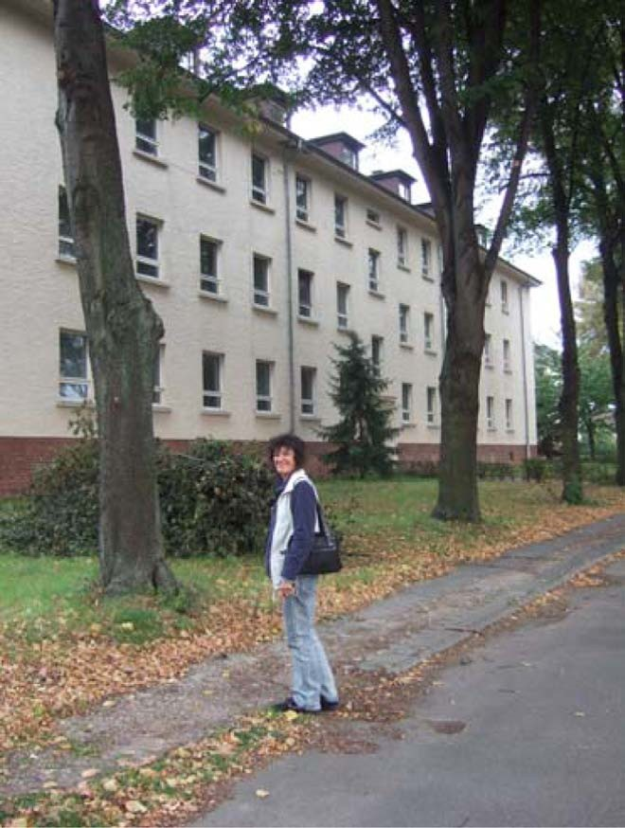
Image 5. Julia outside her childhood home, Gallwitz. Photo by author.
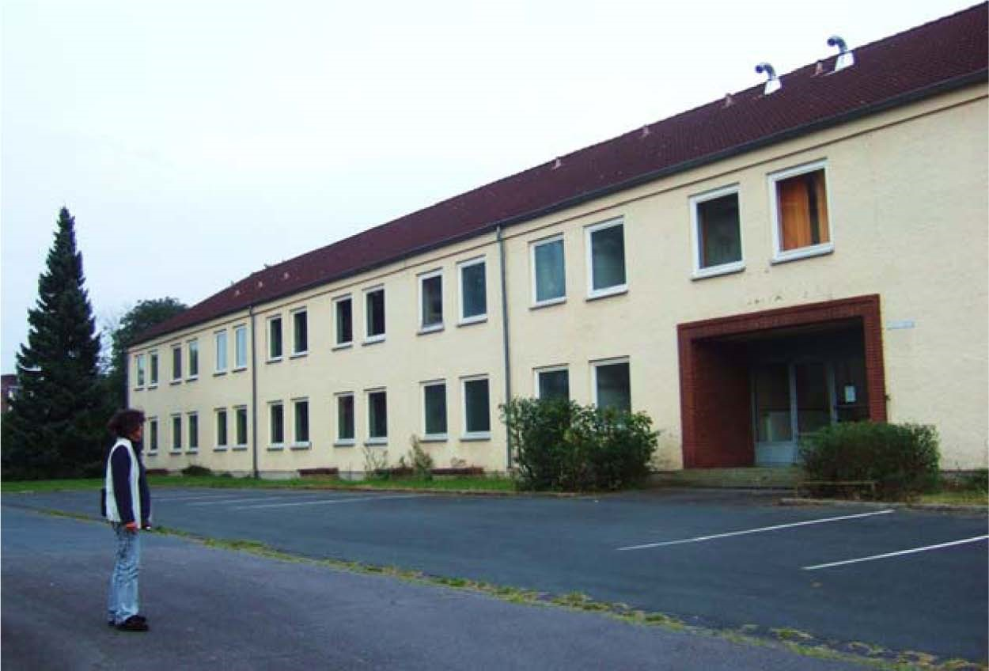
Image 6. Julia, return to Gallwitz.
Photo by author.

Conclusion
This article has investigated the diverse and interactive sites and representations of displacement and memory wherein photography was shown to play an integral role, from the initial photographic artefacts of the DP camps to the inclusion of family photographs in the oral narratives and the taking of new photographs during return visits to former DP camps. Here, images serve not only to initiate and expand stories, they are also a space in which to include others in this process. A photograph can re-access often difficult memories, conflict with opinions and – perhaps most significantly – present the viewer with the possibility of coming to terms with changes both internal and external.
The role of the photograph in memory is much more complex and diverse than its usage in most research suggests. Photography, the reviewing of a photograph and the actual act or event of being photographed are fundamentally embodied activities. In this study, photographs were often a space that called upon the past, present and future simultaneously. On the one hand, they represented the concerns and practices of the DP camp time itself, indicative of ideologies, power relationships and also family histories themselves. However, over a distance of years, they became active tools not only of memory but also of contemporary interactions. Through them, the viewer could reorder experiences and returns to old sites could be re-photographed and reframed according to perspective. Here, memory is a contemporary activity that negotiates changes in time (the body and ageing and the falling away of old buildings and places), attitude (childhood events through adult eyes and also changing national and political borders) and knowledge (of old stories, of outcomes and of changing circumstances). The memory of displacement becomes as strong as the practices of displacement once were, signifying a binding factor, a childhood identity, an understanding of the transitory and an attempt to reorder and reassess from a contemporary perspective.

Acknowledgements
I would like to thank the Geography Department at Manchester Metropolitan University for their support during this research, especially Jon Binnie, Tim Edensor and Julian Holloway. Many thanks also to the article reviewers for their very helpful comments and advice.

References
Azaryahu M (2003) RePlacing memory: the reorientation of Buchenwald. Cultural Geographies 10: 1–20.
Barthes R (1993) Camera Lucida. London: Vintage Classics.
Baudrillard J (1999) ‘Photography, or the Writing of Light’. The Impossible Exchange. Paris: Galilee.
Bauman Z (1997) Postmodernity and Its Discontents. Cambridge: Polity Press.
Boym S (2001) The Future of Nostalgia. New York: Basic Books.
Brennan A (2003) Re-collecting Proskurov. In: Bennett J and Kennedy R (eds) World Memory: Personal Trajectories in Global Time. Hampshire: Palgrave Macmillan, pp. 59–68.
Collier M (2001) Approaches to analysis in visual anthropology. In: von Leeuwen T and Jewitt C (eds) Handbook of Visual Analysis. London: SAGE, pp. 35–60.
Connerton P (2008) Seven types of forgetting. Memory Studies 1: 59–71.
Derrida J (1995) Archive fever: A Freudian impression. Diacritics: A Review of Contemporary Criticism 25(2): 9–63.
Edwards E (2002) Material beings: objecthood and ethnographic photography. Visual Studies 17(1): 67–75.
Featherstone M (2000) Archiving cultures. British Journal of Sociology 51(1): 161–184.
Frosch S (2007) Disintegrating qualitative research. Theory & Psychology 17(5): 635–653.
Green D (ed.) (2003) Where is the Photograph? Brighton: Photoworks/Photoforum.
Harper D (2002) Talking about pictures: a case for photo elicitation. Visual Studies 17(1): 13–26.
Hirsch M (1996) Past lives: postmemories in exile. Poetics Today 17(4): 659–686.
Jenkins KN, Woodward R and Winter T (2008) The emergent production of analysis in photo elicitation: pictures of military identity. Forum: Qualitative Social Research 9(3): Article 30.
Jones O (2005) An ecology of emotion, memory, self and landscape. In: Davidson J, Bondi L and Smith M (eds) Emotional Geographies. Hampshire: Ashgate, pp. 205–218.
Kuhn A (2007) Photography and cultural memory: a methodological exploration. Visual Studies 22(3): 283–292.
Landzelius M (2003) Commemorative dis(re)membering: erasing heritage, spatializing disinheritance. Environment and Planning D: Society & Space 21: 195–221.
Larson J (2005) Families seen sightseeing: performativity of tourist photography. Space and Culture 18(14): 416–434.
Legg S (2005) Contesting and surviving memory: space, nation, and nostalgia in Les Lieux de Memoire. Environment and Planning D: Society & Space 23: 481–504.
Levi P (1989) The Drowned and the Saved. London: Abacus.
Massey D (2005) For Space. London: SAGE.
Meinhof U and Galasinski D (2000) Photography, memory, and the construction of identities on the former East–West German border. Discourse Studies 2: 323–353.
Philo C (2003) ‘To go back up the side hill’: memories, imaginations and reveries of childhood. Children’s Geographies 1(1): 7–23.
Pickering M and Keightley E (2006) The modalities of nostalgia. Current Sociology 54(6): 919–941.
Prus R (2007) Human memory, social process, and the pragmatist metamorphosis. Journal of Contemporary Ethnography 36(4): 378–437.
Rose G (2003) Family photographs and domestic spacings: a case study. Transactions of the Institute of British Geographers 28(1): 5–18.
Ryan JR (1997) Picturing Empire: Photography and the Visualization of the British Empire. London: Reaktion Books.
Sebald WG (2002) The Emigrants. London: Vintage Books.
Shotter J (1997) Dialogical realities: the ordinary, the everyday, and other strange new worlds. Journal for the Theory of Social Behaviour 27(2/3): 345–357.
Soo-Jin Lee S (2003) Aged bodies as sites of remembrance: colonial memories in diaspora. In: Bennett J and Kennedy R (eds) World Memory: Personal Trajectories in Global Time. Hampshire: Palgrave Macmillan, pp. 87–100.
Tagg J (1988) The Burden of Representation: Essays on Photographies and Histories. London: Macmillan.
Thrift N and Dewsbury JD (2000) Dead geographies – and how to make them live. Environment and Planning D: Society & Space 18: 411–432.
Tolia-Kelly D (2004) Locating processes of identification: studying the precipitates of re-memory through artefacts in the British Asian home. Transactions of the Institute of British Geographers 29(3): 314–329.
Trigg D (2009) The place of trauma: memory, hauntings, and the temporality of ruins. Memory Studies 2(1): 87–101.
Williams V (1994) Who’s Looking at the Family Exhibition Catalogue. London: Barbican Art Gallery.
Wylie J (2007) The spectral geographies of W.G. Sebald. Cultural Geographies 14: 171–188.
Zelizer B (2002) Finding aids to the past: bearing personal witness to traumatic public events. Media Culture & Society 24: 697–714.

Author biography
Tamara West was awarded her PhD in Cultural Geography from Manchester Metropolitan University. The thesis explored the spaces within and beyond Displaced Persons camps. She is an associate tutor at the University of Salford and a Research Fellow at the University of Birmingham.

