Title: Responses of intraspecific metabolic scaling to temperature and activity differ between water- and air-breathing ectothermic vertebrates
Authors: Guillermo García-Gómez¹, Andrew G. Hirst^{1,2,3}, Matthew Spencer¹, and David Atkinson⁴
Affiliation: ¹ School of Environmental Sciences, University of Liverpool, UK
² School of Animal, Rural and Environmental Sciences, Nottingham Trent University, UK
³ Centre for Ocean Life, National Institute for Aquatic Resources, Technical University of Denmark, Charlottenlund, Denmark
⁴ Department of Evolution, Ecology and Behaviour, University of Liverpool, UK
Running title: Metabolic scaling in ectothermic vertebrates
Keywords (8): Ecophysiology; oxygen limitation; animal locomotion; bioenergetics; body mass; metabolic theory; Metabolic-Level Boundaries Hypothesis; allometry
Type of article: Letter
Number of words in abstract: 146
Number of words in main text: 4945
Number of references: 82
Number of figures: 4
Number of tables: 1
Corresponding author: Guillermo García-Gómez / guillegar.gz@gmail.com / +34619245191
Statement of authorship:
GG, AH, and DA designed the study and developed the hypotheses. GG and MS wrote the R code for the Bayesian models. GG collected and analysed the data. GG wrote the first draft of this manuscript, and all authors contributed substantially with revisions to the final version.
Data accessibility statement:
The data that support the findings of this study are openly available in OSF at https://osf.io/n6m5j/ [DOI 10.17605/OSF.IO/N6M5J].
      - Abstract
Metabolism underpins all life-sustaining processes and varies profoundly with body size, temperature, and locomotor activity. A current theory explains some of the size-dependence of metabolic rate (its mass exponent, b) through changes in metabolic level (L). We propose two predictive advances that: (a) combine the above theory with the evolved avoidance of oxygen limitation in water-breathers experiencing warming, and (b) quantify the overall magnitude of combined temperatures and degrees of locomotion on metabolic scaling across air- and water-breathers. We use intraspecific metabolic scaling responses to temperature (523 regressions) and activity (281 regressions) in diverse ectothermic vertebrates (fish, reptiles and amphibians) to show that b decreases with temperature-increased L in water-breathers, supporting surface area-related avoidance of oxygen limitation, whereas b increases with activity-increased L in air-breathers, following volume-related influences. This new theoretical integration quantitatively incorporates different influences (warming, locomotion) and respiration modes (aquatic, terrestrial) on animal energetics.

      - 1. Introduction
Metabolism is a fundamental property of life, comprising all biochemical processes that transform energy and materials from the environment into life-sustaining functions and body structures (Humphries & McCann 2014). Metabolic rate (indirectly estimated by respiration rate R in aerobic organisms) is strongly linked to body size (m), through a relationship commonly expressed as a power function, R = am^{b} (Kleiber 1932), where a is a constant, and b is the scaling exponent, or allometric slope of a linear regression between log R and log m. The slope b describes the change in log respiration rate as log body mass increases. Understanding and quantifying the influence of body size on respiration rate has become a central topic in ecology, where the emphasis is placed on combinations of both physical principles and organismal adaptations (Brown et al. 2004; Kooijman 2010; Glazier 2005, 2022; White et al. 2022). The classic description of b as having a value of 0.75 across all life forms (Hemmingsen 1960; West et al. 1999; Savage et al. 2004) is challenged by systematic variation in its value across taxa, lifestyles, ontogeny, as well as with environmental conditions and physiological states (White et al. 2007; Makarieva et al. 2008; DeLong et al. 2010; Hirst et al. 2014; Hatton et al. 2019; Glazier 2010, 2014, 2020, 2022).

The ‘Metabolic-Level Boundaries Hypothesis’ (MLBH; Glazier 2005, 2010, 2014) proposes that variation in the metabolic scaling slope b is influenced by factors related to body volume (V), such as tissue maintenance and locomotive power, and factors related to surface area (SA), such as resource uptake or waste elimination. The relative contribution of volume or surface area-related factors alter as the metabolic level changes. Metabolic level (L) increases with overall energy use, and is often quantified as the mass-specific metabolic rate at the geometric midpoint of the mass range covered by the metabolic scaling relationship (Glazier 2010). According to the MLBH, for organisms that conserve body shape as they grow, b should approach a value of 2/3 (Rubner 1883) if SA-related processes through external exchange surfaces predominate, but should approach 1 if V-related processes predominate (proportional to body mass or volume). Following the MLBH, the amount of locomotor activity and increased environmental temperature, which both increase L, can change the slope b (Glazier 2010) by changing the relative contributions of SA versus V-related processes.

The MLBH predicts that increased active movement and associated energy demands of locomotor musculature, whose mass is typically proportional to whole body mass (Glazier 2005, 2010), will increase the metabolic scaling slope relative to that at rest. During bursts of strenuous activity (maximal L), metabolic rate should be mainly driven by resource demand (and hence be proportional to m¹; Fig. 1), rather than by surface-dependent resource supply or waste removal (Weibel & Hoppeler 2005). This extreme response is only possible because of short-term storage of oxygen and energy in muscles and their temporary tolerance to accumulation of wastes, such as lactic acid (Glazier 2009).

Temperature appears to affect metabolic scaling in more complex ways. Contrary to influential models that assume that temperature affects only metabolic level and not b (e.g., Gillooly et al. 2001), the MLBH predicts changes in b. As temperature increases, resting metabolic demands increase; consequently, the mass-scaling of metabolic rate may decrease if it is increasingly dictated by fluxes through external exchange surfaces (m^{2/3} in isomorphic growers), as limits on resource supply become more influential (Fig. 1). Glazier (2020) observed such a predicted negative relationship between temperature and b in 10 of 13 sedentary ectothermic animals and one plant. However, warming not only increases maintenance demands in ectotherms, but accelerates other energy-demanding processes such as growth (Barneche et al. 2019). Whole-body growth has been described as a V-related process (Glazier 2010, 2020), but growth will not retain the same proportional relationship to volume (or mass) unless mass-specific growth rate remains constant as the organism gets bigger. Such growth would be exponential, in which new tissue is added in direct proportion to body mass (i.e., ∝ m¹; Hirst & Forster 2013). Resource consumption dominated by such mass (or volume)-proportional processes can be sustained by changing body shape during ontogeny, thereby maintaining a high ratio of SA for resource uptake relative to mass (or volume), as in various pelagic invertebrates (Hirst et al. 2014). But more generally, mass-specific growth rates decline during ontogeny, as widely observed in vertebrates and some benthic invertebrates (von Bertalanffy 1951, 1957; Lee et al. 2020). Therefore, we argue that a warming-induced increase in overall growth rate and its contribution to total metabolic costs would lead to lowering b below 1 in most animals due to greater SA-related influences on resource supply (Fig. 1), but also because mass-specific growth rate decelerates during ontogeny. A crucial observation enabling the test of this hypothesis is that standard (i.e., resting, postabsorptive) metabolic rate is inflated by overhead costs of growth, which is thought to include maintaining machinery necessary for growth (Rosenfeld et al. 2015). Therefore, the metabolic components needed for biosynthesis (i.e., “growth machinery”) appear still to work (presumably using energy from reserves) during measurements of oxygen consumption, even in postabsorptive animals. Another effect of temperature on metabolic scaling depends on how it affects locomotor activity. Glazier (2020) found that in contrast to 71% of 14 sedentary species that showed a negative relationship between b and temperature, significantly fewer (18% of 165) mobile species showed a negative relationship, supporting the idea that warming-enhanced locomotion, which includes contribution of muscular output (considered approximately proportional to body mass), mostly countered SA-influenced reduction in b. Clearly, therefore, the predicted mass-scaling of metabolic rate depends on the relative influence of different processes that scale differently with body mass (e.g., SA- versus V-related processes). A major challenge for predictive ecology is to identify situations when particular influences on metabolic scaling predominate.

We propose that combining a second theoretical approach with the influence of processes that scale differently with body mass may help to identify when particular processes predominate. Specifically, the effects of temperature and activity on metabolic scaling may differ between aquatic and terrestrial organisms due to water being 800-fold denser, 60-fold more viscous and contains 43-fold less oxygen than air, making breathing in water more energy-costly than in air (Makarieva et al. 2008; Verberk & Atkinson 2013). Warmer temperatures and larger sizes are expected to combine to place a greater challenge on supplying sufficient oxygen, as the ratio of SA for respiratory exchange relative to oxygen demand from a larger, warmer body mass is reduced (Atkinson & Sibly 1997; Rubalcaba et al. 2020). Makarieva (2008, Appendix) showed that taxa with high breathing costs will need to reduce metabolic rates as organisms grow bigger. Moreover, the ability of water-breathers to increase their oxygen-supply capacity to meet such increased oxygen demands as size and temperature increase tends to be less sensitive to warming than does oxygen demand (metabolic rate), where the supply:demand ratio can decline by up to ca. 5% per ℃ (Deutsch et al. 2022). Therefore, aquatic ectotherms, whose ancestors had experienced oxygen limitation at large sizes under warm conditions (the ‘Ghost of Oxygen Limitation Past’; Verberk et al. 2021; Atkinson et al. 2022), are predicted to have evolved adaptations that enable them to avoid oxygen shortage as size and temperature both increase. Such avoidance strategies could include reduction in the rates of growth and metabolism as size and temperature both increase, and hence reduce b. While Glazier (2020) anticipated that oxygen availability may underpin more negative b-temperature relationships in aquatic vs. terrestrial ectotherms (25 vs. 16%), aquatic species conversely showed greater increases in b between resting and maximally active states (Glazier 2009), adding uncertainty to this idea.

Here, we combine these two theoretical approaches to quantitatively investigate impacts of temperature and activity on intraspecific metabolic scaling in ectothermic vertebrates. Ectothermic vertebrates are ideal to test our predictions quantitatively, because they belong to a monophyletic clade (Subphylum Vertebrata) showing diverse ontogenetic changes in metabolic scaling, but which otherwise share common biological traits, namely: (i) near-isomorphic and indeterminate (continuous post-maturational) growth; (ii) closed circulatory systems and specialised respiratory organs, such as lungs or gills, facilitating the comparison between water- and air-breathing species (Shelton et al. 1986); and (iii) physiological performance and body temperature intrinsically linked to ambient temperature (Angilletta et al. 2002), making it easier to control for temperature when examining the effect of activity alone. Studying vertebrates rather than the phylogenetically diverse invertebrates with varied respiratory and circulatory systems avoids complications from profound and variable body-shape changes over ontogeny that affect surface area for respiratory exchange, hence metabolic scaling, observed in diverse aquatic zooplankton and cephalopods (Hirst et al. 2014; Tan et al. 2019).

A key feature of this investigation is to quantify how the relative importance of two influences on energy use – temperature and locomotor activity – on the metabolic scaling slope b, depend on whether animals are air-breathers or water-breathers. We first hypothesise that b decreases more steeply with warming in water-breathers, which are influenced by (SA-related) avoidance of oxygen shortage. Secondly, we expect that b increases more steeply with activity level in air-breathers, due to increasing metabolic contributions from (V-related) musculature, whereas the muscular contribution in water-breathers may be countered by pressures to reduce oxygen consumption. Through a meta-analysis that compares water- and air-breathing vertebrates, we test the degree to which b changes as metabolic level (L) increases within species: (1) with warming of inactive individuals and (2) with increasing activity. We, therefore, quantify for the first time the overall magnitude of the intraspecific, graded change in b with L across a range of activity levels and temperatures in water- and air-breathers. As predicted, our findings show that b decreases with temperature-increased L only within water-breathers, whereas b overall increases with activity-increased L within air-breathers. Our findings highlight the value of combining more than one theoretical approach to increase the predictive potential of ecological theory.

      - 2. Materials and Methods

2.1. Data collection
To test the relationship between the slope (b) and metabolic level (L) with increasing temperature, we searched the literature for studies that measured metabolic scaling during ontogeny in at least two temperature treatments of the same species, complementing the intraspecific datasets of Glazier (2005, 2020). Searches were carried out with Google Scholar, Web of Science and OATD (Open Access Theses and Dissertations), using the names of the target taxa (i.e., ‘fish’, ‘amphibian’ or ‘reptile’) followed by terms as ‘<name of taxon> + metabolism’, ‘+ metabolic + rate’, ‘+ respiration + rate’, ‘+ oxygen + consumption’, all including ‘temperature’. Finally, we checked the reference lists and citations of all relevant papers (i.e., those including the search terms in the title) for related studies. Here, we only included estimated parameters from scaling regressions in non-active, unstressed animals (i.e., showing no or minimal locomotion), to minimise the effects of muscular activity on metabolic scaling (Glazier 2020). Sets of regressions from studies were grouped by experimental conditions (e.g., metabolic states, such as resting or routine metabolism, if different states were measured) in the same species.

Second, to test the relationship between b and L with increasing locomotor activity, we searched the literature for studies that measured ontogenetic metabolic scaling in at least two activity levels in the same species at the same temperature, complementing the dataset of Glazier (2009). The literature search was identical to that above but replacing ‘temperature’ with ‘activity’. Again, we grouped regressions according to experimental conditions, into single studies, and the same species. Active metabolic rates here were usually measured during sustained activity, including freely moving animals (e.g., Wood et al. 1978; Du Preez et al. 1988), measurements of active (e.g., Brett & Glass 1973) and maximum metabolic rate through experimentally forced exercise at peak locomotory performance (e.g., Rao 1968; Garland 1984), activity sustained to near or complete exhaustion (e.g., Brett 1965; Walton 1988), or immediately after (e.g., Killen et al. 2007).

Species were grouped into their principal respiration modes (water- vs. air-breathers). For air-breathing fish, we preferred regressions based on bimodal respiration (i.e., aquatic + aerial) when available, as this is their normal behaviour in nature (Graham & Wegner 2010). We excluded regressions measured in fish larvae only, given that this life stage exhibits different metabolic influences from those on non-larval stages (Glazier 2005), related to exponential growth and high surface-area of respiratory organs (Post & Lee 1996). All regressions of amphibian species were based on aerial respiration. We disregarded non-statistically significant regressions (p ≥ 0.05, which excluded only 6). When equation parameters or mass ranges were missing in a study, data were extracted from figures using WebPlotDigitizer v4.4 (Rohatgi 2020), performing regressions, if needed, through ordinary least squares models of log-log data. Metabolic levels were calculated as the mass-specific metabolic rate at the geometric mass-midpoint of the mass range of each regression, and converted to mg O₂ g wet mass⁻¹ h⁻¹. All regressions were given equal weight in subsequent analyses, rather than giving more weight to regressions with lower uncertainty in b, because for many studies the information needed to perform such weighting was not available.

2.2. Data analyses
We assessed data comparability by checking for systematic differences between datasets (see Appendix S1 – S2). Specifically, we checked whether scaling regressions covered similar mass ranges in water- and air-breathing species, and whether experiments measured comparable increases in metabolic level by either temperature or activity, as differences in these factors might influence the change in slope b (Glazier 2020). We also checked that acclimation duration showed no obvious influence on b. Moreover, to minimise the variation in metabolic level due to variation in mass between regressions within experiments, we excluded regressions whose mass-midpoints were too dissimilar (i.e., differing by > 0.5 orders of magnitude) to the rest of the set (Appendix S3).

We determined whether temperature and activity underpin the intraspecific variation in slopes b of ectothermic vertebrates through their effects on metabolic level (L), and whether these effects differ between air- and water-breathers, using Bayesian phylogenetic multilevel models. We used linear models with b as the response variable and log₁₀ L as an explanatory variable because: (i) the MLBH predicts a linear relationship between b and log-transformed L (Glazier 2010) when only one of temperature or activity is varied (Fig. 1); (ii) the change in b is expected to be mediated through the change in L, but not the opposite; and (iii) multilevel models allow estimation of variance in b within species and experiments (Bürkner 2018). Moreover, using log₁₀ L as an explanatory variable enabled us to examine the increase in metabolism with warming or activity in a continuous manner, and hence quantify and compare the effects of these influences on b.

To determine the effect of temperature-increased L on b, and whether this effect differs between water and air-breathers, we fitted a regression model with a global intercept (β₀), and the fixed effects of log₁₀ L (β_{L}), animal group according to respiration mode (air- or water-breather, β_{g}) and the interaction between log₁₀ L and group (β_{Lg}), as described in the Appendix (S4). We used a Student’s t distribution to describe errors in b, since this distribution is robust against outliers (Gelman & Hill 2006). We included two random effects: species relatedness with a variance-covariance matrix estimated from a phylogenetic tree (with species-specific intercepts ψ_{k}) and an experiment effect (with experiment-specific intercepts ϕ_{0j} and slopes ϕ_{Lj}). We included the phylogenetic relationship among species as a random effect because evolutionary history influences metabolic scaling in vertebrates (Uyeda et al. 2017), possibly through its effects on geometry. We searched species names in the Open Tree of Life (https://tree.opentreeoflife.org) and built phylogenetic trees through package ‘rotl’ (Michonneau et al. 2016). Polytomies (> 2 species sharing a direct ancestor) were resolved using the function multi2di in package ‘ape’ (Paradis & Schliep 2019), which transforms polytomies into a series of random dichotomies with one of several branches of length close to 0. Variance-covariance matrices on these trees were calculated following Grafen’s method (Grafen 1989) using ‘ape’ package. We also assessed the relevance of phylogenetic signal to our analysis by comparing with models that included species identity but not phylogenetic effects (Appendix S5). By allowing experiment-specific slopes, we accounted for variation in the strength of the relationship between b and log₁₀ L (Harrison et al. 2018), which is expected under varying experimental conditions (Glazier 2020). To analyse the effect of activity-increased L on b, we fitted a similar model but also including the effect of experimental temperature (in ℃, β_{T}), since temperature and activity exert opposite effects on b according to our predictions (Fig. 1).

We used a mix of weakly informative and informative priors. We applied an empirical estimate of the effect of log₁₀ L between species (Killen et al. 2010) and MLBH predictions of the intercept (Glazier 2010), as means of the normal prior distributions for β_{L}, and β₀, respectively. We fitted models using package ‘brms’ (Bürkner 2017, 2018) in R v. 4.2.0 (R Core Team 2022), with the NUTS algorithm and four chains of 3000 warm-up and 16000 sampling iterations (Hoffman & Gelman 2014). Convergence was checked through potential scale reduction factors (R̂, Gelman et al. 2003). Residuals and trace plots were inspected using packages ‘ggmcmc’ (Fernández-i-Marín 2016), ‘bayesplot’ (Gabry et al. 2019), and ‘tidybayes’ (Kay 2022). We checked that we could recover known parameters by simulating 10 data sets under the temperature-effect model, with posterior mean parameter values and the same structure as the real data, and fitting the model to these simulated data sets (Appendix S4). Data and code are available on OSF (https://osf.io/n6m5j/).

2.3. Extending the MLBH: quantifying effects of increased L on b
To quantitatively extend the MLBH, we calculated active metabolism by adding a term aʹm to the inactive metabolic rate (R_{min}), so that active respiration is R_{min} + aʹm. The term aʹm (in mg O₂ h⁻¹) reflects how muscular power elevates metabolic rate, with aʹ = 0 for an inactive organism, and increasing with activity. The active term is thus assumed to be proportional to m (Glazier 2009, 2010). We examined the change in b with activity-increased L using the first derivative of total log R with respect to log m, evaluated at a standard body mass of 10 g (see Appendix S6). This equation (eq. [S7]) predicts the effect of activity on b. The change in b and L (mean ± standard deviation) between inactivity and maximal activity from the literature was compared visually with that expected under this model for water- and air-breathing species.

      - 3. Results
We collected 523 metabolic scaling regressions for 69 water-breathing species (66 teleosts and 3 elasmobranchs) at temperatures between −1.8 °C and 37 °C, and 43 air-breathing species (4 amphibians and 39 reptiles) at temperatures between 4 °C and 45 °C (Table S1). These experiments covered, on average, similar increases of metabolic level (L) in inactive water- and air-breathers (0.12 vs. 0.19 mg O₂ g⁻¹ h⁻¹, respectively). Moreover, we compiled 281 scaling regressions at different activity levels, from inactive to maximal metabolic rates, for 37 aquatic species (35 teleosts and 2 elasmobranchs), and 10 terrestrial species (4 amphibians and 6 reptiles) (Table S2). The latter experiments comprised, on average, smaller increases in L due to locomotor activity in water- than in air-breathing species (0.24 vs. 0.90 mg O₂ g⁻¹ h⁻¹, respectively). This is partially because only a third of experiments measured minimal and maximal L in water-breathers, whereas all but one experiments included both measures in air-breathers. Additionally, the difference in activity-increased L may relate to water-breathing species exhibiting lower mean aerobic scopes (i.e., the difference between max. and min. L) than air-breathing species (0.34 vs. 1.35 mg O₂ g⁻¹ h⁻¹). Last, mass-midpoints of regressions varied over 4 orders of magnitude across species in the datasets, whereas mass ranges covered by the regressions were similar between water- and air-breathers, spanning on average over one order of magnitude.

Our models showed that the values of slopes b were not clearly different between water- and air-breathing species, as 95% equal-tailed credible intervals (CI) of the effect of groups overlapped 0 (Table 1), under both warming (β_{g} = −0.03, CI: (−0.21, 0.16)) and increasing activity (β_{g} = −0.11, CI: (−0.44, 0.23)). However, the effect of increasing log₁₀ L by warming and by increasing activity on b did vary between water- and air-breathers (Table 1). Under warming conditions (Fig. 2A, B), water-breathers showed strong evidence of a negative relationship between b and log₁₀ L (β_{L} + β_{Lg} = −0.09, CI: (−0.13, −0.05)), yet this coefficient was strongly centred on zero in air-breathers (β_{L} = −0.002, CI: (−0.04, 0.04)), which showed a species’ mean b = 0.74 (±0.14 standard deviation). Conversely, under increasing activity (Fig. 2C, D), b showed a positive relationship with log₁₀ L in air-breathers (β_{L} = 0.19, CI: (0.09, 0.30)), but no overall effect in b was found in water-breathers (β_{L} + β_{Lg} = 0.04, CI: (−0.02, 0.10)). Furthermore, the mean estimate of global intercept (i.e., predicted b at L of 1 mg O₂ g⁻¹ h⁻¹) fell between 2/3 and ¾ in the model for temperature-increased L (β₀ = 0.73, CI: (0.58, 0.87)), whereas this estimate was close to 1 in the model for activity-increased L (β₀ = 0.98, CI: (0.68, 1.27)).

The quantitative prediction of changes in b associated with activity-increased L, utilising the MLBH assumption that muscular demands were proportional to body mass (see Methods: 2.3. Extending the MLBH), could predict well the changes seen in air-breathing amphibians and reptiles, but not in fish (Fig. 3): the mean b and its standard deviation for fish at maximal activity fall below the expected value under the MLBH for a given increase in L.

      - 4. Discussion
By combining two theoretical approaches – MLBH and the Ghost of Oxygen Limitation Past – we extended predictions of metabolic scaling beyond those of either hypothesis individually. As the evidence-base to critically test the Ghost of Oxygen Limitation Past hypothesis is hard to obtain, the hypothesis is based on an accumulation of indirect evidence and understanding of principles from physics, geometry, chemistry, ecology, and evolution. Increased locomotor activity is predicted by the MLBH to increase metabolic scaling slopes (b) towards 1, whereas the Ghost of Oxygen Limitation Past predicted that warming – beyond any increase in b due to locomotor activity (Glazier 2020) – contributes to reducing b in water-breathers only, as expected from an evolved avoidance of oxygen limitation at large sizes. Our analysis, using a diverse set of ectothermic vertebrates, temperatures, and activity levels, supported these predictions (Fig. 2; Table 1). We showed that intraspecific slopes b decreased as log₁₀ metabolic level (L) increased with temperature only within water-breathing vertebrates (teleosts and elasmobranchs). Conversely, we found an overall increase in b as log₁₀ L increased with activity only within air-breathers (amphibians and reptiles). Our theoretical approach to understanding intraspecific variation in metabolic scaling combines extrinsic (temperature) and intrinsic (activity) influences on organismal physiology, together with different respiration modes and their evolutionary pressures.

4.1. The effect of temperature
We suggest that metabolic scaling slopes generally decrease with warming in fish, but not in air-breathing amphibian and reptiles, because of greater risks in water-breathers of oxygen becoming limiting at increased temperatures as individuals grow (Fig. 4A, B). Specifically, metabolic rates of water-breathers at increased temperatures are likely influenced to a greater extent than for air-breathers by surface area for oxygen uptake, because energetic costs of increasing water flow over respiratory surfaces to meet increased demand are higher (and oxygen-demanding) (Verberk et al. 2021). Oxygen is thus expected to become limiting in fish when respiratory SA, hence oxygen-supply capacity, is unable to satisfy the increased demand with increasing temperature and body size (von Bertalanffy 1964; Pauly 2021), providing there are no physiological or behavioural adjustments that avoid oxygen shortage (Atkinson et al. 2006; Atkinson et al. 2022). However, if increased temperature is associated with increased risks of oxygen shortage at large sizes in a predictable manner, such adjustments could evolve as adaptive plastic responses to warming such that water-breathers avoid insufficient oxygen (‘gasping for breath’; Pauly 2010), especially under conditions of low exertion and non-extreme warming (Verberk et al. 2021).

Besides measures to improve oxygen-supply capacity at increased temperatures as water-breathers grow (e.g., Nilsson et al 2012; Funk et al. 2021; Woods et al. 2022), oxygen demands may be reduced. Metabolic costs are not just from tissue maintenance, but also include overhead costs of growth, which contribute strongly to metabolic rate (Parry 1983), even in individuals that are resting and postabsorptive (Rosenfeld et al. 2015), as most measurements compiled in our datasets. Growth rate and its metabolic cost increase with temperature mostly in young, small individual fish, but barely change in large, old ones (Imsland & Jonassen 2001; Barneche et al. 2019), which would lead to lower slopes b with warming. Fast-growing fish in warm waters are therefore expected to show lower b values than slow-growing fish in cold waters, as the latter exhibit slower but generally more sustained growth throughout ontogeny (see Imsland & Jonassen 2001; e.g., Björnsson & Steinarsson 2002; Lefébure et al. 2011). Whether temperature also affects the mass-scaling of growth in air-breathing species merits further research to test this idea. Given the greater oxygen-supply constraints in water- vs. air-breathers (Makarieva et al. 2008), the increasingly steep reduction in both mass-specific growth and mass-specific metabolic rates over fish ontogeny with warming may have evolved as a plastic response to maintain a safety margin for oxygen uptake (i.e., aerobic scope; Atkinson et al. 2006), thus avoiding oxygen shortage under specific conditions (Jutfelt et al. 2021). Complementarily, high b values in cold, viscous waters may result from large fish experiencing less drag and smaller boundary layers than small individuals, hence improved oxygen-uptake capacity (Verberk & Atkinson 2013). In resting, slow-growing individuals at cool water temperatures, b would thus approach 1 following predominant V-related influences from body maintenance.

The absence of a general relationship between b and temperature-increased L within air-breathing amphibians and reptiles (Fig. 4B), supports the prediction from the Metabolic Theory of Ecology that warming affects only metabolic level and that the predicted ¾-power scaling is retained (Gillooly et al. 2001; Brown et al. 2004), albeit only within resting conditions. According to the theoretical framework in this paper, this lack of relationship between b and L with temperature in amphibians and reptiles could be attributed to a constant response of metabolic influences across ontogeny including a combination of V-related maintenance and decelerating growth, or possibly SA-related processes (e.g., water loss avoidance or heat conservation; discussed by Glazier 2020).

4.2. The effect of activity
Following the MLBH prediction that increased muscular activity during locomotion increases the relative influence of V-related over SA-related processes (Glazier 2008, 2009), we found that the slope b increased with L as activity increases in amphibians and reptiles. However, no such overall effect of activity on b was observed within fish species. These results contrast with the higher intraspecific b values with locomotion in aquatic ectotherms found by Glazier (2009), possibly because that study compared resting vs. maximal activity measurements, whilst we investigated a wider range of activity levels and species (see Appendix S7). Our quantitative prediction for the effect of activity on b – assuming a metabolic cost of locomotor activity proportional to body mass – was consistent with the observed b values at maximum activity in air-breathing but not in water-breathing species (Fig. 3), which provides further evidence of an influence that prevents b from increasing during muscular power production in fish (Fig. 4C, D). Again, we propose that evolved avoidance of oxygen shortage in water-breathers may explain this finding. Arguably, athletic fish (i.e., high aerobic and locomotory capacity) in cool, flowing, well-oxygenated waters may be less prone to oxygen-supply limits, and thus more likely to show a MLB effect unconstrained by avoidance of oxygen shortage (e.g., Brett 1965; Rao 1968; Ohlberger et al. 2007). Yet, more broadly, we posit that the oxygen costs of aerobically fuelled locomotion will not generally be proportional to body mass (or V) in water-breathers, but will be disproportionately less at larger sizes (e.g., Ohlberger et al. 2006, 2007), following selection against large individuals that over-exert themselves to the extent that oxygen shortage reduces fitness.

High activity and warm temperature would therefore be expected to combine to lower b in water-breathers, but increase it in air-breathers. Indeed, warming-induced reductions in aerobic scope were predicted in a recent quantitative model and supported by empirical data on 286 teleost species (Rubalcaba et al. 2020), suggesting that larger, active individuals may be more susceptible to oxygen limitation in warmer water. Conversely, aerobic scopes exhibit no such decrease with warming in amphibians and reptiles (e.g., Wright 1986; Gifford et al. 2013).

4.3. Intraspecific variation in metabolic scaling: Improving explanatory power
Theory to explain and predict variation in ecological energetics in general, and intraspecific metabolic scaling in particular (see comments on interspecific variation in Appendix S7), needs to account for context, which includes: metabolic state or activity level; body and ambient temperature; and selection pressures on resource supply, demand and allocation among metabolic activities (Glazier 2022). For example, Glazier (2020) partly explained why thermal effects on metabolic scaling in ectotherms were not uniform, because of their dependence on activity level, consistent with the MLBH. Building upon previous work (Glazier 2010, 2020), we have incorporated the idea of evolved avoidance of oxygen limitation in warm, large, and active water-breathers. We found that responses of intraspecific metabolic scaling to warming and activity did indeed differ as predicted between air- and water-breathing ectothermic species. We have also presented new quantitative predictions for the effects of locomotion on metabolic scaling, assuming locomotor costs were proportional to body mass. In so doing, we have bridged empirically the metabolic influences of processes with different body size scaling with the influence of avoiding oxygen shortage.

      - 5. Acknowledgements
We are grateful to Professor Douglas S. Glazier for insightful discussions, and for generously providing data. We also thank Dr Wilco Verberk and Dr Félix Leiva for their advice on statistical analyses, Dr Alejandro Martínez for his helpful suggestions, and four anonymous referees for their thorough feedback on previous versions of this manuscript. GG was funded by a PhD studentship from the School of Environmental Sciences, University of Liverpool (UK).

      - 6. References
Angilletta Jr, M.J., Niewiarowski, P.H. & Navas, C.A. (2002). The evolution of thermal physiology in ectotherms. J. Therm. Biol., 27, 249-268.
Atkinson, D., & Sibly, R.M. (1997). Why are organisms usually bigger in colder environments? Making sense of a life history puzzle. Trends Ecol. Evol., 12, 235-239.
Atkinson, D., Leighton, G. & Berenbrink, M. (2022). Controversial roles of oxygen in organismal responses to climate warming. Biol. Bull., 243, 207-219.
Atkinson, D., Morley, S.A. & Hughes, R.N. (2006). From cells to colonies: at what levels of body organization does the ‘temperature‐size rule’ apply? Evol. Dev., 8, 202-214.
Barneche, D.R., Jahn, M. & Seebacher, F. (2019). Warming increases the cost of growth in a model vertebrate. Funct. Ecol., 33, 1256-1266.
Björnsson, B. & Steinarsson, A. (2002). The food-unlimited growth rate of Atlantic cod (Gadus morhua). Can. J. Fish. Aquat. Sci., 59, 494-502.
Brett, J.R. (1965). The relation of size to rate of oxygen consumption and sustained swimming speed of sockeye salmon (Oncorhynchus nerka). Can. J. Fish. Aquat. Sci., 22, 1491-1501.
Brett, J.R., & Glass, N.R. (1973). Metabolic rates and critical swimming speeds of sockeye salmon (Oncorhynchus nerka) in relation to size and temperature. J. Fish. Res. Board Can., 30, 379-387.
Brown, J.H., Gillooly, J.F., Allen, A.P., Savage, V.M. & West, G.B. (2004). Toward a metabolic theory of ecology. Ecology, 85, 1771-1789.
Bürkner, P.C. (2017). brms: An R package for Bayesian multilevel models using Stan. J. Stat. Softw., 80, 1-28.
Bürkner, P.C. (2018). Advanced Bayesian multilevel modeling with the R package brms. R J., 10, 395-411.
DeLong, J.P., Okie, J.G., Moses, M. E., Sibly, R.M. & Brown, J.H. (2010). Shifts in metabolic scaling, production, and efficiency across major evolutionary transitions of life. PNAS, 107, 12941-12945.
Deutsch, C., Penn, J.L., Verberk, W.C., Inomura, K., Endress, M.G., & Payne, J.L. (2022). Impact of warming on aquatic body sizes explained by metabolic scaling from microbes to macrofauna. PNAS, 119, e2201345119.
Du Preez, H.H., Mclachlan, A. & Marais, J.F.K. (1988). Oxygen consumption of two nearshore marine elasmobranchs, Rhinobatos annulatus (Muller & Henle, 1841) and Myliobatus aquila (Linnaeus, 1758). Comp. Biochem. Physiol., 89, 283-294.
Fernández-i-Marín, X. (2016). ggmcmc: Analysis of MCMC samples and Bayesian inference. J. Stat. Softw., 70, 1-20.
Funk, D.H., Sweeney, B.W., & Jackson, J.K. (2021). Oxygen limitation fails to explain upper chronic thermal limits and the temperature size rule in mayflies. J. Exp. Biol. 224, jeb233338.
Gabry, J., Simpson, D., Vehtari, A., Betancourt, M. & Gelman, A. (2019). Visualization in Bayesian workflow. J. R. Stat. Soc. Ser. A Stat. Soc., 182, 389-402.
Garland Jr, T. (1984). Physiological correlates of locomotory performance in a lizard: an allometric approach. Am. J. Physiol., 247, R806-R815.
Gelman, A. & Hill, J. (2006). Data analysis using regression and multilevel/hierarchical models. Cambridge University Press, Cambridge, UK, pp. 124-125.
Gelman, A., Carlin, J.B., Stern, H.S., & Rubin, D.B. (2003). Bayesian Data Analysis. Second edition. Chapman & Hall/CRC, New York, USA.
Gifford, M.E., Clay, T.A., & Peterman, W.E. (2013). The effects of temperature and activity on intraspecific scaling of metabolic rates in a lungless salamander. J. Exp. Zool. A Ecol. Genet. Physiol., 319, 230-236.
Gillooly, J.F., Brown, J.H., West, G.B., Savage, V.M. & Charnov, E.L. (2001). Effects of size and temperature on metabolic rate. Science, 293, 2248-2251.
Glazier, D.S. (2005). Beyond the ‘3/4-power law’: variation in the intra- and interspecific scaling of metabolic rate in animals. Biol. Rev., 80, 611-662.
Glazier, D.S. (2008). Effects of metabolic level on the body size scaling of metabolic rate in birds and mammals. Proc. Royal Soc. B, 275, 1405-1410.
Glazier, D.S. (2009). Activity affects intraspecific body-size scaling of metabolic rate in ectothermic animals. J. Comp. Physiol. B: Biochem. Syst. Environ. Physiol., 179, 821-828.
Glazier, D.S. (2010). A unifying explanation for diverse metabolic scaling in animals and plants. Biol. Rev., 85, 111-138.
Glazier, D.S. (2014). Scaling of metabolic scaling within physical limits. Systems, 2, 425-450.
Glazier, D.S. (2020). Activity alters how temperature influences intraspecific metabolic scaling: testing the metabolic-level boundaries hypothesis. J. Comp. Physiol. B, Biochem. Syst. Environ. Physiol., 190, 445-454.
Glazier, D.S. (2022). Variable metabolic scaling breaks the law: from ‘Newtonian’ to ‘Darwinian’ approaches. Proc. Royal Soc. B, 289, 20221605.
Grafen, A. (1989). The phylogenetic regression. Philos. Trans. R. Soc. Lond., B, Biol. Sci., 326, 119-157.
Graham, J.B. & Wegner, N.C. (2010). Breathing air in water and in air: The air-breathing fishes. In: Respiratory Physiology of Vertebrates: Life With and Without Oxygen (ed. Nilsson, G.E.). Cambridge University Press, Cambridge, UK, pp. 174–221.
Harrison, X.A., Donaldson, L., Correa-Cano, M.E., Evans, J., Fisher, D.N., Goodwin, C.E. et al. (2018). A brief introduction to mixed effects modelling and multi-model inference in ecology. PeerJ, 6, e4794.
Hatton, I.A., Dobson, A.P., Storch, D., Galbraith, E.D., & Loreau, M. (2019). Linking scaling laws across eukaryotes. PNAS, 116, 21616-21622.
Hemmingsen, A.M. (1960). Energy metabolism as related to body size and respiratory surfaces, and its evolution. Rep. Steno. Meml. Hosp. Cph., 9, 1–110.
Hirst, A.G., & Forster, J. (2013). When growth models are not universal: evidence from marine invertebrates. Proc. R. Soc. Lond. B. Biol. Sci., 280, 20131546.
Hirst, A.G., Glazier, D.S. & Atkinson, D. (2014). Body shape shifting during growth permits tests that distinguish between competing geometric theories of metabolic scaling. Ecol. Lett., 17, 1274-1281.
Hoffman, M.D. & Gelman, A. (2014). The No-U-Turn sampler: adaptively setting path lengths in Hamiltonian Monte Carlo. J. Mach. Learn. Res., 15, 1593-1623.
Humphries, M.M. & McCann, K.S. (2014). Metabolic ecology. J. Anim. Ecol., 83, 7-19.
Imsland, A.K. & Jonassen, T.M. (2001). Regulation of growth in turbot (Scophthalmus maximus Rafinesque) and Atlantic halibut (Hippoglossus hippoglossus L.): aspects of environment×genotype interactions. Rev. Fish Biol. Fish., 11, 71-90.
Jutfelt, F., Norin, T., Åsheim, E.R., Rowsey, L.E., Andreassen, A.H., Morgan, R. et al. (2021). ‘Aerobic scope protection’ reduces ectotherm growth under warming. Funct. Ecol., 35, 1397-1407.
Kay, M. (2022). tidybayes: Tidy data and geoms for Bayesian models. R package version 3.0.2.
Killen, S.S., Atkinson, D. & Glazier, D.S. (2010). The intraspecific scaling of metabolic rate with body mass in fishes depends on lifestyle and temperature. Ecol. Lett., 13, 184-193.
Killen, S.S., Costa, I., Brown, J.A. & Gamperl, A.K. (2007). Little left in the tank: metabolic scaling in marine teleosts and its implications for aerobic scope. Proc. Royal Soc. B, 274, 431-438.
Kleiber, M. (1932). Body size and metabolism. Hilgardia, 6, 315-353.
Kooijman, S.A.L.M. (2010). Dynamic Energy Budget Theory for Metabolic Organisation. Cambridge University Press, Cambridge, UK.
Lee, L., Atkinson, D., Hirst, A.G., & Cornell, S.J. (2020). A new framework for growth curve fitting based on the von Bertalanffy Growth Function. Sci. Rep., 10, 1-12.
Lefébure, R., Larsson, S. & Byström, P. (2011). A temperature‐dependent growth model for the three‐spined stickleback Gasterosteus aculeatus. J. Fish Biol., 79, 1815-1827.
Makarieva, A.M., Gorshkov, V.G., Li, B.L., Chown, S.L., Reich, P.B. & Gavrilov, V.M. (2008). Mean mass-specific metabolic rates are strikingly similar across life's major domains: evidence for life's metabolic optimum. PNAS, 105, 16994-16999.
Michonneau, F., Brown, J.W. & Winter, D.J. (2016). rotl: an R package to interact with the Open Tree of Life data. Methods Ecol. Evol., 7, 1476-1481.
Nilsson, G.E., Dynowska, A., & Stecyk, J.A. (2012). New insights into the plasticity of gill structure. Respir. Physiol. Neurobiol. 184, 214–222.
Ohlberger, J., Staaks, G., & Hölker, F. (2006). Swimming efficiency and the influence of morphology on swimming costs in fishes. J. Comp. Physiol. B., 176, 17-25.
Ohlberger, J., Staaks, G., & Hölker, F. (2007). Effects of temperature, swimming speed and body mass on standard and active metabolic rate in vendace (Coregonus albula). J. Comp. Physiol. B., 177, 905-916.
Paradis, E. & Schliep, K. (2019). ape 5.0: an environment for modern phylogenetics and evolutionary analyses in R. Bioinformatics, 35, 526-528.
Parry, G.D. (1983). The influence of the cost of growth on ectotherm metabolism. J. Theor. Biol., 101, 453-477.
Pauly, D. (2010). Gasping Fish and Panting Squids: Oxygen, Temperature and the Growth of Water Breathing Animals. International Ecology Institute, Oldendorf/Luhe.
Pauly, D. (2021). The gill-oxygen limitation theory (GOLT) and its critics. Sci. Adv., 7, eabc6050.
Post, J.R. & Lee, J.A. (1996). Metabolic ontogeny of teleost fishes. Can. J. Fish. Aquat. Sci., 53, 910-923.
R Core Team (2022). R: A language and environment for statistical computing. R Foundation for Statistical Computing, Vienna, Austria. https://www.R-project.org/
Rao, G.M.M. (1968). Oxygen consumption of rainbow trout (Salmo gairdneri) in relation to activity and salinity. Can. J. Zool., 46, 781-786.
Rohatgi, A. (2020). Webplotdigitizer: Version 4.4. Available at: https://automeris.io/WebPlotDigitizer.
Rosenfeld, J., Van Leeuwen, T., Richards, J., & Allen, D. (2015). Relationship between growth and standard metabolic rate: measurement artefacts and implications for habitat use and life‐history adaptation in salmonids. J. Anim. Ecol., 84, 4-20.
Rubalcaba, J.G., Verberk, W.C., Hendriks, A.J., Saris, B. & Woods, H.A. (2020). Oxygen limitation may affect the temperature and size dependence of metabolism in aquatic ectotherms. PNAS, 117, 31963-31968.
Rubner, M. (1883). Ueber den Einfluss der Körpergrösse auf Stoff- und Kraftwechsel. Z. Biol., 19, 535-562.
Savage, V.M., Gillooly, J.F., Woodruff, W.H., West, G.B., Allen, A.P., Enquist, B.J. et al. (2004) The predominance of quarter‐power scaling in biology. Funct. Ecol., 18, 257-282.
Shelton, G., Jones, D.R. & Milsom, W.K. (1986). Control of breathing in ectothermic vertebrates. In: Handbook of Physiology (ed. Fishman, A.P.). William & Wilkins Company, Baltimore, pp. 857-909.
Tan, H., Hirst, A.G., Glazier, D.S. & Atkinson, D. (2019). Ecological pressures and the contrasting scaling of metabolism and body shape in coexisting taxa: cephalopods versus teleost fish. Philos. Trans. R. Soc. B: Biol. Sci., 374, 20180543.
Uyeda, J.C., Pennell, M.W., Miller, E.T., Maia, R., & McClain, C.R. (2017). The evolution of energetic scaling across the vertebrate tree of life. Am. Nat., 190, 185-199.
Verberk, W.C. & Atkinson, D. (2013). Why polar gigantism and Palaeozoic gigantism are not equivalent: effects of oxygen and temperature on the body size of ectotherms. Funct. Ecol., 27, 1275-1285.
Verberk, W.C., Atkinson, D., Hoefnagel, K.N., Hirst, A.G., Horne, C.R. & Siepel, H. (2021). Shrinking body sizes in response to warming: explanations for the temperature–size rule with special emphasis on the role of oxygen. Biol. Rev., 96, 247-268.
von Bertalanffy, L. (1951). Metabolic types and growth types. The American Naturalist, 85, 111-117.
von Bertalanffy, L. (1957). Quantitative laws in metabolism and growth. Q. Rev. Biol., 32, 217-231.
von Bertalanffy, L. (1964). Basic concepts in quantitative biology of metabolism. Helgoland Marine Research, 9, 5-37.
Walton, M. (1988). Relationships among metabolic, locomotory, and field measures of organismal performance in the Fowler's toad (Bufo woodhousei fowleri). Physiol. Zool., 61, 107-118.
Weibel, E.R. & Hoppeler, H. (2005). Exercise-induced maximal metabolic rate scales with muscle aerobic capacity. J. Exp. Biol., 208, 1635-1644.
West, G.B., Brown, J.H. & Enquist, B.J. (1999). The fourth dimension of life: fractal geometry and allometric scaling of organisms. Science, 284, 1677–1679.
White, C.R., Alton, L.A., Bywater, C.L., Lombardi, E.J. & Marshall, D.J. (2022). Metabolic scaling is the product of life-history optimization. Science, 377, 834-839.
White, C.R., Cassey, P. & Blackburn, T.M. (2007). Allometric exponents do not support a universal metabolic allometry. Ecology, 88, 315-323.
Wood, S.C., Johansen, K., Glass, M.L. & Maloiy, G.M.O. (1978). Aerobic metabolism of the lizard Varanus exanthematicus: Effects of activity, temperature, and size. J. Comp. Physiol., 127, 331-336.
Woods, H. A., Moran, A. L., Atkinson, D., Audzijonyte, A., Berenbrink, M., Borges, F.O., et al. (2022). Integrative approaches to understanding organismal responses to aquatic deoxygenation. Biol. Bull., 243, 85-103.
Wright, J.C. (1986). Effects of body temperature, mass, and activity on aerobic and anaerobic metabolism in juvenile Crocodylus porosus. Physiol. Zool., 59, 505-513.

      - 7. Tables
Table 1. Posterior mean estimates, 95% credible (equal-tailed) intervals and effective sample size of posterior distributions for the fitted parameters of the model examining the variation in slopes b with log₁₀ metabolic level (L, in mg O₂ h⁻¹ g⁻¹) as temperature or activity level increase. These models incorporated the respiration mode (water or air) and the interaction effect with log₁₀ L, to test whether b changes differently with L between water- and air-breathers under warming conditions or increasing locomotion. Experimental temperature (℃) was included as an additional covariate in the model analysing the effect of activity, as temperature and activity-increased L are expected to show opposite effects on b (Fig. 1).

Dataset | Parameter | Posterior mean estimate | Credible interval |  | Effective sample size
 |  |  | 2.5% | 97.5%
Increasing temperature  (n = 523) | Random effects
Experiment
(n = 149)
 | Intercept, ϕ_{0j} | 0.122 | 0.091 | 0.157 | 2,866
 | Slope, ϕ_{Lj} | 0.097 | 0.063 | 0.135 | 1,230
 | Phylogeny, ψ_{k}  (n = 112 spp.) | 0.068 | 0.004 | 0.157 | 1,439
 | Fixed effects
 | Intercept, β₀ | 0.726 | 0.581 | 0.875 | 11,715
 | log₁₀ L, β_{L} | -0.002 | -0.043 | 0.039 | 7,300
 | Group, β_{g} | -0.027 | -0.206 | 0.155 | 10,759
 | log₁₀ L × Group, β_{Lg} | -0.090 | -0.147 | -0.035 | 6,741
Increasing activity  (n = 281) | Random effects
Experiment
(n = 56)
 | Intercept, ϕ_{0j} | 0.103 | 0.044 | 0.157 | 1,804
 | Slope, ϕ_{Lj} | 0.141 | 0.092 | 0.194 | 3,438
 | Phylogeny, ψ_{k}  (n = 47 spp.) | 0.136 | 0.041 | 0.247 | 1,367
 | Fixed effects
 | Intercept, β₀ | 0.978 | 0.679 | 1.273 | 10,953
 | log₁₀ L, β_{L} | 0.194 | 0.085 | 0.302 | 6,758
 | Group, β_{g} | -0.111 | -0.438 | 0.225 | 8,481
 | log₁₀ L × Group, β_{Lg} | -0.152 | -0.274 | -0.029 | 6,639
 | Temperature, β_{T} | -0.002 | -0.004 | 0.001 | 11,530

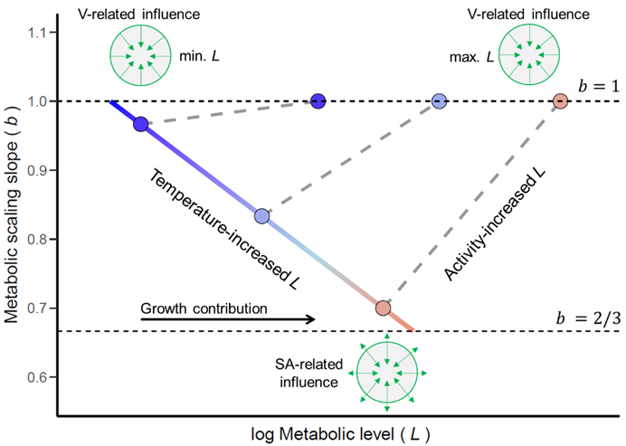
      - 8. Figures

Figure 1. Graphical model of the expected relationship between the metabolic scaling slope (b) and the metabolic level (L, the mass-specific metabolic rate at the geometric mass-midpoint of the scaling regression), building on the ‘Metabolic-Level Boundaries Hypothesis’ (Glazier 2010, 2014). Over the range of metabolic states, the MLBH predicts that b changes with L following a convex relation viewed from below within the limits set by volume-related (V ~ m¹) and surface-area related (SA ~ m^{2/3}) resource demand, denoted here by dashed horizontal lines. In cold temperatures (deep blue) growth is low, so resting metabolic rates (minimal L) are dictated by volume-related body maintenance (b ≈ 1). As temperature rises (from blue to red), resting metabolic rates relatively increase with greater metabolic contribution from growth, becoming more influenced by fluxes through exchange surfaces, thereby reducing b. Activity, conversely, leads b to increase and ultimately approach 1 during strenuous exercise (maximal L), since metabolism is driven temporarily by demands of muscular mass, proportional to body mass (m¹) when growth is isomorphic. Note that L increases here exponentially (or linearly if log-transformed) with temperature and activity. The shape of the relationship between b and log L will depend on the predominant influence of each contributing process under specific temperatures and activity levels.

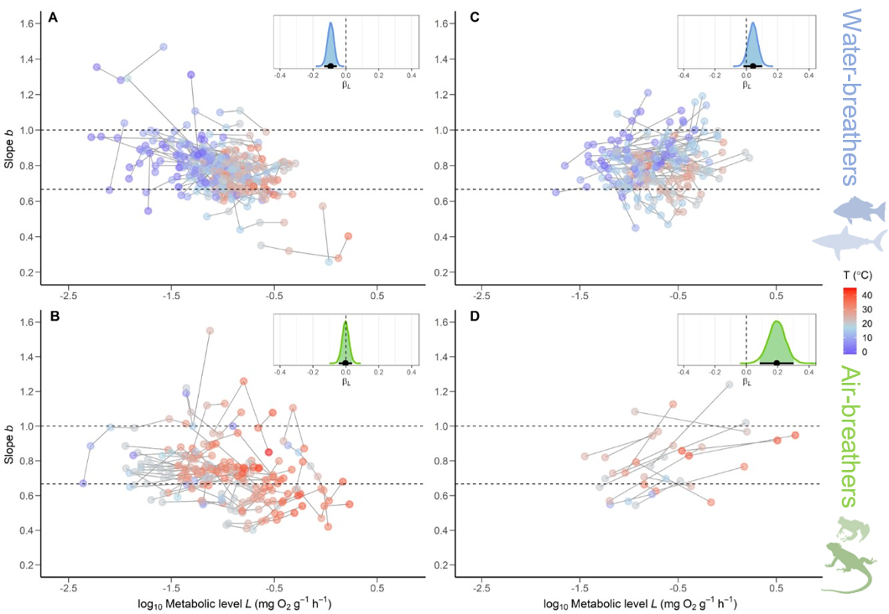
Figure 2. The relationship between the metabolic scaling slope b and log₁₀ metabolic level L within species of ectothermic vertebrates. Left panels show measurements in inactive animals of water- (A) and air-breathing (B) species, where lines join measurements made at different temperatures of single experiments in the same species. Right panels show values for animals under different activity levels of water- (C) and air-breathing (D) species, where lines join measurements made at a single temperature and species (temperature of treatments is indicated by colour). Inset plots show posterior kernel density estimates of the effect of log₁₀ L on b (β_{L}) for each group (water- or air-breathers), with means (dots) and 95% credible intervals (horizontal bars and shaded areas) from Bayesian models (see Table 1). Experimental temperature (T) is shown by a colour scale, and dashed horizontal lines indicate the typical metabolic scaling boundaries under the MLBH.
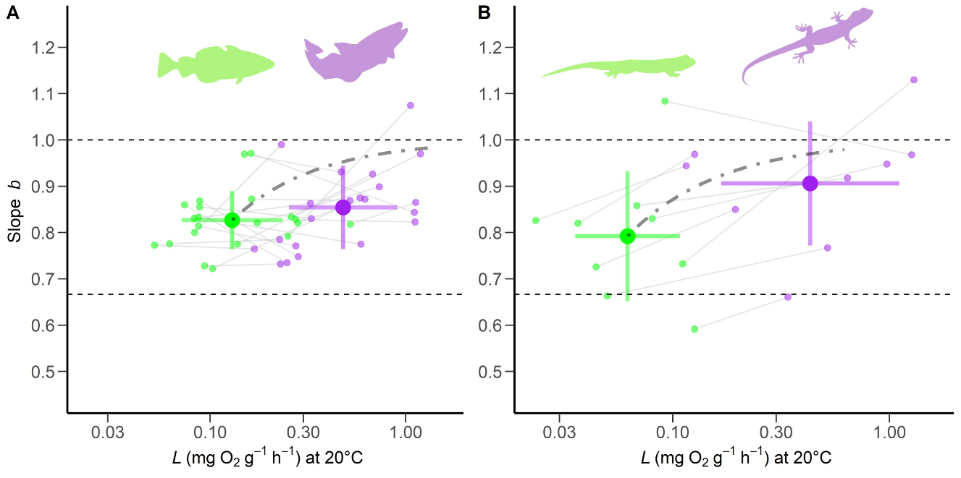
Figure 3. The mean slope b and metabolic level (L) ± standard deviation in water- (A) and (B) air-breathing species at minimal (in green) and maximal activity (purple). L values are adjusted to 20 ℃ for comparison (see Appendix S8). Dash-dotted lines show the expected relationship between b and L, if muscular work scales as m¹, and gradually increases L by an order of magnitude from minimal activity (eq. [S7]). Species’ data are shown to illustrate variation, with a line joining each pair of measurements, i.e., at minimal and maximal activity for single species. Mean values were used when more than one pair of measurements was available for a species. Dashed horizontal lines indicate the typical boundaries proposed by the MLBH.

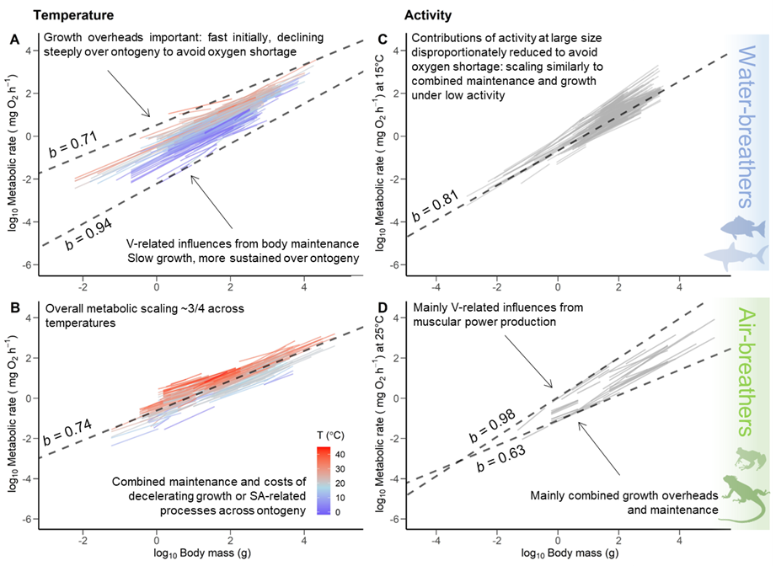
Figure 4. Comparison of the intraspecific metabolic scaling with body mass in ectothermic vertebrates and their interpretations based on our hypotheses. Left panels show scaling regressions performed at various temperatures in inactive individuals of water- (A) and air-breathers (B). Right panels show regressions for individuals under different activity levels of water- (C) and air-breathers (D), adjusted to the approximate mean temperature of each dataset (Appendix S8). Dashed lines denote the upper and lower metabolic scaling slopes (b) as metabolic level (L) increases with temperature (A, B) or activity (C, D). These slopes were predicted through model estimates, by using values of the minimal and maximal L values calculated at the geometric mass-midpoint of the range reported for water- and air-breathing species in each dataset. B and C show mean b and L values, as the estimated change in b overlapped 0, indicating no overall effect of L. The explanation proposed here for these changes in b is shown on each panel.

