Title
Reconstruction of lung tumour volumes from 4D-MRI: the use of a tumour-derived respiratory signal

Authors
Mark Warren¹, Alexander Barrett², Neeraj Bhalla³, Michael Brada⁴, David Cobben^{3,7}, Jamie McClelland⁵, Louise Turtle⁶, John Fenwick⁴

Authors Affiliations
¹The University of Liverpool, School of Health Sciences, Liverpool, United Kingdom; ²Clatterbridge Cancer Centre, Medical Physics, Liverpool, United Kingdom; ³Clatterbridge Cancer Centre, Clinical Oncology, Liverpool, United Kingdom; ⁴The University of Liverpool, Molecular and Clinical Cancer Medicine, Liverpool, United Kingdom; ⁵University College London, Medical Image Computing, London, United Kingdom; ⁶Clatterbridge Cancer Centre, Radiotherapy, Liverpool, United Kingdom; ⁷The University of Liverpool, Health Data Science, Liverpool, United Kingdom

Purpose or Objective
Visualisation of lung tumour volume on 4D-MRI requires slice data to be sorted and assigned to the correct breathing cycle phase. Sorting requires a respiratory signal, which is often extracted from normal tissue surrogates. As normal tissue signals do not fully characterise the tumour’s complex respiratory motion, stitching artefacts can occur during image reconstruction, leading to an unrealistic representation of the tumour volume.
We assessed if a more accurate reconstruction of the tumour could be generated using a surrogate signal derived directly from tumour motion.

Materials and Methods
Signals were extracted from 4D-MRI collected from 10 non-small cell lung cancer patients (stages T1-4) entered into a prospective study.
Initially, sagittal slice signals were correlated with frame-based changes in tumour centre of mass (COM) on the tumour central axis slice. The COM signal was generated by automatically matching a manually-drawn tumour outline to tumour location on image frames. A tumour-specific surrogate signal was generated from principle component analysis (PCA) (figure 1), this provided an alternative to COM that is easy to implement for slice sorting. Normal-tissue respiratory signals were generated from anterior chest wall displacement (CW) and diaphragm displacement (DIA).
Then, sagittal slice signals were standardised and used for sorting, with unsorted consecutive data used as a comparator (Cons). Standardisation of PCA and CW signals used the mean and standard deviation derived from sagittal slice signals only. For DIA, two additional standardisations were tested using mean and standard deviations from an alternative diaphragm signal extracted from coronal images captured at the same imaging session.
Reconstructed tumour surfaces were then extracted from the sorted image sets, with a best-guess “true” surface modelled from the reconstructed surface. The residual sum of squares (RSS) between measured and fitted surfaces were calculated in an attempt to isolate the error caused by sorting inaccuracy. The ratio of RSS between each signal and PCA were then determined for each patient. These ratios were used to test for differences between PCA and other signals across the whole cohort.
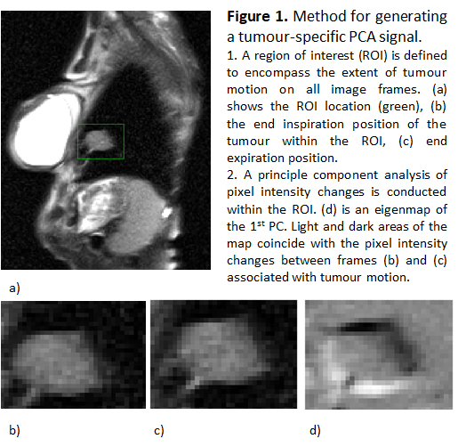

Results
On the central axis of the tumour, PCA correlates better with COM than DIA (r=0.84 vs 0.74, 0.37-0.97 vs 0.24-0.98) (median, range). Median correlations of CW with COM are less than both PCA and DIA (r<0.50).
Table 1 shows the weighted mean ratio of RSS for the cohort, and results of an exact permutation test on the weighted mean ratios. All mean ratios favour the PC signal producing a tumour surface with the lowest RSS. For a 2-sided test, p<0.05 for all mean ratios, except for the ratio between DIA standardised with coronal image data, and PCA.
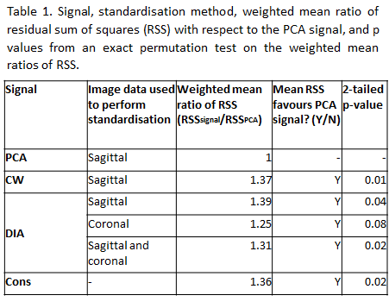

Conclusion
On the central axis slice, an automated tumour signal (PCA) is well correlated with observed tumour COM changes. When used to reconstruct the tumour volume, stitching artefacts are less for PCA than those observed for other signals.

