The susceptibility of bleached enamel to staining as measured by Quantitative Light induced Fluorescence (QLF).

A.A. Adeyemi, N. Pender, S.M Higham
School of Dental Sciences, The University of Liverpool. U.K

Key Words: QLF, Fluorescence, Staining, Bleaching

All correspondence to:
Dr A.A.Adeyemi
School of Dental Sciences
The University of Liverpool
The Edwards Building
Daulby Street
Liverpool
L69 3GN
Tel: +44 151 706 5288 / 5291
Fax: +44 151 706 5809
Email: A.A.Adeyemi@ liverpool.ac.uk
Summary
Title: The susceptibility of bleached enamel to staining as measured by Quantitative Light induced Fluorescence (QLF).

Objectives: This study reports the use of Quantitative Light-induced Fluorescence (QLF) to determine if there was a tendency for bleached enamel to take up extrinsic stains more than unbleached enamel.

Methods: Bovine teeth devoid of stains were selected, the roots removed and enamel gently pumiced. Each tooth was sectioned into two and each half randomly assigned to two groups (bleached or unbleached). Windows were created on each half using clear acid resistant varnish. 38% Hydrogen peroxide gel was applied to the exposed windows of the bleached group for 1 hour. The teeth were rinsed and dried. Bleached and unbleached halves of the same teeth were then mounted on glass rods attached to pot lids using green stick. QLF images were taken. The teeth were subjected to a cycle of artificial saliva, chlorhexidine and tea (2 minutes in each solution). This was repeated 5 times. QLF images were taken at the end of each cycle.

Results: The uptake and progression of stain was detected in all the sections by QLF. Using paired t- test (SPSS) there was no significant difference between the two groups for the change from baseline to the final stain cycle (p>0.05), however there was variability in stain uptake within the groups as the cycles progressed.

Conclusion: Bleaching of enamel in vitro does not appear to increase the susceptibility of enamel to extrinsic staining.

The susceptibility of bleached enamel to staining as measured by Quantitative Light induced Fluorescence (QLF).
Requests for tooth whitening and bleaching procedures are fast gaining popularity.
Patients want to improve the appearance of their teeth in particular the anterior teeth for various reasons which range from wanting a youthful appearance, changing jobs, getting married, to improving self esteem ¹. Vital and non vital bleaching techniques are used to improve the appearance of discoloured teeth. For brightening of discoloured teeth, the use of hydrogen peroxide or peroxide releasing agents such as carbamide peroxide or sodium perborate has become a popular treatment modality ². Several in vivo and in vitro studies have demonstrated the efficacy of external bleaching solutions with varying concentrations of hydrogen peroxide or carbamide peroxide when used as the primary active ingredient ^{3, 4, 5}.

Different clinical studies have reported that tooth colour changed after bleaching and this colour could reverse in varying degrees ^{6, 7, 8}. Very few studies have attempted to investigate the issue of colour rebound and the maintenance of whitening ^{9, 10, 11, 12}. Dietary factors such as coffee, tea, red wine, carrots, oranges, and tobacco have been implicated in the aetiology of extrinsic staining ^{13, 14} and after the eruption of the tooth, aging, pulp necrosis and iatrogenesis are the main causes of intrinsic discolouration ⁷. These dietary factors cause staining which are not just superficial but penetrate into layers of restorative materials causing intrinsic discolouration ¹⁵. Various techniques have been used to measure colour change which range from the subjective use of visual shade guides to objective measurement methods such as colorimeters, digital imaging and the spectrophotometer ^{16, 17}.

Measuring stains with QLF
The use of Quantitative Light-induced Fluorescence (QLF) to measure and quantify stain and stain removal has recently been described ^{18, 19, 20}. Stains produced on teeth have a similar appearance to demineralised lesions when subjected to QLF conditions. QLF uses the natural fluorescence of teeth to distinguish between caries or stains and sound enamel. It measures the percentage change in fluorescence of the stained lesion when compared with the surrounding clean enamel. By employing QLF it is possible to monitor and quantify longitudinally stains and stain reduction on enamel ²⁰.

The aim of this study was to determine, using Quantitative Light-induced Fluorescence, if there was a tendency for bleached enamel to take up extrinsic stains more than unbleached enamel.

Materials and methods
A total of 15 extracted bovine incisor crowns were selected and included if the labial surfaces were found to be devoid of stains, enamel cracks, fractures or other defects. The teeth were gently pumiced and their labial surfaces gently abraded with wet and dry paper (grit size of 400µm). The teeth were then vertically sectioned into half and labelled. Clear acid resistant nail varnish (Maxfactor, Proctor and Gamble, Ltd, UK) was applied to the labial surfaces leaving an exposed window measuring approximately 12mm². The varnish was allowed to dry for 24 hours.

A half of each tooth via a Latin square design was randomly allocated to the bleached or unbleached group thereby ensuring equal distribution. The unbleached halves of each tooth served as controls.
Teeth in the bleached group were moistened with laboratory prepared artificial saliva. 38% Hydrogen peroxide gel (Ultradent Products. Inc, U.S.A) was then applied to the exposed windows for one hour. The teeth were rinsed and dried. Bleached and unbleached halves of the same teeth were mounted on glass rods attached to pot lids (Figure 1) using greenstick (SDS Kerr, Sybron Dental Specialties.CA U.S.A). Baseline QLF images (QLF/ClinTM, Version 2.00c, Inspektor Research Systems BV, NL) were taken. The teeth were subjected to a stain cycle in 30 ml pots containing laboratory prepared artificial saliva, chlorhexidine (Adams Healthcare, England) and tea for 2 minutes in each solution. The tea solution was prepared by brewing 2g of tea bags/ 100ml of boiling water. The infusion was allowed to cool over a period of 3 hours. The staining cycle was repeated five times. Following each cycle the periphery of the windows were cleaned using a cotton swab stick to leave a clear margin around the windows. QLF images were recorded after each cycle. QLF images were analysed at the end of the experiment and ∆ Q values at 5% threshold obtained.
QLF Images
The QLF camera was mounted in a fixed position over a laboratory jack. A repositioning device was made and placed on the jack to enable reproducible placement of the teeth on each occasion. Each tooth on the glass rod was placed on the repositioning device and an image was taken.

Analysis of the QLF image
The lesions captured by the QLF clinical system were analysed quantitatively with QLF software to calculate the percentage of fluorescence loss (ΔQ). The system consisted of a special camera connected to a personal computer to which the QLF software was installed. Visualisation and capturing of an image occurred when white light from an arc lamp based on xenon technology was filtered through a blue- transmitting band pass filter with peak intensity of λ= 410nm and a band width of 80nm, to illuminate the tooth with blue-violet light with the aid of a CCD sensor which had a yellow transmitting filter (λ≥ 520nm) positioned in front of it to filter out reflected and backscattered light. The fluorescence loss value (ΔQ) was obtained by reconstruction of fluorescence of the sound enamel at the site of the lesion from the fluorescence of the surrounding sound enamel. The decrease in fluorescence was determined by calculating the percentage difference between the actual and reconstructed fluorescence surface. The analysis of the image involved the placement of an analysis patch in the stained area ensuring that the borders of the patch fell on sound or unstained enamel. The image was analysed and the reconstructed stained area checked to ensure that it mimicked the original stained area morphology.

Paired t-test analysis was carried out on the data to detect any significant differences in stain uptake between the bleached and unbleached group at the final staining application when compared with baseline.

Results
Bleached teeth fluoresced more than unbleached enamel when examined under QLF conditions.
The uptake and progression of stain was detected in all the teeth sections by QLF. Using paired t- test (SPSS. Version 13), there was no significant difference between the two groups for the change from baseline to the final stain cycle (p>0.05). See Table 1.
There was variability in stain uptake noticed within the groups as the cycles progressed. This trend is shown in Figure 2.

Discussion
In this study we have demonstrated QLF’s capability to detect the uptake and progression of stain by bleached and unbleached bovine teeth (Figure 3). The bleached teeth did not take up more extrinsic stain when compared with the unbleached controls. Bleached sections appeared to fluoresce more than their controls at the commencement of the staining cycles, although as the staining cycles progressed; the measured fluorescence loss between the two groups as viewed by QLF was not significantly different. The influence of tea on the colour of previously bleached teeth has also been investigated by Attin et al. ² . Our results seem consistent and confirmatory of their findings as they reported that the application of tea directly after bleaching had no significant effect on the outcome. A different measuring system (CIELab) was employed in the Attin et al. ²study. They also measured the intrinsic colour of the tooth while QLF measured the extrinsic stain and one aspect of the colour spectrum only. Although QLF was used in this instance in vitro, it can be applied in vivo at chairside and images analysed to measure fluorescence loss within a few minutes. There is clearly a potential for this device to become routinely used in the dental surgery giving patients and clinicians opportunity to view live images.

Various studies have investigated the effect bleaching had on the enamel surface. No macroscopic clinically remarkable damage has been reported in literature ². However, there are reports which demonstrate alterations of the histological aspects and composition of bleached dental enamel ²¹. Some authors have reported slight alterations of the enamel surface noticeable on pictures from the scanning electron microscope, or a decrease in the hardness of the bleached surface possibly due to interactions between the bleaching agent and the tooth surface ^{22, 23, 24}. These have been described as porosities, decalcifications and topographical alterations on the tooth surface whilst, there are also reports which did not find any aspects of destruction of the bleached surface when compared to unbleached enamel ^{25, 26, 27, 28, 29, 30}. White et al. ³¹ reported that whitened teeth revealed no significant mircomorphological changes associated with the whitening process in subsurface enamel, DEJ and dentin areas after bleaching.
There have been also contrasting reports in terms of an increase or decrease in the calcium; phosphate and fluoride content of enamel after bleaching ^{32, 33, 34}. A clinical implication of these findings may be that the teeth are more or less susceptible to extrinsic discolouration after bleaching due to increased or decreased surface roughness ⁷. Attin et al. ²⁴ reported that loss of microhardness on teeth following bleaching could be out weighed by a remineralisation period using saliva and different fluoride treatments and speculated that immersing bleached enamel in saliva repaired the microstructural defects by the adsorption and precipitation of components such as calcium and phosphate. This may account for the results in this study as artificial saliva had a remineralising potential due to its fluoride content.

Discolouration of teeth and restorative materials by dietary factors such as tea and coffee is well known, this is, however, dependent on various parameters such as pH of the solution that increases the staining of teeth, temperature of solution and type of stain solution ^{35, 36}. The effect of these parameters on the uptake of stain after bleaching need to be further investigated as it was not within the confines of this study.

The effect of length and duration of bleaching on stain uptake under QLF conditions as well as varying concentrations on bleaching agents need to be further investigated as this may have varying effects on the surface structure of the enamel and the staining of such enamel. The teeth in this study were subjected to a high concentration of hydrogen peroxide for one hour which might not be sufficient to simulate clinical situations were patients are exposed to a varying concentrations of bleaching agents for longer times.
There was a noticeable variability in stain uptake within the groups as the cycles progressed, this may be due to the individual tooth variation and the differences in adsorption rates of stain formation with the staining regime used in this study. Artificial saliva was used in this study as human saliva from different individuals have varying propensities to cause extrinsic staining of teeth induced by the chromogens of chlorhexidine and tea ³⁶. However, it seems that the use of artificial saliva does not affect the variability of stain uptake by individual teeth.

There are still gaps in explaining why there is a colour rebound effect noticed after bleaching of teeth. However, within the limits of this study, QLF was able to detect and monitor the development of stains longitudinally in bleached and unbleached enamel. There appears to be no significant difference in the intensity of stains formed on bleached enamel when compared with the unbleached controls. In conclusion, bleaching of enamel in vitro does not appear to increase the susceptibility of enamel to extrinsic staining.
References
- Sulieman M. An overview of bleaching techniques: I. History, chemistry, safety and legal aspects. Dental Update. 2004; 31(10):608-10, 612-4, 616
- Attin T, Manolakis A, Buchalla W, Hannig C. Influence of tea on intrinsic colour of previously bleached enamel. Journal of Oral Rehabilitation. 2003; 30:488-494
- Lenhard M. Assessing tooth colour change after repeated bleaching in vitro with a 10 percent carbamide peroxide gel. Journal of the American Dental Association. 1996; 127: 1618-1624
- Kwon YH, Huo MS, Kim KH, Kim SK, Kim YJ. Effects of hydrogen peroxide on the light reflectance and morphology of bovine enamel. Journal of Oral Rehabilitation. 2002; 29: 473-477
- Matis BA, Wang Y, Jiang T, Eckert GJ. Extended at-home bleaching of tetracycline –stained teeth with different concentrations of carbamide peroxide. Quintessence International. 2002; 33:645-655
- Rosenstiel SF, Gegauff AG, Johnston WM. Duration of tooth colour change after bleaching. Journal of American Dental Association. 1991; 122 (4): 54-59
- Dahl JE, Pallesen U. Tooth Bleaching – A critical Review of the Biological Aspects. Critical Review Oral Biology Medicine. 2003; 14 (4): 292-304
- Deliperi S, Bardwell DN. Two-year clinical evaluation of non vital tooth whitening and resin composite restorations. Journal of Esthetic Restorative Dentistry. 2005; 17 (6): 369-378
- Matis BA, Mousa HN, Cochran MA, Eckert GJ. Clinical evaluation of bleaching agents of different concentrations. Quintessence International. 2000; 31(5): 303-310
- Gerlach RW, Gibb RD, Sagel PA. Initial color change and color retention with a hydrogen peroxide bleaching strip. American Journal of Dentistry. 2002: 15 (1): 3-7
- Kugel G, Aboushala A, Sharma S, Ferreira S. Maintenance of whitening with a power toothbrush after bleaching treatment. Compendium of Continuing Education in Dentistry. 2004; 25 (2): 119-131
- Kugel G, Ferreira S. The art and science of tooth whitening. Journal of Massachusetts Dental Society. 2005; 53:34-37
- Hattab FN, Qudeimat MA, al-Rimawi HS. Dental discoloration: an overview. Journal of Esthetic Dentistry. 1999; 11:291-310
- Watts A, Addy M. Tooth discolouration and staining: a review of the literature. British Dental Journal. 2001 (190):309-315
- Chan KC, Fuller FL, Hormati AA. The ability of foods to stain two composite resins. Journal of Prosthetic Dentistry. 1980; 43; 542-545
- Joiner A. Tooth colour: A review of the literature. Journal of Dentistry 2004: 32: 3-12
- Joiner A. The bleaching of teeth: A review of the Literature. Journal of Dentistry. 2006; 34: 412 -419
- Pretty I A, Edgar WM, and Higham SM. The use of QLF to quantify in vitro whitening in a product testing model, British Dental Journal. 2001; 191:566-569
- Amaechi BT and Higham SM. Development of a Quantitative Method to monitor the effect of a tooth whitening agent. Journal of Clinical Dentistry. 2002; 131: 100-103
- Adeyemi AA, Jarad FD, Pender N, Higham SM: Comparison of quantitative light-induced fluorescence (QLF) and digital imaging applied for the detection and quantification of staining and stain removal on teeth. Journal of Dentistry. 2006; 34, 460-466
- Wandera A, Feigal RJ, Douglas WH, Pintado M. Home-use tooth bleaching agents: an in vitro study on quantitative effects on enamel, dentin and cementum. Quintessence International. 1994; 25: 541-546
- Ernst CP, Briseno Marroquin B, Willershausen-Zonnchen B. Effects of hydrogen peroxide-containing bleaching agents on the morphology of human enamel.Quintessence International. 1996; 27(1):53-56
- Josey AL, Meyers IA, Romaniuk K, Symons AL. The effect of a vital bleaching technique on enamel surface morphology and the bonding of composite resin to enamel. Journal of Oral Rehabilitation. 1996; 23(4):244-50
- Attin T, Kielbassa AM, Schwanenberg M, Hellwig E. Effect of fluoride treatment on remineralisation of bleached enamel. Journal of Oral Rehabilitation. 1997; 24: 282- 286
- Haywood VB, Leech T, Heymann HO, Crumpler D, Bruggers K. Nightguard vital bleaching: effects on enamel surface texture and diffusion. Quintessence International. 1990; 21:801- 804
- McGuckin RS, Babin JF, Meyer BJ. Alterations in human enamel surface morphology following vital bleaching. Journal of Prosthetic Dentistry. 1992; 68: 754-760
- Bitter NC, Sanders JL. The effect of four bleaching agents on the enamel surface; a scanning electron microscpic study. Quintessence International. 1993; 24: 817-824
- Shannon H, Spencer P, Gross K, Tira D. Characterization of enamel exposed to 10% carbamide peroxide bleaching agents. Quintessence International. 1993; 24: 39-44
- Gultz J, Kaim J, Scherer W, Gupta H. Two in-office bleaching systems: a scanning electron microscope study. Compendium of Continued Education in Dentistry. 1999; 20:965-970
- Lopes GC, Bonissoni L, Baratieri LN, Viera Lc, Monteiro S Jr. Effect of bleaching agents on the hardness and morphology of enamel. Journal of Esthetics and Restorative Dentistry. 2002; 14(1): 24-30
- White DJ, Kozak KM, Zoladz JR, Duschner HJ, Gotz H. Effects of tooth –whitening gels on enamel and dentin ultrastructure – a confocal laser scanning microscopy pilot. Compendium of Continuing Education Dental Supplement. 2000; 29: S29-34
- Perdigao J, Francci C, Swift EJ Jr, Ambrose WW, Lopes M. Ultra-morphological study of the interaction of dental adhesives with carbamide peroxide-bleached enamel. American Journal of Dentistry. 1998; 11(6):291-301
- McCracken MS, Haywood VB. Demineralization effects of 10 percent carbamide peroxide. Journal of Dentistry. 1996; 24(6):395-8
- Crews KM, Duncan D, Lentz D, Gordy FM. Effect of bleaching agents on chemical composition of enamel. Mississippi Dental Association Journal.1997; 53:20-21
- Addy M, Prayitno S, Taylor L and Cadogan S. An in vitro study of the role of dietary factors in the aetiology of tooth staining associated with the use of chlorhexidine. Journal of Periodontal Research. 1979; 4: 403-410
- Sheen S, Banfield N, Addy M. The propensity of individual saliva to cause extrinsic staining in vitro – a developmental method. Journal of Dentistry 2001; 29: 99- 102

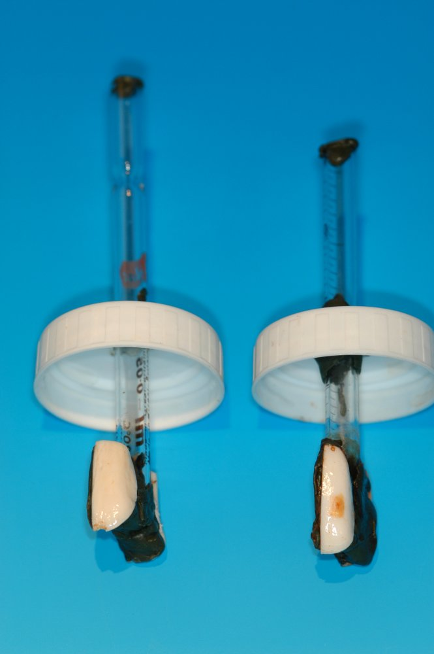
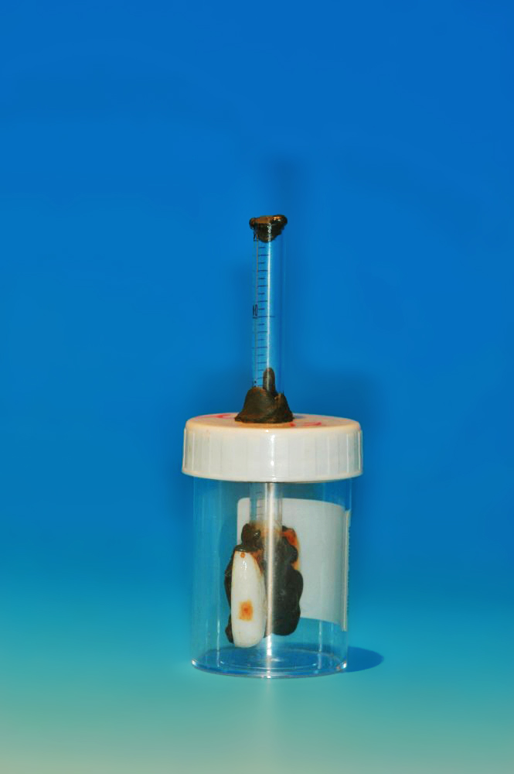

Figure 1: Example of bleached and unbleached teeth mounted on glass rods and attached to pot lids.

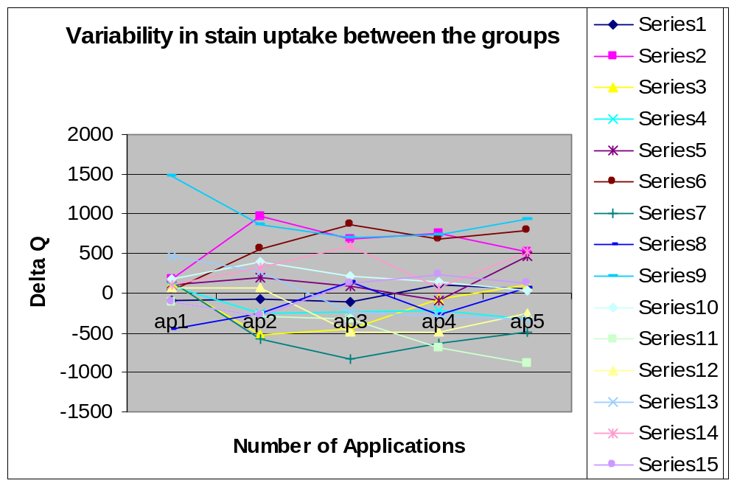
Figure 2: Graph showing the variability in stain uptake between the bleached and unbleached group.

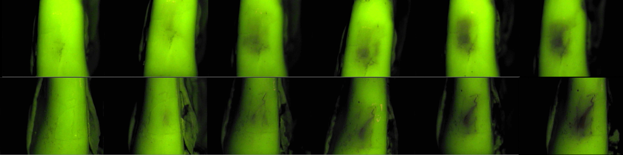

Figure 3: Example of QLF images of bleached half (top) and corresponding unbleached half (below) of the same teeth as the stain cycles progressed. The bleached half appeared to fluoresce more than the unbleached control.

Table 1
Difference in ∆ Q value changes between bleached and unbleached halves for baseline and application 5.
Tooth Number | Baseline ∆ Q value @5% threshold | Application 5@ 5% ∆ Q values
1 | -56.20 | 54.10
2 | 395.20 | 526.90
3 | 46.20 | 106.80
4 | 5.20 | -319.80
5 | 38.20 | 459.00
6 | -19.70 | 791.30
7 | 37.60 | -497.70
8 | -523.50 | 76.90
9 | 89.20 | 939.70
10 | -25.10 | 32.90
11 | -115.20 | -888.60
12 | -70.50 | -260.50
13 | 33.20 | -333.40
14 | -44.60 | 514.40
15 | 109.70 | 121.20

