Endodontics

Title: Inadvertent injection of sodium hypochlorite into the soft tissues beyond the root apex.

Authors:
Miss V.E Baldwin, Fifth year dental student, Liverpool University Dental Hospital, Pembroke place, Liverpool, L3 5PS.

FD Jarad, BDS, PhD, MFDS RCS(Eng), Lecturer/Honorary SpR in Restorative Dentistry, Liverpool University Dental Hospital, Pembroke place, Liverpool, L3 5PS.

MC Balmer, BSc, BChD, FDS RCS, PgCertEd, Acting Consultant in Oral Surgery and Honorary Lecturer, Associate Dean of postgraduate Dental Education.
Liverpool University Dental Hospital, Pembroke place, Liverpool, L3 5PS.

LH Mair, BDS, PhD, FDS RCS(Eng), FADM, Senior Lecturer/ Honorary Consultant in Restorative Dentistry, Liverpool University Dental Hospital, Pembroke place, Liverpool, L3 5PS.
Inadvertent injection of sodium hypochlorite into the soft tissues beyond the root apex.

Abstract:
This paper describes a sodium hypochlorite (NaOCl) incident occurring during routine endodontic treatment of a patient who presented with chronic periapical periodontitis of /_3 and discusses the immediate and late treatment of this case.

Clinical Relevance:
Although NaOCl incidents in root canal therapy are rare, it is paramount that the clinician takes the appropriate safety measures to minimize all risks. This report serves as a reminder of how this most effective irrigant can cause serious injury to vital tissues and so must always be used with great caution.

Objectives:
The reader should be able to describe the clinical symptoms of a NaOCl incident, and explain the appropriate management.

Since the 1920’s, NaOCl has been used as an irrigant in endodontic procedures as part of the chemo-mechanical preparation¹.
NaOCl is by far the best irrigant available due to²:
- It’s ability to dissolve organic tissues as a result of oxidation.
- The Cl- ions released have a significant antiseptic effect (between 0.5% - 5.25%).
- A reduction reaction occurring on contact with organic matter converting NaOCl into non-toxic products (Na+ and Cl-).
Although the above features are ideal in order to obtain a clean, bacteria free canal system, it is these same features that can also elicit severe inflammatory reactions and are cytotoxic to vital tissues2 beyond the root apex. Tissue dissolving effects of NaOCl are complete between 1% and 5.25%3. This may lead to tissue damage. It is therefore essential that NaOCl is prevented from entering the periradicular tissues to the best of the clinicians’ ability.

Case Report

For the purposes of clarity only the treatment relevant to this incident will be discussed.
A previously fit and well 57 year old woman was undergoing treatment at Liverpool University Dental Hospital (Undergraduate Restorative Clinic). On attendance the patient complained of a history of intermittent, spontaneous pain from an upper anterior tooth. On examination the pain was localised to /_3 and the crown of the tooth was almost entirely fractured off and the sclerosed pulp chamber was visible. Radiographic findings showed loss of lamina dura (figure 1) and the tooth gave a negative response to an electric pulp test. Following a discussion of treatment options the patient elected to have the tooth root filled. The tooth was isolated using a dental dam. The estimated working length (EWL) was determined by taking the average length of an adult canine (25mm) and deducting six millimetres for the absent crown. Prior to taking a length determination radiograph K flex files with rubber stops (20 and 25) were used to scout the canal and remove debris. The canal was irrigated with 1% NaOCl, using a Luer Lock 27 gauge endodontic needle with rubber stop. There was no apparent blood in the canal. The patient experienced a severe shooting pain up toward her left eye and across her cheek during irrigation. Clinical examination showed evidence of a slight swelling on the left hand side of the face adjacent to the /_3. The following procedure took place after the incident had occurred:
- Treatment was stopped immediately.
- The patient was informed that the NaOCl used to clean the canal during RCT had gone beyond the apex of the tooth and into the surrounding tissues causing the instantaneous pain.
- Facial massage was carried out to encouraged most of the NaOCl to exude from the canal; the fluid was stained pink indicating that there was blood present. (Discussion point).
- The canal was copiously irrigated using saline solution. (Discussion point).
- Paper points were used in an attempt to dry the canal however this was not achieved.
- Non-setting calcium hydroxide was placed into the canal and the tooth was temporised..
- The patient was prescribed 250mg of amoxicillin and advised to get them from the chemist, but not to take them unless the symptoms worsened. (Discussion point).
- A review appointment was made for three days later. (Discussion point).
By the end of the treatment visit the pain had almost subsided and there was no obvious swelling.

The following day the patient contacted the dental hospital requesting to be seen as she had quite severe facial swelling. The antibiotics prescribed had not been taken. The presenting picture is shown in Figure 2. There was a general swelling of the left side of the face with partial closure and bruising around the left eye. An oral surgery opinion was sought. Clinical examination showed generalised diffused left sided facial swilling extending from below the lower border of the mandible up to the periorbital tissues and left temple. Ocular examination showed all eye movements normal, all facial movements were normal but objective sensory examination showed a decrease in sensation in the region supplied by the inferiororbital nerve. As swelling was likely increase over the next 24 hours, and the patient lived alone a decision was made to admit the patient to the nearest maxillofacial unit to her home. The SHO in the unit was contracted by phone and agreed the admission in advance and a taxi was arranged for transport. Prior to leaving the Dental Hospital the patient was given a 3g dose of oral amoxicillin.

After admission the patient was administered I.V antibiotics – Amoxicillin 500mg given eight hourly, and IV steroid Dexamethasone 8mg IV also given eight hourly. By the following day the swelling had started to subside and the patient was happy to be discharged. .
Seven weeks later the patient returned to the dental hospital, all her acute symptoms had resolved (figure 3). The RCT was completed, using chlorohexidine as an irrigant (figure 4).
The patient stated that her nose remained swollen for six weeks, whilst the numbness and loss of sensation from the upper lip to lower eyelid had subsided one week after the incident. However there was still altered sensation of the infa-orbital nerve, reassurance was given that over time the likelihood would be that normal sensation would return1. Fourteen weeks after the incident occurred the patient regained all sensation on the left hand side of her face.
Discussion
Fortunately these incidents are rare, so when they occur it is likely to be the first time the operator has encountered the situation. From this case it is apparent that a lack of pain and swelling at the end of the treatment session is not an indication that all is well. A number of procedures that may seem like common sense could inadvertently cause further spread of the solution. There is no evidence that further irrigation (with saline) will dilute the NaOCl and it will not remove it from the tissues. Rubbing the affected area to relieve pain, or encourage drainage could cause further spread of the solution. The most important thing is to try and prevent further spread of the solution in the tissues so as to minimise the volume of tissue damage. For this reason the immediate administration of IM steroids will decrease the fluid exude from the local inflammatory response that may spread the NaOCl solution through the tissues. Antibiotics should be prescribed prophylactically to prevent secondary infection of the damaged tissue.

The most important learning point from this case is that everyone is uses NaOCl as an irrigant during endodontic treatment should have a written protocol for what to do should such an event occur. In our opinion, if the symptoms of sudden acute pain occur while irrigating with hypochlorite the following procedures should be followed.

In a hospital or specialist setting .
- Stop treatment immediately and explain the situation to the patient.
- No further irrigation of the canal should take place as this could cause the NaOCl to spread further into the vital tissues and exacerbate the problem.

- An empty syringe may be used to aspirate the excess NaOCl out of the canal or it can be removed with paper points. The canal should be dressed with non setting calcium hydroxide (there is evidence the Ledermix may be effective, but this is not essential6.
- IM steroids (100 mg Hydrocortisone Na Succinate) should be administered immediately to reduce the spread of the NaOcl by the fluid phase of the inflammatory response. 7,⁸ A regime of oral antibiotics should be instigated immediately to prevent secondary infection ^{2,7,8,9} to be taken immediately. These should be continued for 3 days
- Appropriate analgesia should be provided.
- The patient should be kept in the vicinity of the clinic for three or four hours to observe the swelling. If this starts to become rapid overnight admission to a maxillofacial unit should be considered.

In a non specialist practice

If possible all of the above procedures should be undertaken. It there is a reticence to administer IM steroids then the local maxillofacial unit should be contacted and the patient transferred as soon as possible.

In either case the decision about whether to admit the patient for overnight observation will depend on the circumstances of the patients as well as the severity of the swelling. Even if the patient is allowed to go home the local maxillofacial unit should be made aware of the incident in case the patient needs to get in contact out of hours. Again, if patients are sent home they should be seen the next day to assess the situation.

Sodium hypochorite is recognised as an effective agent against a broad spectrum of pathogens⁷, but in vitro it has been demonstrated to have toxic8 effects on vital tissues. Penetration of hypochloite into the tissue inevitably leads to tissue necrosis and instantaneous reactions with extreme pain^{1,3} (with the exception of one case reported where the patient was asymptomatic4). It could be argued that as NaOCl has the potential to cause tissue damage it should not be used for endodontic irrigation. However, these incidents are very rare and it is important to be aware that the benefits of NaOCl far outweigh the risks1⁰. It is, however, important recognise “at risk” situations where an alternative irrigate should be considered. These include¹:
- Teeth with wide apical foramen (idiopathic).
- Cases where there has been over instrumentation of the apical region (incorrect determination of working length).
- Root resorption.
- Extreme pressure during irrigation.
- Binding of needle within the root canal.
The clinical features associate with hypochlorite mishaps are similar to those observed in this case 1:
- Immediate, severe pain.
- Immediate swelling of the adjacent soft tissues.
- Extension of swelling over 1/2 side of face, lip and infra orbital region affected (occurring over the following 24 hours).
- Anaesthesia and paraesthesia of infra orbital nerve (for seven weeks after the incident had occurred).
They can also incluse
- Profuse bleeding from the root canal.
- Profuse interstitial bleeding with ecchymosis.
- Chlorine taste and irritation of the pharynx.
- Secondary infection due to the presence of necrotic tissue and bacteria being forced out of apex.
In cases where there is an increased risk of Naocl accident, it may be safer to use Chlorhexidine¹¹. In this case the most probable explanation for the incident was destruction of the apical constriction prior to working length determination. We have now agreed that, on the teaching clinic, hypochlorite should not be used as an irrigant until the working length has been determined either radiograpahically, or with an apex locator.

In order to minimize complications during endodontic treatment the use of dental dam isolation is essential. An endodontic needle should be used in order to prevent binding within the canal and irrigation carried out at a low pressure2. A rubber stop should be used on the needle at least 2 mm short of the estimated working length in order that the tip of the needle is not introduced to within 2mm of the apex. Rubber stops should always be used on endodontic instruments at estimated working length and after working length determination to avoid over instrumentation.
- This case emphasises the need for action even if there isn’t much swelling at the time of the incident.
- It indicates that patients should be kept under observation for 3 hours after the incident.
- In extreme cases the patient may need urgent referral to hospital7.
Outside a hospital environment it is sensible to inform the local maxillo facial unit as soon as possible even if the patient is assessed to be fit to sent home after early observation.

Since this incident has occurred a protocol and set of guidelines have been implemented in the dental hospital

REFERENCES
M. Hulsmann, W. Hahn. Complications during root canal irrigation – literature review and case reports. International Endodontic journal 2000; 33: 186-193.

2 A. Becking. Complications in the use of sodium hypochlorite during endodontic treatment. Oral Surg Oral Med Oral Pathol 1991; 71: 346-348.

3 A. Serper, M. Ozbek, S. Calt. Accidental sodium hypochlorite – induced skin injury during endodontic treatment. The American Association of Endodontists 2004; 30: 180-181.

4 D. Ehrich, D. Brian, W. Walker. Sodium hypochlorite accident: inadvertent injection into the maxillary sinus. Journal of Endodontics 1993; 19: 180-181.

5 Mitchell L, Mitchel DA. Root canal therapy. In: Oxford Handbook of Clinical Dentistry Third Edition. Oxford, Oxford University Press, 1999; p318.

6 C. Gernhardt, K. Eppendorf, A. Kozlowski, M. Brandt. Toxicity of concentrated sodium hypochlorite used as an endodontics irrigant. International Endodontic Journal 2004; 37: 272-280.

7A Gatot, J. Arbelle, A. Leiberman, I. Yanai-Inbar. Effects of sodium hypochlorite on soft tissues after its inadvertent injection beyond the root apex. Journal of Endodontics 1991; 17: 573-574.

8R Witton, P.A Brennan. Severe tissue damage and neurological deficit following extravasation of sodium hypochlorite during routine endodontics treatment. B.D.J 2005; 198, 12: 749-750.

9 C. Scully, N.G & K. Gulabivala. Systemic complication due to endodontics manipulations. Endodontic Topics 2003; 4: 60-68.

10C. Kavanagh, J. Taylor. Inadvertent injection of sodium hypochlorite into the maxillary sinus. B.D.J 1998; 185, 7: 336-337.

11 P. Ohara, M. Torabinejad, J.D Kettering. Antibacterial effects of various endodontics irrigants on selected anaerobic bacteria. Endodontics and Dental Traumatology 1993; 9: 95-100
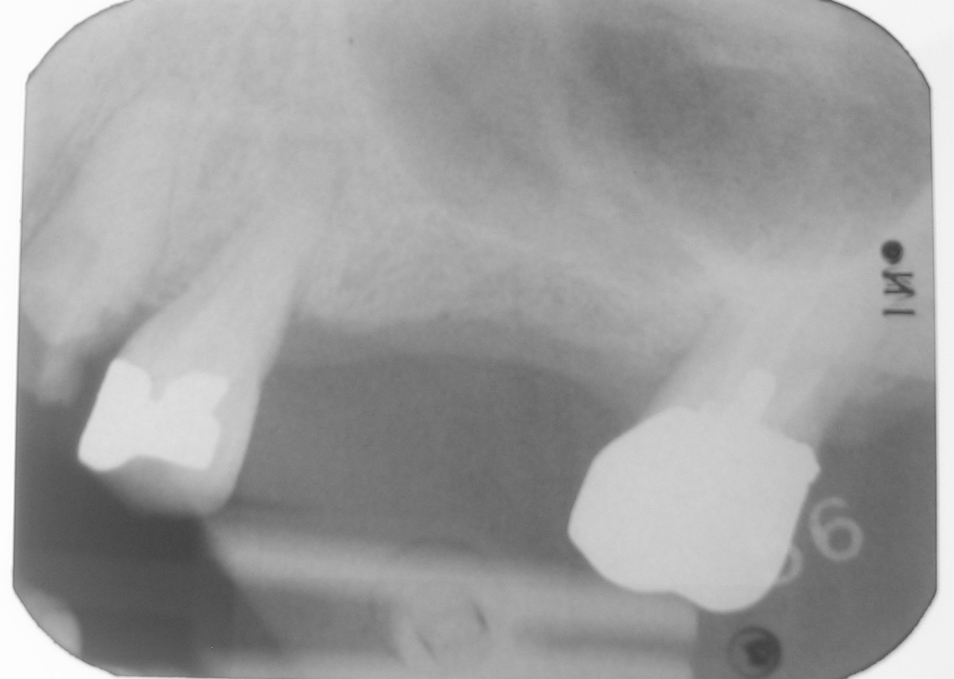
Figure 1: Periapical radiograph of /_3

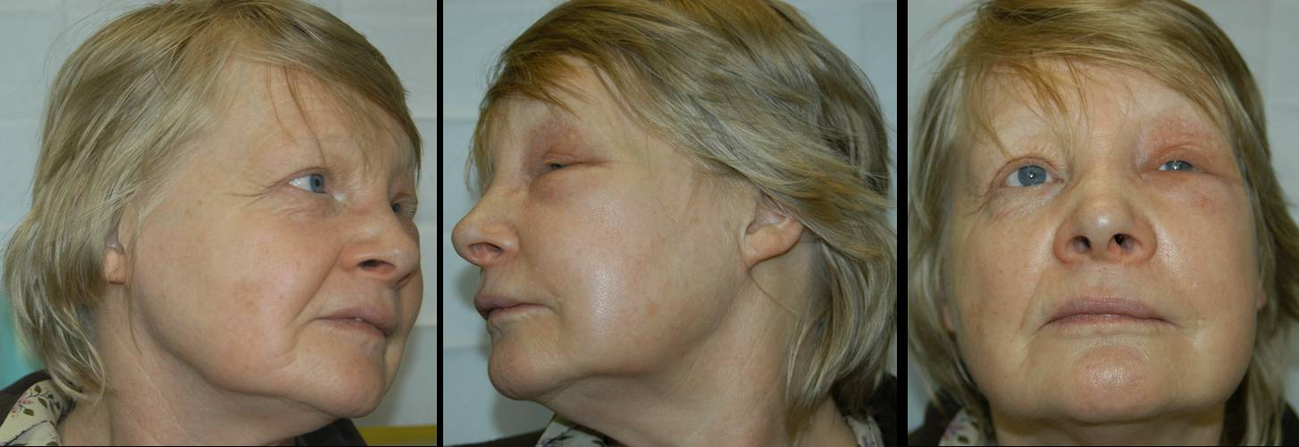
Figure 2: Patient views 24 hours post operative sodium hypochlorite (NaOCl) incident

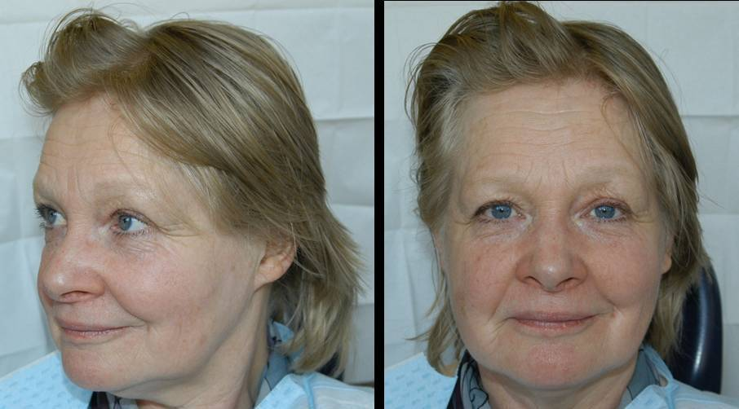
Figure 3 :Patient views 7 weeks post operative sodium hypochlorite (NaOCl) incident

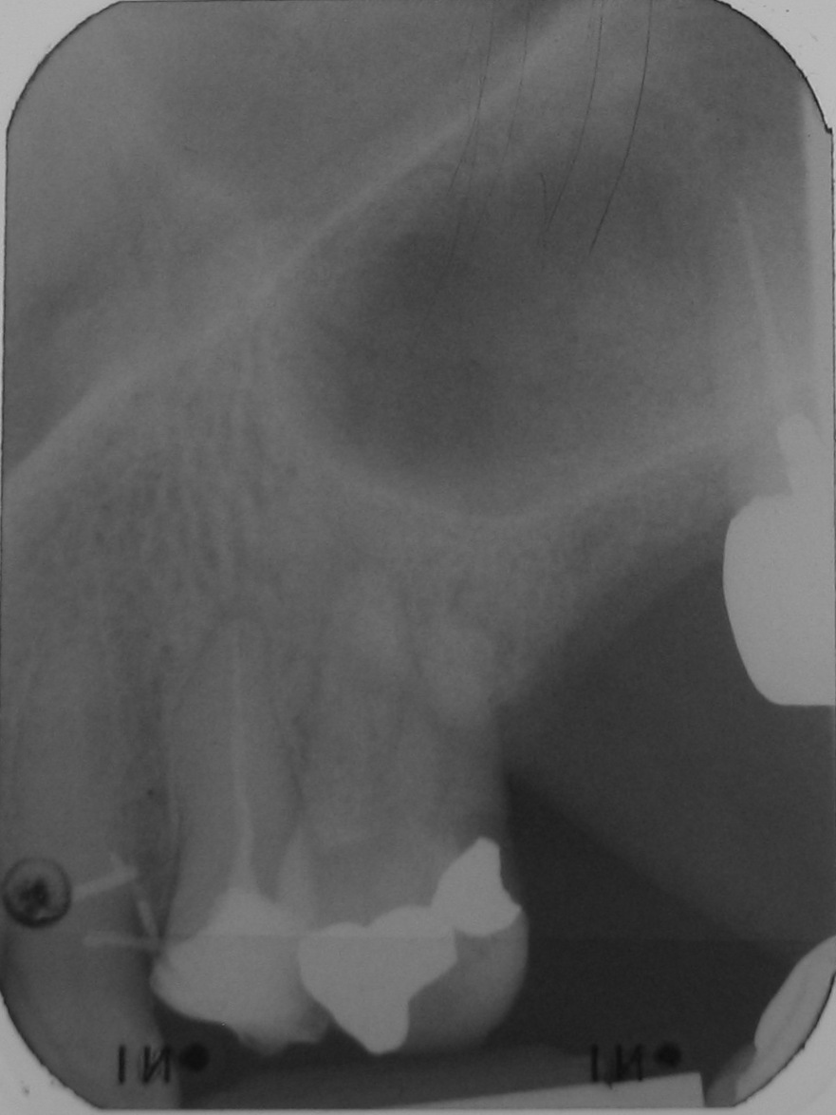

Figure 4: Post obturation radiograph
Figure 1: Periapical radiograph of /_3
Figure 2: Patient views 24 hours post operative sodium hypochlorite (NaOCl) incident
Figure 3 : Patient views 7 weeks post operative sodium hypochlorite (NaOCl) incident
Figure 4: Post obturation radiograph

1
7

