7SGLT2 Inhibitors for Primary and Secondary Prevention of Cardiovascular and Renal Outcomes in Type 2 Diabetes Mellitus: A Meta-Analysis of Cardiovascular Outcomes Trials

Thomas A. Zelniker (a), Stephen D. Wiviott (a), Itamar Raz (b), Kyungah Im (a), Marc P Bonaca (a), Ofri Mosenzon (b), Eri T Kato (c), Avivit Cahn (b), Remo HM Furtado (a), Deepak L Bhatt (a), Lawrence A. Leiter (d), Darren K. McGuire (e), John PH Wilding (f), Marc S. Sabatine (a)

a TIMI Study Group, Cardiovascular Division, Brigham and Women's Hospital, Boston, MA
b The Diabetes Unit, Department of Endocrinology and Metabolism, Hadassah Medical Center, Hebrew University of Jerusalem, The Faculty of Medicine, Jerusalem, Israel
c Department of Cardiovascular Medicine, Kyoto University Graduate School of Medicine, Kyoto, Japan
d Li Ka Shing Knowledge Institute, St. Michael's Hospital, University of Toronto, Ontario, Canada
e Division of Cardiology, University of Texas Southwestern Medical Center, Dallas, TX
f Institute of Ageing and Chronic Disease, University of Liverpool, Liverpool, United Kingdom

Author for correspondence:
Marc S. Sabatine, MD, MPH
TIMI Study Office
60 Fenwood Rd. | Suite 7022-7024W
Boston
MA 02115
Tel: Tel (617) 278-0318
Fax (617) 264-5130
E-mail: msabatine@bwh.harvard.edu

Research in context
Evidence before this study
Sodium-glucose co-transporter-2 inhibitors (SGLT2i) have been studied in large cardiovascular (CV) outcomes trials in patients with type 2 diabetes mellitus (T2DM) and shown to reduce the risk of cardiovascular events. Both patients with established atherosclerotic CV disease (ASCVD) and those with multiple risk factors (MRF) but without ASCVD were studied in these trials. Within individual trials, there has appeared to be a greater magnitude of benefit on MACE in subgroups with established ASCVD, although formal heterogeneity was not demonstrated. Based on these findings American and European guidelines recommend initiation of SGLT2i should be based on the presence of CVD. However, no single trial has been adequately powered to test for such heterogeneity as the numbers of patients and events in those with MRF alone have been relatively low. We searched PubMed and EMBASE until September 24, 2018 using the Medical Subject Heading terms “diabetes mellitus, type 2”, “sodium-glucose-co transporter 2 inhibitor”, and “clinical trial”.
Added value of this study
The present meta-analysis of all SGLT2i cardiovascular outcomes trials showed that clinical benefit of SGLT2i in reducing the risk of myocardial infarction, stroke, or CV death was present only in patients with established ASCVD and not in those with MRF. In contrast, the reductions in risk of hospitalization for heart failure or progression of renal disease were robust regardless of the presence of ASCVD or HF at baseline.
Implications of all the available evidence
These data suggest that SGLT2i should be considered in patients with diabetes regardless of presence of ASCVD or history of heart failure, given that they safely reduce HbA1c and reduce the risk of hospitalization for heart failure and progression of renal disease broadly across the spectrum of patients with T2DM. Reductions in MACE can also be expected in patients with existing atherosclerotic disease.

Abstract:
Background: The magnitude of effect of sodium-glucose co-transporter-2 inhibitors (SGLT2i) on specific cardiovascular and renal outcomes and whether there is heterogeneity based on key baseline characteristics remains undefined.
Methods: We performed a trial-level meta-analysis of randomized cardiovascular (CV) outcomes trials of SGLT2i in patients with T2DM. Efficacy outcomes included major adverse CV events (MACE; MI, stroke, or CV death), the composite of CV death or hospitalization for heart failure (CVD/HHF), and progression of renal disease. Hazard ratios with 95% confidence intervals were pooled across trials, and efficacy outcomes stratified by baseline presence of atherosclerotic CV disease (ASCVD), heart failure and degree of renal function.
Findings: 34,322 patients (60.2% with ASCVD) with 3342 MACE, 2028 CVD/HHF events and 766 renal composite outcomes were included. SGLT2i reduced MACE by 11%, with benefit only seen in patients with ASCVD (HR 0.86, 95% CI 0.80-0.93) and not in those without (HR 1.00, 95% CI 0.87-1.16, p-interaction 0.05). SGLT2i reduced the risk of CVD/HHF by 23%, with comparable benefit in patients with and without ASCVD and with and without a history of heart failure. SGLT2i reduced the risk of progression of renal disease by 45%, with comparable benefit in those with and without ASCVD. SGLT2i showed greater reductions in HHF but lesser for progression of renal disease in those with more severe kidney disease at baseline (P interactions 0.01 and 0.04, respectively).
Interpretation: SGLT-2 inhibitors have moderate benefits on atherosclerotic MACE that seem confined to those with established ASCVD. However, they have robust benefits on reducing hospitalization for heart failure and progression of renal disease regardless of existing ASCVD or a history of heart failure.
Funding: Deutsche Forschungsgemeinschaft (ZE 1109/1-1)

Abstract: 325 words (max 250)

Background
Sodium-glucose co-transporter-2 inhibitors^{1,2} (SGLT2i) have now been studied in several large placebo-controlled cardiovascular (CV) outcomes trials in patients with type 2 diabetes mellitus (T2DM). These trials were done in part to satisfy regulatory requirements to demonstrate CV safety, specifically to exclude an excess in CV death, MI or stroke (major adverse cardiovascular events or MACE).³ The data to date suggest this drug class appears to moderately reduce the risk of MACE, or at least some components of MACE. Complicating the interpretation of these data is that there has appeared to be a greater magnitude of benefit for MACE in patients with established atherosclerotic CV disease (ASCVD) as compared with those with multiple risk factors (MRF) but without ASCVD. This observation has resulted in recommendations by European and American diabetes and cardiology society guidelines giving preference to SGLT2i in patients with ASCVD but not MRF.^{4,5} However, no single trial has been adequately powered to test for such heterogeneity of CV efficacy by baseline ASCVD risk categories, as the numbers of patients and events in those with MRF alone have been relatively low. Results from the recently completed DECLARE-TIMI 58 trial, which had the highest number of patients with MRF, now allows investigation of this issue. In addition, these same CV outcomes trials have demonstrated that SGLT2i’s robustly reduce the risk of hospitalization for heart failure (HHF) and progression of kidney disease.^{1,2,6,7} However, data from one trial suggested that SGLT2i may reduce the risk of CV death and HHF to a larger extent in patients with a history of heart failure than in those without.⁸ Additionally, as the glucosuric effects of SGLT2 inhibitors are dependent on renal function, there is natural interest in whether the clinical benefit is also related to renal function.^{9,10} In terms of safety, there is concern that SGLT2i may increase the risk for amputations,^{2,11} fractures,^{2,12} and diabetic ketoacidosis,¹³⁻¹⁵ but these events are infrequent thus posing difficulty in drawing meaningful conclusions from individual trials.
As such, the goal of the present meta-analysis was to combine data from all the large-scale placebo-controlled CV outcomes trials of the SGLT2i’s in order to gain more reliable estimates of the efficacy and safety of specific outcomes overall, and in relevant subgroups.

Materials and Methods

Data Search and Study Selection:
This meta-analysis was performed using the methods proposed in the Preferred Reporting Items for Systematic Reviews and Meta-Analysis (PRISMA-P) statement.¹⁶⁻¹⁸ This analysis was prespecified in the statistical analysis plan of the DECLARE-TIMI 58 trial. A comprehensive data search of all randomized, placebo-controlled, CV outcomes trials of SGLT2i’s was performed using PubMed and EMBASE until September 24, 2018. The search was performed by two independent reviewers (TAZ, MSS) and any discrepancies were resolved by consensus. The search algorithm is presented in detail in the Supplemental material.

Patient Subtypes & Outcomes
Patients were stratified into those with established ASCVD versus MRF (see Supplemental Table S1 for details), history of HF or not, and by estimated glomerular filtration rate (eGFR) (see Supplemental Methods for details). Efficacy outcomes of interest included: MACE (the composite of myocardial infarction, stroke, or CV death), the composite of CV death or HHF, their individual components, and a standardized composite of renal outcomes including worsening eGFR, end-stage renal disease, or renal death (see Supplemental Table S2 for details). Safety endpoints of interest consisted of non-traumatic lower limb amputations, fractures and diabetic ketoacidosis.

Statistical analysis:
Hazard ratios with the 95% confidence intervals for the effect of randomized treatment allocation on the aforementioned outcomes were pooled across trials overall and within the previously mentioned subgroup strata, using fixed effects models. We tested for treatment effect modification by subgroup using a random effect model applying the method of residual maximum likelihood and Hartung-Knapp adjustment.¹⁹ Heterogeneity was assessed using Cochrane Q statistic, and Higgins’ and Thompsons I². Statistical significance was assessed at a nominal alpha level of 0.05. All reported P values are two-sided and no adjustments for multiple testing were performed. Statistical analyses were performed using R version 3.5.1 (R Core Team, Vienna, Austria) and the R package “metafor” (version 2.0-0).²⁰

Results

Study characteristics
We identified a total of 3 trials²¹⁻²³ and 6 secondary analyses^{6,8-10,24,25} from the same trials that were eligible for inclusion (Table 1). Supplemental Figure S1 shows an overview of the search and the selection process. All trials met criteria for being well conducted and had low risk of bias (see Appendix, Risk of Bias Assessment). In total, data from 34,322 patients were included. The mean age was 63.5 years and 35.1% were women. A total of 20,647 (60.2%) patients were known to have ASCVD and 13,675 (39.8%) had MRF without established ASCVD. Details on the baseline characteristics stratified by established ASCVD versus MRF are presented in the Supplementary Table S2. The proportion with MRF differed among the trials, ranging from 0% in EMPA-REG Outcome trial to 34% in the CANVAS trial program to 59% in DECLARE-TIMI 58. A total of 3,891 (11.3%) of patients had a history of heart failure, a proportion that was similar across all 3 trials. Baseline renal function differed among the trials, with the proportion of those with eGFR <60 ml/min/m² ranging from 25.9% in EMPA-REG Outcome, to 20.1% in CANVAS to 7.4% in DECLARE-TIMI 58 (Table 1).

Composite of myocardial infarction, stroke, and cardiovascular death (MACE)
In total, 3,342 patients experienced a MACE event in the trials. Of those, 77.4% occurred in the ASCVD group. Overall, SGLT2i reduced the risk of MACE by 11% (HR 0.89, 95% CI 0.83 to 0.96; p=0.001; Figure S2). However, this effect was entirely restricted to a 14% reduction in those with ASCVD (HR 0.86, 95% CI 0.80 to 0.93) whereas there was no treatment effect in patients with MRF (HR 1.00, 95% CI 0.87 to 1.16) (Figure 1, P-interaction 0.05).

Individual components of MACE
There were 1,604 patients who experienced a myocardial infarctions (80.5% in the ASCVD group), 1060 a stroke (73.1% in the ASCVD group), and 1,256 cardiovascular death (78.6% in the ASCVD group). Overall, SGLT2i reduced the risk of myocardial infarction by 11% (HR 0.89, 95% CI 0.80 to 0.98; p=0.02) and CV death 16% (HR 0.84, 95% CI 0.75 to 0.94; p=0.002), whereas there was no effect on stroke (HR 0.97, 95% CI 0.86 to 1.10; p=0.64) (Supplemental Figures S3, S4, and S5). Analogous to the pattern seen for MACE overall, SGLT2i reduced myocardial infarction and CV death in patients with ASCVD (HR 0.85, 95% CI 0.76 to 0.95 and HR 0.80, CI 0.71 to 0.91, respectively) whereas there was no treatment effect in patients with MRF; there was no effect on stroke even in those with ASCVD (Supplemental Figures S6, S7, S8).

CV death or hospitalization for heart failure
Overall, SGLT2i significantly reduced the risk for the composite of CV death or HHF by 23% (HR 0.77, 95% CI 0.71 to 0.84, p<0.001), and hospitalization for heart failure by 31% (HR 0.69, 95% CI 0.61-0.79, p<0.001) (Supplemental Figures S9 and S10). In patients with ASCVD the HR for the composite of CV death or HHF was 0.76 (95% CI 0.69 to 0.84) and in patients with MRF it was 0.84 (95% CI 0.69 to 1.01) (p-interaction 0.41; Figure 2). The effect on hospitalization for heart failure alone was robust, with an approximately 30% relative risk reduction in both subgroups (Supplemental Figure S11). The reduction in the composite of CV death or hospitalization for heart failure was not statistically different in patients with (HR 0.71, 95% CI 0.61 to 0.84) and without (HR 0.79, 95% CI 0.71 to 0.88) a history of HF at baseline (p-interaction 0.51, Figure 3), nor were the individual component outcomes (Supplemental Figures S12 and S13).

All-cause mortality
Overall, SGLT2i significantly reduced the risk for all-cause death by 15% (HR 0.78, 95% CI 0.78 to 0.93, p<0.001) (Supplemental Figures S14). In patients with ASCVD the HR was 0.83 (95% CI 0.75 to 0.92) and in those with MRF it was 0.90 (95% CI 0.77 to 1.05) (p-interaction 0.69; Supplemental Figure S15). Similarly, in patients with a history of HF, the HR was 0.80 (95% CI 0.67 to 0.95) and in those without a history of HF it was 0.88 (95% CI 0.80 to 0.97) (p-interaction 0.63; Supplemental Figure S16).

Renal outcome and renal function subgroups
Overall, SGLT2i were renoprotective, reducing the composite of worsening of renal function, end-stage renal disease or renal death by 45% (HR 0.55, 95% CI 0.48 to 0.64, p<0.001). This effect was similarly robust both in those with ASCVD (HR 0.56, 95% CI 0.47 to 0.67) and those with MRF (HR 0.54, 95% CI 0.42 to 0.71; p-value for interaction 0.71) (Figure 4; Supplemental Figure S17).
The reduction in the composite renal endpoint was present across all baseline eGFR levels but was greatest in those with preserved renal function at baseline, with a 33%, 44% and 56% reduction in patients with an eGFR <60, 60-<90, and ≥90 ml/min/1.73m², respectively (Figure 5A; p-interaction 0.04). In contrast, the reduction in HHF was greater in patients with lower eGFR, with a 40%, 31%, and a non-significant 12% reduction in the 3 renal subgroups, respectively (Figure 5B, p-interaction 0.01). There was a directionally similar but not statistically significant trend for effect modification for MACE, with a 18%, 9% and non-significant 6% reduction in the 3 renal subgroups (Figure 5C, p-interaction 0.26).

Safety outcomes
For safety outcomes, there was significant heterogeneity between the trials for amputations and fractures with an increased risk being observed only in one trial (Supplemental Figures S18 and S19). For diabetic ketoacidosis there was a consistent nearly 2-fold increased risk (HR 2.20, 95% CI 1.25 to 3.87, p=0.006), but the event rates were low (<1 per 1000 patient years) (Supplemental Figure S20).

Discussion
The present meta-analysis of SGLT2i cardiovascular outcomes trials includes data from 34,322 patients, 3342 MACE outcomes, 962 HHF events, and 766 renal composite outcomes. The sum of these data now makes several patterns clear. First, SGLT2i have their greatest and most consistent effect on reducing the risk of HHF and of progression of renal disease, with 31% and 45% relative risk reductions, respectively. Their effect on the composite atherosclerotic outcome of MI, stroke or CV death (MACE), a safety outcome stemming from regulatory guidance to show CV safety by demonstration of no excess in MACE, was more modest but still statistically significant, with an 11% relative risk reduction.
Second, for certain outcomes the clinical effects of SGLT2i depend on the patient population in which they are used. The reduction in MACE was apparent only in patients with established ASCVD, whereas no effect was observed in patients with MRF for ASCVD. In contrast, the reduction in HHF was robust and of similar magnitude regardless of the presence of ASCVD or a history of HF. The reduction in progression of renal disease was also equally robust in patients with and without ASCVD. However, there was an interaction between baseline renal function and the clinical benefit of SGLT2 inhibition. Specifically, there was a lesser reduction in progression of renal disease but a greater reduction in HHF. This meta-analysis includes data from dedicated cardiovascular outcomes trials specifically looking at efficacy outcomes overall and in subgroups and the largest number of events, and thus is complementary to previous meta-analyses.²⁶
Despite extensive exploratory analyses, the exact mechanisms of the salutary effects of SGLT2i remain unclear.²⁷ The reduction in HbA1c is 0.5-0.6%^{28,29} and the data to date suggest that glucose control more clearly translates into reduction of micro- rather than macro-vascular complications.³⁰ Our data suggest that the renoprotective effects of SGLT2i coupled with the natriuresis they induce may largely explain the reduction in HHF.^{31,32} Reductions in both, the progression of kidney disease and HHF and their attendant interventions and downstream complications may then reduce the risk of both cardiovascular and all-cause death.
Overall, SGLT2i are well tolerated and generally safe drugs although there is an acknowledged increased risk of mycotic genital infections. The mycotic genital infections are usually easily managed and uncommonly recur. SGLT2i do appear to increase the risk of diabetic ketoacidosis, but the rates were very low and risk can be reduced with proper patient education and vigilance.³³ Also, initial concerns about safety signals for stroke³⁴ were not confirmed in the present meta-analysis. An increased risk of amputation and fracture was only seen in 1 trial.²
These data suggest that SGLT2i should be considered in patients with diabetes regardless of presence of ASCVD or history of heart failure, given that they safely reduce HbA1c and reduce the risk of hospitalization for heart failure and progression of renal disease broadly across the spectrum of patients with T2DM. The latter two effects will differ in magnitude based on baseline renal function, but are present throughout the range of renal function. Reductions in MACE and CV death can also be expected in patients with existing atherosclerotic disease. Patients with diabetes are a particularly vulnerable patient cohort at increased risk of heart failure and renal disease.^{35,36} Ongoing trials in populations with heart failure or kidney disease will clarify whether SGLT2i also exhibit beneficial effects in patients without T2DM.
We acknowledge several limitations. This meta-analysis used aggregated study-level data rather than individual participant data. In addition, the exact inclusion criteria and definitions of endpoints varied among the included trials, but only slightly. Lastly, baseline presence of established CVD was investigator-reported in all trials and it is possible that some patients may have had undiagnosed ASCVD or HF at baseline.

Conclusion
In conclusion, SGLT-2 inhibitors have moderate benefits on atherosclerotic MACE that seem confined to those with established ASCVD. However, robust reductions in hospitalization for heart failure and progression of renal disease are seen regardless of baseline atherosclerotic risk category or a history of heart failure.

Authors contributions:
TAZ contributed to study design, data collection, statistical analysis, data interpretation, and drafting of the manuscript. SDW contributed to study design, data collection, data interpretation, and critical review of the manuscript. IR contributed to data interpretation, and critical review of the manuscript. KI contributed to statistical analysis, and critical review of the manuscript. MPB contributed to data collection, data interpretation, and critical review of the manuscript. OM contributed to data interpretation, and critical review of the manuscript. EK contributed to data interpretation, and critical review of the manuscript. AC contributed to data interpretation, and critical review of the manuscript. RHMF contributed to data interpretation, and critical review of the manuscript. DLB contributed to data interpretation, and critical review of the manuscript. LAL contributed to data interpretation, and critical review of the manuscript. DKM data interpretation, and critical review of the manuscript. JPHW data interpretation, and critical review of the manuscript. MSS contributed to study design, data collection, statistical analysis, data interpretation, and critical review of the manuscript. MSS is the guarantor of this work and, as such, had full access to all the data in the study and takes responsibility for the integrity of the data and the accuracy of the data analysis.

Funding
This work was supported in part by the Deutsche Forschungsgemeinschaft (ZE 1109/1-1 to TAZ).

Conflicts of interest
[…]

References
1. Zinman B, Wanner C, Lachin JM, et al. Empagliflozin, Cardiovascular Outcomes, and Mortality in Type 2 Diabetes. N Engl J Med 2015; 373(22): 2117-28.
2. Neal B, Perkovic V, Mahaffey KW, et al. Canagliflozin and Cardiovascular and Renal Events in Type 2 Diabetes. N Engl J Med 2017; 377(7): 644-57.
3. U.S. Food and Drug Administration. Guidance for Industry: Diabetes Mellitus Evaluating Cardiovascular Risk in New Antidiabetic Therapies to Treat Type 2 Diabetes. 2008. www.fda.gov/downloads/Drugs/GuidanceComplianceRegulatoryInformation/Guidances/ucm071627.pdf (accessed 11/24/2017.
4. Piepoli MF, Hoes AW, Agewall S, et al. 2016 European Guidelines on cardiovascular disease prevention in clinical practice: The Sixth Joint Task Force of the European Society of Cardiology and Other Societies on Cardiovascular Disease Prevention in Clinical Practice (constituted by representatives of 10 societies and by invited experts)Developed with the special contribution of the European Association for Cardiovascular Prevention & Rehabilitation (EACPR). European heart journal 2016; 37(29): 2315-81.
5. American Diabetes Association. 8. Pharmacologic Approaches to Glycemic Treatment: Standards of Medical Care in Diabetes-2018. Diabetes Care 2018; 41(Suppl 1): S73-S85.
6. Wanner C, Inzucchi SE, Lachin JM, et al. Empagliflozin and Progression of Kidney Disease in Type 2 Diabetes. N Engl J Med 2016; 375(4): 323-34.
7. Perkovic V, Zeeuw D, Mahaffey KW, et al. Canagliflozin and renal outcomes in type 2 diabetes: results from the CANVAS Program randomised clinical trials. Lancet Diabetes Endocrinol 2018.
8. Radholm K, Figtree G, Perkovic V, et al. Canagliflozin and Heart Failure in Type 2 Diabetes Mellitus: Results From the CANVAS Program (Canagliflozin Cardiovascular Assessment Study). Circulation 2018.
9. Neuen BL, Ohkuma T, Neal B, et al. Cardiovascular and Renal Outcomes With Canagliflozin According to Baseline Kidney Function: Data from the CANVAS Program. Circulation 2018.
10. Wanner C, Lachin JM, Inzucchi SE, et al. Empagliflozin and Clinical Outcomes in Patients With Type 2 Diabetes Mellitus, Established Cardiovascular Disease, and Chronic Kidney Disease. Circulation 2018; 137(2): 119-29.
11. Chang HY, Singh S, Mansour O, Baksh S, Alexander GC. Association Between Sodium-Glucose Cotransporter 2 Inhibitors and Lower Extremity Amputation Among Patients With Type 2 Diabetes. JAMA Intern Med 2018; 178(9): 1190-8.
12. Alba M, Xie J, Fung A, Desai M. The effects of canagliflozin, a sodium glucose co-transporter 2 inhibitor, on mineral metabolism and bone in patients with type 2 diabetes mellitus. Curr Med Res Opin 2016; 32(8): 1375-85.
13. Bonner C, Kerr-Conte J, Gmyr V, et al. Inhibition of the glucose transporter SGLT2 with dapagliflozin in pancreatic alpha cells triggers glucagon secretion. Nat Med 2015; 21(5): 512-7.
14. U.S. Food and Drug Administration. FDA warns that SGLT2 inhibitors for diabetes may result in a serious condition of too much acid in the blood. 2015. https://www.fda.gov/downloads/Drugs/DrugSafety/UCM446954.pdf (accessed 6/4/2018.
15. Garg SK, Henry RR, Banks P, et al. Effects of Sotagliflozin Added to Insulin in Patients with Type 1 Diabetes. N Engl J Med 2017; 377(24): 2337-48.
16. Hutton B, Salanti G, Caldwell DM, et al. The PRISMA extension statement for reporting of systematic reviews incorporating network meta-analyses of health care interventions: checklist and explanations. Ann Intern Med 2015; 162(11): 777-84.
17. Moher D, Shamseer L, Clarke M, et al. Preferred reporting items for systematic review and meta-analysis protocols (PRISMA-P) 2015 statement. Syst Rev 2015; 4: 1.
18. Shamseer L, Moher D, Clarke M, et al. Preferred reporting items for systematic review and meta-analysis protocols (PRISMA-P) 2015: elaboration and explanation. BMJ 2015; 350: g7647.
19. Hartung J, Knapp G. A refined method for the meta-analysis of controlled clinical trials with binary outcome. Stat Med 2001; 20(24): 3875-89.
20. Viechtbauer W. Conducting Meta-Analyses in R with the metafor Package. 2010 2010; 36(3): 48.
21. Neal B, Perkovic V, Mahaffey KW, et al. Canagliflozin and Cardiovascular and Renal Events in Type 2 Diabetes. N Engl J Med 2017; 377(7): 644-57.
22. Zinman B, Wanner C, Lachin JM, et al. Empagliflozin, Cardiovascular Outcomes, and Mortality in Type 2 Diabetes. N Engl J Med 2015; 373(22): 2117-28.
23. Wiviott SD, Raz I, Bonaca MP, et al. Dapagliflozin and Cardiovascular Outcomes in Type 2 Diabetes. Under Review 2018.
24. Fitchett D, Zinman B, Wanner C, et al. Heart failure outcomes with empagliflozin in patients with type 2 diabetes at high cardiovascular risk: results of the EMPA-REG OUTCOME(R) trial. European heart journal 2016; 37(19): 1526-34.
25. Mahaffey KW, Neal B, Perkovic V, et al. Canagliflozin for Primary and Secondary Prevention of Cardiovascular Events: Results From the CANVAS Program (Canagliflozin Cardiovascular Assessment Study). Circulation 2018; 137(4): 323-34.
26. Monami M, Dicembrini I, Mannucci E. Effects of SGLT-2 inhibitors on mortality and cardiovascular events: a comprehensive meta-analysis of randomized controlled trials. Acta Diabetol 2017; 54(1): 19-36.
27. Zelniker TA, Braunwald E. Cardiac and Renal Effects of Sodium-Glucose Co-Transporter 2 Inhibitors in Diabetes: JACC State-of-the-Art Review. J Am Coll Cardiol 2018.
28. Scheen AJ. Pharmacokinetic and pharmacodynamic profile of empagliflozin, a sodium glucose co-transporter 2 inhibitor. Clin Pharmacokinet 2014; 53(3): 213-25.
29. Devineni D, Polidori D. Clinical Pharmacokinetic, Pharmacodynamic, and Drug-Drug Interaction Profile of Canagliflozin, a Sodium-Glucose Co-transporter 2 Inhibitor. Clin Pharmacokinet 2015; 54(10): 1027-41.
30. Advance Collaborative Group, Patel A, MacMahon S, et al. Intensive blood glucose control and vascular outcomes in patients with type 2 diabetes. N Engl J Med 2008; 358(24): 2560-72.
31. Cherney DZ, Perkins BA, Soleymanlou N, et al. Renal hemodynamic effect of sodium-glucose cotransporter 2 inhibition in patients with type 1 diabetes mellitus. Circulation 2014; 129(5): 587-97.
32. Heerspink HJ, Perkins BA, Fitchett DH, Husain M, Cherney DZ. Sodium Glucose Cotransporter 2 Inhibitors in the Treatment of Diabetes Mellitus: Cardiovascular and Kidney Effects, Potential Mechanisms, and Clinical Applications. Circulation 2016; 134(10): 752-72.
33. Garg SK, Peters AL, Buse JB, Danne T. Strategy for Mitigating DKA Risk in Patients with Type 1 Diabetes on Adjunctive Treatment with SGLT Inhibitors: A STICH Protocol. Diabetes Technol Ther 2018; 20(9): 571-5.
34. Zinman B, Inzucchi SE, Lachin JM, et al. Empagliflozin and Cerebrovascular Events in Patients With Type 2 Diabetes Mellitus at High Cardiovascular Risk. Stroke 2017; 48(5): 1218-25.
35. Cavender MA, Steg PG, Smith SC, Jr., et al. Impact of Diabetes Mellitus on Hospitalization for Heart Failure, Cardiovascular Events, and Death: Outcomes at 4 Years From the Reduction of Atherothrombosis for Continued Health (REACH) Registry. Circulation 2015; 132(10): 923-31.
36. Rawshani A, Rawshani A, Franzen S, et al. Mortality and Cardiovascular Disease in Type 1 and Type 2 Diabetes. N Engl J Med 2017; 376(15): 1407-18.
37. Wiviott SD, Raz I, Bonaca MP, et al. The design and rationale for the Dapagliflozin Effect on Cardiovascular Events (DECLARE)–TIMI 58 Trial. American Heart Journal 2018; 200: 83-9.

Table 1: Summary of randomized controlled phase 3/4 clinical trials of sodium-glucose co-transporter-2 inhibitors
 | EMPA-REG Outcome²² | CANVAS Program^{21,25} | DECLARE-TIMI 58³⁷
Drug | Empagliflozin | Canagliflozin | Dapagliflozin
Doses Analyzed | 10 mg, 25 mg (q.d.) | 100 mg, 300 mg (q.d.) | 10 mg (q.d.)
Median Follow-Up Time (years) | 3.1 | 2.4 | 4.5
Trial participants (n) | 7020 | 10142 | 17160
Age (mean) | 63.1 | 63.3 | 64
Female Sex | 2004 (28.5%) | 3633 (35.8%) | 6422 (37.4%)
Proportion of Patients with Established Atherosclerotic Cardiovascular Disease (n, %) | 7020 (100%) | 6656 (66%) | 6974 (41%)
History of Heart Failure | 706 (10.1%) | 1461 (14.4%) | 1724 (10.0%)
Proportion of patients with eGFR <60 ml/min/1.73 m² | 1819 (25.9%) | 2039 (20.1%) | 1265 (7.4%)

The CANVAS Program consisted of 2 trials, the CANVAS and CANVAS-R trials, but are presented combined.

Figure Legends:

Figure 1: Meta-analysis of SGLT2 inhibitor trials on the composite of myocardial infarction, stroke, and cardiovascular death (MACE) stratified by the presence of established atherosclerotic cardiovascular disease
Forest plot for risk of the composite of composite of myocardial infarction, stroke, and cardiovascular death according to presence or absence of established atherosclerotic cardiovascular disease. Results from fixed effects models are presented per subgroup. There was no indication of heterogeneity in terms of between-study variance in the respective subgroups (ASCVD: Q statistic = 0.94, p=0.63, I²= 0%; MRF: Q statistic = 0.03, p=0.86, I²= 0%, τ²=0). Test for subgroup differences were based on F-tests in a random effect meta-regression estimated using restricted maximum likelihood and Hartung Knapp adjustment. The p-value for subgroup differences was 0.05.

Legend: ASCVD: Atherosclerotic Cardiovascular Disease; FE: Fixed Effects, MRF: Multiple Risk Factor

Figure 2: Meta-analysis of SGLT2 inhibitor trials on hospitalization for heart failure and cardiovascular death stratified by the presence of established atherosclerotic cardiovascular disease
ASCVD: Q statistic = 3.49, p=0.17, I²= 42.7%
MRF: Q statistic = 0.00, p=1.00, I²= 0%
P-value for subgroup differences: 0.41

See Figure 1 legend for details.

Figure 3: Meta-analysis of SGLT2 inhibitor trials on hospitalization for heart failure and cardiovascular death stratified by history of heart failure
Prior HF: Q statistic = 2.02, p=0.37, I²= 0.8%
No HF: Q statistic = 5.89, p=0.05, I²= 66%
P-value for subgroup differences: 0.51

See Figure 1 legend for details.

Figure 4: Meta-analysis of SGLT2 inhibitor trials on the composite of renal worsening#, end-stage renal disease, or renal death stratified by the presence of established atherosclerotic cardiovascular disease
ASCVD: Q statistic = 0.19, p=0.91, I²= 0%
MRF: Q statistic = 0.52, p=0.47, I²= 0%
P-value for subgroup differences: 0.71

See Figure 1 legend for details.

Figure 5: Meta-analysis of SGLT2 inhibitor trials on A) the composite of worsening of renal function, end-stage renal disease, or renal death, B) hospitalization for heart failure, C) major adverse cardiovascular events stratified by the eGFR levels
5A)
eGFR <60 ml/min/1.73m²: Q statistic = 0.36, p=0.84, I²= 0%
eGFR 60 to <90 ml/min/1.73m²: Q statistic = 0.19, p=0.91, I²= 0%
eGFR ≥90 ml/min/1.73m²: Q statistic = 3.24, p=0.20, I²= 38.2%
P-value for subgroup differences: 0.04

5B)
eGFR <60 ml/min/1.73m²: Q statistic = 0.60, p=0.74, I²= 0%
eGFR 60 to <90 ml/min/1.73m²: Q statistic = 0.51, p=0.78, I²= 0%
eGFR ≥90 ml/min/1.73m²: Q statistic = 0.86, p=0.65, I²= 0%
P-value for subgroup differences: 0.01

5C)
eGFR <60 ml/min/1.73m²: Q statistic = 2.76, p=0.25, I²= 27.5%
eGFR 60 to <90 ml/min/1.73m²: Q statistic = 3.25, p=0.20, I²= 38.5%
eGFR ≥90 ml/min/1.73m²: Q statistic = 1.29, p=0.53, I²= 0%
P-value for subgroup differences: 0.26

See Figure 1 legend for details.

Figures:

Figure 1: MACE, Stratified by ASCVD vs MRF
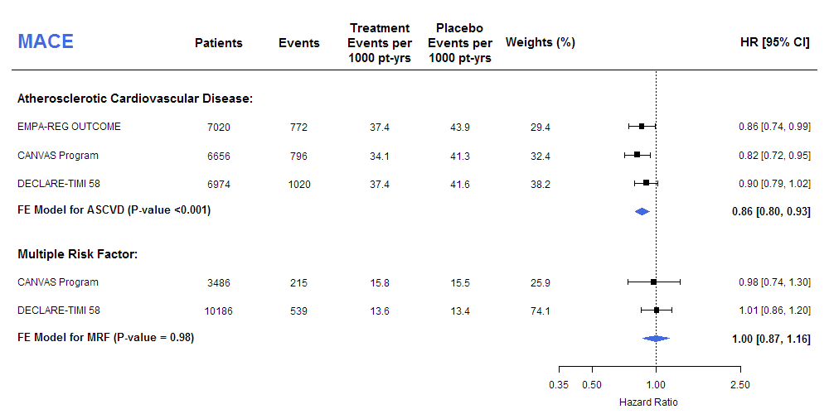

Figure 2: CV Death/HHF, Stratified by ASCVD vs MRF
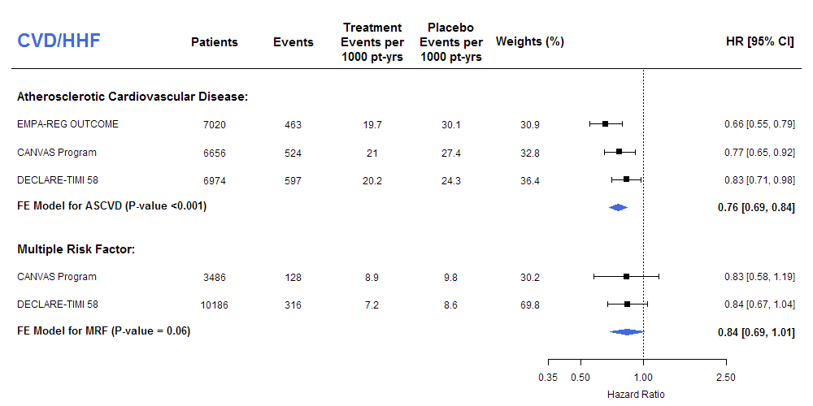

Figure 3: CV Death/HHF, Stratified by History of Heart Failure
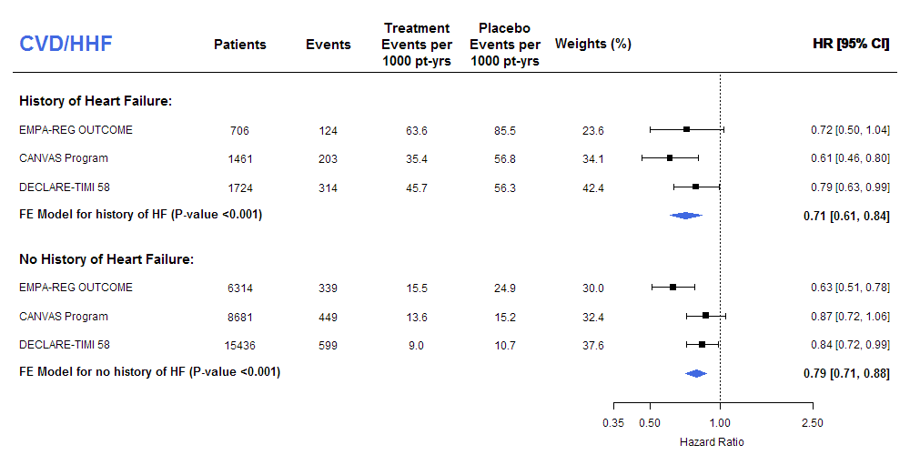

Figure 4: Progression of Renal Disease, Stratified by ASCVD vs MRF

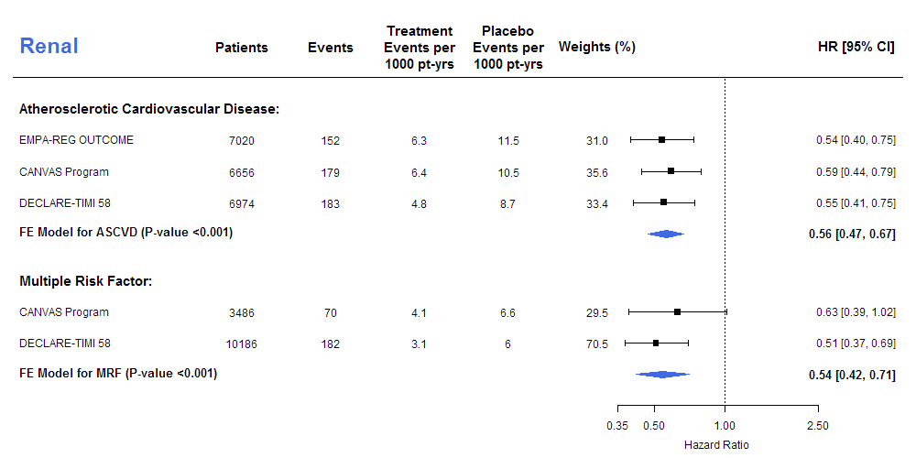

Figure 5A: Progression of Renal Disease, Stratified by Baseline Renal Function
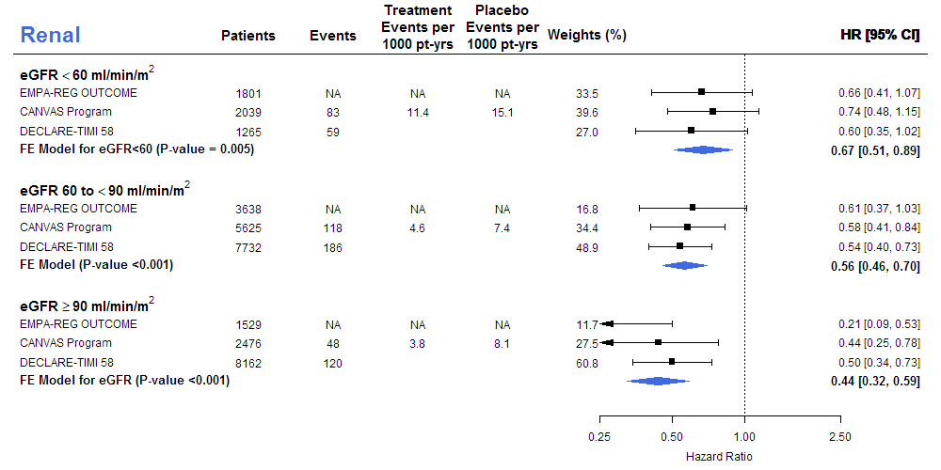

Figure 5B HHF, Stratified by Baseline Renal Function IR will be included
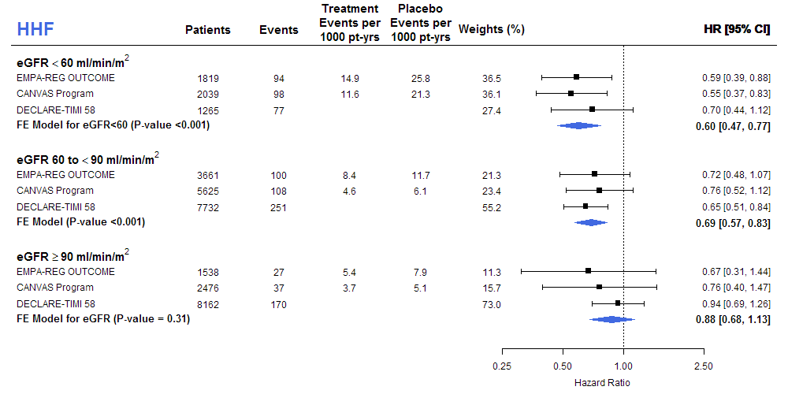

Figure 5C MACE, Stratified by Baseline Renal Function IR will be included
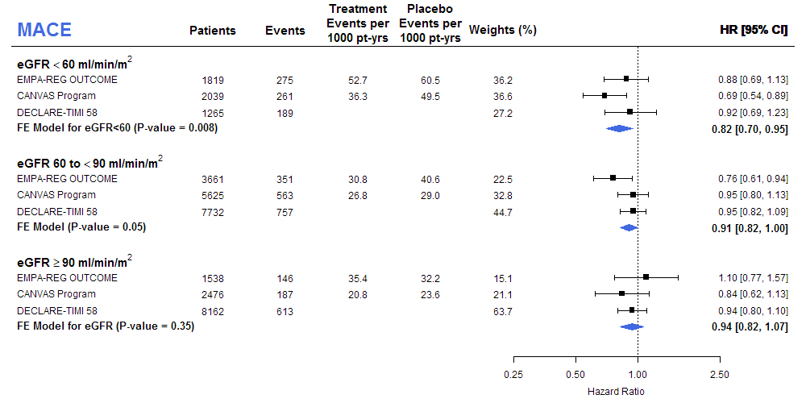

Appendix:
Search Algorithm: 33
Pubmed Search: 33
Embase Search: 33
Supplementary Methods: 34
Data Extraction Form 36
Risk of Bias Summary: 38
Table S1: Definition of Cardiovascular Disease and Multiple Risk Factors in the Included Trials 39
Table S2: Baseline Characteristics of Patients with established Cardiovascular Disease and MRF 41
Figure S1: PRISMA-P Flow Diagram: Study selection 42
Figure S2: Pooled data for the composite of myocardial infarction, stroke, and cardiovascular death (MACE) 43
Figure S3: Pooled data for myocardial infarction 44
Figure S4: Pooled data for cardiovascular death 45
Figure S5: Pooled data for stroke 46
Figure S6: Treatment effect on myocardial infarction stratified by presence or absence of established atherosclerotic cardiovascular disease 47
Figure S7: Treatment effect on cardiovascular death stratified by presence or absence of established atherosclerotic cardiovascular disease 48
Figure S8: Treatment effect on stroke stratified by presence or absence of atherosclerotic cardiovascular disease 49
Figure S9: Pooled data for composite of CV death and HHF 50
Figure S10: Pooled data for hospitalization for heart failure 51
Figure S11: Treatment effect on hospitalization for heart failure stratified by by presence or absence of atherosclerotic cardiovascular disease 52
Figure S12: Treatment effect on cardiovascular death stratified by history of heart failure 53
Figure S13: Treatment effect on hospitalization for heart failure stratified by history of heart failure 54
Figure S14: Pooled data for all-cause mortality. 55
Figure S15: Treatment effect on all-cause mortality stratified by presence or absence of atherosclerotic cardiovascular disease 56
Figure S16: Treatment effect on all-cause mortality stratified by history of heart failure 56
Figure S17: Pooled data for the composite of worsening of renal function, end-stage renal disease or renal death. 58
Figure S18: Risk of amputations 59

Search Algorithm:

Pubmed Search:
(“Diabetes Mellitus, Type 2”[Mesh] OR “diabetes mellitus type 2”[tiab] OR “type 2 diabetes mellitus”[tiab] OR “T2D*”[tiab]) AND ( “Empagliflozin”[tiab] OR “Dapagliflozin”[tiab] OR “Canagliflozin”[tiab] OR “ertugliflozin”[tiab]) AND (random*[tw] OR "Letter"[pt] OR “trial”[tiab]) AND (“Myocardial Infarction”[Mesh] OR “Myocardial Infarction” [tiab] OR “stroke”[Mesh] OR “stroke”[tiab] OR “death”[Mesh] OR “death”[tiab] OR “MACE”[tiab] OR “major adverse cardiovascular events”[tiab] OR “major adverse cardiac events”[tiab] OR “heart failure”[Mesh] OR “heart failure”[tiab]) NOT (Review[ptyp])

Embase Search:
('non insulin dependent diabetes mellitus'/exp OR T2DM:ab,ti) AND (empagliflozin:ab,ti OR Canagliflozin:ab,ti OR dapagliflozin:ab,ti OR ertugliflozin:ab,ti) AND (random*:ti,ab,de AND placebo:ab,ti) AND 'controlled study'/de AND ('heart infarction'/exp OR 'myocardial infarction':ab,ti OR 'cerebrovascular accident'/exp OR 'stroke':ab,ti OR 'death'/exp OR 'death':ab,ti OR 'major adverse cardiac event'/exp OR 'MACE':ab,ti OR 'major adverse cardiovascular event':ab,ti OR 'heart failure'/exp OR 'heart failure':ab,ti) NOT ('chapter'/it OR 'conference review'/it OR 'editorial'/it OR 'review'/it OR 'meta-analysis':ti)

Supplementary Methods:

The primary endpoint major adverse cardiovascular events (MACE) was the composite of myocardial infarction, stroke, and cardiovascular death. DECLARE-TIMI 58 used ischemic stroke for MACE, but for consistency with other trials, all stroke was used in this meta-analysis. For stroke and myocardial infarctions stratified by presence or absence of established atherosclerotic cardiovascular disease, only non-fatal events are reported in the CANVAS Program and as such included in the present meta-analysis. If event rates (per 1,000 patient years) were not available, they were estimated using event numbers and median follow-up time. If hazard ratios were not available, the relative risk ratio was used.
The renal composite outcomes were similar but differed slightly for each trial. For EMPA-REG Outcome the effect estimates for doubling of serum creatinine, initiation of renal replacement therapy, or death due to renal disease was used. In the CANVAS Program, sustained (measured ≥30 days apart) 40% reduction in the estimated glomerular filtration rate (according to the Modification of Diet in Renal Disease equation), the need for renal-replacement therapy, or death from renal causes was used. In DECLARE- TIMI 58, sustained (measured ≥30 days apart) 40% reduction in the estimated glomerular filtration rate (according to the CKD-EPI), end-stage renal disease, or death from renal causes was used. In terms of subgroups of baseline renal function by eGFR, EMPA-REG Outcome and the CANVAS Program used the Modification of Diet in Renal Disease equation, and DECLARE-TIMI 58 use the CKD-EPI equation (Levy et al 2009). Levels of GFR results were combined into the following three categories: <60, 60-90, ≥90 ml/min/1.73 m². If strata were reported in finer cuts, groups were combined by meta-analyzing them using fixed effects models. Estimates for EMPA-REG Outcome were derived from forest plots.

Risk of Bias Summary:

 | Random sequence generation (selection bias) | Allocation concealment (selection bias) | Blinding of participants and personnel (performance bias) | Blinding of outcome assessment (detection bias) (patient-reported outcomes) | Blinding of outcome assessment (detection bias) (Mortality) | Incomplete outcome data addressed (attrition bias) (Short-term outcomes (2-6 weeks)) | Incomplete outcome data addressed (attrition bias) (Longer-term outcomes (>6 weeks)) | Selective reporting (reporting bias)
EMPA-REG Outcome | Low | Low | Low | Low | Low | Low | Low | Low
CANVAS Program | Low | Low | Low | Low | Low | Low | Low | Low
DECLARE-TIMI 58 | Low | Low | Low | Low | Low | Low | Low | Low

Table S1: Definition of Cardiovascular Disease and Multiple Risk Factors in the Included Trials
Trial | Definition of Cardiovascular Disease | Definition of Multiple Risk Factor
EMPA-REG Outcome  Study Drug: Empagliflozin  Inclusion:  - ≥18 years  - HbA1c ≥7.0% and ≤10.0%  - BMI ≤45kg/m²  - eGFR ≥30 ml/min/1.72m²  - Presence of cardiovascular disease | Ischemic Heart Disease: MI (>2 months prior to informed consent), or  Multivessel CAD (50% stenosis in ≥2 major coronary arteries or the left main artery (i.e., previous revascularization ≥2 major coronary arteries or left main artery; or combination of revascularization in at least 1 main artery and 50% stenosis in 1 main coronary artery), OR  Single vessel CAD (50% stenosis in ≥1 main coronary artery and a positive stress test OR hospital discharge for unstable angina ≤12 months prior to consent), or  Unstable angina with evidence of single or multivessel CAD (>2 months prior to consent), OR  History of stroke (ischemic or hemorrhagic), OR  Peripheral artery disease prior revascularization, OR previous limb or foot amputation due to circulatory insufficiency; or angiographic evidence of significant (>50%) peripheral artery stenosis in at least one limb; or evidence from a non-invasive measurement of significant (>50% or as reported as hemodynamically significant) peripheral artery stenosis in at least one limb; or ankle brachial index of < 0.9 in at least one limb. | Not included
CANVAS Program  Study Drug: Canagliflozin  Inclusion:  - HbA1c ≥7.0% to ≤10.5% | Age ≥30 years with either:  - stroke;  - MI;  - hospital admission for unstable angina;  - coronary revascularization (CABG, PCI);  - peripheral revascularization (angioplasty or surgery);  - symptomatic with documented hemodynamically-significant carotid or peripheral vascular disease; or  - amputation secondary to vascular disease. | Age ≥50 years with ≥2 of the following risk factors:  - Duration of type 2 diabetes of 10 years or more,  - Systolic blood pressure >140 mmHg  - Current daily cigarette smoker,  - Documented microalbuminuria or macroalbuminuria,  - documented high-density lipoprotein (HDL) cholesterol of <1 mmol/l (<39 mg/dl).
DECLARE-TIMI 58  Study Drug: Dapagliflozin  - HbA1c ≥6.5% to <12% | Age ≥40 years with either:  Ischemic heart disease (any of the following): Documented Myocardial Infarction, Percutaneous Coronary Intervention, Coronary Artery Bypass Grafting, Objective Findings of Coronary Stenosis (> 50%) in at least 2 coronary artery territories (ie, left anterior descending, ramus intermedius, left circumflex, right  coronary artery) involving the main vessel, a major branch, or a bypass graft  Cerebrovascular disease (any of the following): Documented ischemic Stroke (known transient ischemic attack, primary intracerebral haemorrhage or sub-arachnoid hemorrhage do not qualify), Carotid stenting or endarterectomy  Peripheral Arterial Disease (any of the following): Peripheral arterial intervention, stenting or surgical revascularization, lower extremity amputation as a result of peripheral arterial obstructive disease, or Current symptoms of intermittent claudication AND ankle/brachial index < 0.90 documented within last 12 months | Age > 55 years in men and > 60 in women and presence of at least 1 of the following additional risk factors:  - Dyslipidemia (LDL-C>130 mg/dl)  - Hypertension (either systolic BP (> 140 mmHg) and elevated diastolic BP (> 90 mmHg) at enrollment or on anti-hypertensive therapy lowering  - Current Tobacco use (≥5 cigarettes per day)

Table S2: Baseline Characteristics of Patients with established Cardiovascular Disease and MRF
 | EMPA-REG Outcome²² |  | CANVAS Program^{21,25} |  | DECLARE-TIMI 58³⁷
Presence of Established Cardiovascular Disease: | Yes | No | Yes | No | Yes | No
Age (years) | 63.2 | - | 63.6 | 62.7 | 62.6 | 64.4
Female sex (%) | 28.5 | - | 30.9 | 45.2 | 28.0 | 43.9
HbA1c | 8.1 | - | 8.2 | 8.3 | 8.4 | 8.3
eGFR (ml/min/1.73m²) | 74.1 | - | 75.5 | 78.3 | 84.7 | 85.6
eGFR <60 ml/min/1.73m² (%) | 25.9 |  | 15.6 | 4.5 | 8.1 | 6.4
Myocardial infarction(%) | 46.4 | - | 44.1 | 0.5 | 51.4 | 0
Congestive heart failure (%) | 10.1 | - | 17.6 | 8.2 | 16.6 | 5.6
Stroke (%) | 23.3 |  | 19.1% | <0.01 | 15.9⁺ | 0
History of PAD (%) | 20.8 | - | NA | NA | 14.7 | 0
Smoking | NA | - | 14.1 | 24.8 | 14.9 | 14.4
Systolic Blood Pressure | 135.5 | - | 135.0 | 139.8 | 134.1 | 135.6
Antiplatelet or Anticoagulant Therapy (%) | 89.9 | - | 86.9 | 49.0 | NA | NA
Diuretics (%) | 43.2 | - | 44.2 | 44.4 | 40.8 | 40.6
Beta-Blockers (%) | 64.9 | - | 64.2 | 32.9 | 72.7 | 38.9
ACE-inhibitors or ARBs (%) | 80.7 | - | 79.8 | 80.5 | 82.3 | 80.7
Lipid-Lowering Therapy (%) | 81.0 | - | 81.1* | 63.2* | 86.9 | 66.9

*Statin therapy reported

Figure S1: PRISMA-P Flow Diagram: Study selection

Total citations identified (n=175)
PubMed: 59
EMBASE: 116
Screening
Included
Eligibility
Identification
Record abstracts screened (n=156)
Duplicates (n = 20)
Excluded (n = 147)
- No Cardiovascular Outcomes Trial or Not Contributory Secondary Secondary Analysis (n=109)
- Design Manuscripts (n=19)
- Commentary. Editorial, or Review (n=19)
Unique trials included (n = 3)
Contributory Secondary Analyses (n=6)
Key Search Terms:
(“Diabetes Mellitus, Type 2”) AND

("SGLT2 inhibitor" OR "Canagliflozin" OR "Dapagliflozin" OR “Empagliflozin” OR "Ertugliflozin") AND

("randomized controlled trial“) AND

(“myocardial infarction” OR “stroke” OR “death” OR “heart failure”)
DECLARE-TIMI 58 Trial

Figure S2: Pooled data for the composite of myocardial infarction, stroke, and cardiovascular death (MACE)

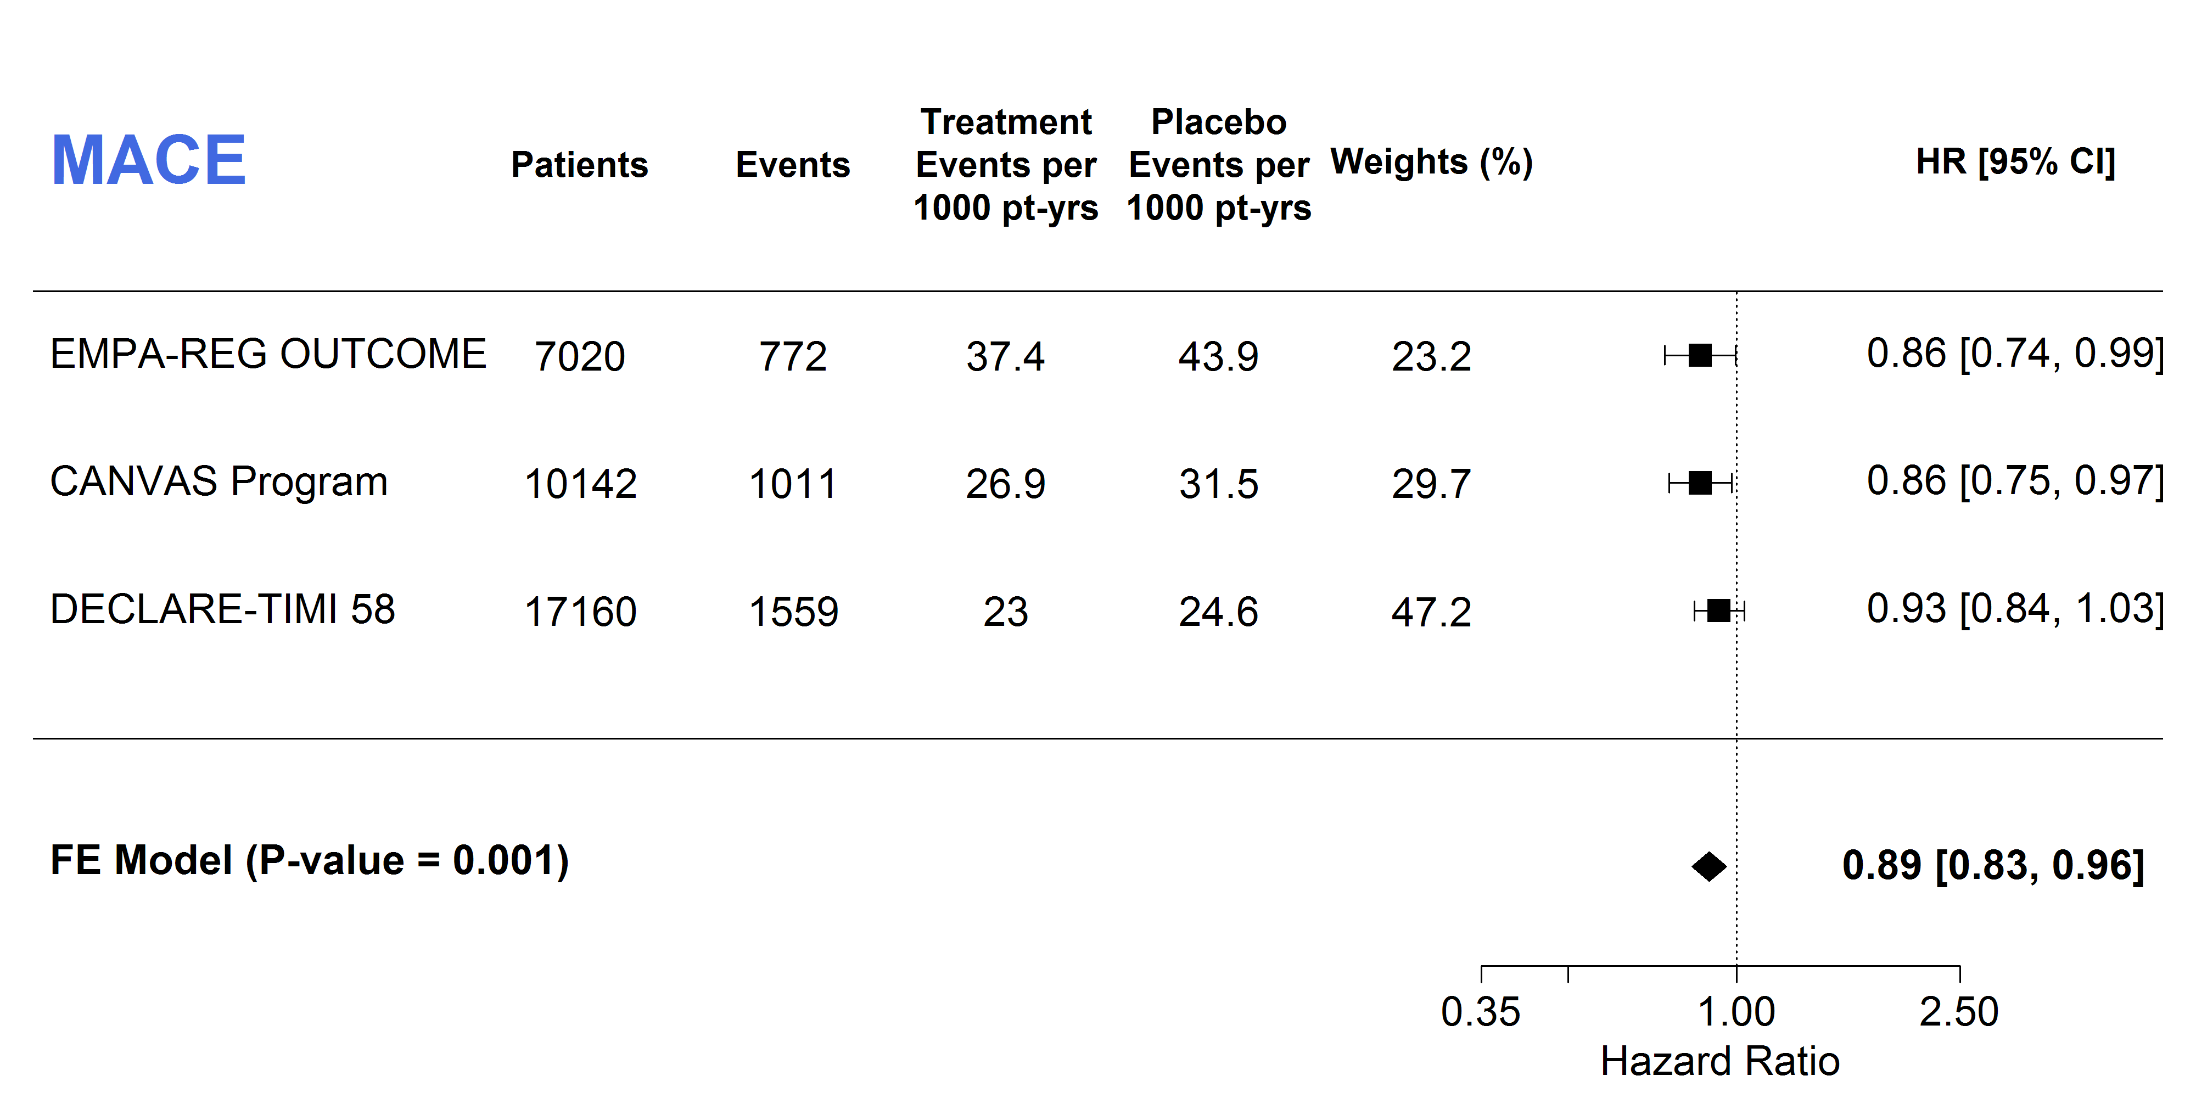
Q statistic = 1.20, p=0.55, I²= 0%

Figure S3: Pooled data for myocardial infarction

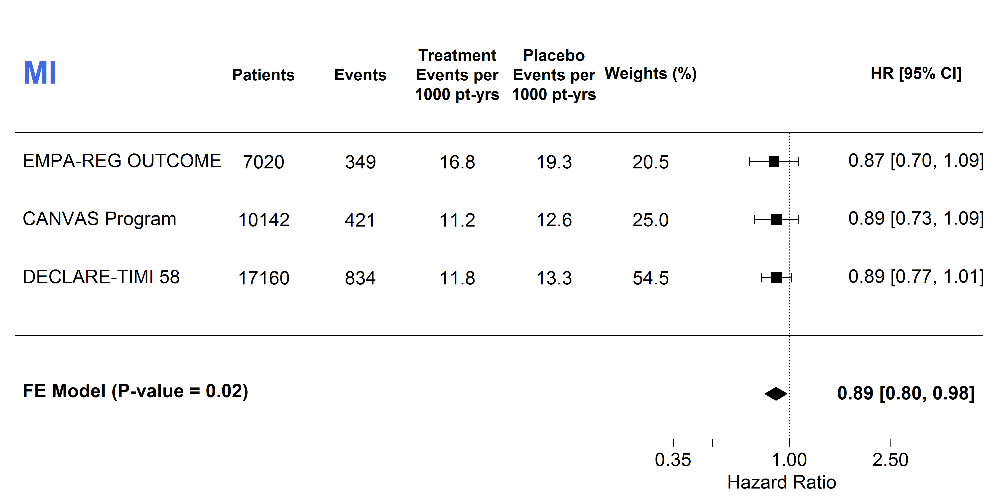
Q statistic = 0.03, p=0.98, I²= 0%

Figure S4: Pooled data for cardiovascular death
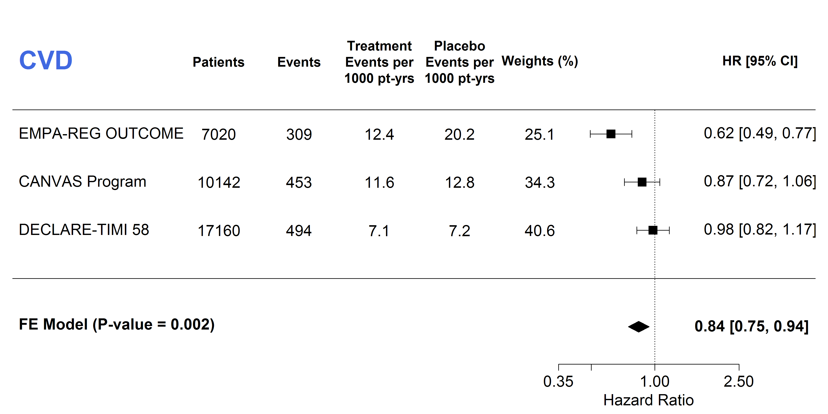
Q statistic = 9.95, p=0.01, I²= 79.9%

Figure S5: Pooled data for stroke
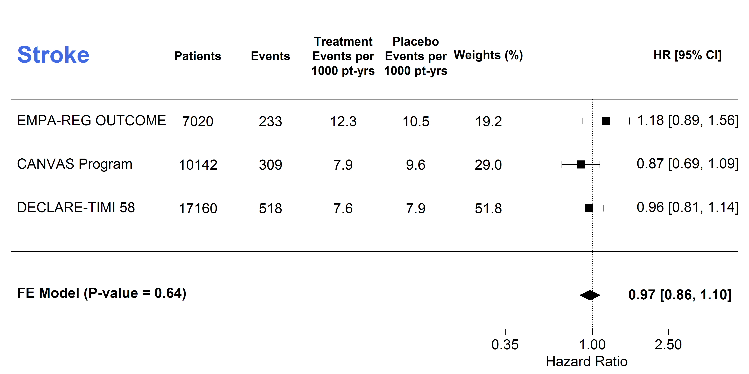
Q statistic = 2.76, p=0.25, I²= 27.5%

Figure S6: Treatment effect on myocardial infarction stratified by presence or absence of established atherosclerotic cardiovascular disease
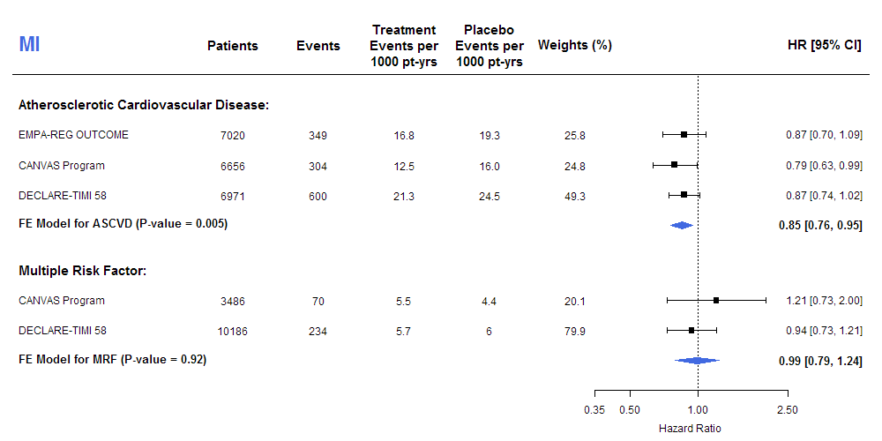 ASCVD: Q statistic = 0.53, p=0.77, I²= 0%; MRF: Q statistic = 0.77, p=0.38, I²= 0%. P-value for subgroup differences: 0.17

Figure S7: Treatment effect on cardiovascular death stratified by presence or absence of established atherosclerotic cardiovascular disease
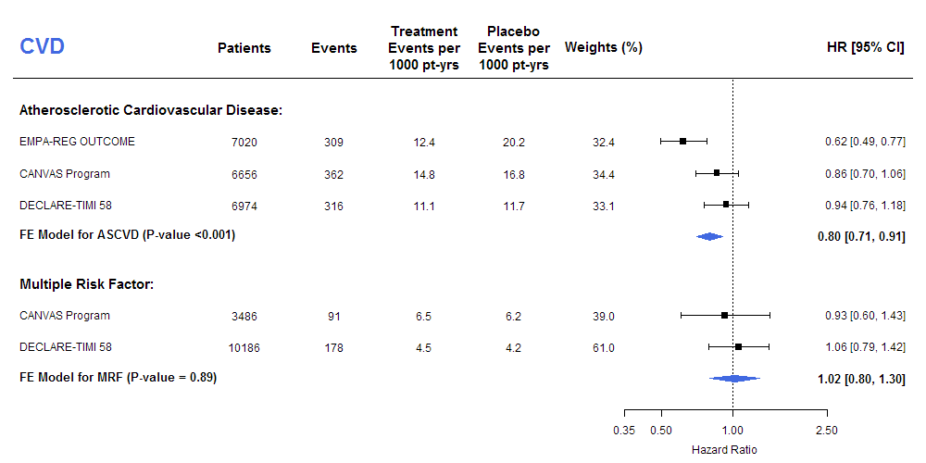
ASCVD: Q statistic = 7.42, p=0.02, I²= 73.0%; MRF: Q statistic = 0.24, p=0.62, I²= 0%. P-value for subgroup differences: 0.31

Figure S8: Treatment effect on stroke stratified by presence or absence of atherosclerotic cardiovascular disease

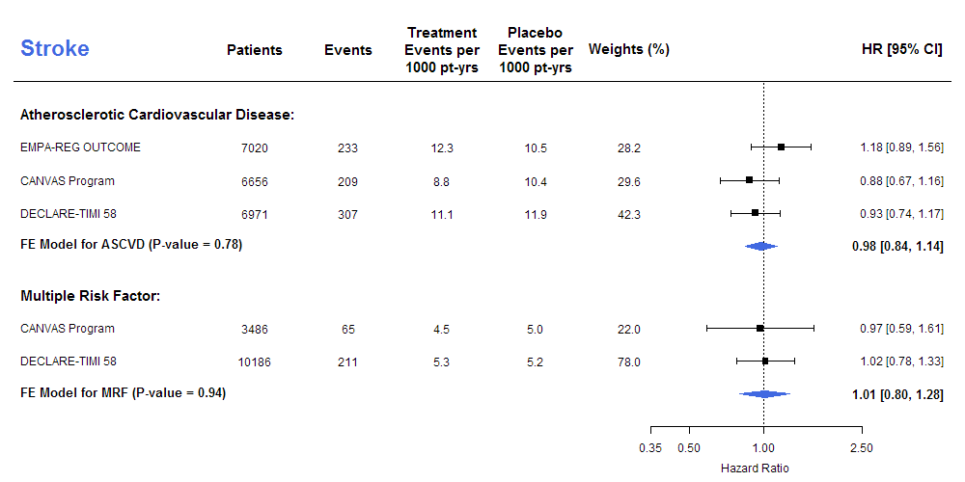
ASCVD: Q statistic = 2.47, p=0.29, I²= 19.2%; MRF: Q statistic = 0.03, p=0.86, ²= 0%. P-value for subgroup differences: 0.83

Figure S9: Pooled data for composite of CV death and HHF

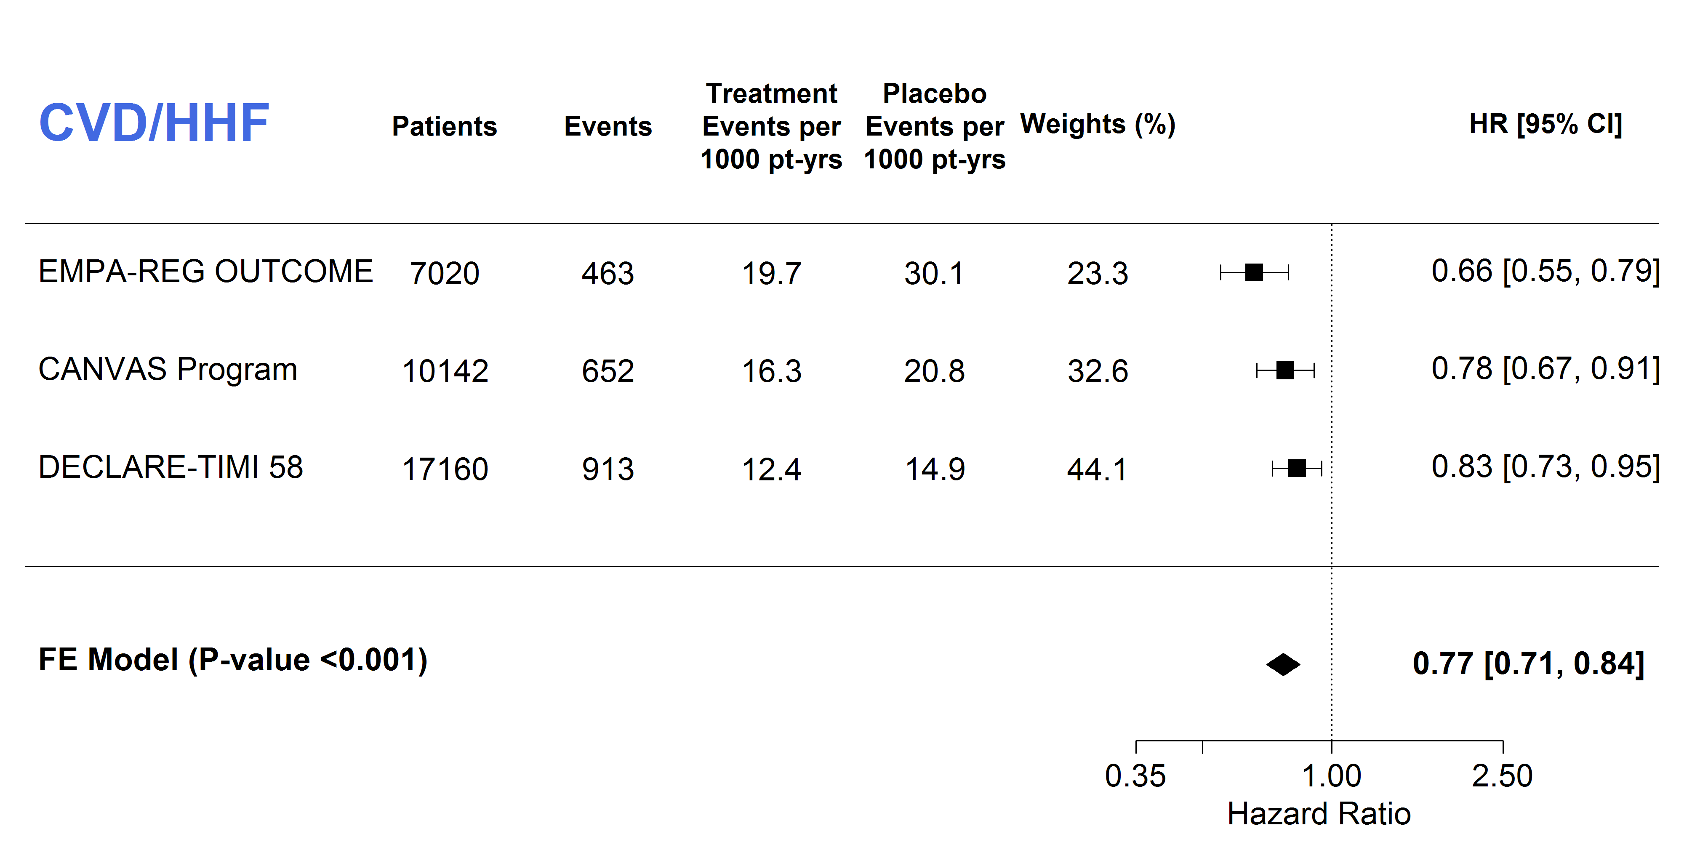
Q statistic = 4.06, p=0.13, I²= 50.7%

Figure S10: Pooled data for hospitalization for heart failure
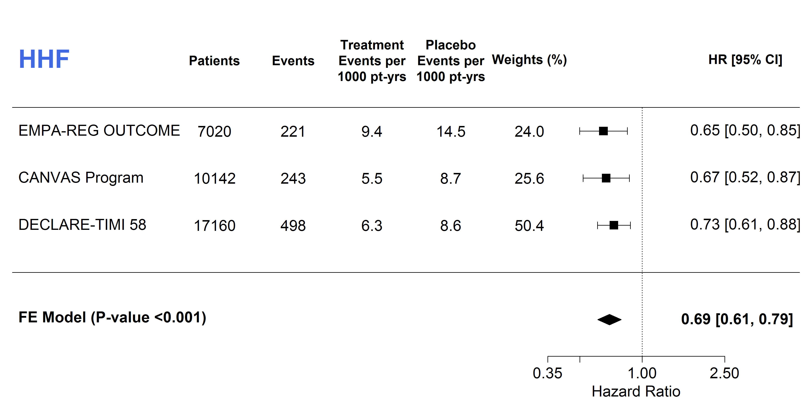
Q statistic = 0.60, p=0.74, I²= 0%

Figure S11: Treatment effect on hospitalization for heart failure stratified by presence or absence of atherosclerotic cardiovascular disease
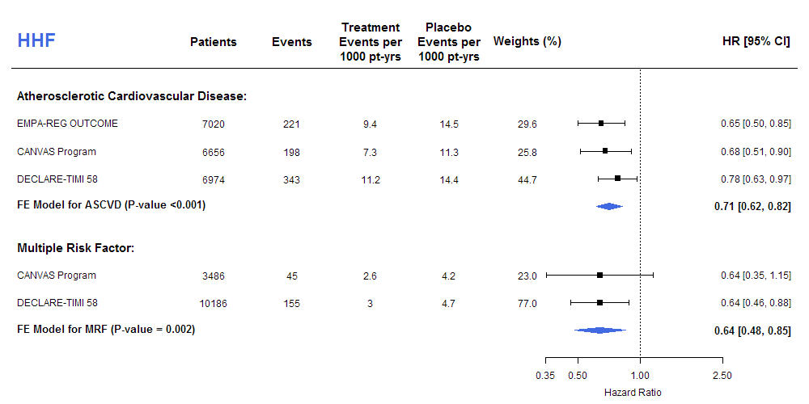
ASCVD: Q statistic = 1.24, p=0.54, I²= 0%; MRF: Q statistic = 0.00, p=1.00, I²= 0%. P-value for subgroup differences: 0.38.

Figure S12: Treatment effect on cardiovascular death stratified by history of heart failure
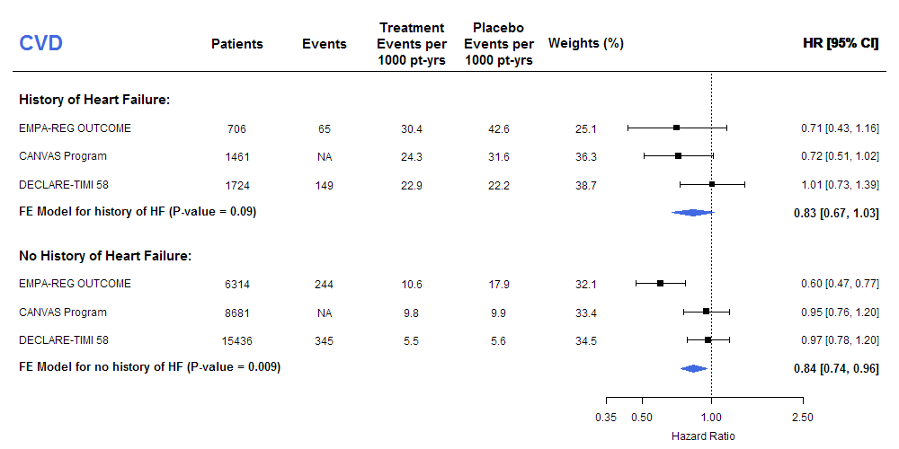
Prior HF: Q statistic = 2.45, p=0.29, I²= 18%
No HF: Q statistic = 9.97, p=0.01, I²= 80%
P-value for subgroup differences: 0.97

Figure S13: Treatment effect on hospitalization for heart failure stratified by history of heart failure
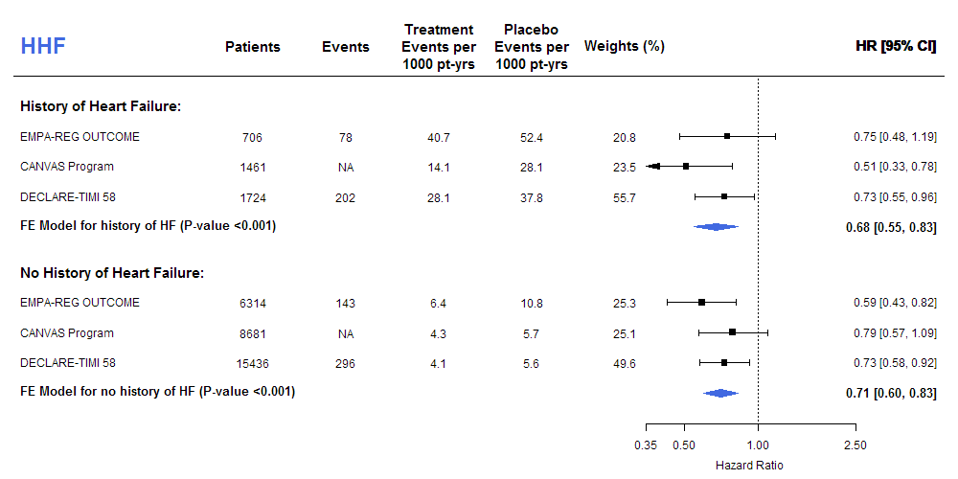
Prior HF: Q statistic = 2.14, p=0.34, I²= 6.6%
No HF: Q statistic = 1.73, p=0.42, I²= 0%
P-value for subgroup differences: 0.76

Figure S14: Pooled data for all-cause mortality.
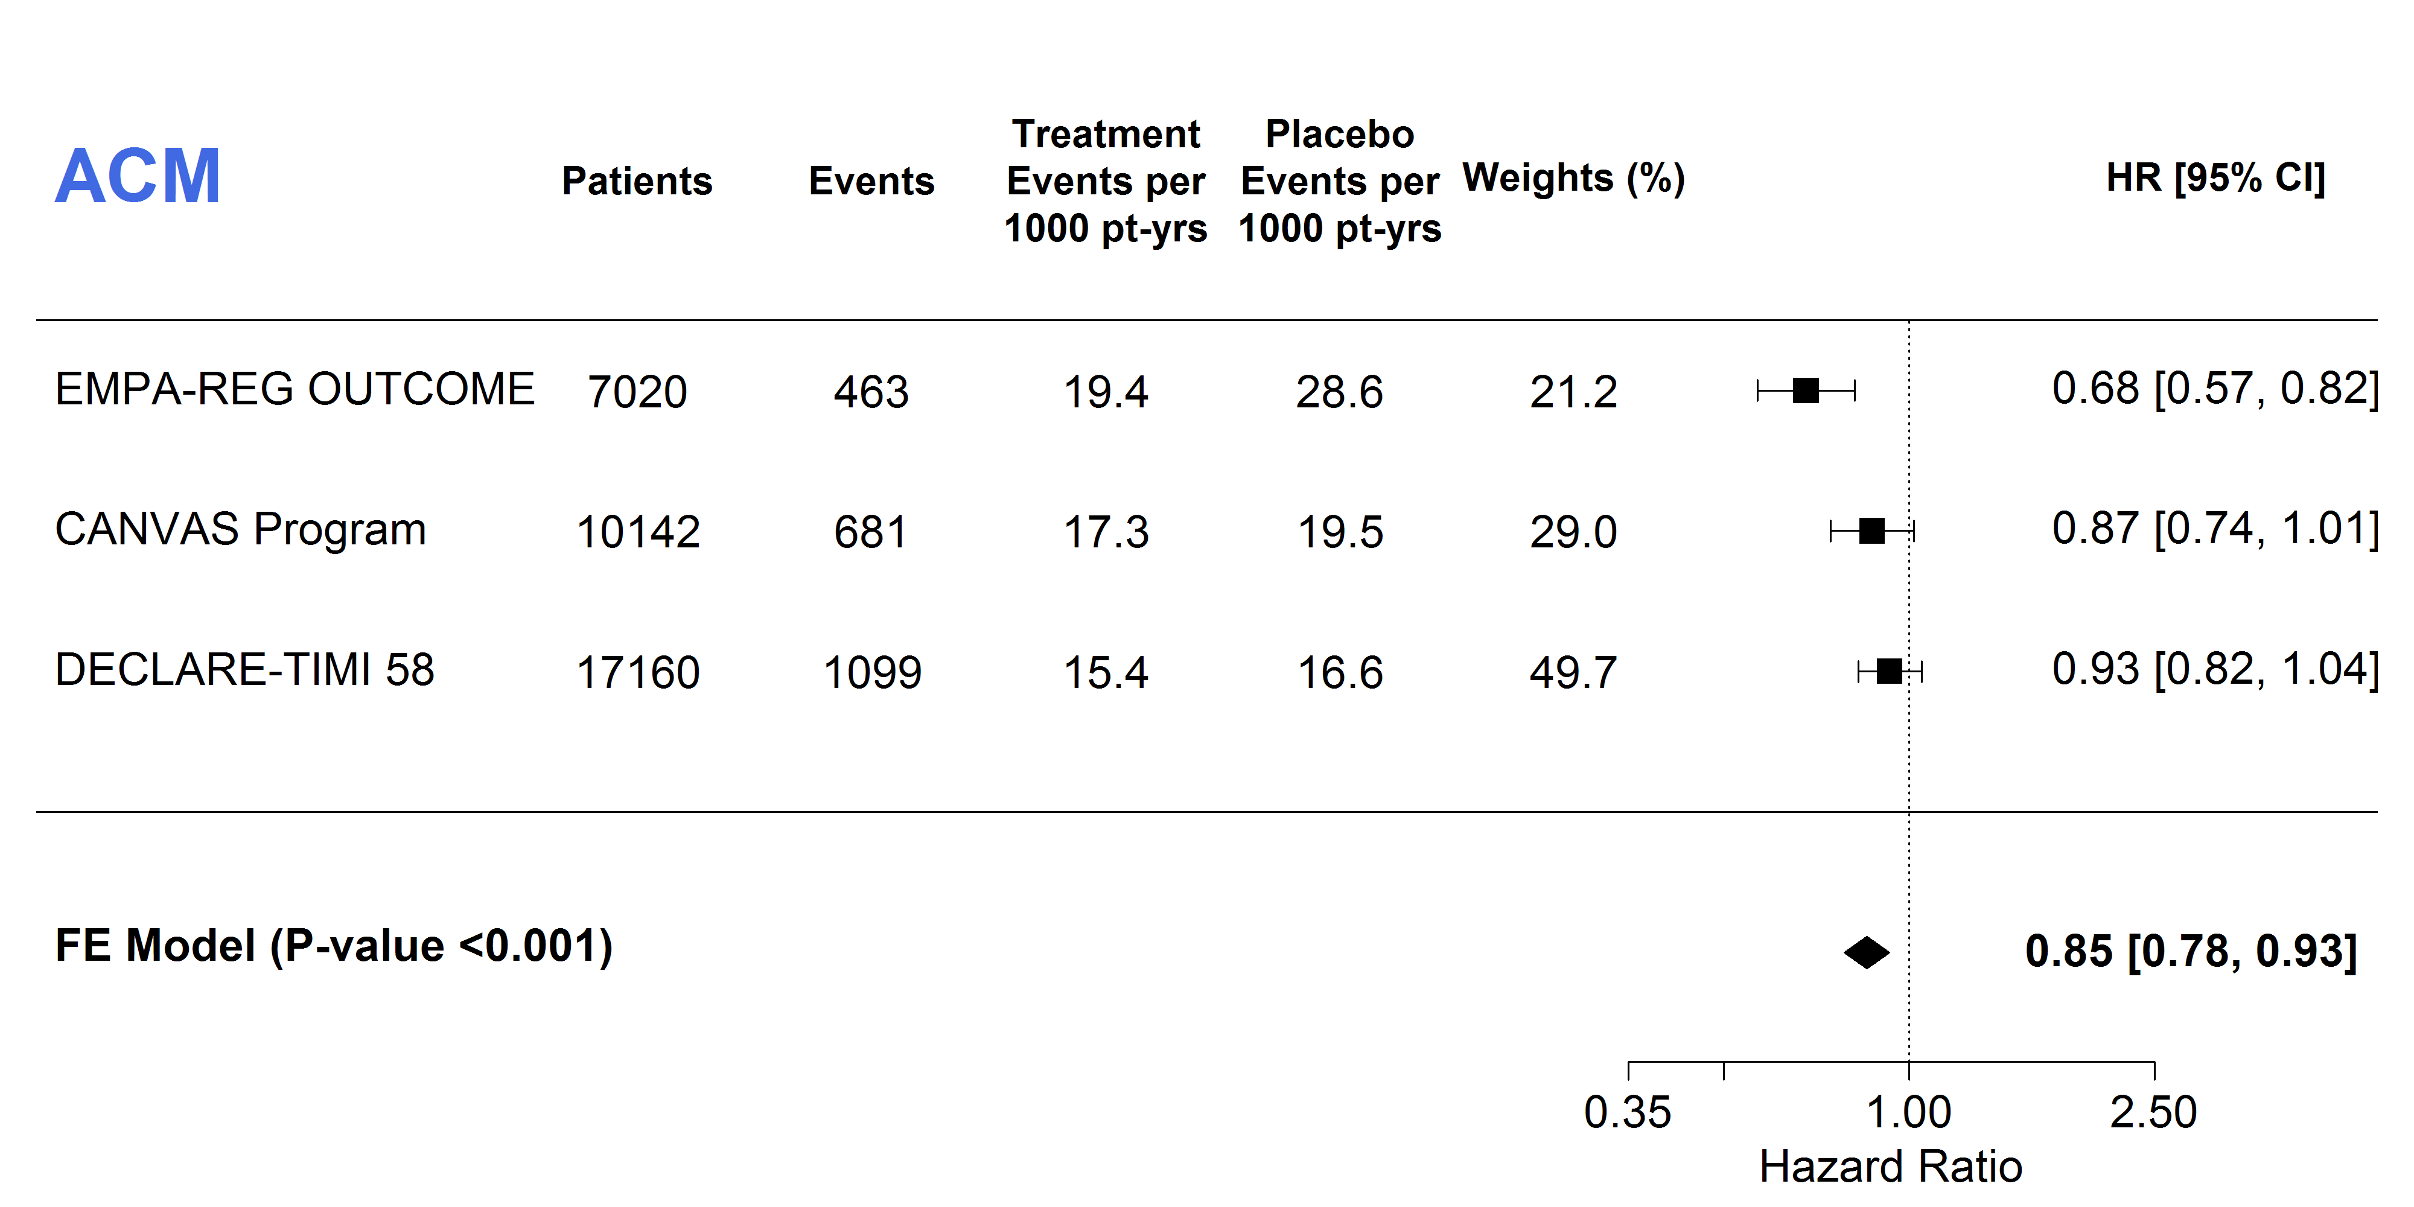
Q statistic = 8.06, p=0.02, I²= 75.2%

Figure S15: Treatment effect on all-cause mortality stratified by presence or absence of atherosclerotic cardiovascular disease
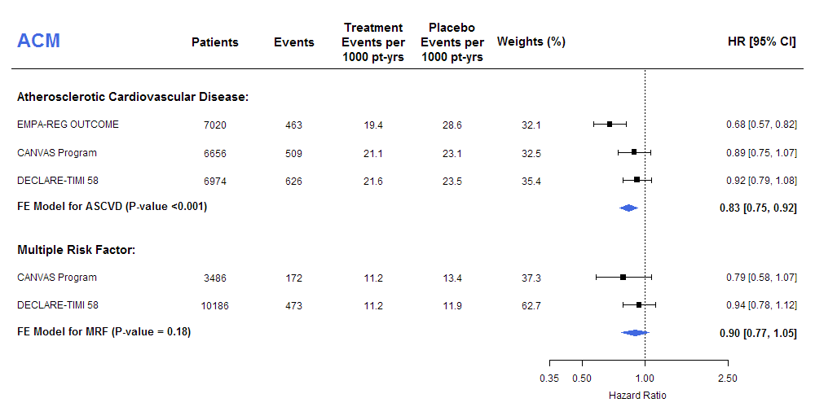
ASCVD: Q statistic = 6.87, p=0.03, I²= 70.9%; MRF: Q statistic = 0.92, p=0.34, I²= 0%. P-value for subgroup differences: 0.69

Figure S16: Treatment effect on all-cause mortality stratified by history of heart failure
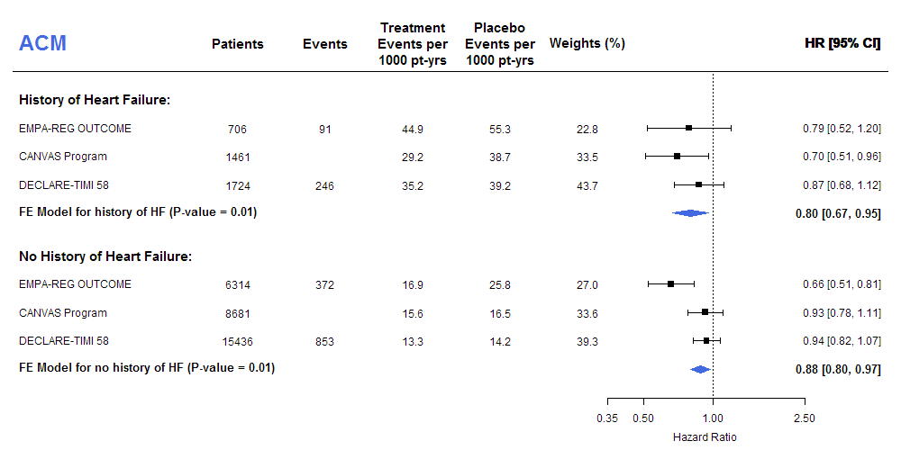
ASCVD: Q statistic = 1.12, p=0.0.57, I²= 0%; MRF: Q statistic = 7.26, p=0.03, I²= 72%. P-value for subgroup differences: 0.63

Figure S17: Pooled data for the composite of worsening of renal function, end-stage renal disease or renal death.
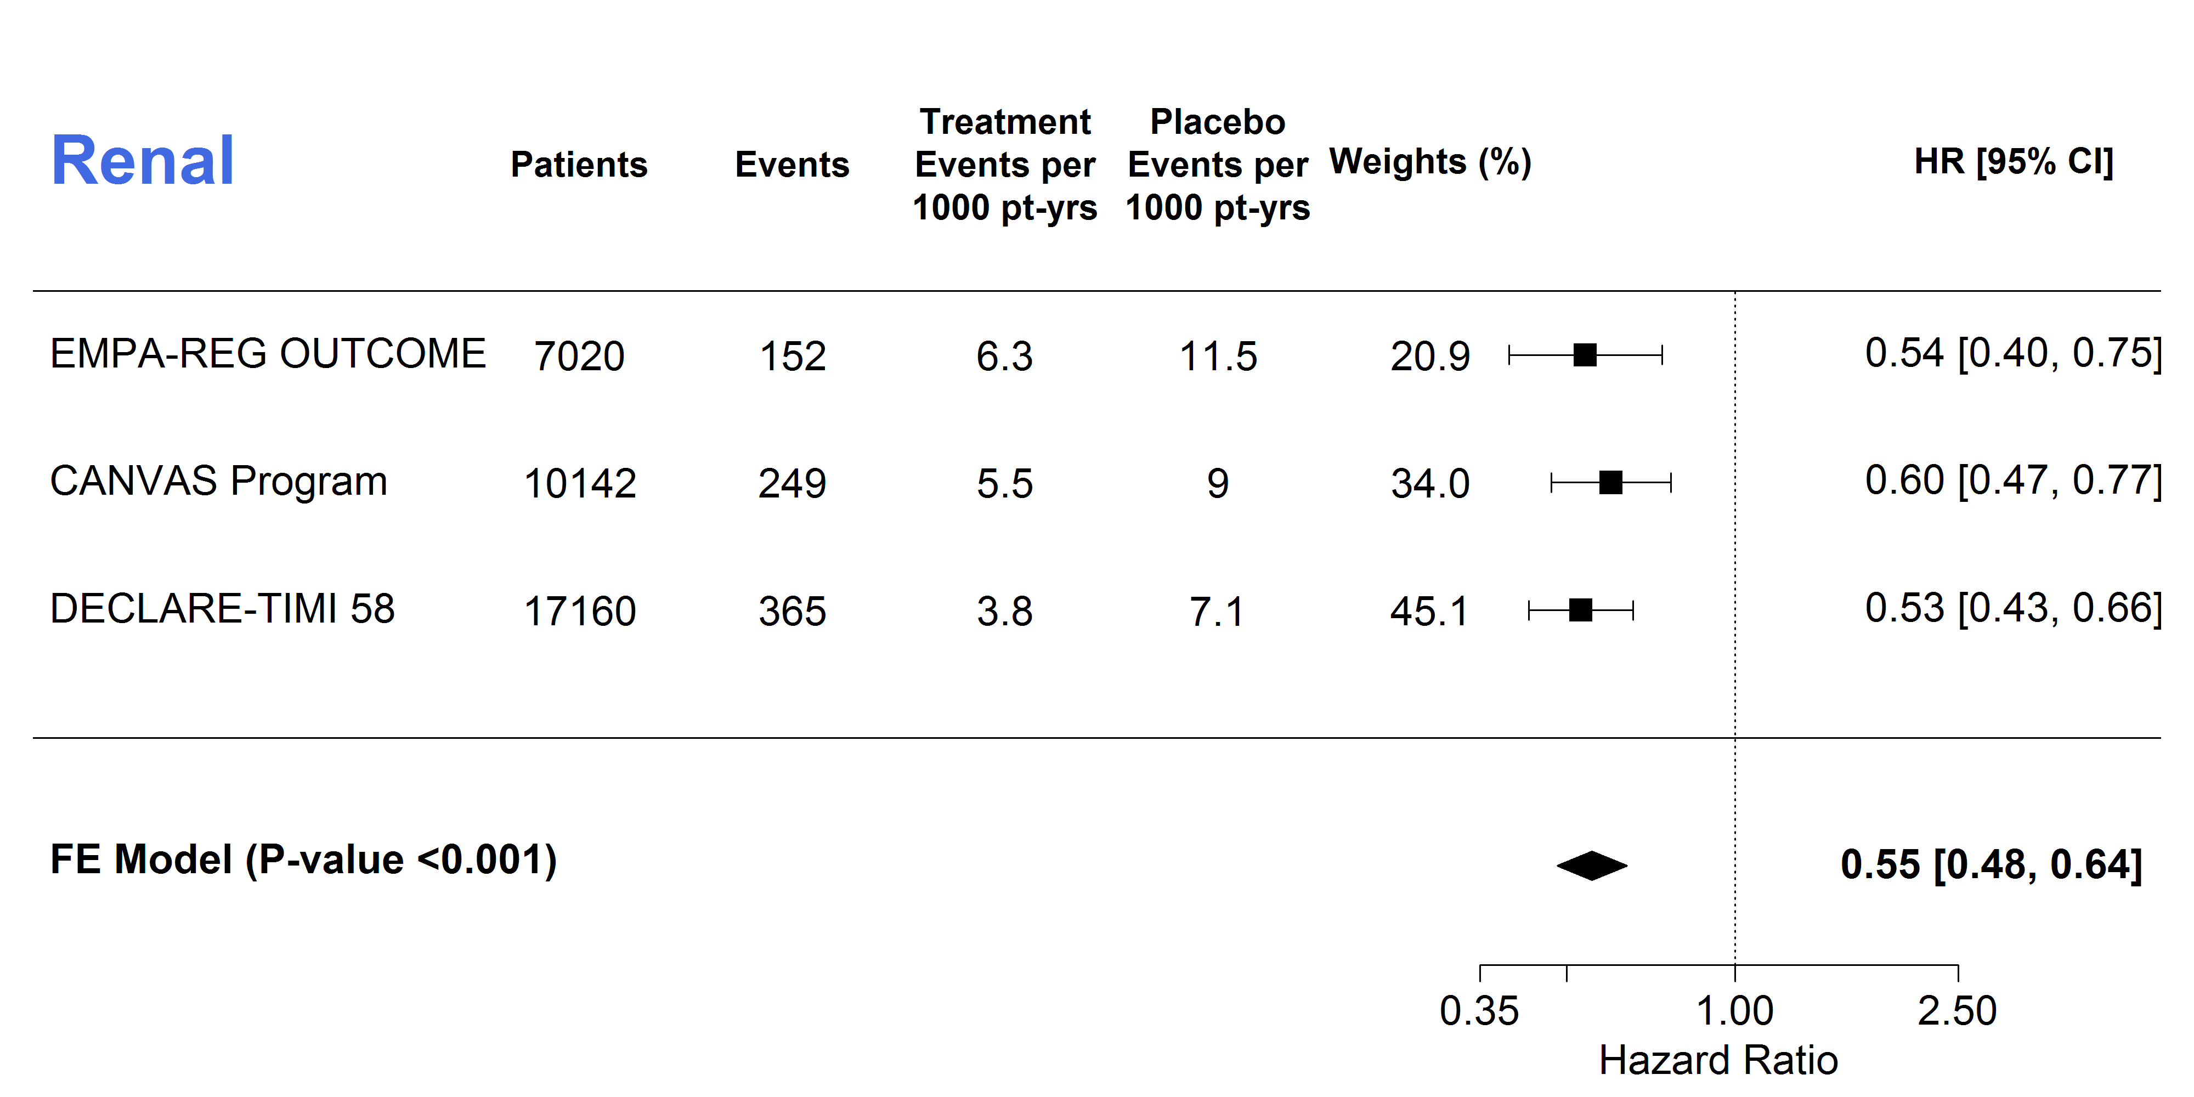
Q statistic = 0.59, p=0.74, I²= 0%

Figure S18: Risk of amputations
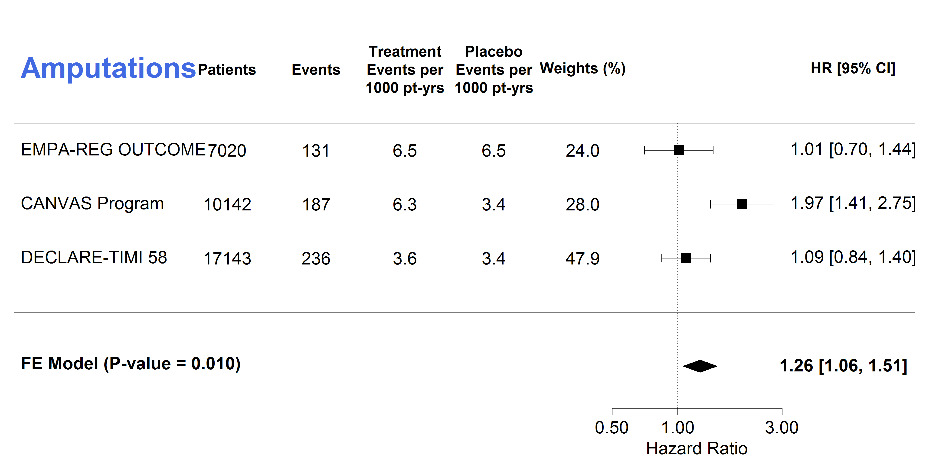
Q statistic = 9.56, p=0.01, I²= 79.1%

Figure S19: Risk of Fractures

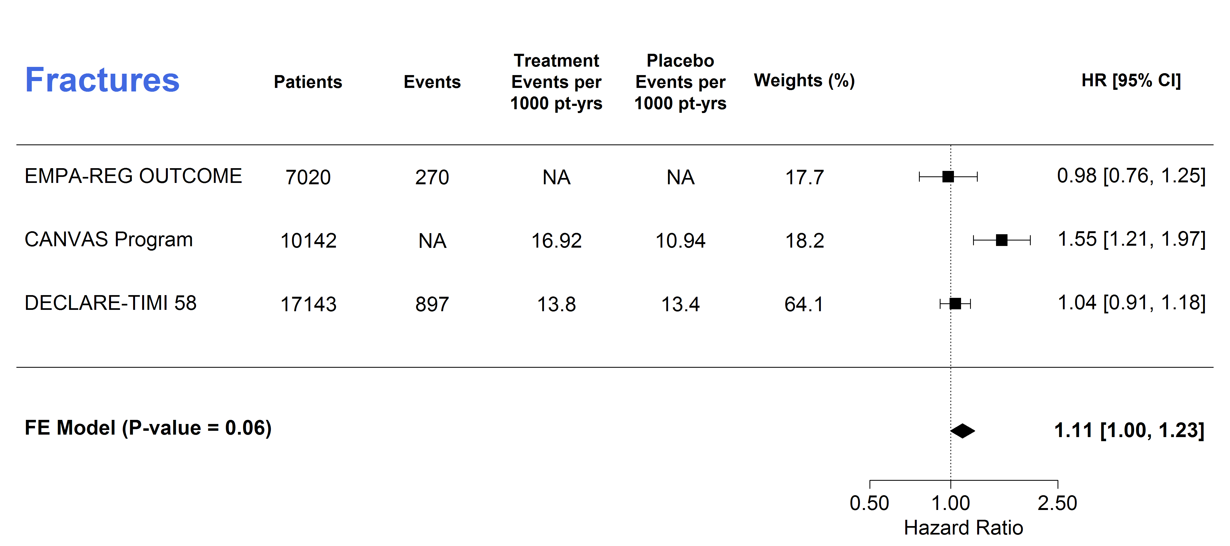
Q statistic = 9.16, p=0.01, I²= 78.2%

Figure S20: Risk of diabetic ketoacidosis
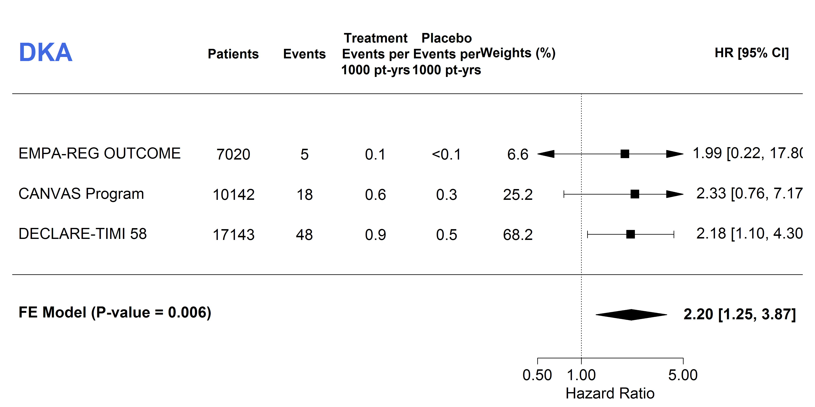
Q statistic = 0.02, p=0.99, I²= 0%

