They Preferred to Sit on the Floor:
Rock Music in South Wales at a Time of Industrial Change.

Historians are not alone in their attempts to recognise and define periods of accelerated and significant change, which retrospectively tend to be awarded the designation of ‘transitional’. This does not inhibit argument and debate about the defining characteristics of such phases, but a broad consensus usually exists about their reality and distinctiveness. The 1960s in Britain conforms to most peoples’ understanding of the term, which in some contexts has gained the sobriquet ‘Swinging Sixties’. The latter does less than justice to the immense changes which the decade encapsulated. All spheres of life – economic, political, social and cultural – were profoundly affected. Although London was the epicentre, the major trends made a deep impression in all corners of the realm. (Jones 2004: 85)
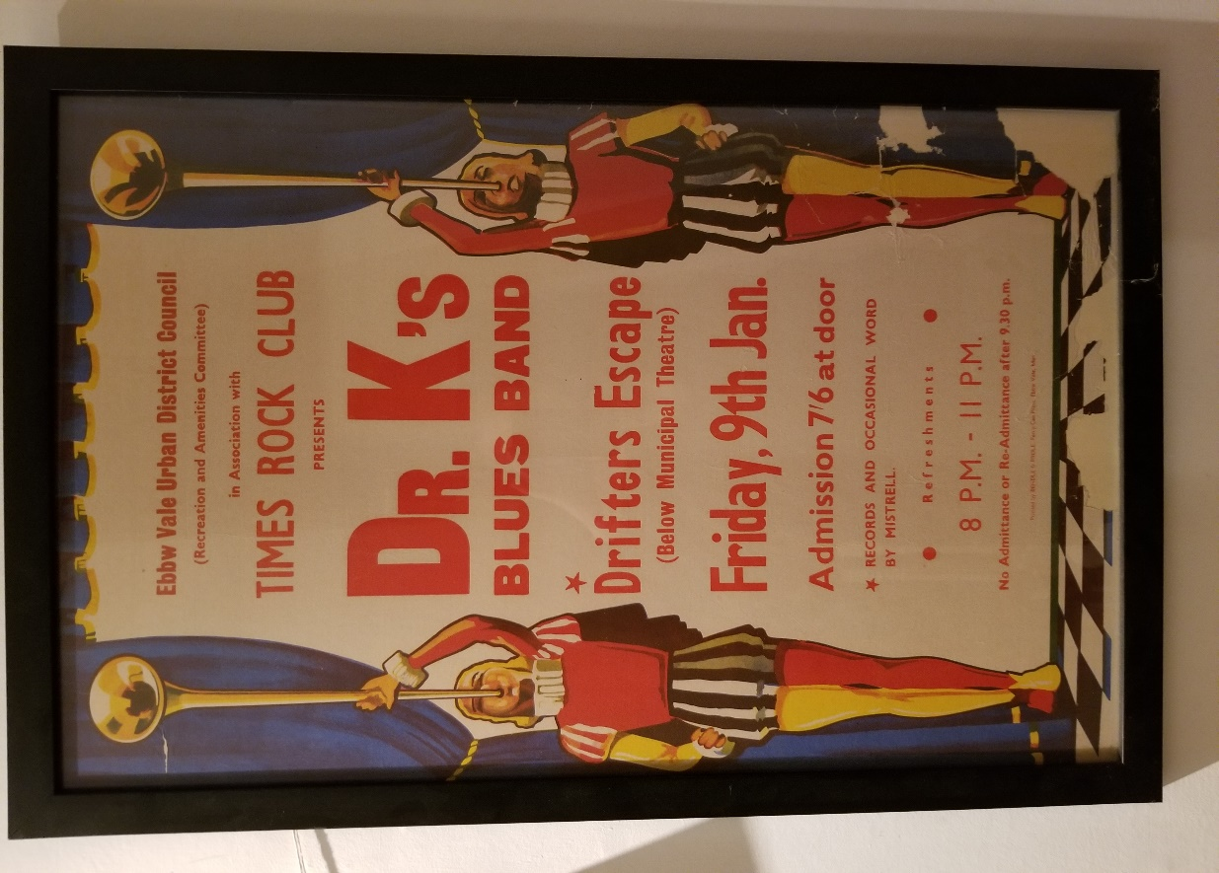
Introduction
An account of the rise and fall of a short-lived, obscure but highly-successful rock venue in Ebbw Vale, south Wales, is an exercise in extreme contrasts. The venue functioned between December 1969 and November 1970. Working from local council minutes, contemporary newspaper reports, memorabilia and participant interviews, what can be argued to have shaped the experience of the Drifter’s Escape is a ‘grinding’ of social and political ‘gears’ that it would be misleading to reduce to commonplace conflict between generations. Rather, there is enough evidence to suggest that what was at stake in this microcosmic event, was conflict between declining and emerging social structures and their allied cultural patterns. In this, the Drifter’s Escape was, simultaneously, an arena for, and evidence of, the transition to which Jones refers. Further, unpacking the brief life of the Drifter’s Escape conveys a sense of how formidable was the momentum of the ‘accelerated and significant change’ which he identifies. In all of this, what is recognised is that even when ‘change’ is ‘immense’ it is rarely accomplished in a single episode. Rather, what this predominantly conflictual encounter can be argued to uncover are lines of strain in a status quo unequipped to respond to a new order of challenges to its authority.
Ebbw Vale was defined by its place in industrialisation. The town existed because the area in which it became located enjoyed two sets of resources, not only coal but also the key ingredients for iron and then steel production. Iron working began towards the end of the 18th Century but it was not until almost a hundred years later that the town took on civic status in the form of Ebbw Vale Urban District Council (EVUDC). As later remarks explore, EVUDC was effectively a nexus of power and authority in the town, one that united inter-connecting networks of seniority. It was the EVUDC which opened and closed the Drifter’s Escape, and both actions can be read as ones that failed to comprehend ‘major trends’ that were reaching into and transforming ‘all corners of the realm’.
The clashes that marked and marred an initially-productive relationship between a town council and two over-lapping sets of young people in that town are significant for the way they reveal two different sets of cultural resources, one that had grown from the social and political struggles of the 19th and early-20th centuries and another newly-emergent one that drew its strength and inspiration from a rapidly internationalising popular culture. The Drifter’s Escape had been initiated to meet a short-fall in council provision for young people in the town. Ungenerously, the initiative could be represented as an entirely pragmatic one; certainly, and as it transpired, it was short-sighted in its conception. It was ‘short-sighted’ because those who proposed handing over a council-owned venue to young people did so in the absence of an awareness of the scale, and more importantly nature, of the cultural and social changes that had seen their own efforts to entertain young people founder.
At heart, what became the Drifter’s Escape was an act of good faith; the pity of this act of good faith was that, when the experiment soured (at least from the perspective of the EVUDC), its own lack of preparation became instantly transmuted into the bad faith of the young people whom they had empowered. Nothing captures this transmutation more powerfully than an anonymous letter to a local newspaper:
A popular teenage dance night in Ebbw Vale will be discontinued because of ‘disgusting behaviour’ and vandalism. The town’s recreation committee decided last night to suspend the weekly “Drifter’s Escape” dance at the Municipal ballroom in Beaufort. Mr Brian Scully, who was present at the last dance held there, told the meeting, “I was shocked by what I saw. The moral standards were completely foreign to anything I have experienced. There was fighting, and things being taken, and I was told by officers that it was a mild night”… Mr Ray Williams said the scene at the dance “could have been a back street in Cairo”. (Gwent Gazette, 5 November 1970, 5).
We will need to return to the strong indignation that drives these remarks; it is by unpacking it that we access its sub-text, a sense of ‘dignity’ that this litany of ‘disgusting behaviour’ so offends, in this, what counts is who was offended, by what and why.
A Teenage Dance Night
The Drifter’s Escape was the name given to Beaufort Ballroom by a collection of teenagers drawn into promoting rock and folk gigs at that venue. This opportunity was initiated by a decision taken by EVUDC at the June 1969 meeting of its Recreation and Amenities Committee (council minutes: June 11 1969 10/34 ii). The Beaufort Municipal Theatre and Ballroom began its existence as the Electric Theatre in 1914. As Valley towns are invariably steep, the building was a two-storey one on two levels with two distinct entrances: an upper entrance, at the front, at street level to a theatre, and a lower entrance at the rear to a separate venue (initially a billiard hall). The upper venue sat 600 people and was intended as a cinema but with a deep stage, proscenium arch and orchestra pit for up to fifteen players it enjoyed the potential to stage plays and musical events. It and the billiard hall beneath were connected by an internal staircase for the use of members of staff. As it transpired, the cinema struggled while the billiard hall prospered, where both phenomena can be attributed to the hardships associated with the economic turbulence that marked the two decades following World War One, followed by the onset of World War Two. As a local historian has written,
The theatre was bought by the council in March 1952, and while some members wanted it demolished, the council decided to keep it until money was available for its development. Government legislation later made it possible to spend the product of a penny rate on cultural schemes. The Theatre was one of the first schemes to be approved. In 1960, it became the Municipal Theatre and Ballroom. (Thomas 2000: 48)
The decision to take over the building in 1952 led to a costly refurbishment. Central to this was the conversion of the billiard hall into a ballroom. The ballroom came complete with sprung floor, mirrored walls and mirror-ball lighting. On its opening as a ballroom, the former billiard hall had hosted a demonstration by world-champion ballroom dancers, Harry Smith-Hampshire and Doreen Casey. The appearance of such prestigious performers was intended to launch the Municipal Ballroom as a notable and up-to-date venue. To this end, ‘Old-Time’ dancing was held on a Monday, ‘Modern’ on a Tuesday, with both styles featuring on a Saturday evening. More anomalous, however well-intentioned, was what was referred to as ‘The Teenagers’ Dance’. The idea that this could somehow be slotted in on a Wednesday night indicates a degree of unworldliness on the part of the council which was evident in the later episode of the Drifter’s Escape – Wednesday was a school night; the weekend was when teenagers would be seeking entertainment.
Even with four nights of ballroom dancing involving a range of dance styles, attendances became increasingly poor – towards the end of the 1960s the average attendance had dwindled to such an extent that the Treasurer and Accountant recommended ‘that both functions be discontinued July, Aug, Dec, Jan, Feb. (when attendance) dips from 50-27 in these months’. (30/1/70 Annual Report of Treasurer and Accountant). As that particular annual report shows, Beaufort Ballroom as a ballroom dancing venue had reached the end of its active life by 1969. So it was that when the Recreation and Amenities Committee came to reconsider the ‘Wednesday teenagers dance’ (June 11, 1969 10/34 ii) it took the bold decision to seek the advice of a group of actual teenagers in creating a replacement. To this end, councillors initiated discussions over several months with the organisers of the town’s Folk Club and with others connected to one of the town’s rock bands. Ultimately, the Committee took the bold step of handing over the Ballroom to what became called a ‘Folk Committee’ and a ‘Rock Committee’ for folk and rock gigs on alternate Friday evenings. The process was represented in the local press in the following way:
It was … reported that a teenagers’ dance on Wednesday night had attracted attendances of only eleven to 37 people. The entertainments clerk … reported that the committee chairman (of the Recreation and Amenities committee) and vice-chairman had met … a folk dance club to try to find out what they wanted in the way of a dance. … They wanted a group night one week and a folk night on alternate weeks. No chairs were needed in the ballroom … they preferred to sit on the floor. The ballroom they felt was too bright and clean; they suggested that hessian be draped over the wall mirrors. The chairman said “these young people don’t see the world as we see it. They’ve got their own ideas and I suggest we let them have a go”. The committee agreed that arrangements proceed for group and folk nights at the ballroom. (South Wales Argus, 4 December 1969, 15).
They Preferred to sit on the Floor
The nub of the problem that surfaced quite quickly for EVUDC is captured in the recognition that, at this new version of ‘The Teenagers’ Dance’, dancing would be optional rather than obligatory. The young people most prominent in music-making in the town were those who had become caught up the later incarnations of the folk revival and its inter-connection with the rise of rock music after 1965. The fashion for sitting on the floor was a new one; one derived directly from the idea that folk music and then rock music were experiences that demanded collective and concentrated attention. The extent to which this had been digested or could have been articulated by the various organisers at the time is moot, but as one expressed it to me in an interview,
It was a bit ahead of its time, the whole concept … more cosmopolitan than the valleys had ever imagined.
The use of the term ‘cosmopolitan’ is instructive here, the ready antonyms for it are ‘insular’ and ‘parochial’ and there is much insularity and parochialism evident in how the end of the venue was announced in the local press in a letter from someone styling himself ‘Townsman’:
Today it appears, plenty of energy is left over … for some youngsters to engage in repulsive behaviour in the permissive society in our land, and this ugly modern mode has seeped into Ebbw Vale (…) With heads enveloped in golliwog bushes or apostle-styles many people prefer dirty jeans and silly coats … This Drifter’s Escape, as a result also of immoral conduct, is now discontinued … until another means of more becoming entertainment is embarked upon. (Gwent Gazette, 12 November 1970, 2).
There is an undercurrent of pathos in the formulation of the responses to the beginning and the end of the Drifter’s Escape: the supportive if bewildered terms of ‘these young people don’t see the world as we see it’ and ‘I suggest we let them have a go’ when set against the deeply-reactionary and intolerant ‘a back street in Cairo’, and ‘golliwog bushes’. Even so, discursively, these are two ends of the same spectrum. Essentially, the town elders, collected as these were as EVUDC, came from another, earlier epoch and one ‘held over’ as it were from the Edwardian era in face of the need to survive the decades of hardship that had followed the First World War. This idea will be explored further in this discussion, here it is worth reflecting that a phrase such as ‘more becoming entertainment’ was an archaic one even fifty years ago, but it is the expressions ‘permissive society in our land’ and the ‘seep(ing)’ (as poison or raw sewage might) of an ‘ugly modern mode’ that indicate how isolated was EVUDC from political, social, economic and cultural processes that had already begun to change the fabric of the community they led. And because they were isolated, they had no effective response to the ‘knocking’ of such processes at the door of their authority – in both the formal and informal senses of that term.
Municipalism and Local Authority
Ebbw Vale Urban District Council was established under the provisions of the Local Government Act 1894. John (2014: 689) makes the point that,
Textbooks on English local government often begin with an account of the 1835 Municipal Corporations Act (for example, Chandler 2007), which set up the system of local committees and created the legal person of the local authority (Keith-Lucas 1980).
Wollman (2010: 643) makes this broad overview resonate more closely with EVUDC when he explains,
It was through the secular reforms of 1888 and 1894 … that the territorial basis of England’s modern two-tier local government structure was put in place that persisted until the 1970s. The local councils exercised their political and administrative functions through ‘government by committees’ over a broad range of responsibilities which were financed almost entirely through a locally levied property tax (‘the rates’).
The trouble with the dry approach of specialists in constitutional politics is that, notably when dealing with the industrial regions of the UK, and especially when dealing with the wholesale transformation of south Wales from the 1780s onwards, what is lost is the enormity of the ongoing struggles of people drawn together in brutal working and living conditions under a harsh climate in an exposed upland region. More, they omit what it took for a vast host of incoming labourers from within Wales, from its bordering English counties, and sometimes from far beyond to come together, to become a cohesive political grouping in order to improve and defend what were always precarious livelihoods. Williams (1985: 173) conveys the scale of this challenge in When Was Wales?
There were something over half a million people in Wales in the middle of the eighteenth century … From the 1780s as iron strikes its roots into the east, the increase becomes cumulative. During the first half of the nineteenth century, it is breakneck. By 1921 … there were 2,600,00 people in Wales. Over little more than four generations the population had nearly quintupled.
Central to this enormous influx of population, and to its growth, was coal; as Curtis (2011:577) identifies,
Looking back from the early years of the twenty- first century, it seems difficult to imagine now just how central the coal industry was to the shaping of modern south Wales. This period saw the zenith of the south Wales coalfield’s economic power, with its peak production figure of 57 million tons being reached in 1913. By this time, there were over 234,000 miners in south Wales, employed at hundreds of pits across the coalfield. South Wales was the largest coalfield in Britain, supplying 19.7 per cent of the British coal output and almost one-third of the entire world exports of coal of all types.
If we consider the scale of industrial south Wales in these quantitative terms, it is a wonder that any political coherence could be won so helter-skelter is the expansion in population and so enormously hard was the work of digging coal underground. Yet we know that such coherence was won and fashioned. When confronted with the spectrum of sentiments represented particularly in the demise of the Drifter’s Escape, the questions then are why and how did this combative and focused political effort become so conservative and reactionary?
The questions need to be asked this way because it is tempting to understand the coalfield communities as monolithically and comprehensively politically radical. Certainly, if their joint history is read as a long list of confrontational and politically-incremental developments then the cultural formation of ‘the Valleys’ as a political ‘cipher’ for radicalism would seem unproblematic: the Merthyr Rising of 1831, Chartism (1837-48), creation of the South Wales Miners Federation (SWMF) (1898), the founding of the Labour Party (1906), the development of Syndicalism (1910), the Miners Strikes of 1910, 1912 and 1921, the General Strike of 1926, the formation of the National Unemployed Workers Movement and its organisation of the Hunger marches (notably 1932), the Labour election victory of 1945, and the creation of the National Health Service (among other key welfare reforms of that government) in 1948 by Aneurin Bevan, the Member of Parliament for Ebbw Vale. This truly is a long list, and one difficult to gainsay, but if we begin its unpacking with Aneurin Bevan and work backwards in time to the beginning of the 20th century then other interpretations the political culture of south Wales are made possible.
Aneurin Bevan was adopted as candidate for Ebbw Vale in 1929. He replaced the sitting MP, Evan Davies. In an unprecedented move, Davies was ousted from what, even by that time, had become a safe Parliamentary seat. As Jones (1982:96) argues, Davies was undermined by his inadequate representation of his constituents. So substantial was this ‘neglect of his duties’ that his own agent, Archie (later ‘Sir Archibald’) Lush, worked with and through the SWMF to create an open selection procedure which Bevan duly won (and for whom Lush thereafter worked as agent). Davies’s seeming indifference to his constituents is odd given that he had followed a well-trodden path of community representation in many spheres and at successive levels of prominence; as Jones (1982:93/94) describes it, Davies,
had begun work at one of the local mines … at the age of twelve. (He) became sub-agent in 1904, and agent in 1913 to the Ebbw Vale district of the South Wales Miners’ Federation … He was elected a member of Ebbw Vale (Urban) District Council, of which he became Chairman in 1914-15, and he was chosen as a Justice of the Peace in the following year. Davies also took an active part in a local Methodist church, was a Sunday school officer and a fervent advocate of temperance.
Evan Davies’s career-trajectory is typical of all those individuals (almost entirely men) who took their place in the unionised and more conventionally politically-structured south Wales following the passage of the Local Government Act of 1894. Certainly, other aspects of Davies’s place in the local hierarchy (Methodism and the Temperance Movement) derived from deeply-rooted frameworks of earlier provenance, but it is interesting to see how this accumulation of leading roles across unions, local politics, religion and the community continued to characterise Ebbw Vale’s ‘power structure’ in later decades. For example, in the case of the 1969 Recreation and Amenities committee, Councillor Eli Luff was an Elder in the Presbyterian church; councillors Ron Evans and Neville Morgan were JPs, and Evans had succeeded Archie Lush as Aneurin Bevan’s agent and carried on in that role as agent for Bevan’s successor, Michael Foot. If we consider that other Labour members would certainly have been either lay or elected trade union officials then what a body of councillors represented was a nexus of (formal and informal) authority which did not simply derive its power from the statutes governing local government and did not feel limited to them in its exercise; as a magistrate contemporary with the committee expressed it to me in an interview,
you could say things then … “look here my boy, I know your father and I don’t want to see you in here ever again”. You dare not say things like that now; you’ve got to be very circumspect.
This type of observation indicates the persistence and permeation of an authority that was paternalistic, patriarchal and parental in its cast. In this way, the EVUDC, through its committees, was not just a force of authority, it is was a force for stability; for unchangingness; for values that appeared to be self-evidently strong and appropriate and that were reckoned to have stood the test of time. And it is essential to recognise that, at the launch of the Drifter’s Escape, the ‘test(s) of time’ had been many and severe and were still fresh in the collective memory.
For example, a councillor who was 70 years old at that time would have been born before the formation of the Labour Party and only just after the formation of the SWMF. He (virtually every EVUDC councillor was a man) would almost certainly have worked either in the mines or in the iron and then steel works. He would have lived through all of the social turbulence experienced within the coalfield from 1910 onwards and would have known Aneurin Bevan, personally. Similarly, a councillor who was 40 years old at the time would have been born just after the General Strike; would have lived through the Depression and the Second World War; and would have lived in exactly the era that Aneurin Bevan was M.P. for Ebbw Vale. In November 1970, Bevan had been dead for little over ten years, so not simply his memory but his coterie and their values were still strong and active within the town’s and the constituency’s political culture. Set against the enormity of the political struggles, and achievements, of the Twentieth Century to that point, a short-lived cultural innovation led by teenagers was easily reduced to ‘dirty jeans and silly coats’ and easily dismissed as ‘disgusting behaviour’, but the challenge perhaps carried rather than represented by rock music went deeper than was imagined in such rebukes.
Why ‘Drifter’s Escape’?
The episode represented by the conversion of Beaufort Ballroom into the Drifter’s Escape has a far wider resonance than might seem apparent for the reason that a handful of ‘teenagers’ was ready and able, overnight, to move into a moribund economic and cultural space and to transform it into a vibrant rock venue. Their confidence, insight and ability is all the evidence necessary that a ‘modern mode’ was indeed present in Ebbw Vale. Here, as will be argued, the irony and the pathos is that the people who found its manifestation so offensive were exactly the people who had facilitated it, both directly and indirectly.
The venue was renamed The Drifter’s Escape after the Bob Dylan song of that name. Dylan is a touchstone for the processes concentrated in this small Valley’s town for the reason that he, perhaps more than any other figure in the popular music of the day, seemed to be the lightning rod for the emergence of two relatively separate yet intertwined phenomena: the rise of rock music and its creation of a vehicle for ‘counter-culture’. Clearly, histories of rock music and Bob Dylan are beyond the scope of an article of this nature (Frith 1978 & 1988, Keightley 2002, Negus 1996, are the best overviews of rock as a culture; there is a huge and very mixed literature on Dylan, see Shelton 2011, Author). Even so, if we begin from Keightley’s (2002:119) observation that ‘Rock emerged out of the overlapping of several musical cultures, none of which on its own would be considered rock’, then what Bob Dylan brought to the cultural mix was a considerable ability to synergise between and, decisively, beyond, those ‘musical cultures’.
From his arrival in New York late in 1960, Bob Dylan put down firm roots in the Folk Revival which quickly led to a recording contract with a major record company. He followed a first album made up largely of folk blues covers with an album of self-written songs but ones based mainly but not solely on folk ballads; he then extended his song-writing beyond the limits of folk and blues; he became a nationally and then internationally-prominent singer-songwriter; and finally he set aside his acoustic guitar for an electric guitar together with the support of a rock and roll band, and all of this in four years. In exactly the period that the Beatles became a globally-recognised pop group, Bob Dylan became an internationally-renowned album ‘artist’; more than anything, what gave birth to rock was the combination and coincidence of the attention to, and generational focus on, popular music won by the Beatles at exactly the time that Bob Dylan appeared to show that such attention could be rewarded with new and exciting (and album-centred) content - as in a range of engaging and critical ideas expressed not just lyrically but in the form of an ‘attitude’ to existing relations of power (encapsulated in the idea that ‘The Times They are ‘a Changin’).
What else Bob Dylan brought to this cultural ferment was a direct connection with the political figures and organisations involved with the Folk Revival together with the writers and poets of the Beat Generation. In being able to move beyond musical cultures into political and literary ones - at a time of increasing political polarisation in the USA – Dylan enjoyed a cachet that the Beatles could only envy. To put this latter point in perspective, in late-October 1965 the Beatles received MBEs from the Queen at Buckingham Palace while more than two years before, in August 1963, Bob Dylan had played on the same platform as Martin Luther King to a quarter of million people at the March on Washington (an event pivotal in driving Civil Rights legislation). The Beatles and Bob Dylan were never in the antithetical political and cultural positions these events would seem to suggest, and their mutual musical admiration led quickly to the Beatles converting to album-making (beginning with a ‘Dylanesque’ semi-acoustic one, Rubber Soul) while Dylan hired a band and donned a pair of ‘Beatle Boots’ to effect his break from the folk revival.
Taken as a whole, this was a very mixed set of ‘signals’ for those who bought (into) Bob Dylan and Beatles records and who followed the popular cultural ‘breadcrumb trails’ both parties scattered behind them. In Ebbw Vale, a short-lived folk club was established early in 1968. This was replaced by a folk club founded by a set of Grammar School students, some of whom were astute enough to invest the proceeds from its weekly events into promoting a concert by Bert Jansch in Beaufort Theatre in the Spring of 1969. This was a sold-out concert (Jansch was a big draw and a member of the very successful Pentangle). More than anything, it was this concert, held on the council’s own failing premises, that showed there was an appetite and an audience for a different form of music abroad in the town.
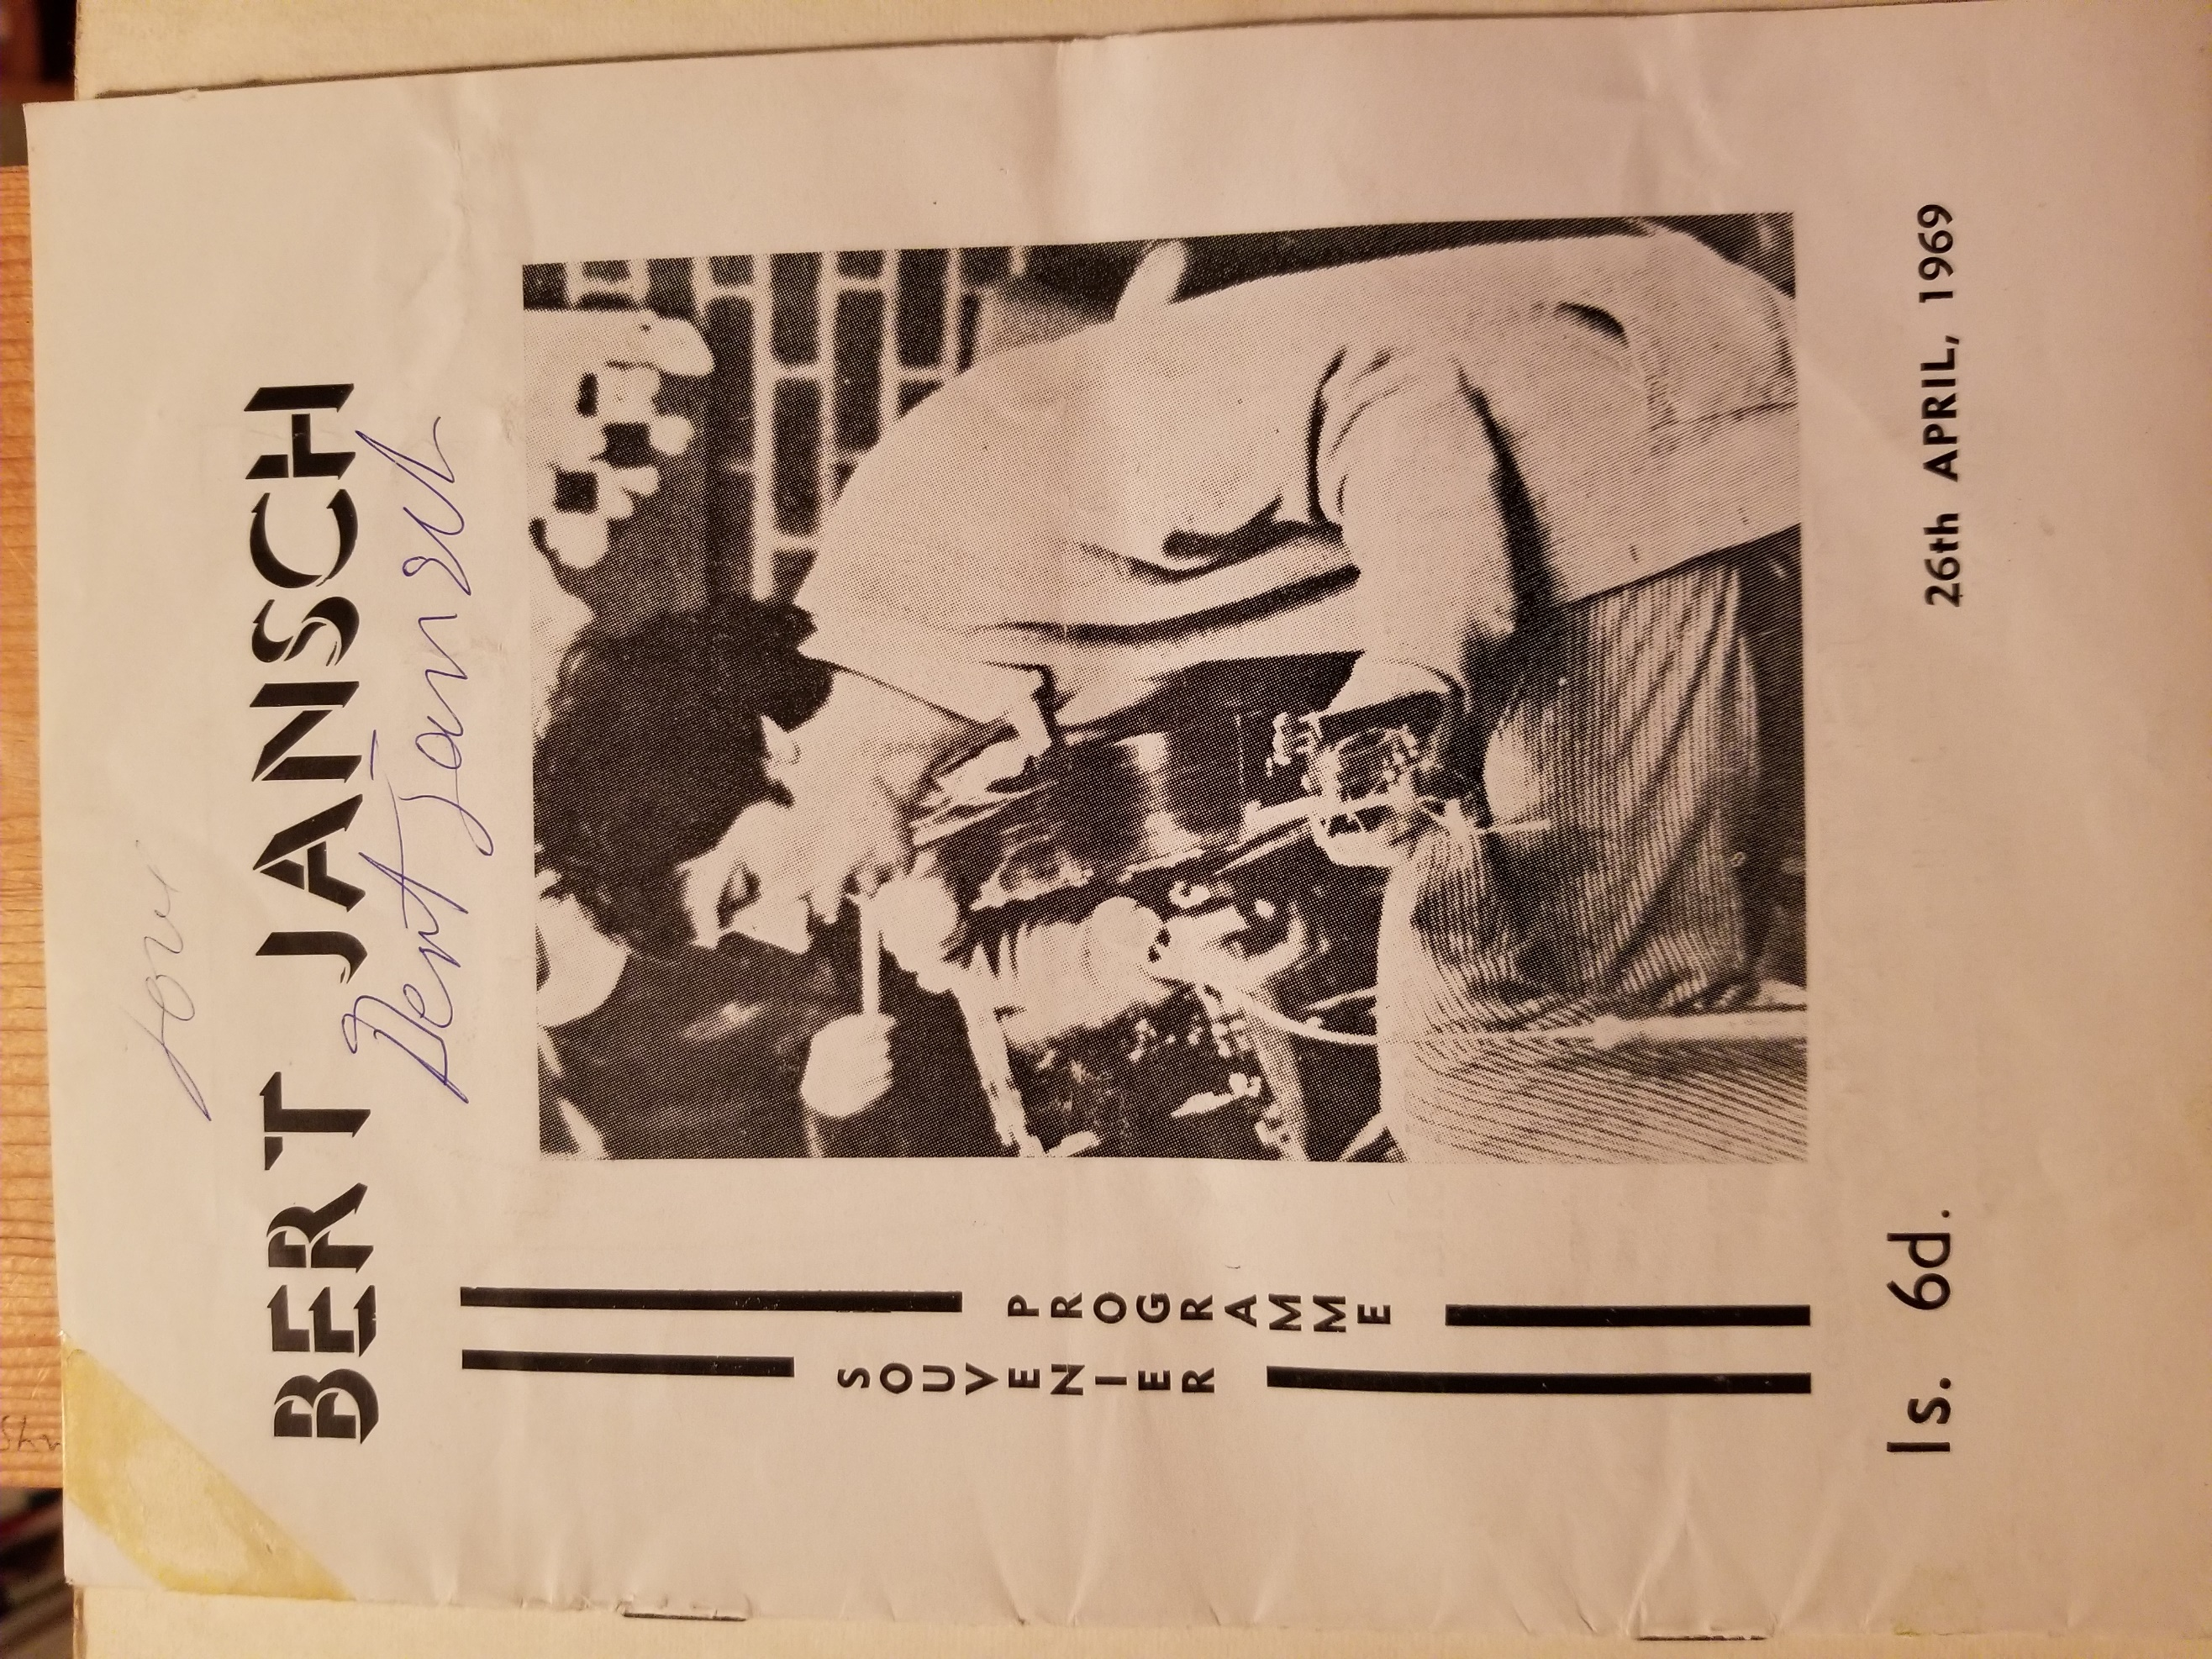
The Rise of the Drifter’s Escape
It was the folk club organisers who were the most ‘politicised’ and counter-cultural teenagers in Ebbw Vale. In pressing for the venue to be re-named, re-designed and re-imagined, the seeds of the eventual vituperative closure were present from the outset. In December 1969, all of this was to come; the first gig was one transferred from the folk club. To prepare for it, the ballroom was indeed redecorated by draping hessian over the its mirrored walls, but those hessian drapes also bore political slogans. These followed the precedent set by the membership card of the existing ‘Times’ folk club (also from the Dylan song). The card bore the slogan ‘smash capitalism now!’ which was printed alongside a CND (peace) logo. That ‘smashing’ contradicted the pursuit of ‘peace’ was not solely the folk club organisers’ contradiction but was eloquent of charged but confusing times.
Encapsulated, in the UK, as a range of political objectives in the 1967 launch of the ‘May Day Manifesto’ (see Williams: 1968) and translated into more accessible if eclectic forms by the underground press (especially IT and Oz) the counter culture was an energetic yet incoherent collection of political, social and cultural ideals and objectives. For example, a typical issue of IT from the first weeks of 1969 contained a florid dissection of the chances of revolution in the USA; a moving and harrowing account of attacks on civil rights marchers in the north of Ireland; a plea for marijuana to be legalised; and a set of illustrated texts taken from the Bhagavad Gita. This was a heady mix, a ‘wish-list’ that drew on political fantasies, political realities, ‘liberated’ sex, the benefits of illegal drugs and alternative spiritual values. Considered in these terms, the variously and newly-surfaced ‘manifestos’ of the day indicated that he counter-culture was an attempt to fix all perceived problems at once – from the alienation of individual psyches to the exploitation of working people as a social class. In turn this mobilised and gave a fleeting sense of connectedness to a very wide range of what were in practice quite distinct groups and value-systems. In its way the Drifter’s Escape could not but be a microcosm of this willing confusion.
With rock as a musical soundtrack for this openness to cultural influence and exploration, the rock gig became the collective point of access not just to music but to a set of – contradictory and dimly-perceived – ideals. What this meant that the (sedate-sounding) ‘Teenage Dance’ had become an arena and a rallying point for alternative perspectives and values, in a way and on a scale for which the EVUDC was simply, and on any front, not prepared. The ‘rock committee’ of the Drifter’s Escape had already attempted to organise an Arts Lab in Ebbw Vale – a phenomenon inspired by enthusiastic reporting in IT - and this had been used, very briefly, to experiment in music in the form a ‘fusion’ band, Mad Parliament. In their way, then, these teenagers had their own (microcosmic) ‘cultural capital’ and they were the ones who were immersed in the changes afoot in music industry and, through them more widely, in popular culture.
What the apparent trans-Atlantic confluence in an exciting and articulate form of counter-culture meant for the UK music industries was that the coming of rock ushered in not so much a second ‘British Invasion’ of the USA but the creation of a trans-Atlantic infrastructure for marketing a new commodity, the rock album. Until the rise of rock, record companies concentrated on releasing singles and used radio (and to a limited extent television) to promote them to a substantially domestic mass market for pop music. That rock differentiated itself from pop so profoundly led those same companies to switch to the album form as its key product and to expect to market them far more widely. Further, rock’s ‘communal’ cast, together with its own creation of new forms of cultural reproduction (underground newspapers, happenings and gatherings, rock festivals) provided ready-made conduits to consumers.
Advertising of live rock music events took the form of posters and hand-bills (fliers) in elaborate designs. This ‘home made’ marketing around live events demonstrated to record companies that marketing and promotion beyond radio was not just a viable undertaking but a necessary one. Further still, following the example of artist managers working independently of record companies, it began to make sense nationally (thanks to the example of Peter Jenner and Andrew King of Blackhill Enterprises) and then internationally (thanks to the less culturally-sensitive Don Arden and Peter Grant) to maximise this new live performance bounty by systematising it into extensive and co-ordinated international tours by acts with albums to sell. Into this mix, the comparatively short-lived ‘sampler’ album, alongside newly-created (and sometimes ‘budget’) rock labels made complete sense until the (trans-Atlantic) infrastructural re-focussing from the selling of singles to the selling of albums could be effected.
In the USA, it was Bob Dylan’s label CBS that had sensed the emergence of the need to make as many rock bands as available as quickly as possible which they did through the release of the sampler album The Rock Machine Turns You On (Sept. 1968). In the UK, this precedent was responded to by the independent record company, Island Records who released the sampler You Can All Join In six months later. This record featured a dozen emergent rock bands and singer-songwriters. Both albums sold for very low prices. From there, EMI (with Harvest) and Decca (with Deram Nova) and RCA (with Neon) created rock labels (and Nova was also a budget one). Of the 19 rock bands to play the Drifter’s Escape, one was an Island signing, one a Deram Nova, one an RCA Neon, two C.B.S and three Harvest with four others signed to non-dedicated labels of major companies.
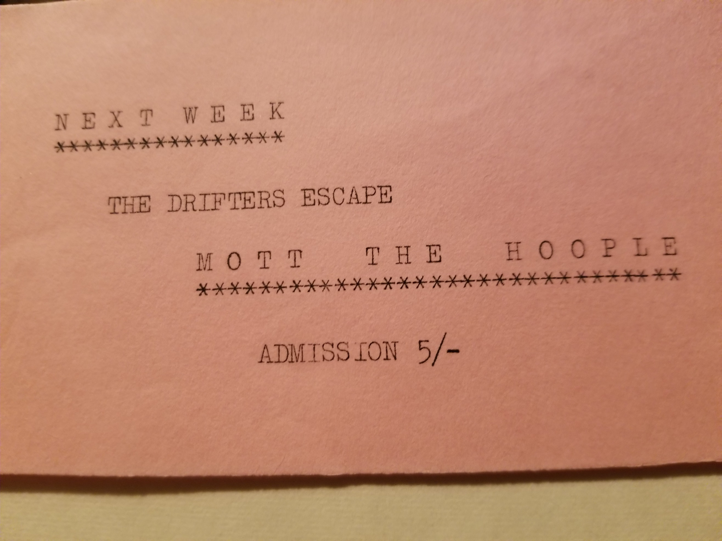
To illustrate the advantage to the organisers of the rock gigs at the Drifter’s Escape of this embryonic rock-album focused music industry, the example of the appearance of Mott the Hoople at the venue is eloquent: Mott the Hoople appeared at the Drifter’s Escape on the 23rd of January 1970. Their first album had been released only two months before. Certainly, by the 1980s it would have been inconceivable to have booked a band signed to a powerful label (in their case Island Records) at short notice so closely following the release of an album. Instead the band’s manager would have negotiated a tour through an agent and they would have been booked months, if not over a year, in advance. Further, if the local promoter did not have a relationship with that agent then there would be slim chance of their winning such a gig even if they had approached the agent in plenty of time. Further still, the fee charged for an appearance by a ‘signed’ act would likely have been beyond a venture such as the Drifter’s Escape; In Mott the Hoople’s case this was £54.00, not cheap even then (when some other, nationally-known acts appeared for as little as £30.00) but certainly far below what the price of an equivalent band would have been only a few years later.
As this example shows, for EVUDC, which underwrote the Drifter’s Escape, the formative stages of rock music as an industrial product meant that the bands they contracted had high market value (overnight ‘national’ reputations together with much sub-cultural credibility) but low market cost (they were fledgling bands that could not command high fees). From this low cost base, and with economically-priced tickets (the EVUDC finance department made bookings and set ticket prices at a variable break-even point only they calculated), the council made considerable profit and was happy to do this. From a purely business-perspective, the bands were well-chosen; the reputation of the new venue grew quickly; attendances climbed from an initial 203 to a peak of 695. In comparison, the folk gigs reached an early ceiling-average of 166, but even factoring-in these lower attendances, the venue-average was in excess of 300. When this is set against ‘attendances of only eleven to 37 people’ (South Wales Argus, 4 December 1969, 15) then it is little wonder that early praise was elicited from EVUDC, as this council minute attests:
Moved by E. Winterson, seconded by H. R. Rosser that the present arrangements respecting Friday dances be continued; further that a letter of appreciation be sent to the committee concerned. (3rd Feb 1970 109/142)
It would be the same councillor who led the condemnation nine months later, and what needs to be identified are the processes that led to the end of the honeymoon and the ‘quickie’ and bitter divorce.
After the Ball was Over
To the return to the intense indignation expressed in the newspaper article and letter, the forms of behaviour that drew these comments clearly played a role in the closure of the venue. The immediate cause of the closure was vandalism to a shop window near the premises. From interviews with participants, underage drinking was evident, fights took place inside and outside the venue, drug-taking was unproven, allegations of public sex appear to be accurate. Cognisant of this shopping list of misdemeanours, the local councillor who had praised the initiative in its earliest stages (Winterson), became chief antagonist (two motions to council: increased policing in Beaufort; limiting attendance to fire limit 3rd Nov 1970, /66 & /94). What is notable about this bad behaviour, though, is how it had long been part and parcel of Ebbw Vale’s social scene; as one interviewee put it:
Most venues (in Ebbw Vale), including various dance venues were closed down because of violence. So basically, much of what happened at the Drifter's Escape was consistent with the past.
Clearly, this is an observation that requires evidence. It was certainly true of the even more short-lived (and nearby) Abertillery Jazz club in 1967 (closed after an extremely violent incident) but to put this in its context, ‘night life’ is a term used to distinguish human activity that demonstrates a form of agency (as freely-chosen activity) in contrast to work and its prescriptions and regimes of discipline; take these observations made by another participant:
It was the highlight of the week ... It totally opened me up to something different. The atmosphere in there was second to none … I was in the apprentice school (of British Steel) … boys from Tredegar, Brynmawr, Abertillery; that’s all we talked about, what band is up there, have you heard these? The likes of Duster Bennett … Mott the Hoople; we’d all meet up … we’d have a few pints, underage drinks, then we go up Beaufort … and we just loved it. I don’t know anyone who had a bad word for it, except for the people living around it, perhaps.
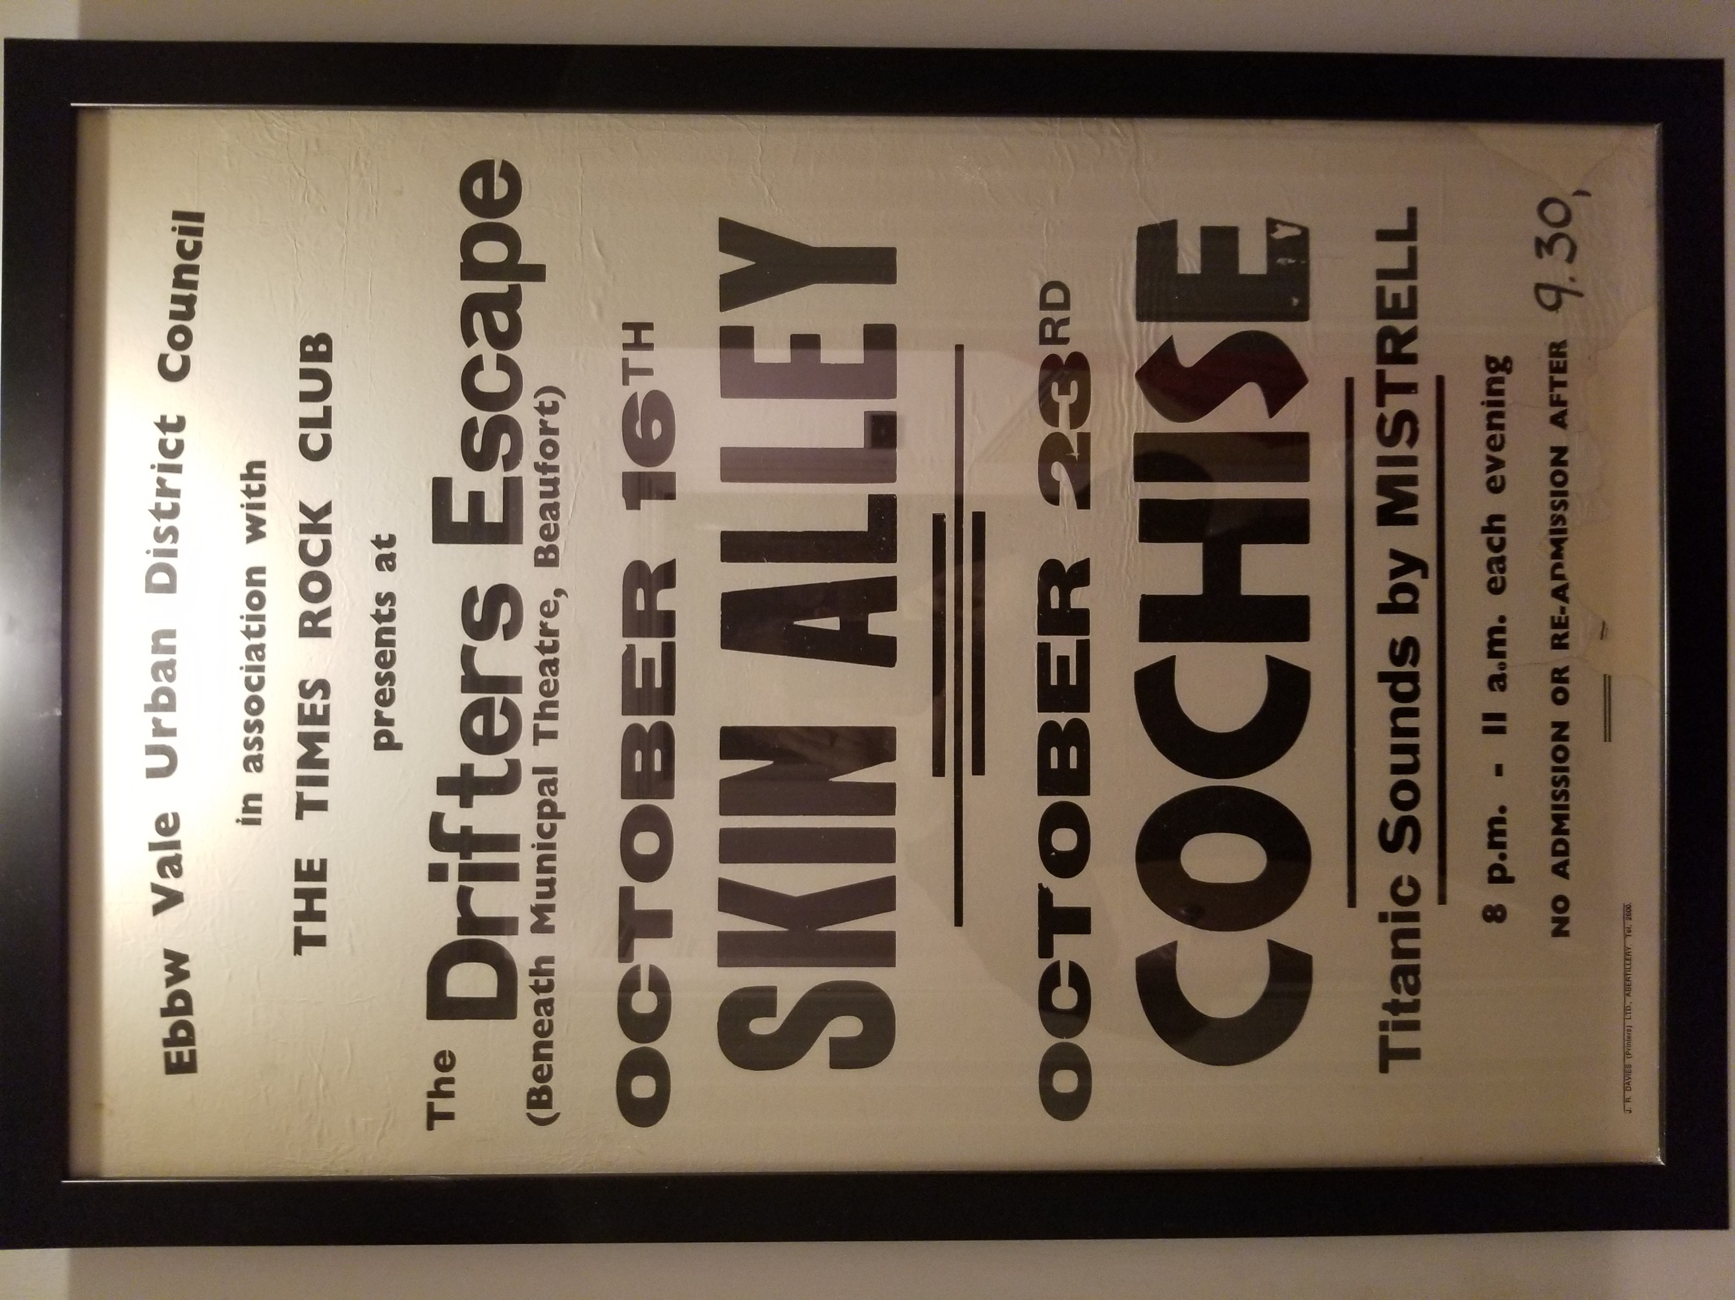

Night-life needs a framework of control; one that is not so intrusive that it denies (or appears to compromise) agency, but not so relaxed that ‘agency’ becomes dangerous disorder. It is worth pointing out that the council staff-complement at the Drifter’s Escape, even when 695 people saw Steamhammer in April 1970, was exactly what it had been when those 11 people attended one of the last nights of the ‘Teenagers Dance’. This is not to shift ‘blame’ back to EVUDC, but the inadequate staffing is emblematic of their misreading of their initiative in the sense that there seemed to be the anticipation that the Drifter’s Escape would be as docile and compliant as a Teenager’s Dance cannot help but sound.
It is here that the generational tension surrounding ‘repulsive behaviour’ begins to give way to deeper, defining issues. Stead (1973) offers a well-reasoned account of Working Class Leadership in South Wales 1900-1920. In this article, he concentrates on the Edwardian period as one in which an emergent Labour Party became the rallying-point for a campaign to supersede the then existing practice of trade unionists being sponsored as members of Parliament by the Liberal Party. There were a range of forces in contention to formulate and prosecute a definitive place within the political process for the ‘working class’ of south Wales. In this, the most intractable conundrum was how to be staunch opponents of a system that constantly resisted working class interests, while working within it, to its rules, rhythms, perspectives and imperatives. In all of this, the 1894 Local Government act is a touchstone for the way it both consolidated and fostered a process ‘on the ground’:
Institutional developments were calling forth working class leaders in every community. Men who had developed administrative expertise … in churches, chapels, friendly societies, and in a whole host of educational of educational and recreational organizations’ (1972:345).
As such men became ‘legitimate’ political actors they became increasingly relocated into a ‘new consensus’; one in which, as Stead (1972:350) describes it:
Most working-class leaders accepted many obligations and restraints far exceeding those which bound them to their own group.
This is a delicate and reasonable way of identifying the integration of ‘working class leaders’ into an existing political framework, one in which they had a ‘seat at the table’ rather than a hand in over-turning it as some working class radicals might have desired. This still does not account for the Evan Davies’s dereliction of duty, but it does suggest how magnetic was the draw of conformity and respectability (rather, perhaps, than embourgeoisement and deference) for Members of Parliament who had progressed through the ranks of administrative roles in trade unions ‘local government … and … non-conformist chapels’.
In the General Election of 1922 16 Labour MPs were elected for south Wales seats. All of these would have been supported by further tiers of active political figures in an increasingly stable and formalised political infrastructure. This infrastructure was then subject to the severe tests previously identified. So it was that, as the slump of the early 1920s gave way to the Depression of the 1930s (with the bitter experience of the General Strike and its aftermath always to absorb), a body such as EVUDC would be made up of men invested in a ‘consensus’ in which they had fought for respectability in Edwardian times only to have to maintain its decorum through the extreme privations of the inter-war decades.
In the face of hardship, and in the face of the need to hold onto a respectability that was so hard to win, maintaining decorum can be seen almost as the prime directive of the working-class leadership of south Wales. And if ‘decorum’ seems a strange word to use about town councils principally made up of manual workers, consider the confluence between chapel-going and temperance and trade unionism - the pursuit of a dignified life even in the absence of its conditions; the dignity of labour even when labour power was bought and sold by employers indifferent to the condition of its human bearers.
It is little wonder that Townsman and the councillors saw behaviour at the Drifter’s Escape as unacceptable – it was unacceptable because it was undignified, but it was also unacceptable because it drew attention to the possibility that being dignified isn’t always enough, even when the maintenance of dignity had demanded enormous sacrifice. The ‘table’ at which working class people had struggled so hard to win their seat was populated by exactly those forces that had closed the coal mines, fought to undermine the General Strike and imposed means-tested benefits. It was hard to remain on civil terms with them, but there appeared no alternative such had been the nature of the triumphant political strategy in the coalfield.
As full-employment returned from the mid-1950s onwards (if only for a short while as it has since transpired), rather than absorb that the gains made (a national health service, family allowances, national insurance and, most importantly of all in this instance, free secondary schools) had brought about change in cultural preferences, expression and expectations, the EVUDC was, perhaps, backward-looking rather than ‘conservative and reactionary’ as previous remarks claimed. They had kept the flame burning for an essentially Edwardian social ordering for so long that, now that conditions had appeared to reward their immense efforts, they were absolutely unprepared for behaviour that offended its precepts.
Conclusion
The behaviour that so offended councillors Scully, Williams and Winterson and that was condemned by ‘Townsman’ was ‘permitted’ by the fact that teenagers had had the acumen to emulate the emergent national trend for small-scale rock venues. This acumen could only be evidence of a new social phenomenon, and one that the Labour Movement, in its very widest sense, had worked and sacrificed for – the social mobility of young people from the industrial heartlands. Rather than castigate it, EVUDC should have acted to restore order to nights that were hugely successful and allowed the venue to continue to flourish. The impact of the Drifter’s Escape, even in its short-life was considerable; as a previously-quoted respondent put it, ‘It totally opened me up to something different’, and as he further observed,
the atmosphere in there was second to none. Friday nights have never been the same since. It was absolutely superb; I’m smiling thinking about it even now.
For such memories to have lasted almost 50 years is testimony to the success of the venue as an artery to changes in popular culture. Certainly, some of the behaviours associated with the connection to a rapidly-commercialising popular culture could not be seen to be under-written by a town council, and some of those behaviours were as old as the hills on which the town was built (so that not everything that was ‘ugly’ was ‘modern’). Even at this particular peak, ‘Counter Culture’ was barely in evidence in the town, but, for a brief moment, Ebbw Vale was part of the tapestry of ‘rock music’. To paraphrase Jones’s opening observation, so ‘accelerated’ was change in music industry that the open window that allowed the Drifter’s Escape to flourish was closing even as this flourishing was being enjoyed, but it is the conditions of the engagement with music industry, the new experience of social mobility for working-class young people, that is the is the ‘significant change’ in the tightly-prescribed cultural and social patterns typical in south Wales in this time.

Bibliography
Curtis, B. 2011. ‘Man of the People: The Place of Lewis Jones in South Wales Coalfield Society’. Welsh History Review 25/4: 576-595.
Frith, S. 1978. The Sociology of Rock. London: Constable.
Frith, S. 1988 ‘The industrialisation of music’ in Music for Pleasure ed Simon Frith, 11-23. Cambridge: Polity.
John, P. 2014 The Great Survivor: ‘The Persistence and Resilience of English Local Government’. Local Government Studies, 40:5: 687-704.
Jones, J. G. 1982. ‘Evan Davies and Ebbw Vale: a Note’ Llafur 3/3: 93-99.
Jones, P. N. 2004. ‘A Valley Community in Transition: Ynysybwl in 1967’. Llafur 9/1: 85-94.
Keightley, K. 2001. ‘Reconsidering Rock’. In Cambridge Companion to Pop and Rock, eds Simon Frith, Will Straw and John Street, 109-142. Cambridge: Cambridge University Press.
Negus, K. 2010. Popular Music in Theory. Cambridge: Polity Press.
Shelton, R. Thomson, E. Humphries, P. 2011. No Direction Home: The Life and Music of Bob Dylan. London: Omnibus.
Stead, P. 1972. ‘Working Class Leadership in South Wales: 1900-1920’ Welsh History Review 6/4: 329-353.
Thomas, K. 2000. Heritage: A History of Ebbw Vale Vol 1, Cwmbran: Kerin Publishers.
Williams, G. A. 1985. When Was Wales: A History of the Welsh. Harmondsworth: Penguin Books.
Williams, R (ed.). 1968. Mayday Manifesto 1968. Harmondsworth: Penguin Books.
Wollmann, H. (2004). ‘Local Government Reforms in Great Britain, Sweden, Germany and France: Between Multi-Function and Single-Purpose Organisations’. Local Government Studies 30:4: 639-665.

Mike Jones
14/11/18

Anonymous 1 in conversation with the author July 10 2016
Anonymous 2 in conversation with the author July 6 2016
Anonymous 3 in conversation with the author July 15 2016
Anonymous 4 in conversation with the author July 8 2016
Anonymous 4 in conversation with the author

