Hybrid VNS-PSO Algorithm for Robust Distribution Path Planning of Fresh Agricultural Products with Time Windows under Demand Uncertainty

Shiyan Tan¹, Jie Chu^{1,*}, Junyi Lin¹, Jimmy H-T Chan², Louisa Yee Sum Lee, and Leven J. Zheng²
¹ International Business School Suzhou, Xi’an Jiaotong-Liverpool University
² Lee Shau Kee School of Business and Administration, Hong Kong Metropolitan University

Abstract
Consumers' demand for fresh agricultural products (FAPs) and their quality requirements are increasing in the current agricultural product consumption market. Due to the unique features of perishability and short shelf-life of FAPs, it requires a high level of delivery efficiency to ensure the freshness and quality of agricultural products. However, consumers’ demand for FAPs is contingent and geographically dispersed. Therefore, it is important to consider the conflicting relationship between the costs associated with the logistics distribution and the level of delivery quality. In this paper, we consider a fresh agricultural product distribution path planning problem with time windows (FAPDPPPTW). To address FAPDPPPTW under demand uncertainty, a mixed-integer linear programming model based on robust optimization has been proposed. Moreover, a particle swarm optimization algorithm combined with a variable neighborhood search (VNS-PSO) is designed to solve the proposed mathematical model. The numerical experiment results show the robustness and fast convergence of the algorithm.

Keywords: fresh agricultural products, distribution routing optimization, soft time windows, PSO

Introduction
With the improvement of quality of life and pursuit of healthy diet, the consumers’ demand for fresh agricultural products (FAPs), e.g., fruits, vegetables, aquatic products, livestock and other primary products, has been growing rapidly over the past decade. As a major global consumer of FAPs, China’s market scale of FAPs has reached 2 trillion yuan in 2019 (Cang and Wang, 2021), and the market still has huge potential with the increase of various purchasing channels in the country, such as agricultural e-commerce, community group buying, and live broadcasting selling (Liu et al., 2022; Zhao et al., 2021). However, the perishable and corrosive characteristics of FAPs may pose a great challenge for distribution planning since the distribution paths need to be planned with explicit consideration of freshness and quality requirements for FAPs. Indeed, Han et al. (2021) point out that the main challenges facing agricultural logistics in China are high spoilage and deterioration rate, low distribution efficiency and high logistics cost in the distribution process. The rapid reduction in the quality of FAPs during transportation requires the delivery of the products within consumer-specified delivery times, or time windows. Early or delayed delivery will result in the lower consumer satisfaction for logistics service quality (Sun et al., 2022). In addition to the quality of the agricultural products, the increasing environmental concerns regarding the high fuel consumption and carbon emission of the distribution vehicles, particularly in cold chain distribution, have become another important factor to be considered in the logistics and distribution planning for FAPs. The optimization of the logistics distribution of FAPs with various economic and environmental considerations has been extensively examined in the literature (Bortolini et al., 2016; Chen et al., 2020; Devapriya et al., 2017; Kown et al., 2013; Li et al., 2020; Rong et al., 2011; Sun et al., 2022; Wang et al., 2020).
The key to improving the logistics distribution systems of FAPs lies in the effective planning of distribution paths. The distribution path planning problem can be also viewed as the vehicle routing problem (VRP) (Dantzig and Ramser, 1959). In the context of distribution path optimization for FAPs, the vehicle routing problem with time windows (VRPTW) are typically formulated to ensure the timely delivery by distribution vehicles while achieving the shortest transportation distance (time) and thus the lowest transportation cost (e.g., Amorim et al., 2014; Chen et al., 2009; Hsu et al., 2007; Naso et al., 2007; Ombuki et al., 2006; Osvald and Stirn, 2008; Shukla and Jharkharia, 2013; Xia and Fu, 2019). In particular, Xia and Fu (2019) point out that although serving consumers’ demand for FAPs with hard time window requirement (i.e., the delivery must be made within the specified time windows) is conductive to achieving high consumer satisfaction for logistics service, it may cause low vehicle utilization and restrict the choice of distribution paths, thus resulting in the increased number of vehicles required and higher logistics distribution costs. For this reason, the soft time windows (i.e., the delivery can be made outside the specified time windows) would be more advantageous in terms of gaining more flexibility in distribution routing.
Solving VRP/VRPTW models can be extremely computational challenging since VRP/VRPTW is recognized as a combinatorial integer programming problem, which is NP-hard in general (Savelsbergh, 1985). Hence, the use of state-of-the-art heuristic/metaheuristic approaches is usually required. For example, Xia and Fu (2019) construct a bi-objective programming model for the VRP with soft time windows and satisfaction rate. Moreover, they design an enhanced tabu-search algorithm and numerically show its superiority over several other metaheuristic methods reported in the literature. Similarly, Gmira et al. (2021) also propose a tabu-search heuristic-based solution approach for solving the VRPWT in which the time-dependent travel time associated with each arc in the distribution network is considered. Hiermann et al. (2019) develop an integrated routing and vehicle selection model to address the VRPTW involving multiple vehicle types, for which a solution method that combines a genetic algorithm with neighborhood search has been proposed. Chiang and Russell (1996) describe a simulated annealing procedure for the VRPTW. Importantly, their computational results suggest that the solution method has potential, in terms of solution quality and computational time, to be implemented in large-scale VRPTW environments. In this paper, we present a solution method based on Particle Swarm Optimization (PSO) algorithm. PSO is essentially a random search algorithm proposed by Kennedy and Eberhart (1995), which seeks to iteratively improve the candidate solutions obtained (called particles) by traversing the search space (called a swarm) until the best known solution is attained. Since PSO has characteristics of strong robustness and fast convergence, it has been successfully applied to solve many NP-hard optimization problems including VRP and its variants (e.g., Gong et al., 2011; Guo et al., 2017; Hannan et al., 2018; Kachitvichyanukul et al., 2015; Khouadjia et al., 2012). In particular, Guo et al. (2017) formulate a two-stage optimization model in a fresh food distribution and recycling network, in which the network design and route planning for FAPs are jointly considered. By adopting PSO algorithm as the solution method, the proposed two-stage model is solved and validated through a case study of the Shanghai fresh food e-commerce enterprises.
In this paper, we study a fresh agricultural product distribution path planning problem with time windows (FAPDPPPTW), in which the soft time windows are assumed. The distribution network under study consists of a single distribution center and multiple demand locations. The distribution vehicles should be carefully planned to deliver FAPs from the distribution center to all the demand locations, however the distribution routing needs to be determined by taking into account the costs associated with vehicle distribution, freshness degradation, and penalty of time window violation. The freshness degradation of agricultural products occurring during the distribution process can be characterized by the quality deterioration (Cai et al., 2013; Chen et al., 2009; Chen et al., 2018) as well as the physical quantity deterioration (or quantity loss) (Qin et al., 2014; Wang and Chen, 2017) which reflects the portion of the FAPs that are spoiled or damaged when being transported. In this study, we only consider the quantity deterioration over time and the impact of which is incorporated as part of the overall distribution cost.
Different from the previous studies in VRP/VRPTW literature that typically assume deterministic or stochastic demand with known distribution, we assume that demand at each location point varies within an interval with known mean and deviation. Accordingly, we develop a robust optimization model for FAPDPPPTW (termed RO-FAPDPPPTW). To the best of our knowledge, only a limited number of research deals with robust version of VRP/VRPTW in the fresh produce distribution literature (e.g., Liu and Zhang, 2023; Tirkolaee et al., 2020; Yan et al., 2021).
The remainder of this paper is organized as follows. Section 2 describes FAPDPPPTW and provides the corresponding RO-FAPDPPPTW model. The PSO-based solution algorithm is introduced in Section 3. In Section 4, the computational results are present and discussed. Finally, Section 5 concludes the paper and provides possible directions for future research.

Model Formulation
2.1 Problem Description
In this section, we formulate a robust optimization model of FAPDPPPTW. The distribution network under consideration consists of a single distribution center and multiple demand points with known geographic locations. The distribution center has a sufficient number of vehicles undertaking distribution tasks, which depart from the distribution center and deliver one type of FAP to all the demand points according to the planned routes. These distribution vehicles have the identical maximum load capacity while their travel speeds may be different. Each demand location can be visited exactly once and served by one distribution vehicle, while each distribution vehicle can serve multiple demand points. Once the vehicles arrive at the demand points, they need to provide unloading service as well. We assume that the unloading service time required may vary at different demand points. After the distribution services have been completed, all the vehicles shall return to the distribution center.
In this study, we assume a known time window at each demand location, however the time windows may vary across different locations. The time windows are soft; that is, a vehicle may arrive at a demand point outside the time window, however the time cost due to the early or late delivery will be incurred. Specifically, if the vehicle arrives early at the demand location, it needs to wait until the earliest time for delivery service, thus the extra waiting cost will be incurred; in contrast, if the vehicle arrives late at the demand location, the overtime penalty cost will be incurred. The demand of the FAP is random, and all the demand must be satisfied. To ensure that each demand point can be served by only one vehicle, we further assume that the quantity required at any demand point shall not exceed the maximum load of the vehicle. In addition, due to perishable nature of the FAP, the quantity deterioration aspect of the FAP during transportation process is considered. Inspired by Sana et al. (2004) and many other works in which the inventory models with deteriorating items are studied, we characterize the distribution cost associated with the quantity deterioration by considering the Weibull distributed deterioration. The goal of FAPDPPPTW is to produce the distribution route solution that yields the lower distribution cost and higher delivery quality.

2.2 Notations and Decision Variables
To formulate the FAPDPPPTW model, we use the graph $G=\left(N,E\right)$ to represent the distribution network considered, where $N$ and $E$ denote the set of nodes and set of paths in the graph, respectively. Let $0$ denote the distribution center, and let $C=\left\{1,2,…,n\right\}$ denote the set of consumer demand points, thus $N=0∪C=0,1,…,n$. The set of distribution vehicles is denoted by $V=\{1,…,k\}$. The path between locations $i$ and $j$ is denoted as $\left(i,j\right)$, and therefore the set of paths in the network can be expressed by $E=\left\{\left(i,j\right) | i, j∈N, i≠j\right\}$. The travel time between locations $i$ and $j$ for vehicle $k$ is denoted by $t_{ijk}$, where $\left(i,j\right)∈E$ and $k∈V$.
There are four types of decision variables that need to be determined in the mathematical formulation for FAPDPPPTW. First, let $x_{ijk}$ be the 0-1 variable corresponding to distribution routing for all$\left(i,j\right)∈E$ and $k∈V$; if $x_{ijk}=1$, it indicates that vehicle $k$ travels on path $\left(i,j\right)$, and 0 otherwise. Then, let $y_{ik}$ be another 0-1 variable related to the delivery for all$i∈C$ and $k∈V$; if $y_{ik}=1$, it indicates that demand location $i$ is served by vehicle $k$, and 0 otherwise. Finally, let $β_{ik}$ and $g_{ik}$denote the arrival and departure time of vehicle $k$ at demand point $i$, respectively. Other notations used for the mathematical formulation are defined in Table 1.

2.3 Distribution Cost Analysis
The distribution costs in FAPDPPPTW model include fixed cost of vehicle use, distribution (time) cost, quantity loss cost, and penalty cost. In the following, the mathematical expressions for these costs are described.

Table 1. Notations for the mathematical model

Notations | Description
Sets
0 | Distribution center
$$C$$ | Set of demand nodes, $C=\left\{1,2...,n\right\}$
$$N$$ | Set of nodes in the distribution network, $N= \{0,1,2,...,n\}$
$$E$$ | Set of paths in the distribution network
$$V$$ | Set of distribution vehicles owned by the distribution center
Parameter
$$n$$  $$k$$ | Number of demand points  Number of distribution vehicles
$$Q$$ | The maximum load capacity of each vehicle
$$q_{i}$$ | The demand at location$i$
$$w_{i}$$ | Unloading service time of each vehicle at demand point $i$
$$\left[s_{i}{,e}_{i}\right]$$  $$\left[a_{i}{,b}_{i}\right]$$ | Time window specified by consumers at demand point $i$, where $s_{i}$ and $e_{i}$ indicate the earliest and latest delivery time, respectively  Time window that can be accepted by consumers at demand point $i$, where $a_{i}$ and $b_{i}$ indicate the earliest and latest delivery time consumers can accept, respectively
$$σ_{ik}$$ | Waiting time of vehicle $k$ at demand point $i$ in case of early arrival. If $β_{ik}<s_{i}，σ_{ik}=s_{i}-β_{ik}$; otherwise, $σ_{ik}=0$
$$P$$  $$P_{1}$$ | Unit cost of the fresh produce  The fixed cost per vehicle used
$$P_{2}$$ | Cost per unit of time for vehicle use during transportation
$$t_{0ik}$$  $$t_{ijk}$$ | Travel time required from the distribution center to demand point $i$ for vehicle$k$  Travel time required on path $\left(i,j\right)$ for vehicle$k$
Variables
$$x_{ijk}$$ | Binary decision variable; $x_{ijk}=1 if vechicle k$travels through path$(i,j)$and $0$ otherwise
$$y_{ik}$$  $$β_{ik}$$  $$g_{ik}$$ | Binary decision variable; $y_{ik}=1 if vehicle k$serves demand location $i$ and $0$otherwise  Time at which vehicle $k$arrives at demand point $i$  Time at which vehicle $k$ leaves demand point $i$

    - Fixed Cost ($C_{1}$)
The fixed cost includes various types of costs of using vehicles for distribution tasks, including vehicle repair and maintenance cost, labor cost of drivers, and vehicle depreciation cost, etc., which only depends on the number of vehicles to be used for the distribution. The fixed cost can be expressed as follows.

$$C_{1}=P_{1}\sum_{kϵV}{\sum_{i∈C}{x_{0ik}}}$$
(1)

    - Distribution Time Cost ($C_{2}$)
The distribution Time cost refers to the time cost that varies with the paths travelled and demand points served in the distribution process. This type of cost can be derived by multiplying the total distribution time of the vehicles and the corresponding cost of vehicle use per unit of time. The distribution time is composed of travel time, waiting time, and service time (i.e., unloading service time). Since we assume that the travel speed may vary by vehicles, the travel time of the vehicles on the same path might be different (i.e., $t_{ijk}$). The distribution cost is calculated as follows.

$$C_{2}=P_{2}\left(\sum_{iϵN}{\sum_{j∈N}{\sum_{k∈V}{{t_{ijk}x}_{ijk}+}}}\sum_{iϵC}{\sum_{k∈V}{σ_{ik}y_{ik}}}+\sum_{iϵC}{\sum_{k∈V}{w_{i}y_{ik}}}\right)$$
(2)
where $σ_{ik}=max\left(s_{i}-β_{ik},0\right)$ for all $i∈C$ and $k∈V$.

    - Quantity Loss Cost ($C_{3}$)
As discussed, the quantity deterioration of the FAP during the distribution process is considered in this study, thus the corresponding quantity loss cost is generated. In the inventory literature with perishable items, the Weibull distribution is commonly used to describe the item deterioration (Covert and Philip, 1973; Qin et al., 2014; Skouri et al., 2009; Yang, 2012). Following these prior works, we assume that the deterioration rate of physical quantity of the FAP at time $t$ follows the three-parameter Weibull distribution whose probability density function is $f\left(t\right)={αβ\left(t-γ\right)}^{{-α\left(t-γ\right)}^{β-1}}\exp{{-α\left(t-γ\right)}^{β}}$, $α≥0,β≥1, t≥γ≥0$, where $α,β, γ$ are parameters of Weibull distribution. It is noteworthy that $f\left(t\right)=0$ when $t<γ$, suggesting that the deterioration occurs after time $γ$. Thus, the expression of the quantity loss of the FAP caused during transportation from the distribution center to demand location $i$ by vehicle $k$ is given by,

$$S_{ik}=q_{i}\left(e^{α\left(β_{ik}-γ\right)}-1\right)$$
(3)
Therefore, with the assumption of Weibull distributed deterioration, the associated quantity loss cost can be obtained as follows,

$$C_{3}=\sum_{i∈C}{\sum_{k∈V}{PS_{ik}y_{ik}}}=P\sum_{i∈C}{\sum_{k∈V}{q_{i}\left(e^{α\left(β_{ik}-γ\right)}-1\right)y_{ik}}}$$
(4)
Notice that the quantity loss cost is mainly affected by the three factors: the unit cost of the FAP ($P$), the demand quantity ($q_{i}$), and the travel time required for the delivery ($β_{ik}-γ)$.

    - Penalty Cost ($C_{4}$)
In addition to the quantity deterioration rate, the delivery time itself is also an important indicator to measure the service quality on the VRP for FAPs (Sun et al., 2022). Early or late delivery can result in the reduction of consumer satisfaction and thus incur penalty cost. In this paper, we consider the penalty costs in five cases according to the delivery time. The corresponding unit penalty cost $f_{e}$ with the delivery time is depicted in Figure 1.

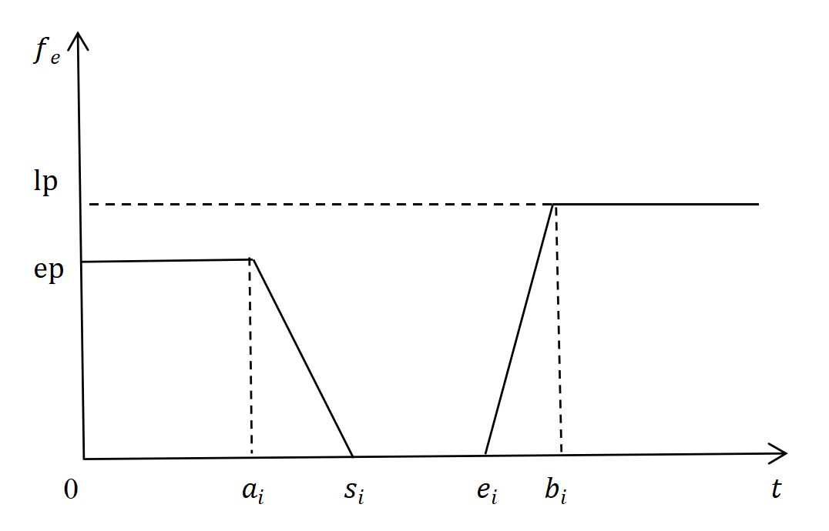
Figure 1. Penalty cost rate curve
As can be seen from the figure, if vehicle $k$ arrives too early or too late at demand location $i$, i.e., $β_{ik}∈\left[0,a_{i}\right)$ or $β_{ik}∈\left(b_{i},+∞\right)$ then the unit waiting and late penalty costs are$ep$ and $lp$, respectively. If the vehicle arrives within the time interval $\left[a_{i},s_{i}\right)$, the unit penalty cost will decrease with the delivery time; in contrast, if the vehicle arrives within the time interval $\left(e_{i},b_{i}\right]$, the unit penalty cost will increase with the delivery time. If the time when the vehicle arrives is within the time interval $\left[s_{i},e_{i}\right]$, the unit penalty cost is $0$. Thus, the penalty cost function with the delivery time $β_{ik}$ is expressed as follows.

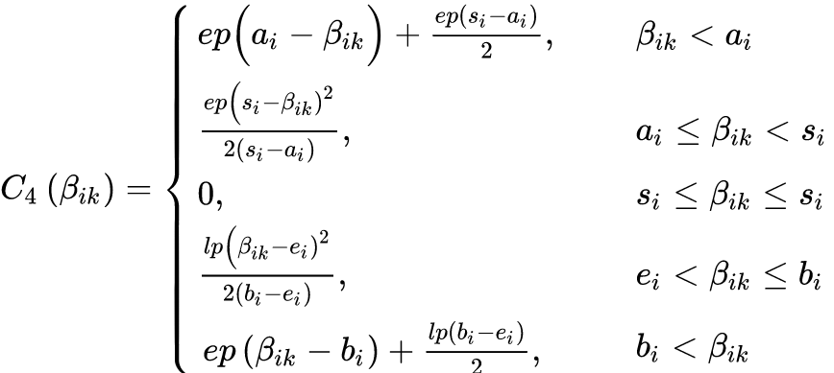
(5)

2.4 RO-FAPDPPPTW Model
The consumer demand for FAPs may involve large uncertainty since the consumers are sensitive to the freshness and logistics service quality of FAPs. The presence of such uncertainty makes deterministic VRP/VRPTW models less reliable to tackle real-world FAPDPPPTW applications (Liang et al., 2021). In an effort to study the FAPDPPPTW under demand uncertainty, we formulate the problem under robust optimization (RO) theory discussed in Ben-Tal et al. (2009), in which uncertain parameters are assumed to vary within intervals with known mean and deviation, while the largest deviations from their mean values are restricted by the so-called budget-of-uncertainty (Bertsimas and Sim, 2004).
Following the budget uncertainty sets discussed in Agra et al. (2012) and Hu et al. (2018) for the uncertain VRPTW, we assume that the random demand variable ${\tilde{q}}_{i}$, for all $i∈C$, varies within the symmetric interval $\left[{\overline{q}}_{i}-{\hat{q}}_{i}, {\overline{q}}_{i}+{\hat{q}}_{i}\right]$, where ${\overline{q}}_{i}$ and ${\hat{q}}_{i}$, respectively, represent the mean demand and maximum deviation from the mean value. In addition, we define the auxiliary variable $η_{i}=({\tilde{q}}_{i}-{\overline{q}}_{i})/{\hat{q}}_{i}$ which takes value in $\left[-1, 1\right]$. Then, the following demand uncertainty set $U_{q}$ is considered for the robust version of FAPDPPPTW.

$$U_{q}=×_{k∈V}U_{q}^{k}$$
(6)
where

$U_{q}^{k}=\left\{\tilde{q}∈R^{\left|N^{k}\right|}\left|{\tilde{q}}_{i}={\overline{q}}_{i}{+η}_{i}{\hat{q}}_{i},\sum_{iϵN^{k}}{\left|η_{i}\right|≤Γ_{q}^{k},}\right.\left|η_{i}\right|≤1,Γ_{q}^{k}=\left\lceil θ_{q}\left|N^{k}\right|\right\rceil , ∀i∈N^{k}\right\}$
(7)

Equation (7) defines the demand budget uncertainty set $U_{q}^{k}$ for each vehicle $k$, where $N^{k}$ denotes the set of consumers on the distribution route of vehicle $k$, and $Γ_{q}^{k}$ is the uncertainty budget that reflects the degree of demand uncertainty on the travel route of vehicle $k$. The value of $Γ_{q}^{k}$ is set to $\left\lceil θ_{q}\left|N^{k}\right|\right\rceil$, where $θ_{q}$ denotes the demand uncertainty budget factor and takes a value between 0 and 1, and $\left\lceil ω\right\rceil$ represents the smallest integer that is greater than or equal to $ω.$ Together, $θ_{q}$and $\left|N^{k}\right|$ determine the upper limit imposed on the number of consumer locations with high demand uncertainty.
Agra et al. (2012) investigate the robust VRPTW model under demand and travel time uncertainty. According to their results, only the extreme points in the budget uncertainty set need to be considered in the resulting robust formulation. As such, we formulate the RO-FAPDPPPTW with the consideration of demand vector $q∈ext(U_{q})$, where $ext(U_{q})$ denotes all extreme points of set $U_{q}$ given in Equation (6), as follows,

$$(RO-FAPDPPPTW) Z=min{ C}_{1}+C_{2}+C_{3}+\sum_{i∈C}{\sum_{k∈V}{C_{4}\left(β_{ik}(q)\right)}}$$
(8)
s.t.
$$\sum_{jϵC}{x_{0jk}=\sum_{iϵC}{x_{i0k}}≤1, ∀k∈V}$$
(9)
$$\sum_{kϵV}{y_{ik}=1, ∀i∈C}$$
(10)
$$\sum_{iϵN}{x_{ijk}=\sum_{j∈N}{x_{ijk}}, ∀p∈N,k∈V}$$
(11)
$$\sum_{iϵN}{{\tilde{q}}_{i}}y_{ik}≤Q, ∀k∈V, q∈ext\left(U_{q}\right)$$
(12)
$$\sum_{iϵN}{x_{ijk}=y_{jk}, ∀j∈N,k∈V}$$
(13)
$${ β}_{jk}(q)=g_{ik}(q)+t_{ij}, ∀(i, j)∈E, q∈ext\left(U_{q}\right)$$
(14)
$$g_{ik}(q)=\left\{\begin{aligned}β_{ik}(q)(1-y_{ik})+(s_{i}+w_{i})y_{ik}, { β}_{ik}(q)<s_{i} \\ β_{ik}(q)+w_{i}y_{ik}, { β}_{ik}(q)≥s_{i} \end{aligned}\right.,$$
$$∀i∈N, k∈V, q∈ext\left(U_{q}\right)$$
(15)
$$x_{ijk}∈\left\{0,1\right\}, { y}_{ik}∈\left\{0,1\right\}, ∀(i, j)∈E, k∈V$$
(16)

Objective function (8) minimizes the total cost including fixed cost of vehicle use, vehicle distribution (time) cost, quantity loss cost, and penalty cost of time window violation. Constraint (9) ensures that the vehicles depart from the distribution center will return to the distribution center after the distribution task is completed, and each vehicle can be used at most once. Constraint (10) guarantees that each demand location is served by only one vehicle. Constraint (11) is the flow balance constraint, making sure that each vehicle arrives and leaves the same demand point. Constraint (12) indicates that the load on each vehicle used should not exceed the maximum load capacity of the vehicle. Constraint (13) shows that a demand location can be served by a vehicle only when that vehicle travels through the location. Constraint (14) and (15) calculate the arrival and departure time of a vehicle at each location, respectively. Note that Constraint (14) contains quadratic term, which can be linearized using classical “big-M” method. Constraint (16) states the binary decision variables.

Solution Algorithm
The proposed RO-FAPDPPPTW model (8)-(16) is difficult to solve for instances of large scale. In this paper, a hybrid Variable Neighborhood Search and Particle Swarm Optimization (VNS-PSO) algorithm is designed. As already mentioned, PSO is a random search algorithm that aims to iteratively improve the candidate solutions (i.e., particles) by traversing the feasible solution space, which has been successfully applied on solving VRP/VRPTW-related problems. The heuristics-based VNS (Mladenović and Hansen, 1997) is integrated to potentially improve the search efficiency of the PSO algorithm and can effectively avoid the particle swarm falling into local convergence in the search process, thus maintaining the diversity of the particles.
The structure of the VNS-PSO algorithm is identical to that of the classic PSO algorithm, while the best solution found by PSO is further improved by VNS in each iteration. In PSO, the algorithm randomly initializes a group of particles (i.e., feasible solutions), and each particle, such as $i$-th, has two main attributes in the search space d, namely the current position $x_{i}^{d}$ and velocity $v_{i}^{d}$. The particle $i$moves in the search space and tends to move along two directions, either the best position experience by particle $i$ in all preceding iterations (i.e., local optimum), denoted by ${pBest}_{i}^{d}$, or the best position found so far among all the particles (i.e., global optimum), denoted by ${gBest}^{d}$. The corresponding formulas to calculate the updated position and velocity for particle $i$ in each iteration are given as follows (Shi and Eberhart, 1998),

$$v_{i}^{d}=ωv_{i}^{d}+c_{1}r_{1}^{d}({pBest}_{i}^{d}-x_{i}^{d})+c_{2}r_{2}^{d}({gBest}^{d}-x_{i}^{d})$$
(17)
$$x_{i}^{d}=x_{i}^{d}+v_{i}^{d}$$
(18)

where $c_{1}$ and $c_{2}$ are fixed numbers known as particle accelerators; $r_{1}^{d}$ and $r_{2}^{d}$ are random numbers between 0 and 1; and $ω$ is the weighting factor that controls the speed of convergence of the PSO algorithm.
The performance of the position $x_{i}^{d}$ is evaluated based on the predefined fitness function value $f(x_{i}^{d})$ (note that the objective function $Z$ defined in Equation (8) is used as the particle fitness function in the proposed algorithm). If the current fitness function value of $x_{i}^{d}$ is better than that of ${pBest}_{i}^{d}$, then ${pBest}_{i}^{d}$ is set to $x_{i}^{d}$. Further, if the current fitness function value $f({pBest}_{i}^{d})$ is better than that of ${gBest}^{d}$, then ${gBest}^{d}$ is set to ${pBest}_{i}^{d}$. The algorithm continues to update the position and velocity for the particles according to Equation (17) and (18), and perform the comparisons between fitness function values until the termination criteria is met. The reader is referred to Kennedy and Eberhart (1995) for the details of PSO algorithm.
It is important to note that the initial group of particles considered may significantly affect the convergence speed and quality of the VNS-PSO algorithm. In this paper, the natural integer number coding method is used for particle swarm initialization. Specifically, the natural integer numbers between two adjacent 0s are the demand locations to be served by the same vehicle. If there is no natural integer number before 0, the vehicle is considered unused. For example, suppose the distribution center has 3 vehicles. There are 5 demand locations numbered [1,2,…,5] and each of which requires 1.2 tons of a particular FAP. The load capacity of each vehicle is 5 tons. Figure 2 shows a distribution plan for these randomly generated demand points, in which 0s correspond to the vehicles. The figure indicates that the first vehicle ($v_{1}$) is not used, while the second vehicle ($v_{2}$) and the third vehicle ($v_{2}$) are used to serve demand locations [1,2] and [3,4,5], respectively. As a result, the cargo weights at the second and third vehicles are 2.4 tons and 3.6 tons, respectively. Clearly, such a distribution plan will not violate the capacity constraint. To make the position of the particle swarm more effective, two positions $x_{v}$ and $x_{r}$ are constructed, where $x_{v}$ represents a vehicle and $x_{r}$ represents the paths taken by the vehicle.

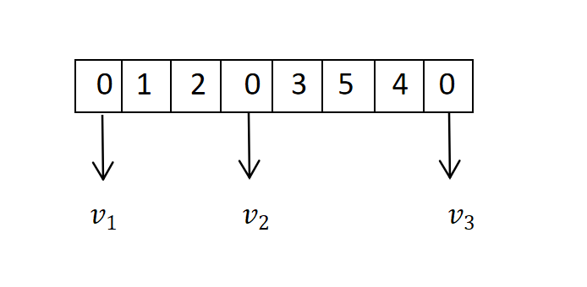
Figure 2. Example of distribution task for five randomly generated demand nodes
Once the particles are obtained by PSO, the neighborhood operators used in the VNS heuristics are applied to further optimize the particles’ position. In this paper, several classic internal-route and external-route neighborhood structures are used in VNS-PSO algorithm to explore the search space and thus improve the quality of the solutions. Specifically, the following three types of neighborhood structures are considered.

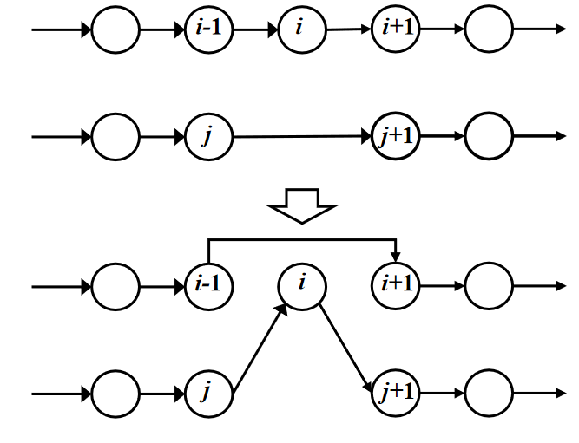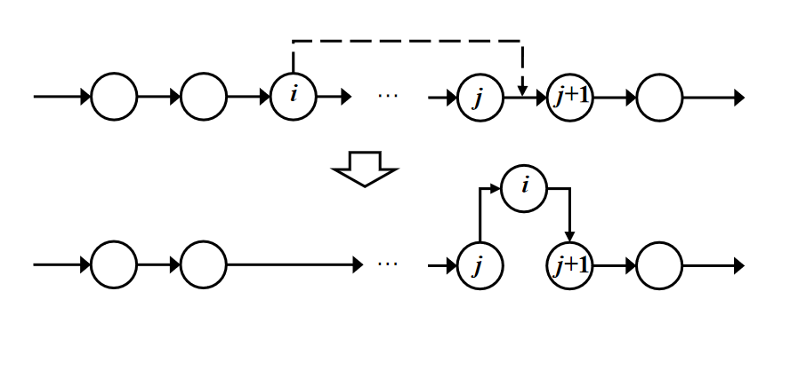
- (b)
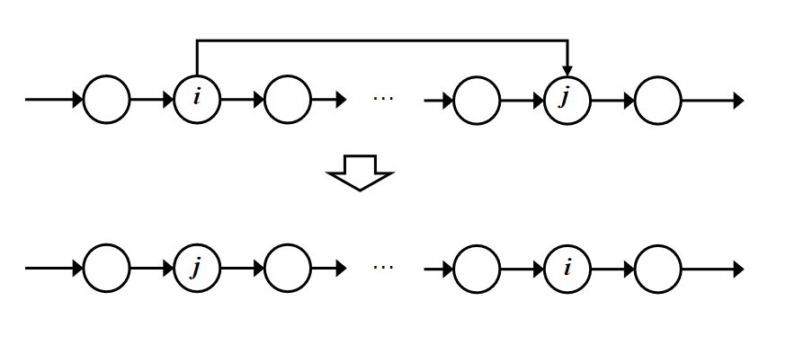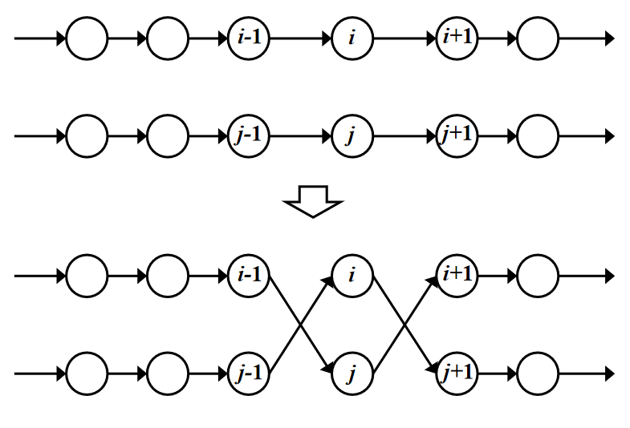
- (d)
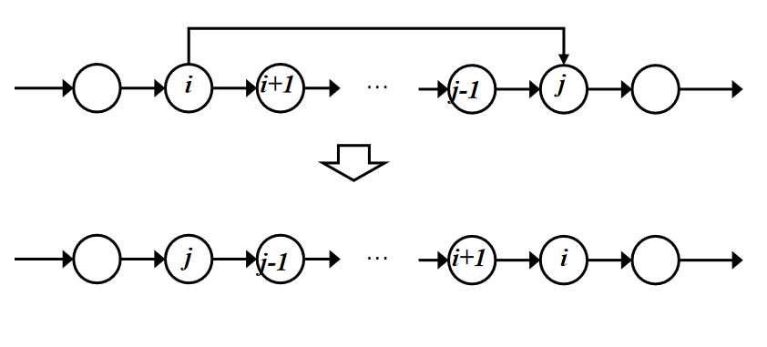
(e)
Figure 3. Example of the neighborhood structures
Relocation. In this type of neighborhood structure, one of the demand nodes is removed from its current position in the route and will be either inserted into the same position in another route (see Figure 3(a)) or inserted into different position in the same route (see Figure 3(b)).
Exchange. This neighborhood structure involves exchanging the position of two demand nodes from the same route (see Figure 3(c)) or from the two distinct routes (see Figure 3(d)).
Reverse. This neighborhood structure changes the sequence of demand nodes in the route to its reverse order (see Figure 3(e)).

Experimental Results
In this section, the simulation experiments are carried out to investigate the effectiveness and performance of the proposed VNS-PSO algorithm. The well-known C1-type, R1-type and RC1-type instances from Solomon's VRPTW test problem library are adopted for testing purpose (http://web.cba.neu.edu/~msolomon/problems.htm). These instances correspond to the VRPTW with 100 demand locations and 25 distribution vehicles, each with a maximum loading capacity of 200 kg. The travel time between two demand locations is set to be the corresponding Euclidean distance. Note that the geographical coordinates of demand locations are randomly generated in type-R1 instance, clustered in C1-type instance, and mixed in RC1-type instance (i.e., a small number of demand locations are clustered while the rest are randomly generated). The three instances also differ in the width of the time windows and service time durations. In particular, it is observed that most demands in C1-type instance have relatively narrower time windows (less than one hour), whereas demands in R1-type and RC1-type instances typically have wider time windows (more than one hour). The algorithm is coded using MATLAB, and the experiments are performed on a PC in Windows 10 Home (64-bit) with 1.5GHz Intel Core i5 Processor and 8 GB of RAM.
The optimization results obtained from solving RO-FAPDPPPTW model by the proposed VNS-PSO algorithm under three different types of instances are shown in Table 2. Specifically, the model outputs including total travel time (or distance), quantity deterioration rate, and number of vehicles used are reported in the table. It should be noted that the quantity loss rate refers to the average percentage of the quantity of FAP deteriorated during transportation. CPU Time represents the average computational time of 10 runs. Several observations are made from the results.

Table 2 Comparison of optimization results under three problem instances

Problem Type | Total Travel Time/Distance | Quantity Deterioration Rate | Number of Vehicles Used | CPU Time  (Sec)
C1 | 828.9 | 16.60% | 10 | 582.25
R1 | 1669.2 | 17.59% | 19 | 672.66
RC1 | 1118.1 | 24.86% | 9 | 650.82

- It is observed that C1-type instance leads to the lowest total travel distance. This is mainly due to the fact that the demand locations in this problem instance are clustered, thus the distance between these demand locations are relatively close. However, due to the narrower consumer time windows (less than one hour) and longer service time considered in C1-type instance, it is seen that 10 vehicles are still needed to complete the distribution task so that the higher cost resulting from the time window violation can be avoided.
- The total travel distance of RC1-type instance is lower than that of R1-type instance and requires less vehicles for distribution task. The main reason lies in the fact that the demand locations in RC1-type has a mix of randomly generated and clustered demand locations whereas those in R1-type are uniformly distributed (thus more geographically dispersed). Since the demand locations in RC1-type are overall closer to each other and the faster service time is assumed, the number of vehicles needed for distribution task is reduced compared to that of R1-type.
- With regard to the average quantity deterioration, it is seen that less than 20% of the product delivered are deteriorated in both C1-type and R1-type instances, while RC1-type achieves almost 25% quantity deterioration. This is mainly caused by the fact that in RC1-type instance fewer number of vehicles are used and thus each vehicle has a long driving distance.
- The computational time shown in the column “CPU Time” indicates that the proposed VNS-PSO algorithm is very stable across different problem instances, suggesting that the algorithm may achieve good computational efficiency for solving RO-FAPDPPPTW model of similar scale.
The distribution paths obtained from the VNS-PSO algorithm and the corresponding algorithm convergence diagram are shown in Figure 4 and Figure 5, respectively. From Figure 4, it can be seen that the vehicle routes of C1-type instance exhibit a simple distribution pattern where the neighboring demand locations are served by the same vehicle, while the R1-type and RC1-type instances generate many intersecting routes.

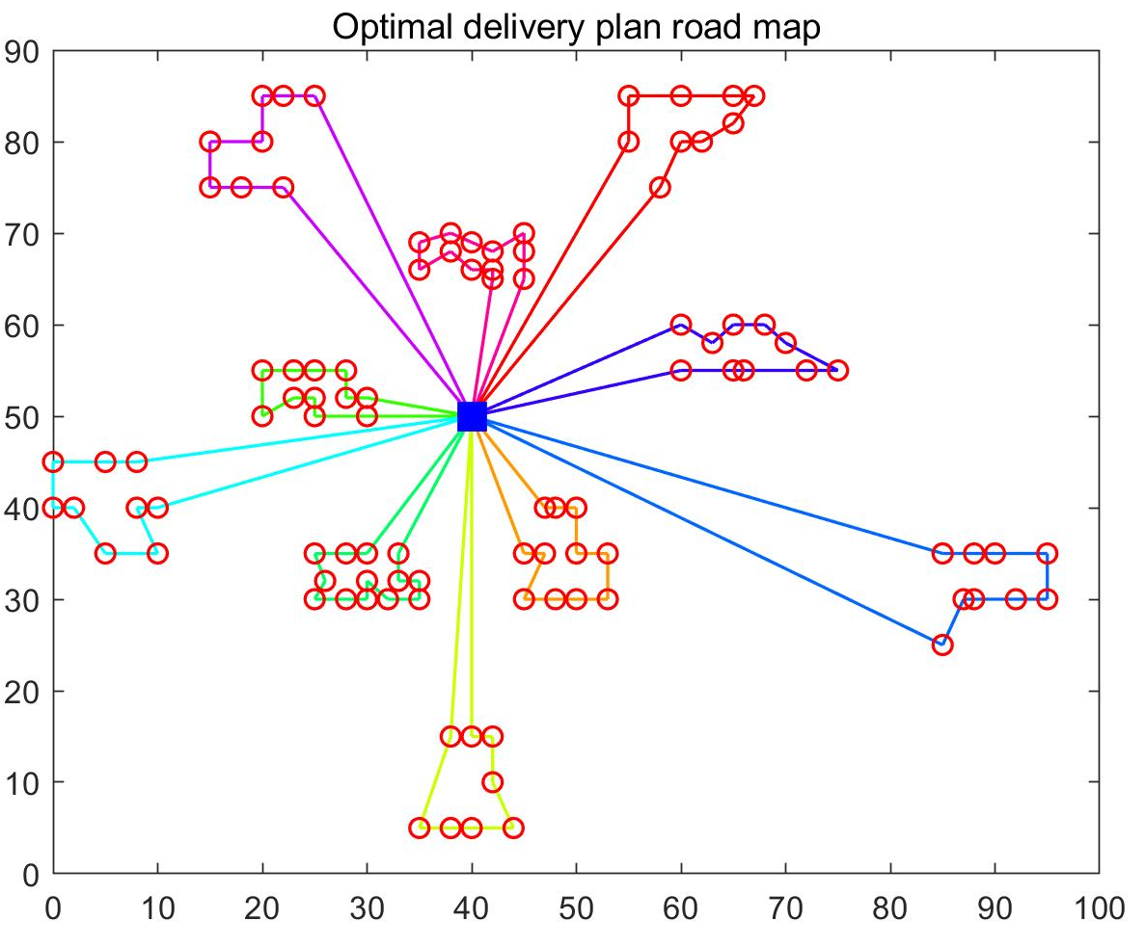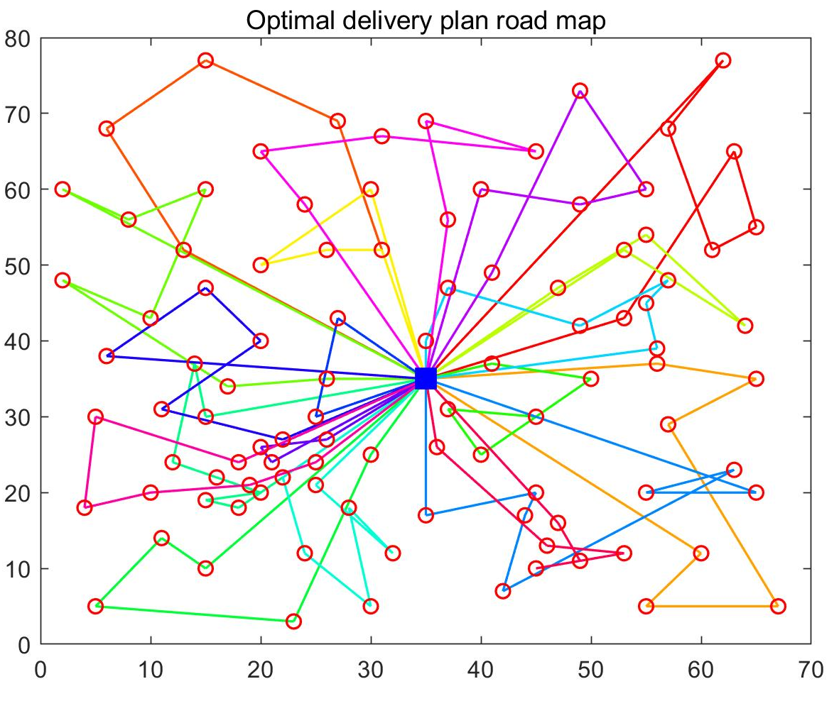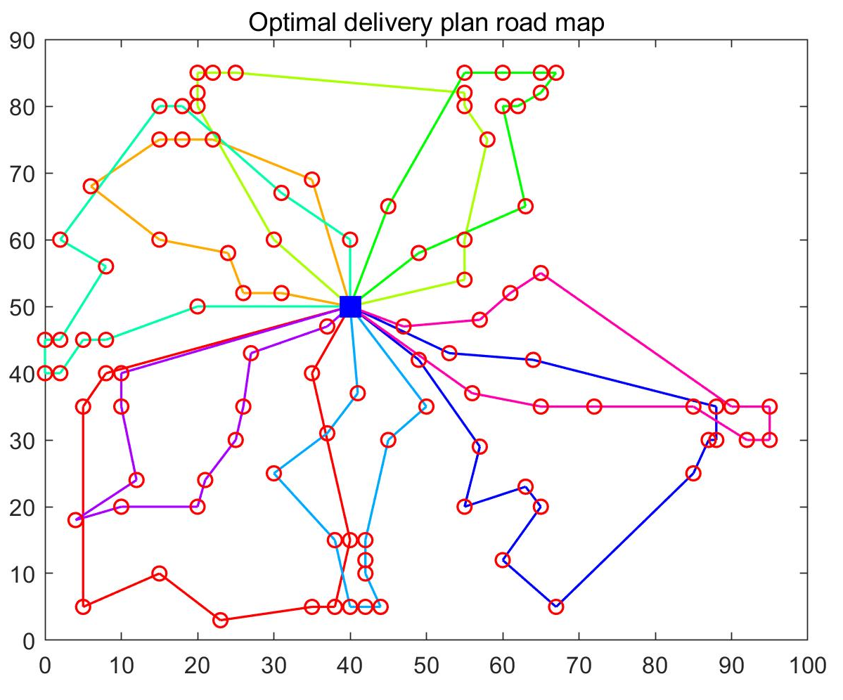
- (b) (c)
Figure 4. Path planning diagram for C1 (left), R1 (middle), and RC1 (right) instances
Figure 5 demonstrates robustness, good neighborhood search, and fast convergence speed of the VNS-PSO algorithm. The algorithm achieves the stable travel time values (i.e., optimal or near-optimal solutions) for C1-type, R1-type, and RC1-type instances only after 15, 15 and 12 iterations, respectively. The results suggest that the algorithm has protentional to be used for solving larger FAPDPPPTW instances.

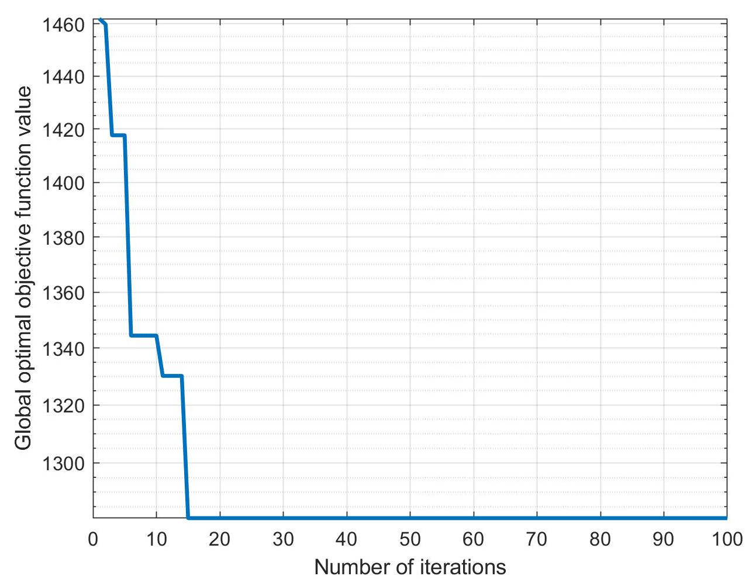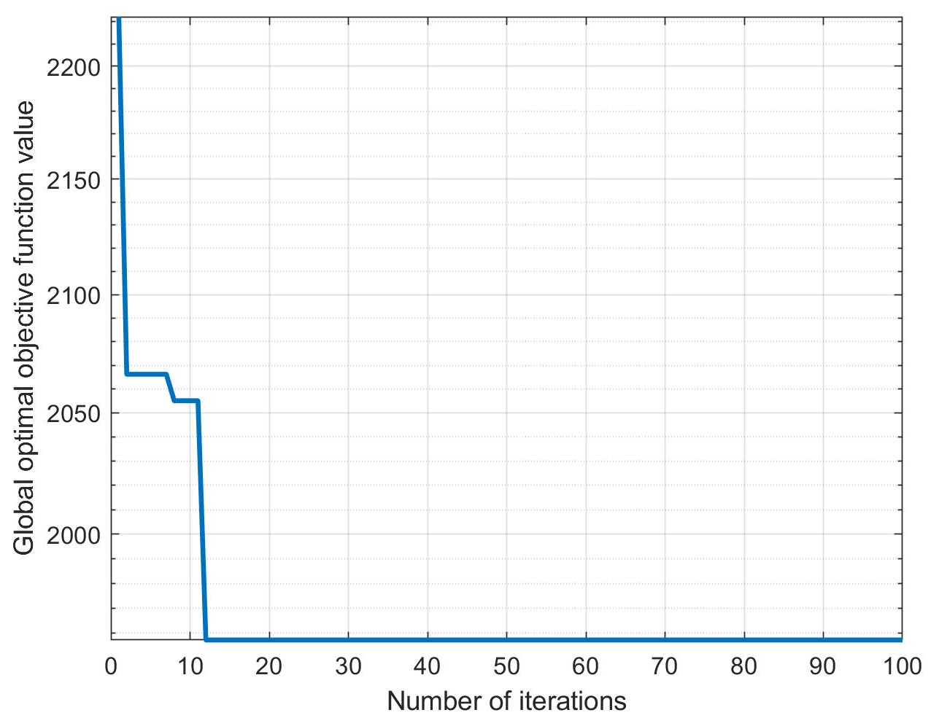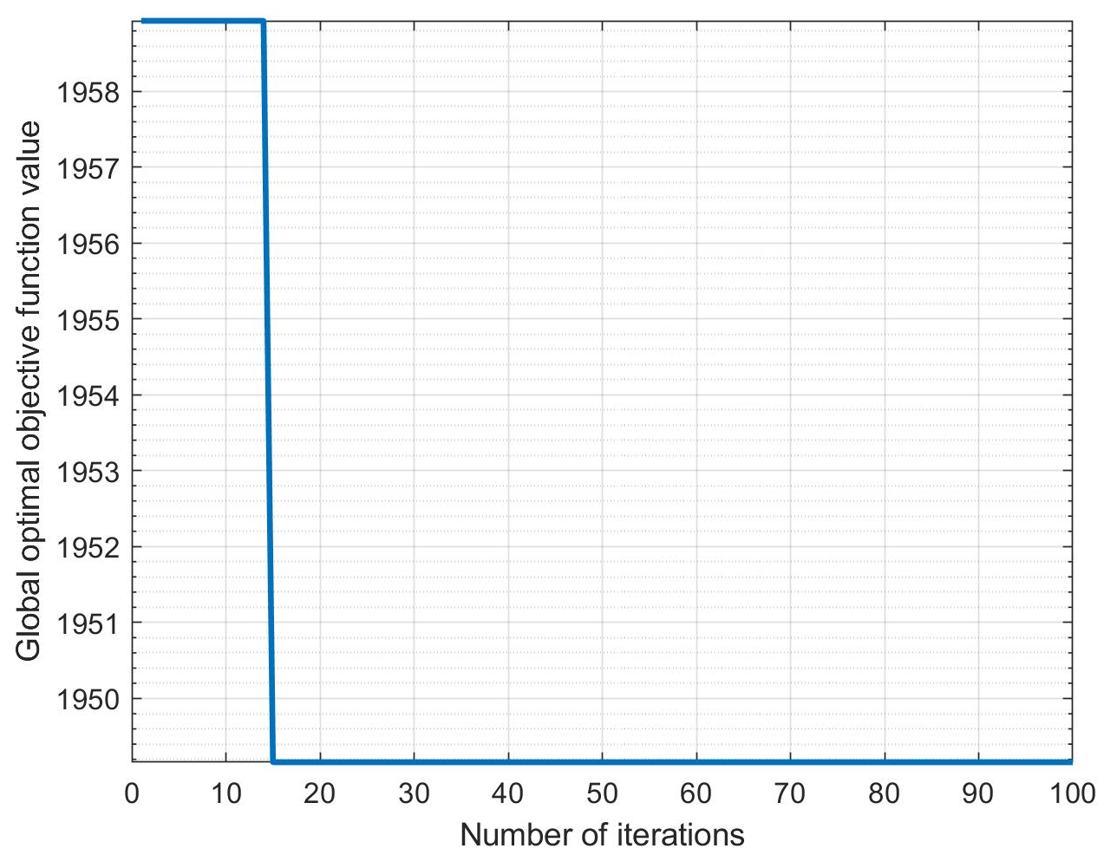
- (b) (c)
Figure 5. VNS-PSO convergence curve for C1 (left), R1 (middle), and RC1 (right) instances. The x-axis corresponds to the number of iterations, and the y-axis corresponds to the total travel time
The vehicle routing details are shown in Tables 3-5.

Table 3 The vehicle distribution routes for C1-type instance

Vehicle | Vehicle route
1 | 0-98-96-95-94-92-93-97-100-99-0
2 | 0-67-65-63-62-74-72-61-64-68-66-69-0
3 | 0-57-55-54-53-56-58-60-59-0
4 | 0-20-24-25-27-29-30-28-26-23-22-21-0
5 | 0-43-42-41-40-44-46-45-48-51-50-52-49-47-0
6 | 0-32-33-31-35-37-38-39-36-34-0
7 | 0-81-78-76-71-70-73-77-79-80-0
8 | 0-90-87-86-83-82-84-85-88-89-91-0
9 | 0-13-17-18-19-15-16-14-12-0
10 | 0-5-3-7-8-10-11-9-6-4-2-1-75-0

Table 4 The vehicle distribution routes for R1-type instance

Vehicle | Vehicle route
1 | 0-65-71-78-34-35-77-0
2 | 0-63-64-49-48-0
3 | 0-39-23-67-54-24-80-0
4 | 0-31-88-7-10-0
5 | 0-33-29-81-50-0
6 | 0-36-47-19-8-46-60-89-0
7 | 0-28-12-40-53-26-0
8 | 0-14-44-38-43-13-0
9 | 0-5-83-61-85-37-91-100-0
10 | 0-92-42-15-87-57-97-0
11 | 0-27-69-76-79-3-68-0
12 | 0-2-21-73-41-55-4-25-0
13 | 0-52-6-0
14 | 0-45-82-18-84-96-0
15 | 0-59-99-94-0
16 | 0-30-51-9-66-1-0
17 | 0-62-11-90-20-32-70-0
18 | 0-95-98-16-86-17-93-0
19 | 0-72-75-22-56-74-58-0

Table 5 The vehicle distribution routes for RC1-type instance

Vehicle | Vehicle route
1 | 0-65-22-23-25-77-58-75-13-11-0
2 | 0-70-2-6-7-79-60-88-98-69-0
3 | 0-96-54-41-42-44-1-3-5-45-4-55-0
4 | 0-61-43-40-36-35-37-38-39-72-81-0
5 | 0-53-12-14-15-16-17-47-78-73-8-46-100-68-0
6 | 0-56-64-20-49-19-18-48-21-24-57-83-66-0
7 | 0-92-67-31-30-32-33-89-76-63-85-51-84-91-0
8 | 0-90-82-99-52-86-74-59-97-87-9-10
9 | 0-95-62-50-34-28-26-27-29-71-93-94-80-0

Conclusions
In this paper, we consider a distribution path planning problem with time windows for FAP delivery. Addressing demand uncertainty by a budget uncertainty set, a mixed-integer structured mathematical model based on robust optimization approach has been developed to minimize the total distribution cost associated with vehicle use, vehicle distribution time, product quantity deterioration, and consumer time window violation. To solve this model, the PSO algorithm is used, in which the variable neighborhood search operators are integrated to avoid the particle swarm falling into local optimum and therefore enhance the overall algorithm performance. Our simulation results show that the proposed VNS-PSO algorithm perform well in terms of robustness, search efficiency, and convergence speed for different problem instances. For the future research, it is of great practical value to extend our problem setting by considering simultaneous quality and quantity deteriorations. In addition, the consideration of various uncertainty such as unexpected vehicle breakdown and road damage could also be an interesting direction for future research.

References
Agra, A., Christiansen, M., Figueiredo, R., Magnus Hvattum, L., Poss, M., & Requejo, C. (2012). Layered formulation for the robust vehicle routing problem with time windows. In Combinatorial Optimization: Second International Symposium, ISCO 2012, (pp. 249-260). Springer.
Amorim, P., Parragh, S. N., Sperandio, F., & Almada-Lobo, B. (2014). A rich vehicle routing problem dealing with perishable food: a case study. Top, 22, 489-508.
Ben-Tal, A., El Ghaoui, L., & Nemirovski, A. (2009). Robust optimization (Vol. 28). Princeton University Press.
Bertsimas, D., & Sim, M. (2004). The price of robustness. Operations Research, 52(1), 35-53.
Bortolini, M., Faccio, M., Ferrari, E., Gamberi, M., & Pilati, F. (2016). Fresh food sustainable distribution: cost, delivery time and carbon footprint three-objective optimization. Journal of Food Engineering, 174, 56-67.
Cai, X., Chen, J., Xiao, Y., Xu, X., & Yu, G. (2013). Fresh-product supply chain management with logistics outsourcing. Omega, 41(4), 752-765.
Cang, Y. M., & Wang, D. C. (2021). A comparative study on the online shopping willingness of fresh agricultural products between experienced consumers and potential consumers. Sustainable Computing: Informatics and Systems, 30, 100493.
Chen, H. K., Hsueh, C. F., & Chang, M. S. (2009). Production scheduling and vehicle routing with time windows for perishable food products. Computers & Operations Research, 36(7), 2311-2319.
Chen, J., Dong, M., & Xu, L. (2018). A perishable product shipment consolidation model considering freshness-keeping effort. Transportation Research Part E: Logistics and Transportation Review, 115, 56-86.
Chen, J., Dan, B., & Shi, J. (2020). A variable neighborhood search approach for the multi-compartment vehicle routing problem with time windows considering carbon emission. Journal of Cleaner Production, 277, 123932.
Chiang, W. C., & Russell, R. A. (1996). Simulated annealing metaheuristics for the vehicle routing problem with time windows. Annals of Operations Research, 63, 3-27.
Covert, R. P., & Philip, G. C. (1973). An EOQ model for items with Weibull distribution deterioration. AIIE Transactions, 5(4), 323-326.
Dantzig, G. B., & Ramser, J. H. (1959). The truck dispatching problem. Management Science, 6(1), 80-91.
Devapriya, P., Ferrell, W., & Geismar, N. (2017). Integrated production and distribution scheduling with a perishable product. European Journal of Operational Research, 259(3), 906-916.
Gmira, M., Gendreau, M., Lodi, A., & Potvin, J. Y. (2021). Tabu search for the time-dependent vehicle routing problem with time windows on a road network. European Journal of Operational Research, 288(1), 129-140.
Gong, Y. J., Zhang, J., Liu, O., Huang, R. Z., Chung, H. S. H., & Shi, Y. H. (2011). Optimizing the vehicle routing problem with time windows: A discrete particle swarm optimization approach. IEEE Transactions on Systems, Man, and Cybernetics, Part C (Applications and Reviews), 42(2), 254-267.
Guo, J., Wang, X., Fan, S., & Gen, M. (2017). Forward and reverse logistics network and route planning under the environment of low-carbon emissions: A case study of Shanghai fresh food E-commerce enterprises. Computers & Industrial Engineering, 106, 351-360.
Han, J. W., Zuo, M., Zhu, W. Y., Zuo, J. H., Lü, E. L., & Yang, X. T. (2021). A comprehensive review of cold chain logistics for fresh agricultural products: Current status, challenges, and future trends. Trends in Food Science & Technology, 109, 536-551.
Hannan, M. A., Akhtar, M., Begum, R. A., Basri, H., Hussain, A., & Scavino, E. (2018). Capacitated vehicle-routing problem model for scheduled solid waste collection and route optimization using PSO algorithm. Waste Management, 71, 31-41.
Hiermann, G., Hartl, R. F., Puchinger, J., & Vidal, T. (2019). Routing a mix of conventional, plug-in hybrid, and electric vehicles. European Journal of Operational Research, 272(1), 235-248.
Hsu, C. I., Hung, S. F., & Li, H. C. (2007). Vehicle routing problem with time-windows for perishable food delivery. Journal of Food Engineering, 80(2), 465-475.
Hu, C., Lu, J., Liu, X., & Zhang, G. (2018). Robust vehicle routing problem with hard time windows under demand and travel time uncertainty. Computers & Operations Research, 94, 139-153.
Kachitvichyanukul, V., Sombuntham, P., & Kunnapapdeelert, S. (2015). Two solution representations for solving multi-depot vehicle routing problem with multiple pickup and delivery requests via PSO. Computers & Industrial Engineering, 89, 125-136.
Kennedy, J., & Eberhart, R. (1995, November). Particle swarm optimization. In Proceedings of ICNN'95-International Conference on Neural Networks (Vol. 4, pp. 1942-1948). IEEE.
Khouadjia, M. R., Sarasola, B., Alba, E., Jourdan, L., & Talbi, E. G. (2012). A comparative study between dynamic adapted PSO and VNS for the vehicle routing problem with dynamic requests. Applied Soft Computing, 12(4), 1426-1439.
Kwon, Y. J., Choi, Y. J., & Lee, D. H. (2013). Heterogeneous fixed fleet vehicle routing considering carbon emission. Transportation Research Part D: Transport and Environment, 23, 81-89.
Li, D., Cao, Q., Zuo, M., & Xu, F. (2020). Optimization of green fresh food logistics with heterogeneous fleet vehicle route problem by improved genetic algorithm. Sustainability, 12(5), 1946.
Liang, Z., Liu, H., Zuo, M., Zhu, H., & Zuo, Y. (2021). Optimal procurement strategy of fresh produce retailer under stochastic product qualification and market demand. Journal of Control and Decision, 8(2), 192-200.
Liu, Z., Zhao, J., Yu, Z., Zhou, Z., Wang, L., & Chen, Y. (2022). How Has the COVID-19 Pandemic Changed Urban Consumers’ Ways of Buying Agricultural Products? Evidence from Shanghai, China. Healthcare (Vol. 10, No. 11, p. 2264). MDPI.
Liu, S., & Zhang, C. (2023). Robust optimization of agriculture products urban distribution path considering demand uncertainty. Alexandria Engineering Journal, 66, 155-165.
Mladenović, N., & Hansen, P. (1997). Variable neighborhood search. Computers & Operations Research, 24(11), 1097-1100.
Naso, D., Surico, M., & Turchiano, B. (2007). Scheduling production and distribution of rapidly perishable materials with hybrid GA's. Evolutionary Scheduling, 465-483.
Ombuki, B., Ross, B. J., & Hanshar, F. (2006). Multi-objective genetic algorithms for vehicle routing problem with time windows. Applied Intelligence, 24, 17-30.
Osvald, A., & Stirn, L. Z. (2008). A vehicle routing algorithm for the distribution of fresh vegetables and similar perishable food. Journal of Food Engineering, 85(2), 285-295.
Qin, Y., Wang, J., & Wei, C. (2014). Joint pricing and inventory control for fresh produce and foods with quality and physical quantity deteriorating simultaneously. International Journal of Production Economics, 152, 42-48.
Rong, A., Akkerman, R., & Grunow, M. (2011). An optimization approach for managing fresh food quality throughout the supply chain. International Journal of Production Economics, 131(1), 421-429.
Sana, S., Goyal, S. K., & Chaudhuri, K. S. (2004). A production–inventory model for a deteriorating item with trended demand and shortages. European Journal of Operational Research, 157(2), 357-371.
Savelsbergh, M. W. (1985). Local search in routing problems with time windows. Annals of Operations Research, 4(1), 285-305.
Shi, Y., & Eberhart, R. (1998, May). A modified particle swarm optimizer. In 1998 IEEE international conference on evolutionary computation proceedings. IEEE World Congress on Computational Intelligence (Cat. No. 98TH8360) (pp. 69-73). IEEE.
Shukla, M., & Jharkharia, S. (2013). Artificial Immune System-based algorithm for vehicle routing problem with time window constraint for the delivery of agri-fresh produce. Journal of Decision Systems, 22(3), 224-247.
Skouri, K., Konstantaras, I., Papachristos, S., & Ganas, I. (2009). Inventory models with ramp type demand rate, partial backlogging and Weibull deterioration rate. European Journal of Operational Research, 192(1), 79-92.
Sun, J., Jiang, T., Song, Y., Guo, H., & Zhang, Y. (2022). Research on the Optimization of Fresh Agricultural Products Trade Distribution Path Based on Genetic Algorithm. Agriculture, 12(10), 1669.
Tirkolaee, E. B., Hadian, S., Weber, G. W., & Mahdavi, I. (2020). A robust green traffic‐based routing problem for perishable products distribution. Computational Intelligence, 36(1), 80-101.
Wang, C., & Chen, X. (2017). Option pricing and coordination in the fresh produce supply chain with portfolio contracts. Annals of Operations Research, 248, 471-491.
Wang, Y., Yang, C., & Hou, H. (2020). Risk management in perishable food distribution operations: A distribution route selection model and whale optimization algorithm. Industrial Management & Data Systems, 120(2), 291-311.
Xia, Y., & Fu, Z. (2019). Improved tabu search algorithm for the open vehicle routing problem with soft time windows and satisfaction rate. Cluster Computing, 22(Suppl 4), 8725-8733.
Yang, H. L. (2012). Two-warehouse partial backlogging inventory models with three-parameter Weibull distribution deterioration under inflation. International Journal of Production Economics, 138(1), 107-116.
Yan, L., Meng, X., & Ma, X. (2021, December). Robust Optimization of Urban Cold Chain Logistics Distribution Routing under Uncertain Demand. In 2021 International Conference on Networking, Communications and Information Technology (NetCIT) (pp. 5-11). IEEE.
Yu, B., Yang, Z. Z., & Yao, B. (2009). An improved ant colony optimization for vehicle routing problem. European Journal of Operational Research, 196(1), 171-176.
Zhang, H., Zhang, Q., Ma, L., Zhang, Z., & Liu, Y. (2019). A hybrid ant colony optimization algorithm for a multi-objective vehicle routing problem with flexible time windows. Information Sciences, 490, 166-190.
Zhao, K., Shi, H., Zhang, Y. Y., & Sheng, J. (2021). Fresh produce E-Commerce and online shoppers’ purchase intention. The Chinese Economy, 54(6), 415-429.

